Supplementary figures
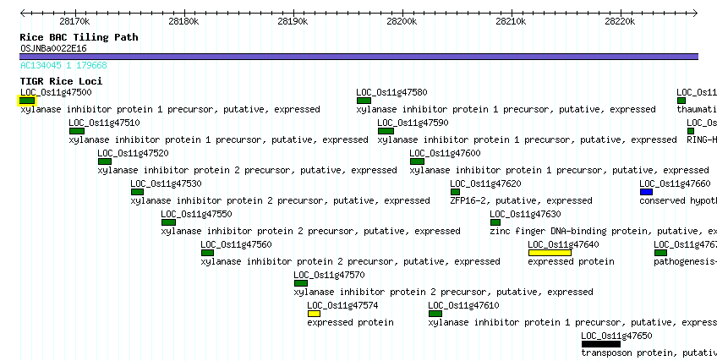
Supplementary Figure SF1: Cluster of high GC₃ genes on rice chromosome 11, as shown in TIGR genome browser (www.tigr.org)

Supplementary Figure SF2: Frequency of a canonical TATA-box in the 50 nucleotides upstream of the transcription start site for TSS predictions refined using the TSSer algorithm. Overall, 48% of rice promoters contain a canonical TATA-box; only 33% of genes with GC₃ < 0.45 are equipped with TATA+ promoters as compared to 68% of those with GC₃ > 0.95.

Supplementary Figure SF3: Intron density as a function of GC₃ in Oryza sativa and Sorghum bicolor. Intron density is defined as a number of introns per 1000 nucleotides of transcript length.

Supplementary Figure SF4: Distribution of dinucleotides CG and GC in O. sativa, stratified by high (CG₃>0.8) and low (CG₃<0.8) CG content in the third position of the codon.

Supplementary Figure SF5: Relative abundances ρC₃G₁ and ρC₂G₃ of GC at the wobble position. For rice and sorghum, we defined GC₃ high is >0.8 and GC₃ low is <0.5. For arabidopsis, we assumed GC₃ high >0.6 and GC₃ low<0.3.

Supplementary Figure SF6: Distribution of position-specific relative abundance HEAT repeat, O. sativa.

Supplementary Figure SF7: Distribution of position-specific relative abundance for protein kinase families, O. sativa.

Supplementary Figure SF8: Distribution GC₃ in honey bee (Apis mellifera), fruit fly (Drosophila melanogaster), and fire ant (Solenopsis invicta). Generally low GC₃ organism honey bee has a surprising medium and high GC₃ tail, containing approximately 25% of genes. This tail consists of a bunch of various “receptor” encoding genes (e.g. Metabotropic glutamate receptor, Toll-like receptor, Dopamine receptor type D2, D2-like dopamine receptor, Ephrin receptor, SIFamide receptor, Ecdysteroid receptor A isoform, Antennapedia protein, Nicotinic acetylcholine receptor alpha1 subunit, Alpha-glycosidase G-protein coupled receptor, etc). Based on current annotation, 2.2% of all Apis mellifera genes encode receptors. Considering two extremes (1000 genes with highest and lowest values of GC₃), lowest GC₃ genes encode receptors in 1.3% of cases as compared with 5.6% of high GC₃ genes.

Supplementary Figure SF9: Distribution GC₃ in Brachypodium distachyon. Distribution is bimodal with high (~47%) fraction of ORFs having GC₃ ≥0.8. Since this analysis was done based on available collection of Brachypodium distachyon ESTs (www.brachypodium.org), this effect may be due to sequence redundancy.

