Additional file 3: Male-specific expression tested by PCR. Each contig tested is represented by an example of the PCR results. The lanes correspond to (1) male cDNA, (2) female cDNA, (3) control male sample without reverse transcriptase, (4) control female sample without reverse transcriptase, and (5) control with no template.
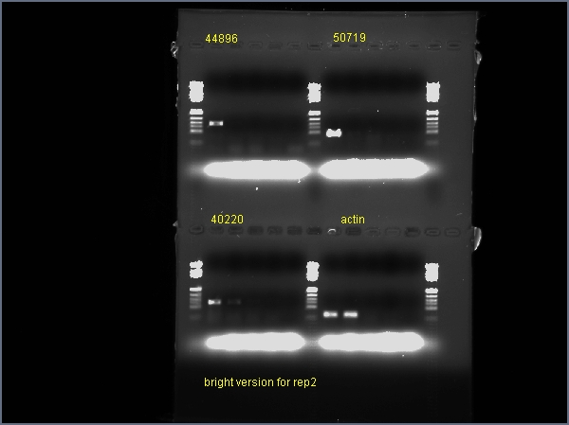
contig44905- male specific
contig50719- not male specific
contig44896- male specific
contig42251- not male specific
contig50654- male specific
contig40220- not male specific

