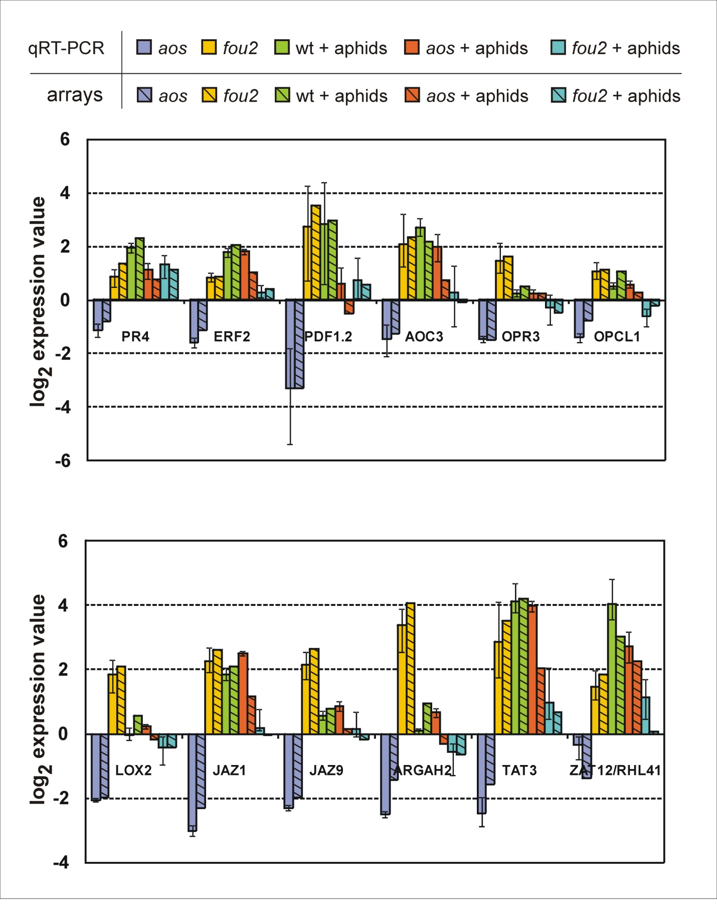
Additional file Figure S2. Verification of microarray data by quantitative RT-PCR. Bars represent averages of log₂ transformed expression values +/- standard errors for three biological replicates. Abbreviations: aos, changes in gene expression profile in the aos mutant in comparison to wt as revealed by qRT-PCR and microarray results; fou2, changes in gene expression profile in the fou2 mutant in comparison to wt as revealed by qRT-PCR and microarray results; wt + aphids, changes in gene expression mediated by B. brassicae attack in wt plants as revealed by qRT-PCR and microarray results; aos + aphids, changes in gene expression mediated by B. brassicae attack in the aos mutant as revealed by qRT-PCR and microarray results; fou2 + aphids, changes in gene expression mediated by B. brassicae attack in the fou2 mutant as revealed by qRT-PCR and microarray results; PR4, PATHOGENESIS-RELATED 4; ERF2, ETHYLENE RESPONSIVE TRANSCRIPTION FACTOR 2; PDF1.2, PLANT DEFENSIN 1.2; AOC3, ALLENE OXIDE CYCLASE 3; OPR3, OPDA REDUCTASE 3; OPCL1, OPC-8:0 CoA LIGASE 1; LOX2, LIPOXYGENASE 2; JAZ1, JASMONATE-ZIM-DOMAIN PROTEIN 1; JAZ9, JASMONATE-ZIM-DOMAIN PROTEIN 9; ARGHA2, ARGININE AMIDOHYDROLASE 2; TAT3, TYROSINE AMINOTRANSFERASE 3; ZAT12/RHL41, RESPONSIVE TO HIGH LIGHT 41.

