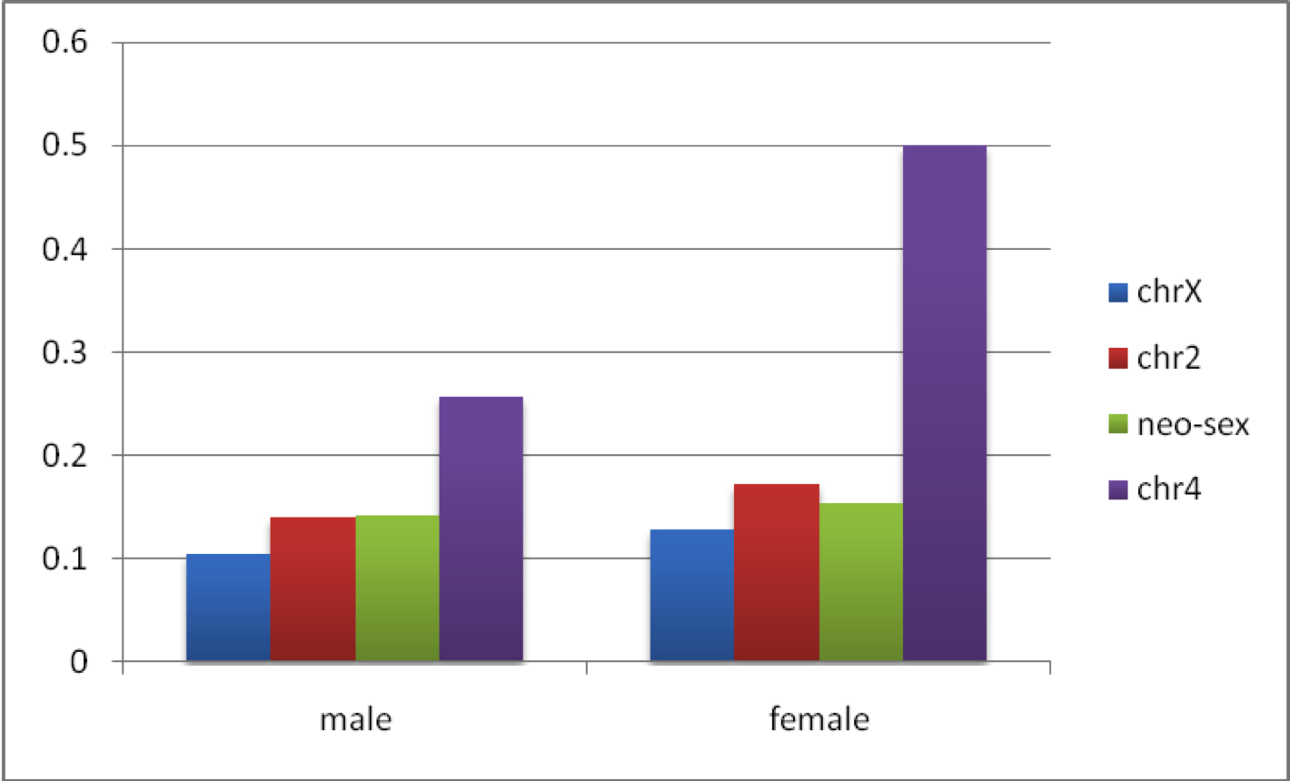
Additional File 13: Figure S7. Proportions of dispersed duplications overlapping coding regions on each chromosome.

