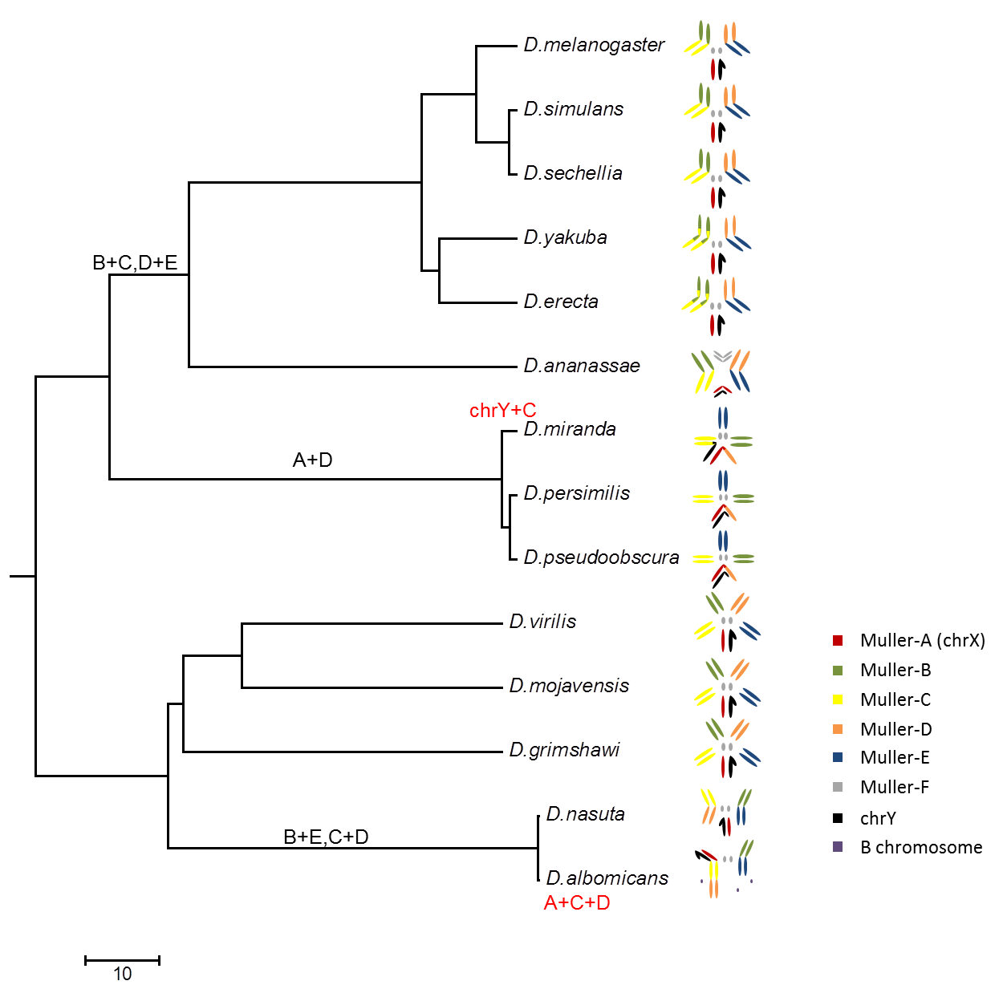

Additional File 1: Figure S1. Karyotyp of D. albomicans and other Drosophila species. Fusions of specific chromosomes (Muller’s elements) are shown along phylogenetic lineages. Modified from ref. [1].
1. Chang TP, Tsai TH, Chang HY: Fusions of Muller's elements during the chromosome evolution of Drosophila albomicans Zool Stud 2008, 47(5):574-584.

