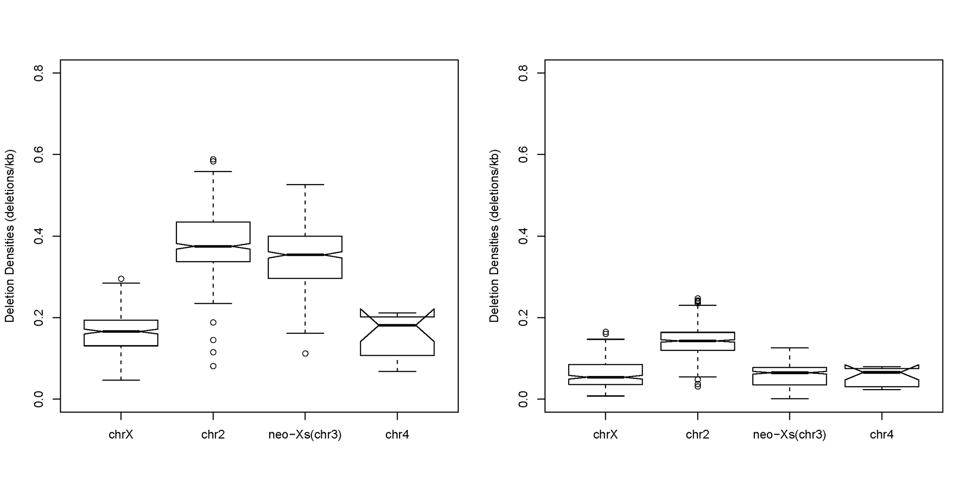
B.
A.
Additional File 7:Figure S4 Short deletions (1-6bp) densities along each chromosome
Densities of short deletions were calculated every 1Mb window with a step size of 100kb. (A) Short deletion densities using male reads. (B) Short deletion densities using female reads.

