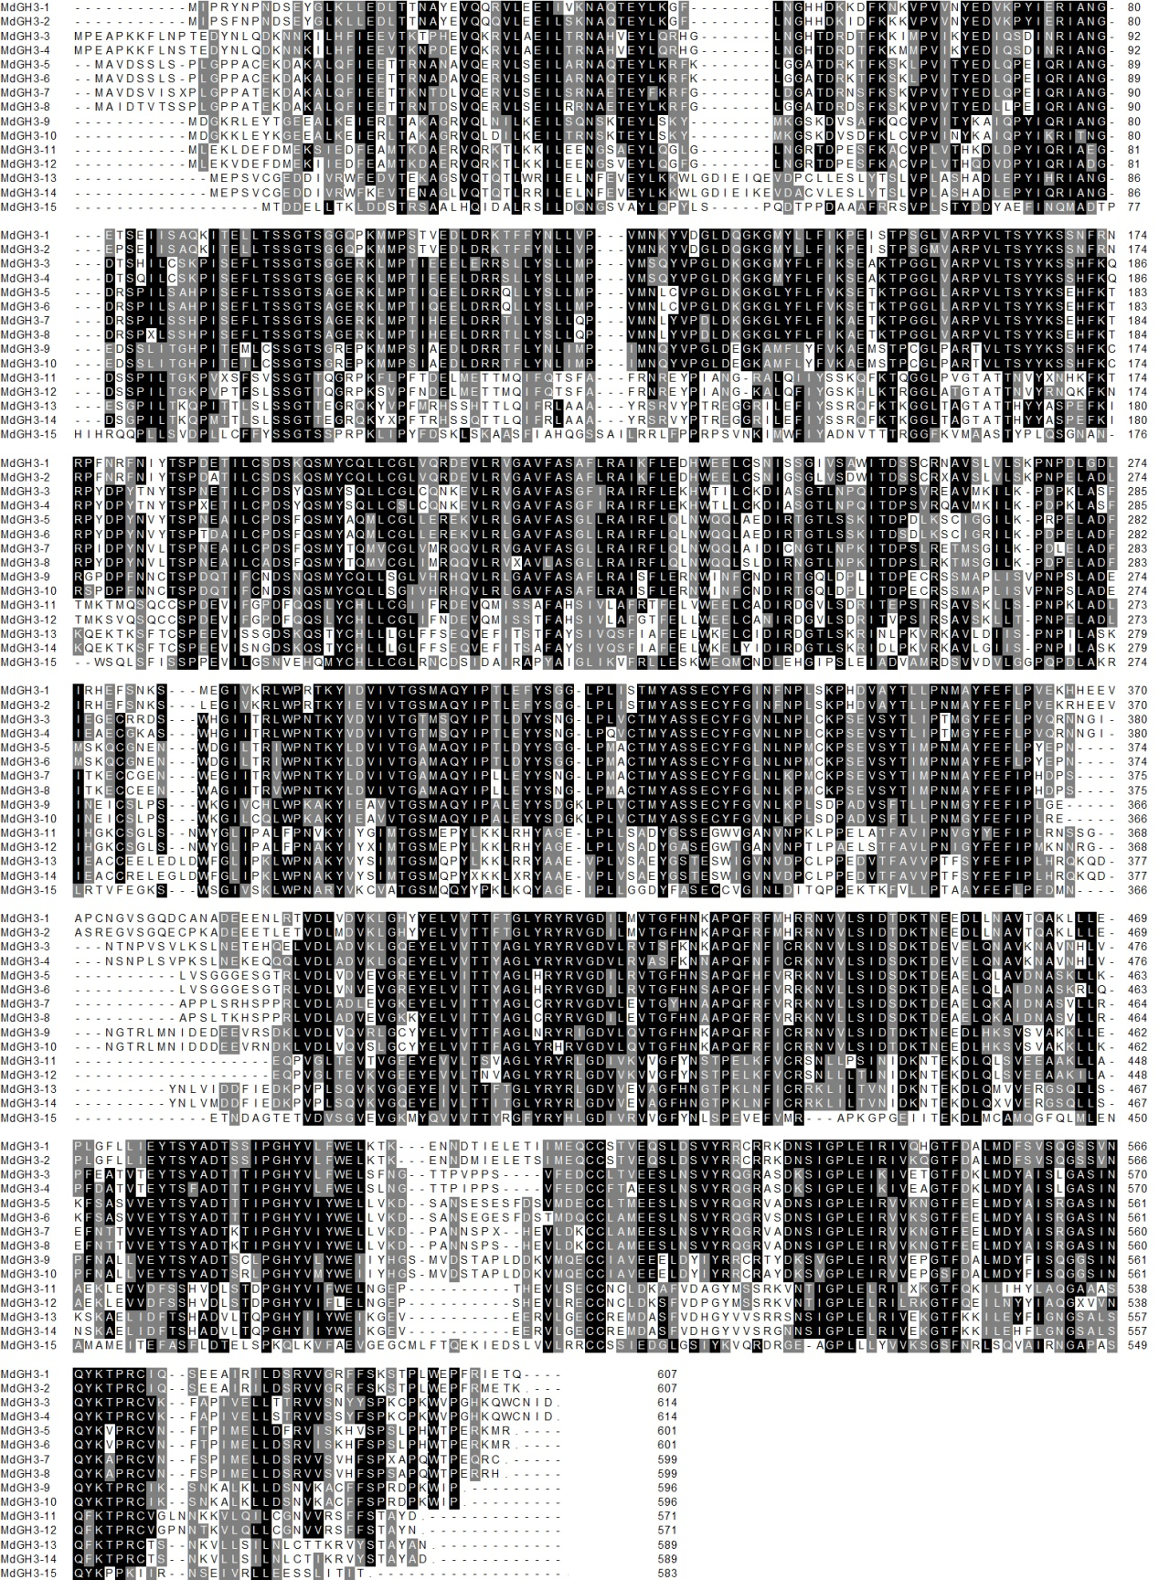Multiple sequence alignments of full-length MdGH3s. Identical and conserved residues (present in more than 50% of aligned sequences) are highlighted in black and gray, respectively. Alignments were generated using ClustalW.

