Figure S1. The Venn diagrams showing the pair-wise overlap between CTCF and Rad21, Smc3, and Znf143 when both are constitutive or non-constitutive. Counts provide for each region in the Venn diagrams.
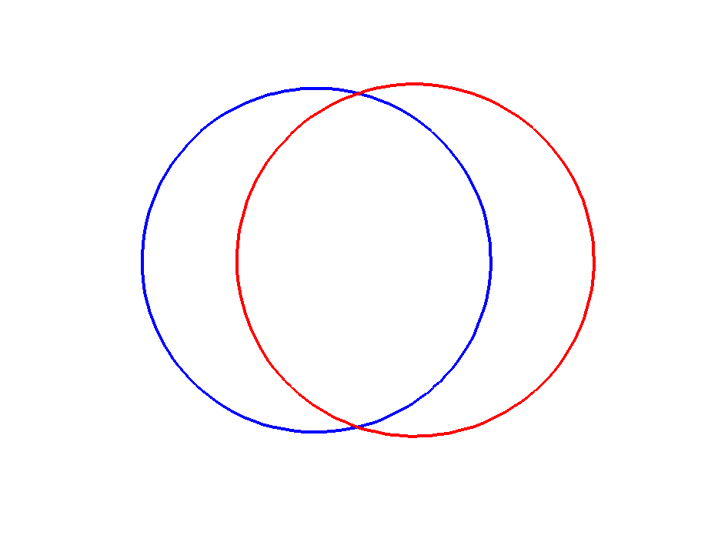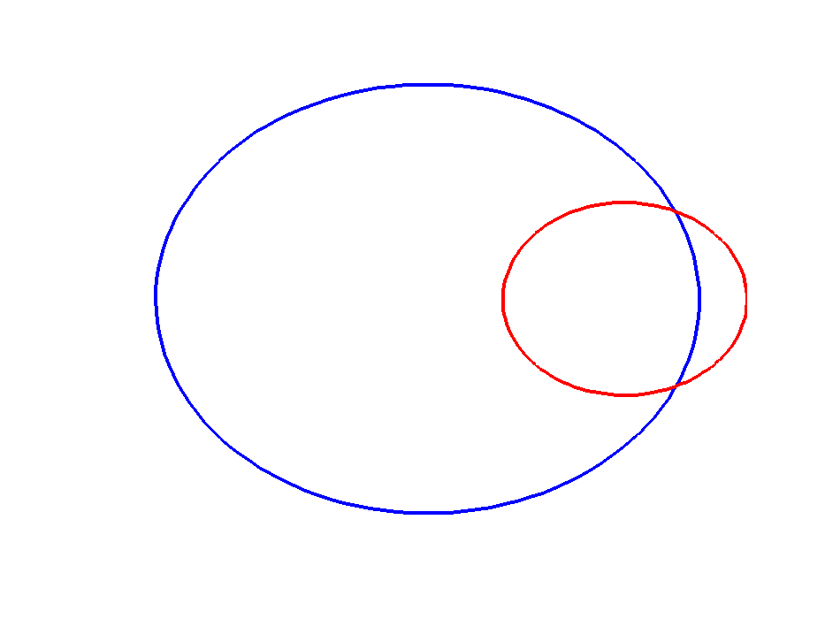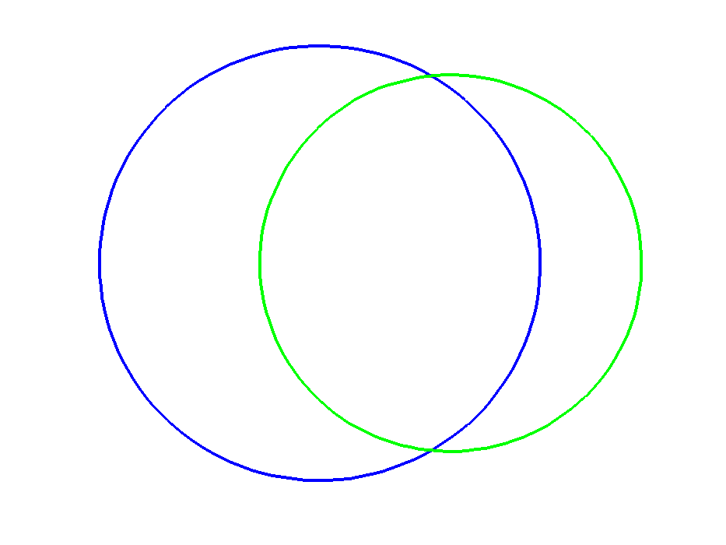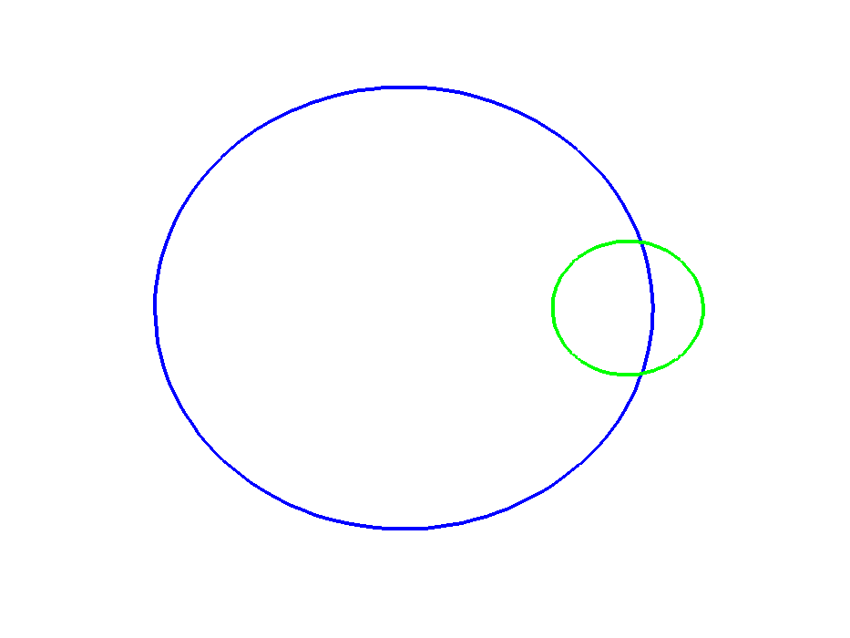
(a) Constitutive (26,631)
CTCF
19224
7407
12741
301473
12202
60965
(a) Non-constitutive (374,640)
6483
Rad21
20148
CTCF
362438
Rad21
73167
9248
4444
9976
339987
10696
22451
(b) Constitutive (23,668)
(b) Non-constitutive (373,134)
CTCF
362438
CTCF
19224
Smc3
14420
Smc3
33147
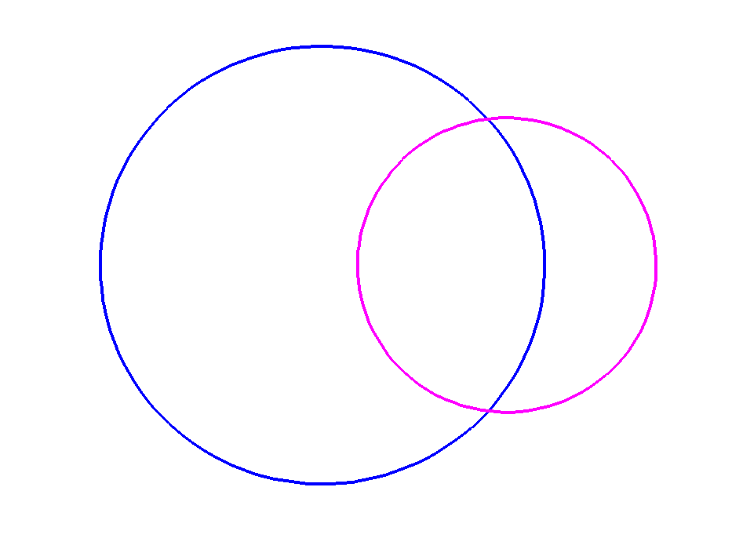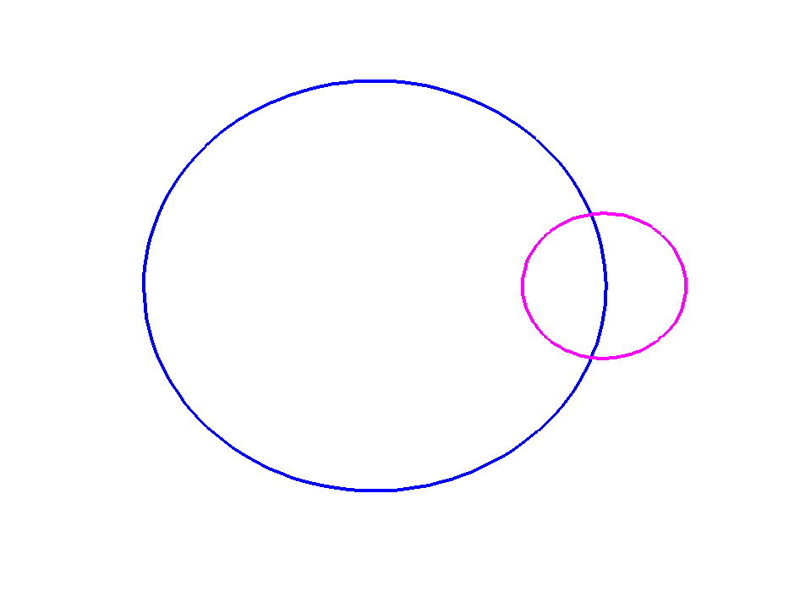
14148
3611
5076
CTCF
362438
Znf143
45268
21537
(c) Constitutive (22,835)
(c) Non-constitutive (386,169)
Znf143
8687
CTCF
19224
340901
23731

Figure S2. The Venn diagrams showing the trio-wise overlap between CTCF and Rad21 and Smc3, Rad21 and Znf143, and Znf143 and Smc3 when both are constitutive or non-constitutive. Counts are provided for regions where all 3 proteins bind (3-way intersection) and where only one protein binds; counts for regions where exactly 2 proteins bind can be calculated.
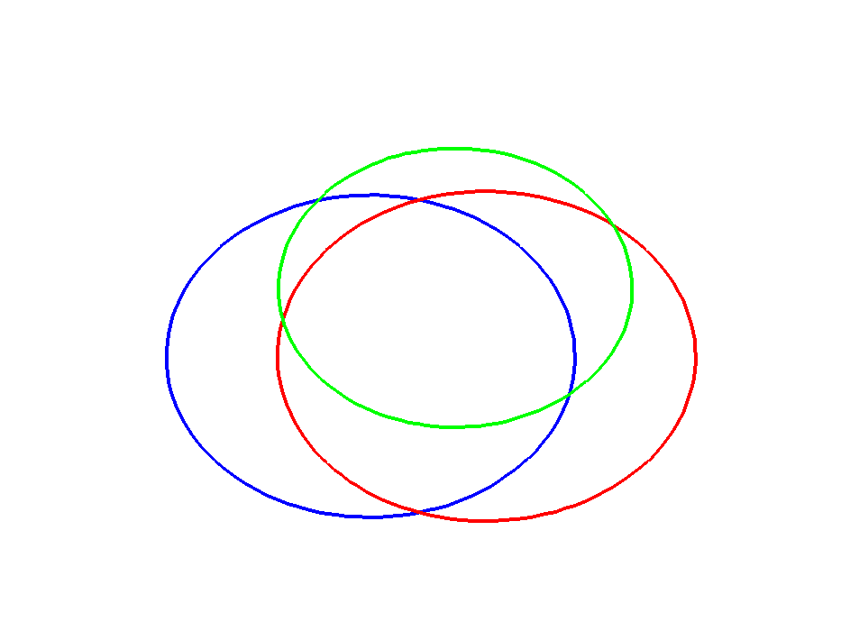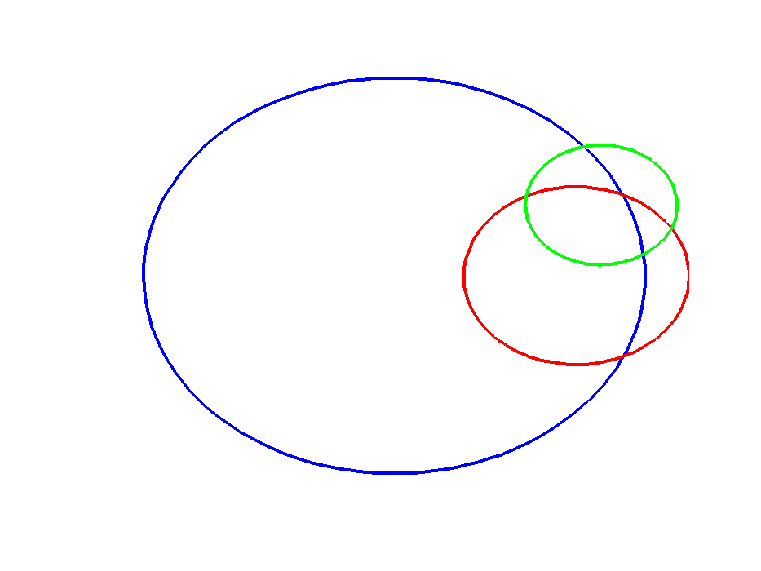
CTCF
19224
Smc3
14420
8795
CTCF
362438
Smc3
33147
15061
(a) Constitutive (28,086)
(a) Non-constitutive (381,050)
4418
7916
1455
Rad21
20148
5302
294183
Rad21
73167
6310
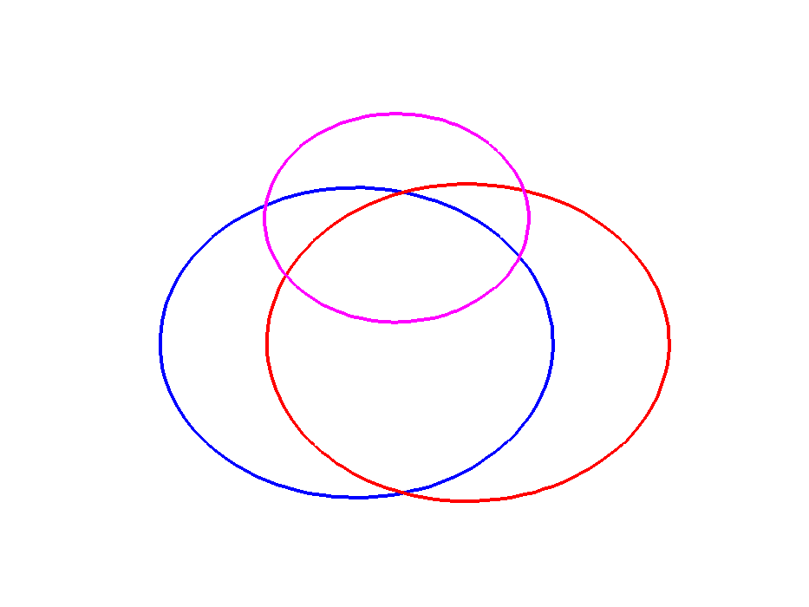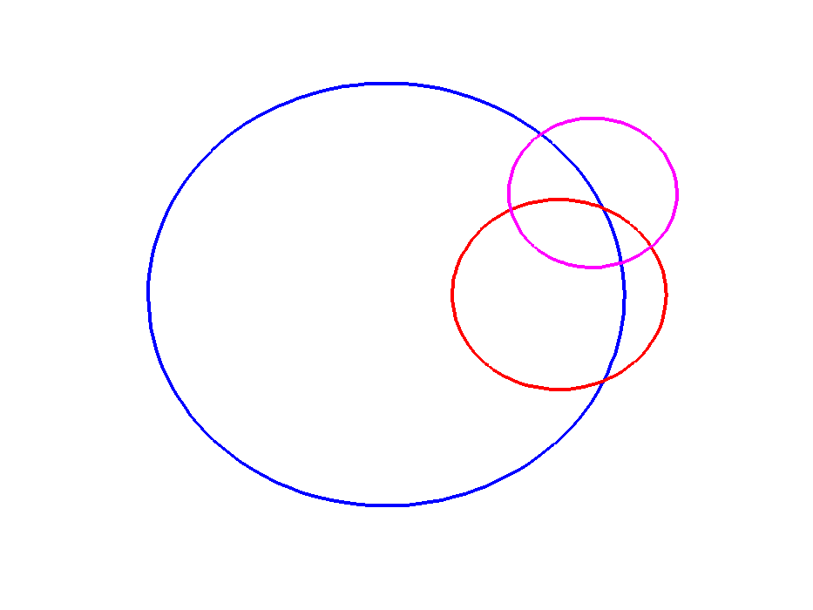
5612
2957
4025
(b) Constitutive (29,588)
6753
290568
19317
10532
(b) Non-constitutive (394,057)
7888
Znf143
8687
CTCF
19224
Rad21
20148
CTCF
362438
Znf143
45268
Rad21
73167
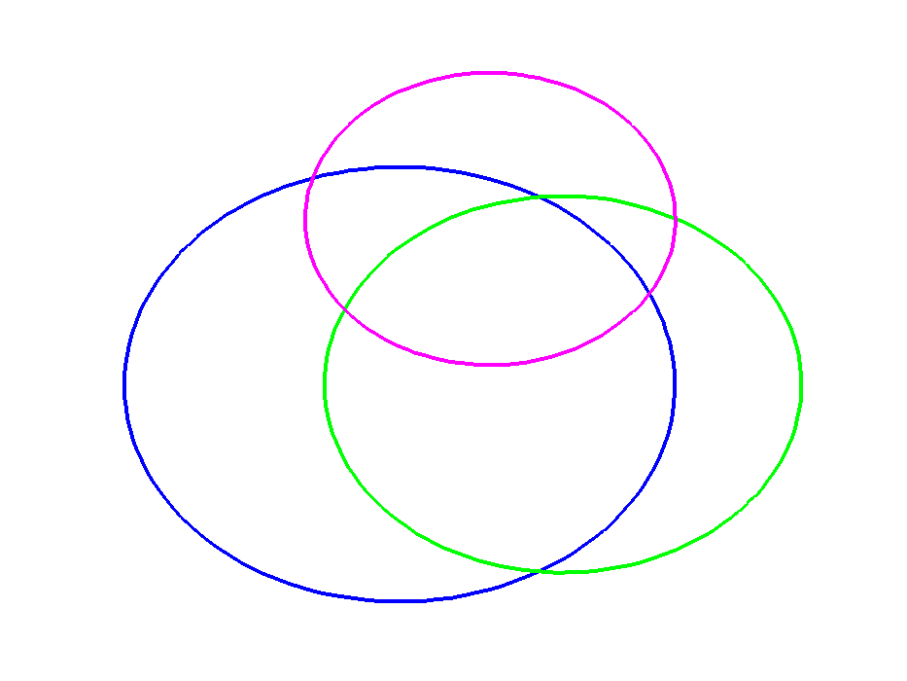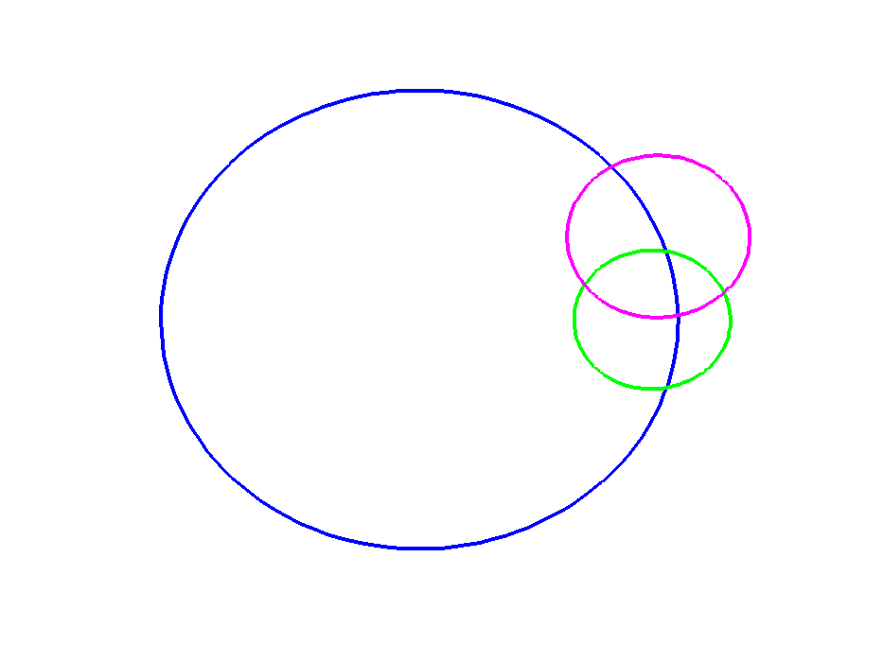
7728
3923
3556
(c) Constitutive (26,758)
3090
326089
18509
7639
(c) Non-constitutive (391,643)
5474
Znf143
8687
Smc3
14420
CTCF
19224
CTCF
362438
Smc3
33147
Znf143
45268
Figure. S3. Box plots of the fraction of overlap within each cell line between classes of CTCF sites and various factors/features. The classes of CTCF sites are: cCTCF/cCohesin sites (black), cCTCF-Cohesin sites (red), or all CTCF sites bound in each cell line excluding cCTCF sites (blue). Each point in a box plot represents a cell line.

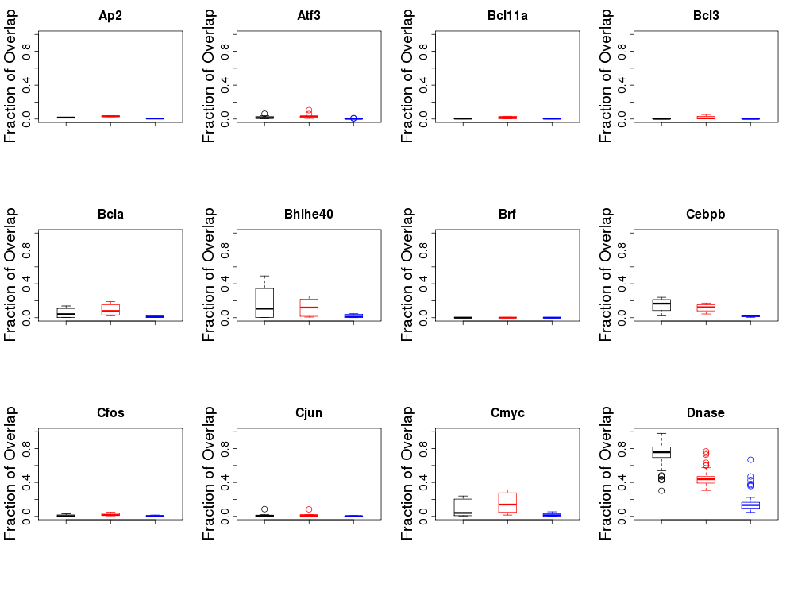
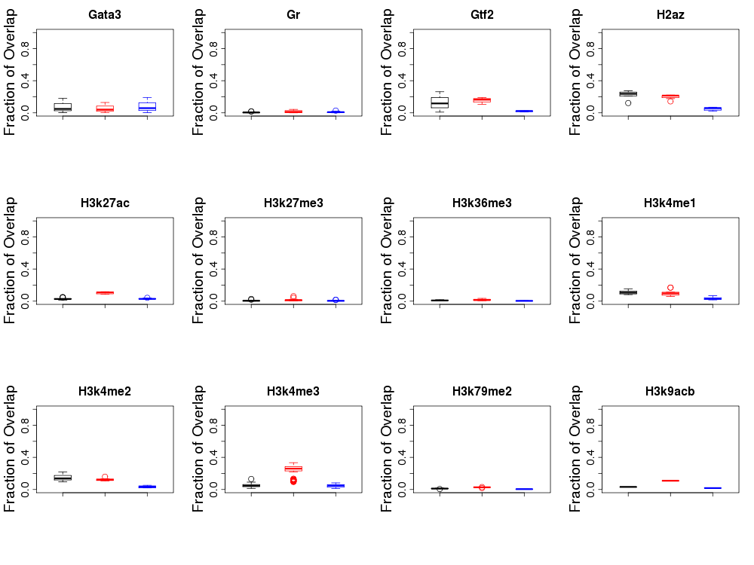
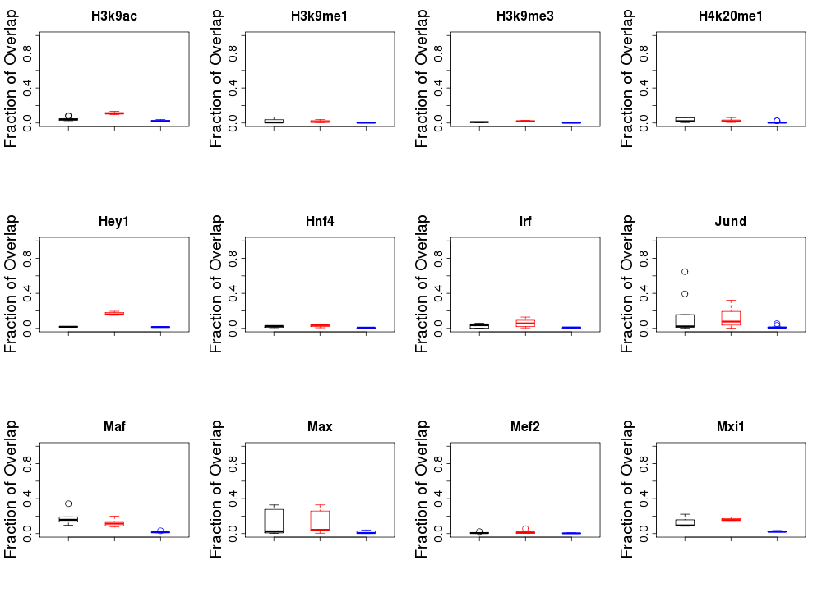
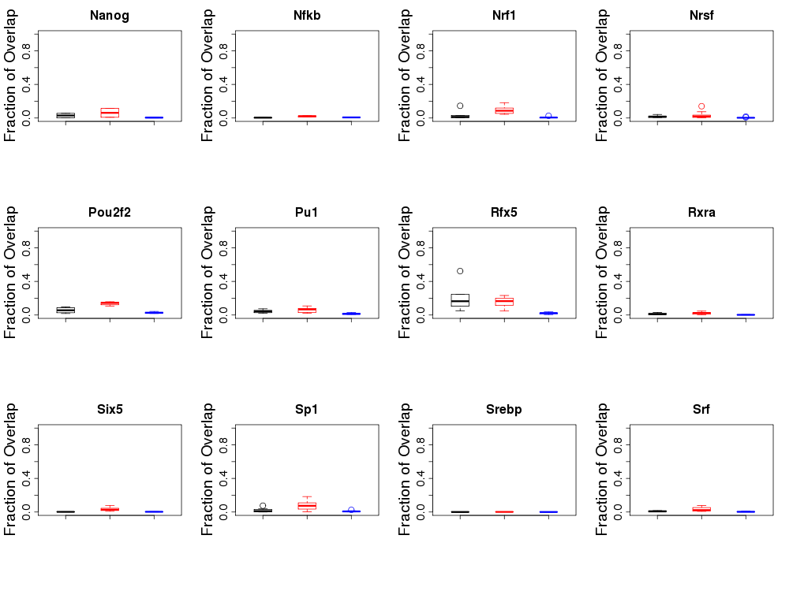
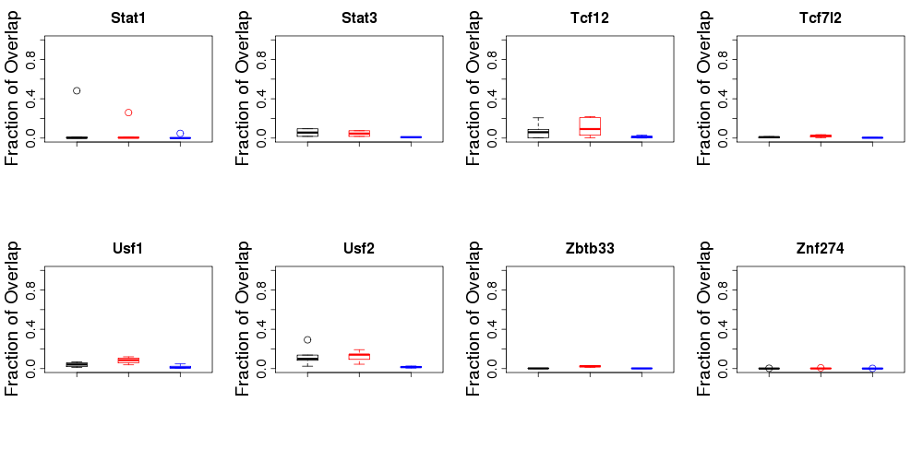

Figure S4. Density of epigenetic marks cCTCF/cCohesin loci (top panels, black) and the cCTCF-Cohesin loci (bottom panels, red) in Gm12878, Helas3, Hepg2, and K562 cell lines.
