Additional File 10 – Module eigengenes
Summary of the module eigengenes.

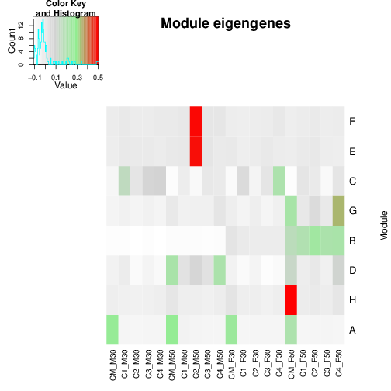

Module eigengenes (ME) as provided by the moduleEigengenes function in package WGCNA [Langfelder, Horvath, 2008] (averaged per condition).

