Additional File 8 – Module inference
Colored dendrogram showing the modules as inferred from the co-expression network.

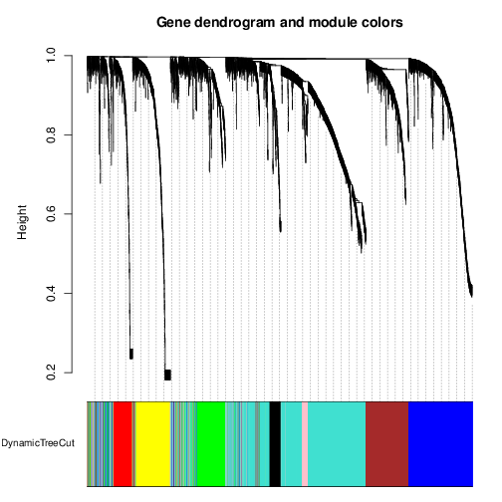

Colors represent the different modules.

