Alcasabas, de Clare, Pir & Oliver

Supplementary Information

Methods

Real Time (RT) PCR to measure transcript levels

Total RNA was extracted from 10ml exponential-phase cultures (OD600 = 0.4 to 0.6) using standard procedures with Trizol reagent (Invitrogen) and chloroform. Total RNA was quantified by measuring absorbance at 260nm and by visualisation on an agarose gel. cDNA was amplified from approximately 500ng of total RNA using SuperScriptIII (Invitrogen). The resulting cDNA (20µl) was diluted to 400µl with nuclease-free water. 3µl was used for every 19µl RT-PCR reaction.

RT-PCR was performed in a Rotor-Gene 6000 (Corbett Research), all primers and probes are listed in Supplementary Table S3. For the cdc28 tetraploid and diploid deletion series, transcripts of ACT1, CDC28, and damage-inducible genes were amplified using reagents and conditions specified by the Rotor-Gene SYBR Green Kit (Qiagen). RT-PCR conditions used were 5 min. initial denaturation at 95°C, followed by 35 cycles of 30 sec each at 95°C, 56°C, and 72°C when fluorescence was measured in the green channel, followed by 10 min. at 72°C, and finally a melting curve where the temperature was raised by 1°C every five sec and fluorescence measured until 99°C. Apart from the expected fluorescence curves during both the PCR and melting steps, we also confirmed that these conditions and primers produced only the expected PCR product by agarose gel electrophoresis (data not shown). No-template controls were used for each set of reactions, and RT-PCR quantitation was also initially tested using different dilutions of cDNA from WT.

For the other gene deletion series, ACT1 and kanMX transcripts were measured in a duplex reaction using reagents and conditions specified by the Rotor-Gene Multiplex Kit (Qiagen), and primers and fluorescent probes listed in Supplementary Table S3. RT-PCR conditions used were 5 min. initial denaturation at 95°C, followed by 35 cycles of 15 sec. each at 95° and 60°C, when fluorescence was measured in both the green (kanMX) and yellow (ACT1) channels. The target gene for each series was amplified in a separate RT-PCR reaction using the Rotor-Gene SYBR Green Kit (Qiagen) and conditions described above for CDC28.

For each strain, RT-PCR using reference ACT1 primers, was first performed in triplicate to confirm that the cycle threshold (Ct) values for all strains were within 1 cycle. Ct was calculated using the Rotor-Gene 6000 software (Corbett Research). We then performed RT-PCR for each test primer in triplicate, together with reference ACT1. The Ct value taken for each primer was the average of the closest two replicates, eliminating the third replicate. Where there was no clear outlier, then the average Ct of all three replicates was taken. To calculate gene transcript concentration relative to that of the WT strain (Supplementary Figure S1), we used the following formula:

Construction of a CDC28 dosage series

The CDC28 tetraploid dosage series was derived from the heterozygous CDC28/cdc28 diploid. This strain was transformed with pAA404 (a centromeric plasmid bearing URA3 and CDC28) and sporulated to obtain the cdc28 haploids AY274B and AY277 in which the null mutation is complemented by the presence of pAA404 (confirmed by the transformants’ sensitivity to 5-fluoro-orotic acid; 5FOA). These two haploids were crossed to obtain the cdc28/cdc28 diploid. To convert this diploid to MATa/MATa and MATα/MATα diploids (as described in Methods), we swapped pAA404 with pAA402 (a centromeric plasmid bearing HIS3 and CDC28) in order to use pGAL-HO, which has URA3 as the selectable marker. The resulting strains were named AY389 and AY390A (all strains and plasmids are listed in Supplementary Table S2).

The single-copy CDC28 tetraploids, AY398D_4 and AY398D_14, were constructed by crossing mating-competent diploids AY389 and AY244A. Tetraploids were streaked out to single colonies and replica-plated onto a medium without histidine to identify tetraploids that were cured of plasmid pAA402.

To make cdc28-DAmP tetraploids, we first obtained a cdc28-DamP diploid by crossing the cdc28-DAmP haploid MATa strain (Breslow et al., 2008; OpenBiosystems) to AY274B. The resulting single-copy DAmP diploid, AY412A, was converted to a MATa/MATa diploid, strain AY409A with pGAL-HO (Materials and Methods). This was then crossed with AY389 and AY249 to obtain tetraploids AY413B/C and AY414, respectively; these strains contain the cdc28-DAmP allele.

RT-PCR was performed to determine the CDC28 expression level in all CDC28 tetraploid and diploid series (Supplementary Figure S1B and S1C).

Construction of a strain in which Cdc28p activity can be titrated by an inhibitor
Haploid S.cerevisiae strains in which the native CDC28 locus was replaced with the kanMX cassette, and the loss complemented by the presence of pJU1189 (pRS416::CDC28) or pJU1203 (pRS416::cdc28-as1 (F88G)) were obtained from Stefania Vaga (ETH, Zurich).

These were mated with AY274B to produce a cdc28/cdc28 diploid bearing pAA402 and pJU1189 or pJU1203. Strains were re-streaked onto medium without uracil but with histidine to encourage loss of pAA402. After four rounds of re-streaking, single colonies were selected and loss of pAA402 was confirmed by the lack of growth on medium lacking histidine, and the sensitivity of the pJU1203-bearing strain to treatment with 1nm-PP1.

Quantification of growth and viability on YPD Plates

Each tetraploid strain was grown in liquid YPD for 48h, then spotted as eight replicates onto a YPD-agar plate containing 0.001% phloxine B. This was done in a 16x24 format using a RoToR HDA robot (Singer Instruments). After 24h, the plate was scanned against a black background using an Epson Perfection 1240 flatbed scanner and saved as 8-bit RGB jpeg file at 300ppi resolution. Background colour was set to black using ImageJ (http://rsb.info.nih.gov/ij) software. The images were then read using MATLAB (MathWorks) into a three-dimensional matrix of intensities. The first two dimensions correspond to the two dimensions of the image, their size being equal to the pixel size of the image. The third dimension corresponds to the colour channels (RGB), hence its size is three. Coordinates of the colony centres are identified interactively as a function of user-defined centres of the four colonies at the corners of the image. The image is partitioned into diamond-shaped sub-images, the centres of which correspond to the centres of the colonies they contain. Every sub-image was analysed for the size of the colony it contains, pixels brighter than the background of the sub-image were counted and total number of pixels were assigned as the size (area) of the corresponding colony. The backgrounds of the sub-regions were calculated as the mean intensity of the diagonals of the sub-region multiplied by a user-defined constant coefficient; in this case, an optimized coefficient (4.5) was used for black background. For colony size quantification, only the intensities from the blue channel were used.

The average colony size (in pixels) of the 8 replicates, determined using the blue channel, was calculated for each tetraploid strain, and plotted relative to wild-type growth, as well as growth in liquid medium and that predicted by modelling (Figure 3).

For viability measurements, within each colony, data from all three channels were used for quantifying phloxine B dye uptake as an indication of the fraction of dead cells in the colonies. The “redness” of a pixel was calculated as follows: The product of the intensities from the blue, red and inverted green channels (calculated as [255 - intensity of green channel]) were normalized by dividing by the cube of the sum of the intensities from red and blue channel. Average “redness” values from all pixels of the colony were multiplied by 100% to calculate a percent “Redness Index”. The average red index of the 8 replicates per strain were calculated and plotted relative to wild-type growth (Supplementary Figure S4A).

Viability measurements tetraploid cultures

To measure the proportion of viable cells within liquid cultures (Supplementary Figure S5B), selected tetraploid strains were grown in liquid YPD to an OD600 of 0.4 to 0.6. 500µl of cultures were centrifuged, resuspended in 0.5mg/ml of propidium iodide, and incubated for 5min to 1h. These were analysed using a CyAn flow cytometer (Beckman Instruments) to count the number of dead cells which are fluorescent in a population of 10,000 cells. The percentage of dead cells (fluorescent in the red channel) were plotted relative to the total number of cells (Supplementary Figure S4B).

Table S1. Extension of the logical model of the cell cycle
Species added to the Fauré et al. (2009) cell-cycle model in this work, and the logical rules governing their Boolean values are listed, along with species having altered logical rules due to the addition of new intermediate nodes

Species | Logical expression | Comment
sit4 | Mass
cln3 | mass & !rad53 | DNA damage & consequent RAD53 activation, halts progression through START
bck2 | sit4
smbf | ! (clb2==3 & !(sic1 | cdc6)) & (bck2 | cln3 | cln2 | (clb5 & !sic1))
cln2 | smbf & mass
swi5 | mcm1 & ! (clb2 & !(sic1 | cdc6)) | (mcm1 & clb2 & !(sic1 | cdc6) & (cdc14=1 & !net1) | (cdc14=2 & !net1=2))
mpk1 | !bud
pp2a | as Faure et al. species 'PP2ACdc55' | Complex of several HFC genes, not resolved in this work
sld2 | (clb5 & !sic1) | ((clb2=2 | clb2=3) & !(sic1 | cdc6))
cdc45 | sld2
mcm | cdc45 & (mcm1 | dbf4) | MCM complex consisting entirely of HFC genes
origin | mcm | (origin & (clb5=3 | clb2=3 | (clb5=1 & !sic1) | (clb2=1 & !(sic1|cdc6)) | Firing of origins of replication, as in Faure et al.
cdc34 | TRUE | Basal value
lte1 | G2 & !spindle | G2 represented by activated Clb2/5 & repression of SIC1 & CDC6
tem1 | lte1
cdc14 | dbf2 & ccr4
dbf4 | clb5 & !sic1
esp1 | TRUE
condensin | rad61 & pds1 | Spindle checkpoint, the presence of the additional HFC species is required for spindle formation & elongation. The components of the condensin complex, all HP, are not resolved in this model
cohesin & ctf8 | rad61 & pds1
bik1 | G2/M & !cytokinesis
nuf2 | G2/M & !cytokinesis
mcm21 | G2/M & !cytokinesis
nkp2 | G2/M & !cytokinesis
dma1 | G2/M & !cytokinesis
ndl1 | G2/M & !cytokinesis
spindle | (condensin & cohesin & ctf8 & (bik1 & nuf2 & mcm21 & nkp2 & dma1 & ndl1)) | (spindle & G2)
mad2 | origin & !spindle
bub2 | origin & (!spindle | pp2a=2 | !cdc5polo)
clb1 | As Faure et al. species ‘clb2’, with dependencies on Cdc20 removed
clb2 | As Faure et al. species ‘clb2’
bfa1 | origin & (!spindle | pp2a=2 | !cdc5polo)
cdc5 polo | !rad53 & clb2 & !(sic1|cdc6) & !cdh1
pds1 | chk1 | (mc1 & smbf & !cdc20=2) | ((mcm1 | smbf) & !cdh1 & !cdc20)
rad61 | (mcm1 & smbf & !cdc20=2) | ((mcm1 | smbf) & !cdh1 & !cdc20)
msh2 | ss_damage & rad53 | DNA damage response module; damage (SS or DS) persists until repaired, requiring the presence and correct progression of the repair species
mlh1 | ss_damage & rad53
rad1 | ss_damage & rad53 | top1
dnl4 | ds_damage & rad53
ccr4 | ds_damage & rad53
csm3 | ds_damage & rad53
rad53 | mec1 & !G2
rad9 | ds_damage & G2
mec1 | ds_damage | rad9
chk1 | mec1
ss_damage | ss_damage & !(msh2 & mlh1 | rad1)
ds_damage | ds_damage & ( !(dnl4 & ccr4 & csm3) & cohesin & ctf8 | !epl1 )
top1 | top1 & !(rad1 & cdc45)
hsl1 | (hsl7 | epl1) | (hsl1 & !cdh1)
hsl7 | (bud & !hog1 & !zds1) | (hsl7 & !cdh1)

Supplementary Table S2. Plasmids and yeast strains used in this study.

Plasmids
 | pGal-HO | YCp50 (URA3) + HO under GAL1 promoter | Herskowitz and Jensen, 1991
 | pAA 402 | pRS413 (HIS3) + CDC28 under its own promoter | this study
 | pAA 404 | pRS416 (URA3) + CDC28 under its own promoter | this study
Haploids of cdc28
 | AY 274B | cdc28∆::kanMX MATα lys2∆0 leu2∆0 his3∆1 ura3∆0 [pAA404] | this study
 | AY 277 | cdc28∆::kanMX MATa met15∆0 leu2∆0 his3∆1 ura3∆0 [pAA404] | this study
 | cdc28-DamP | cdc28-DAmP MATa met15∆0 leu2∆0 his3∆1 ura3∆0 | Breslow et al., 2008, OpenBiosystems
Diploids
WT | BY4743 | MATa/MATα his3∆1/his3∆1 leu2∆0/leu2∆0 met15∆0/MET15 LYS2/lys2∆0 ura3∆0/ura3∆0 | Brachmann et al., 1998
 | WBY25 | as BY4743, MATa/MATa | this study
 | WBY26 | as BY4743, MATα/MATα | this study
HO | AY 282 | as BY4743, ho∆::kanMX4/HO MATa/MATa [pGAL-HO] | this study
HOG1 | AY 257 | as BY4743, hog1∆::kanMX4/hog1∆::kanMX4 MATa/MATa | this study
 | AY 259 | as BY4743, hog1∆::kanMX4/hog1∆::kanMX4 MATα/MATα | this study
 | AY 246A | as BY4743, hog1∆::kanMX4/HOG1 MATa/MATa | this study
MIH1 | AY 258 | as BY4743, mih1∆::kanMX4/mih1∆::kanMX4 MATa/MATa | this study
 | AY 382a | as BY4743, mih1∆::kanMX4/mih1∆::kanMX4 MATα/MATα | this study
 | AY 247A | as BY4743, mih1∆::kanMX4/MIH1 MATa/MATa | this study
SLT2 | AY 253 | as BY4743, slt2∆::kanMX4/slt2∆::kanMX4 MATa/MATa | this study
 | AY 383A | as BY4743, slt2∆::kanMX4/slt2∆::kanMX4 MATα/MATα | this study
 | AY 242A | as BY4743, slt2∆::kanMX4/SLT2 MATa/MATa | this study
SWE1 | AY 254 | as BY4743, swe1∆::kanMX4/swe1∆::kanMX4 MATa/MATa | this study
 | AY 255 | as BY4743, swe1∆::kanMX4/swe1∆::kanMX4 MATα/MATα | this study
 | AY 243 | as BY4743, swe1∆::kanMX4/SWE1 MATa/MATa | this study
HSL1 | AY 256 | as BY4743, hsl1∆::kanMX4/hsl1∆::kanMX4 MATa/MATa | this study
 | AY 291A | as BY4743, hsl1∆::kanMX4/hsl1∆::kanMX4 MATα/MATα | this study
 | AY 245A | as BY4743, hsl1∆::kanMX4/HSL1 MATa/MATa | this study
CLB1 | AY 251 | as BY4743, clb1∆::kanMX4/clb1∆::kanMX4 MATa/MATa | this study
 | AY 288 | as BY4743, clb1∆::kanMX4/clb1∆::kanMX4 MATα/MATα | this study
 | AY 240 | as BY4743, clb1∆::kanMX4/CLB1 MATa/MATa | this study
CLB2 | AY 250A | as BY4743, clb2∆::kanMX4/clb2∆::kanMX4 MATa/MATa | this study
 | AY 289A | as BY4743, clb2∆::kanMX4/clb2∆::kanMX4 MATα/MATα | this study
 | AY 239 | as BY4743, clb2∆::kanMX4/CLB2 MATa/MATa | this study
CDC28 | AY 390A | as BY4743, cdc28∆::kanMX4/cdc28∆::kanMX4 MATa/MATa [pAA402] | this study
 | AY 389 | as BY4743, cdc28∆::kanMX4/cdc∆::kanMX4 MATα/MATα [pAA402] | this study
 | AY 244A | as BY4743, cdc28∆::kanMX4/CDC28 MATa/MATa | this study
 | AY 249 | as BY4743, cdc28∆::kanMX4/CDC28 MATα/MATα | this study
 | AY409A | as BY4743, cdc28∆::kanMX4/cdc28-DAmP MATa/MATa | this study
 | het CDC28 | as BY4743, cdc28∆::kanMX4/CDC28 | Winzeler et al., 1999, OpenBiosystems
 | AY 412A | as BY4743, cdc28∆::kanMX4/cdc28-DAmP | this study
 | AY 412B | as BY4743, cdc28∆::kanMX4/cdc28-DAmP | this study
 | cdc28-as diploid | as BY4743, cdc28∆::kanMX4/cdc∆::kanMX4 [pJU1203 (pRS416; cdc28-as1 (F88G))] | this study
 | CDC28 ctrl diploid | as BY4743, cdc28∆::kanMX4/cdc∆::kanMX4 [pJU1189 (pRS416; CDC28)] | this study
Tetraploids
WT | AY 353 | WT tetraploid from WBY25 x WBY26 first isolate – MATa/MATa/MATα/MATα his3∆1/his3∆1/his3∆1/his3∆1 leu2∆0/leu2∆0/leu2∆0/leu2∆0 met15∆0/met15∆0/MET15/MET15 LYS2/LYS2/lys22∆0/lys2∆0 ura3∆0/ura3∆0/ura3∆0/ura3∆0 | this study
WT | AY 354 | as AY353 (WT tetraploid from WBY25 x WBY26 second isolate) | this study
3_HO | AY 376A | as AY353, ho∆::kanMX4/HO/HO/HO (comparable to WT in growth rate) | this study
0_HOG1 | AY 397C | as AY353, hog1∆::kanMX4/hog1∆::kanMX4/hog1∆::kanMX4/ hog1∆::kanMX4 | this study
1_HOG1 | AY 401B | as AY353, hog1∆::kanMX4/hog1∆::kanMX4/hog1∆::kanMX4/ HOG1 | this study
2_HOG1 | AY 342A | as AY353, hog1∆::kanMX4/hog1∆::kanMX4/HOG1/HOG1 | this study
3_HOG1 | AY 343A | as AY353, hog1∆::kanMX4/HOG1/HOG1/HOG1 | this study
0_MIH1 | AY 391D | as AY353, mih1∆::kanMX4/mih1∆::kanMX4/mih1∆::kanMX4/ mih1∆::kanMX4 | this study
1_MIH1 | AY 393B | as AY353, mih1∆::kanMX4/mih1∆::kanMX4/mih1∆::kanMX4/ MIH1 | this study
2_MIH1 | AY 347B | as AY353, mih1∆::kanMX4/mih1∆::kanMX4/MIH1/MIH1 | this study
3_MIH1 | AY 365B | as AY353, mih1∆::kanMX4/MIH1/MIH1/MIH1 | this study
0_SLT2 | AY 387A | as AY353, slt2∆::kanMX4/slt2∆::kanMX4/slt2∆::kanMX4/ slt2∆::kanMX4 | this study
1_SLT2 | AY 386B | as AY353, slt2∆::kanMX4/slt2∆::kanMX4/slt2∆::kanMX4/SLT2 | this study
2_SLT2 | AY 371A | as AY353, slt2∆::kanMX4/slt2∆::kanMX4/SLT2/SLT2 | this study
3_SLT2 | AY 339B | as AY353, slt2∆::kanMX4/SLT2/SLT2/SLT2 | this study
0_SWE1 | AY 402D | as AY353, swe1∆::kanMX4/swe1∆::kanMX4/swe1∆::kanMX4 /swe1∆::kanMX4 | this study
1_SWE1 | AY 403C | as AY353, swe1∆::kanMX4/swe1∆::kanMX4/swe1∆::kanMX4/ SWE1 | this study
2_SWE1 | AY 370B | as AY353, swe1∆::kanMX4/swe1∆::kanMX4/SWE1/SWE1 | this study
3_SWE1 | AY 340A | as AY353, swe1∆::kanMX4/SWE1/SWE1/SWE1 | this study
0_HSL1 | AY 392B | as AY353, hsl1∆::kanMX4/hsl1∆::kanMX4/hsl1∆::kanMX4/  hsl∆::kanMX4 | this study
1_HSL1 | AY 384B | as AY353, hsl1∆::kanMX4/hsl1∆::kanMX4/hsl1∆::kanMX4/HSL1 | this study
2_HSL1 | AY 368A | as AY353, hsl1∆::kanMX4/hsl1∆::kanMX4/HSL1/HSL1 | this study
3_HSL1 | AY 359A | as AY353, hsl1∆::kanMX4/HSL1/HSL1/HSL1 | this study
0_CLB1 | AY 400C | as AY353, clb1∆::kanMX4/clb1∆::kanMX4/clb1∆::kanMX4/clb1∆::kanMX4 | this study
1_CLB1 | AY 399B | as AY353, clb1∆::kanMX4/clb1∆::kanMX4/clb1∆::kanMX4/CLB1 | this study
2_CLB1 | AY 346B | as AY353, clb1∆::kanMX4/clb1∆::kanMX4/CLB1/CLB1 | this study
3_CLB1 | AY 344A | as AY353, clb1∆::kanMX4/CLB1/CLB1/CLB1 | this study
0_CLB2 | AY 395C | as AY353, clb2∆::kanMX4/clb2∆::kanMX4/clb2∆::kanMX4/ clb2∆::kanMX4 | this study
1_CLB2 | AY 394A | as AY353, clb2∆::kanMX4/clb2∆::kanMX4/clb2∆::kanMX4/CLB2 | this study
2_CLB2 | AY 349B | as AY353, clb2∆::kanMX4/clb2∆::kanMX4/CLB2/CLB2 | this study
3_CLB2 | AY 358C | as AY353, clb2∆::kanMX4/CLB2/CLB2/CLB2 | this study
DaMP_ CDC28_b | AY 413B | as AY353, cdc28-DAmP/ cdc28∆::kanMX4/cdc28∆::kanMX4/cdc28∆::kanMX4 | this study
DaMP_ CDC28_c | AY 413C | as AY353, cdc28-DAmP/ cdc28∆::kanMX4/cdc28∆::kanMX4/cdc28∆::kanMX4 | this study
1_CDC28_4 | AY398D_4 | as AY353, cdc28∆::kanMX4/cdc28∆::kanMX4/cdc28∆::kanMX4/CDC28 | this study
1_CDC28_  _14 | AY398D_14 | as AY353, cdc28∆::kanMX4/cdc28∆::kanMX4/cdc28∆::kanMX4/CDC28 | this study
1+DaMP  _CDC28_a | AY 414A | as AY353, cdc28-DamP/ cdc28∆::kanMX4/cdc28∆::kanMX4/CDC28 | this study
2_CDC28 | AY 369D | as AY353, cdc28∆::kanMX4/cdc28∆::kanMX4/CDC28/CDC28 | this study
3_CDC28 | AY 363A | as AY353, cdc28∆::kanMX4/CDC28/CDC28/CDC28 | this study

Supplementary Table S3. Primers Used in this Study
Primer Name | Sequence
To amplify CDC28 and its native promoter from genomic DNA
Bam-CDC280-F | ggatcCGCACGCAGTGTATCAATTT
Sal-CDC28-R | gtcgacAATGACAGTGCAGTAGCATTTG
Mating type determination
MAT alpha-F | gcacggaatatgggactacttcg
MATa-F2 | gcaaagccttaattccaagg
MAT-R | agtcacatcaagatcgtttatgg
RT-PCR primers to measure CDC28 mRNA level
ACT1-RT-F | CTGCCGGTATTGACCAAACT
ACT1-RT-R | CGGTGATTTCCTTTTGCATT
CDC28-RT-F | CCTCGATTTGGACCTGAAAA
CDC28-RT-R | ACGATGCAGAATACGGTGTG
RT-PCR primers and probes for ACT1 and KanMX duplex RT-PCR
ACT1-GS-F | ATCATGGTCGGTATGGGT
ACT1-GS-R | CCGTGTTCAATTGGGTAA
ACT1-probe | HEX-5’-TCTTGGATTGAGCTTCAT-3’-BHQ2
KanMX-GS-F | GCAATCAGGTGCGACAA
KanMX-GS-R | CATCATTGGCAACGCTAC
KanMX-probe | FAM-5’-ACAACTCTGGCGCATCG-3’-BHQ1
RT-PCR primers to measure mRNA of other target genes
CLB1-RT-F | CCAAGGACCATTCTCGGTAA
CLB1-RT-R | GTCATCGGCTCTCGAAACAT
CLB2-RT-F | TGGTATCCAACTCCCCAAAA
CLB2-RT-R | TCGCTGAGGAGGATTCTTGT
HOG1-RT-F | GATGCCGTAGACCTTTTGGA
HOG1-RT-R | CGTGGTAAGGAGCCGAATAA
HSL1-RT-F | TGGTCTCGAAGGGAAAGCTA
HSL1-RT-R | TCAGGCTTCAGATCACGATG
MIH1-RT-F | TGGCATCTTCTGCACTATCG
MIH1-RT-R | TTTCGTCGCCTGTACTCTCA
SLT2-RT-F | AAGGCGATTGACGTATGGTC
SLT2-RT-R | CTGGGGGTGTCCCTAAAACT
SWE1-RT-F | CCAACAGCTCTCCACAAACA
SWE1-RT-R | CTCGTCCGTGCCGTATAAAT
RT-PCR primers for DNA damage inducible genes
RAD54-RT-F | AAGGTGTTGGTGGGTCTCAG
RAD54-RT-R | GTACGTCCCTGGCTTTTGAA
PLM2-RT-F | CAACCGCGATTGTATCTCCT
PLM2-RT-R | GGGATAAAGGCGTTTGTTGA
dun1-rt-f | CGCGAAAATCCAAGTCAAGT
dun1-rt-r | GACTTCGGGCGCTACATAAG
DIN7-RT-F | TAGCGGAATTTGGAAAGTGG
DIN7-RT-R | AACGCATAATTGGCGAACTC
RNR3-RT-F | CCGTCTCAGAATTGGATCGT
RNR3-RT-R | ATTGTTTCCGTTGGAACTGC

Supplementary Figure S1. mRNA levels in the tetraploid deletion series. a) Relative abundance of kanMX transcript (grey bars) relative to the null strain and of specific genes (blue bars) relative to the WT tetraploid strain AY353. b-c) Relative abundance of the CDC28 transcript (blue bars) in both the cdc28 tetraploid (b) and diploid (c) deletion series

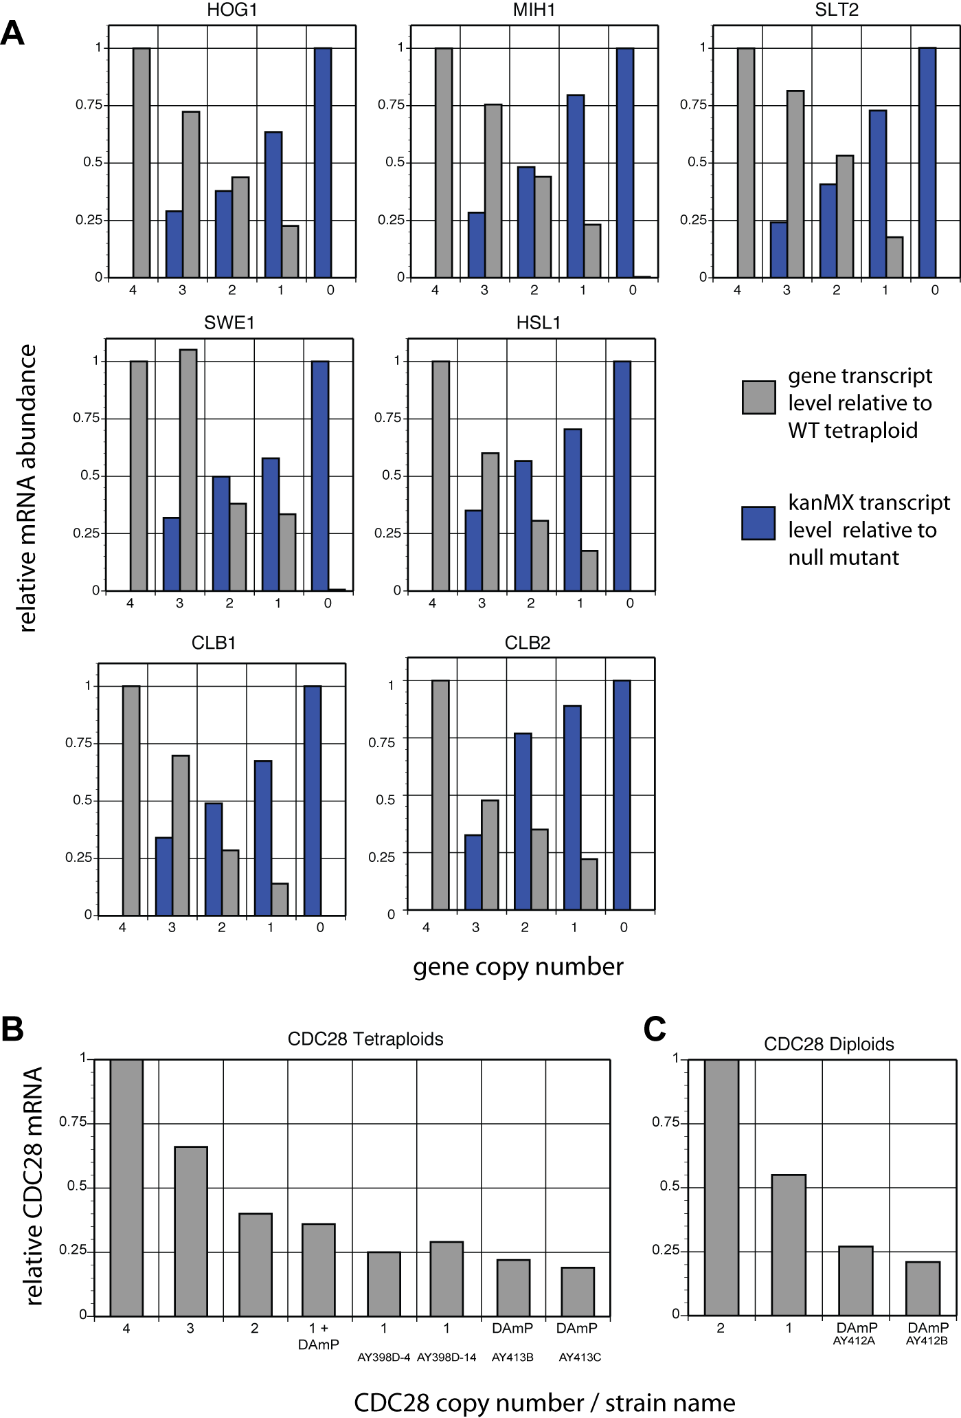
Supplementary Figure S2. Effect of ploidy on tolerance to cell wall-specific stressors.
Maximum growth rate upon treatment with 20-40μg/mL calcofluor white, and 1-2M sorbitol, relative to untreated growth, for WT tetraploid, diploid and haploid cells.

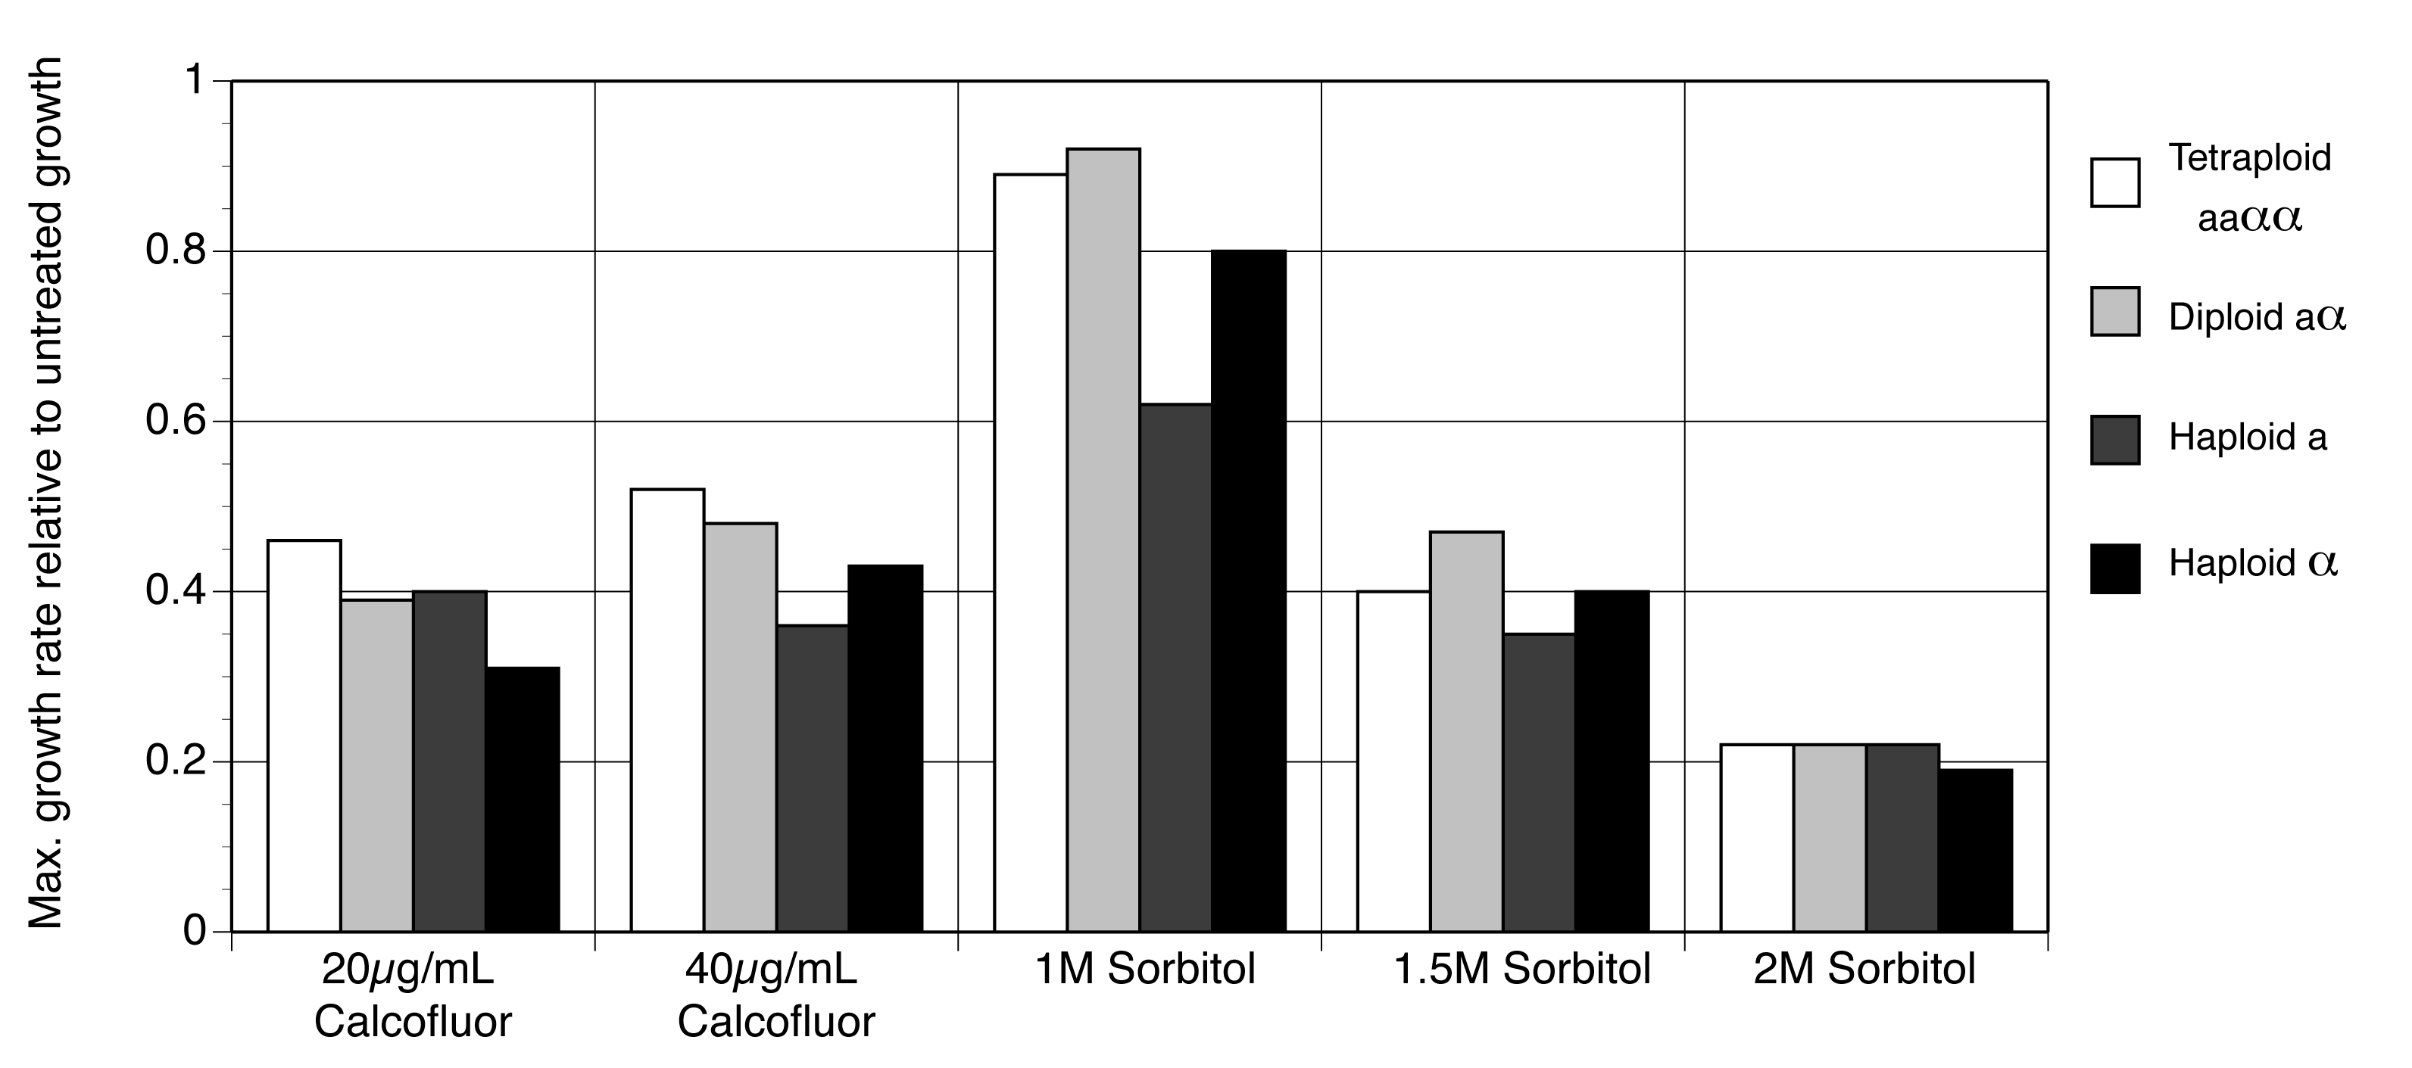

Supplementary Figure S3. Cell-cycle profiles predicted for tetraploid series.
Model predictions for the cell cycle profiles of SLT2, SWE1, HOG1 and HSL7, which are largely unperturbed from the wild-type profile. G1: blue; S/G2: red; M-phase: green.

Supplementary Figure S4. Viability of tetraploid strains.
Proportion of dead cells in tetraploid cultures on YPD agar plates as measured by phloxine-B staining. Pink band indicates range of WT red index (A). Proportion of dead cells of tetraploid strains grown in liquid YPD cultures by flow cytometry (B).

A

B
Supplementary Figure S5. In vivo cell cycle profiles
Lengths of the cell cycle and G1, S/G2, M phases of the CDC28, CLB2 and HSL1 tetraploid series.

Supplementary Figure S6. Response of the CDC28 tetraploid deletion series to G1 and G2/M stressors
Growth rate relative to WT of the CDC28 tetraploid deletion series in the presence of 1µg/ml tunicamycin (green filled squares), 2µg/ml tunicamycin (green open squares), and 3µM nocodazole (black triangles).

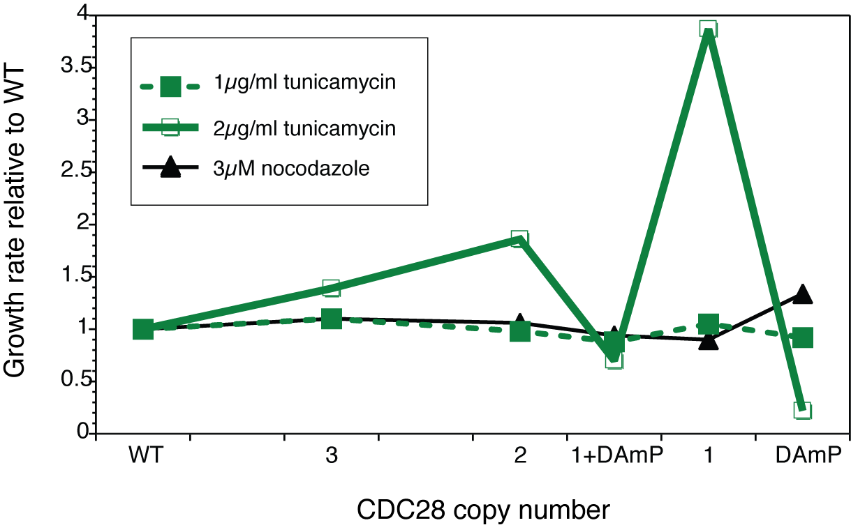
Supplementary Figure S7. Transcript levels of DNA-damage genes.
mRNA levels of the downstream DNA damage reporter genes RAD54, PLM2, DUN1, DIN7 and RNR3 in WT and cdc28 tetraploid deletion mutants (A) and WT and cdc28 diploid mutants (B).

Supplementary Model S1. Annotated Python script for the Extended Cell Cycle Model

#! /usr/bin/python
import random

Degree of knockdown
knockdown_degree = [0,0.25,0.5,0.75,1.]

Genes to be deleted (can be a list of multiple genes, to be deleted individually, or an array of multiples, for multiple-deletion mutants)
target_gene= ['sit4']
for k in range(0,len(target_gene)):
def rsit4(sit4):
if target_gene[k] == 'sit4':
ran = random.random()
if ran>knockdown_degree[i]:
var2=0
else:
var2=sit4
return var2
else:
return sit4
This subfunction (which would used for each gene in the array ‘target_gene’ tests, firstly, that SIT4 is the kth member of the target gene array, and hence that being deleted in the current iteration of the code. Then, a pseudorandom number between 0 and 1 is generated using the NumPy call, and if that number is greater than the current level of knockdown required (i.e. the ith member of the array ‘knockdown_degree’), then the value returned by the subfunction is 0 (i.e., no protein molecule is found). Otherwise, the value 1 is returned (i.e., a molecule of Sit4p is found).

Loop over degree of knockdown (i.e. 4,3,2,1,0 copies respectively)
for i in range(0,len(knockdown_degree)):
for j in range(0,100):
tmax=60

Initialise arrays of values for each gene throughout the cycle
cln3a=[0]*tmax
bck2a=[0]*tmax
smbfa=[0]*tmax
sit4a=[0]*tmax
cln2a=[0]*tmax
clb5a=[0]*tmax
clb2a=[0]*tmax
cln5a=[0]*tmax
yhp1a=[0]*tmax
cdc20a=[0]*tmax
mcm1a=[0]*tmax
mad2a=[0]*tmax
oria=[0]*tmax
spna=[0]*tmax
sic1a=[0]*tmax
rad61a=[0]*tmax
nuf2a=[0]*tmax
mcm21a=[0]*tmax
cdc6a=[0]*tmax
hsl1a=[0]*tmax
swi5a=[0]*tmax
swe1a=[0]*tmax
net1a=[0]*tmax
ck1a=[0]*tmax
cdh1a=[0]*tmax
mpk1a=[0]*tmax
dbf4a=[0]*tmax
cdc34a=[0]*tmax
sld2a=[0]*tmax
cdc45a=[0]*tmax
mcma=[0]*tmax
dbf2_ccr4a=[0]*tmax
cohesin_ctf8a=[0]*tmax
nkp2a=[0]*tmax
mih1a=[0]*tmax
lte1a=[0]*tmax
tem1a=[0]*tmax
cdc15a=[0]*tmax
cdc14a=[0]*tmax
bub2_bfa1a=[0]*tmax
pp2aa=[0]*tmax
cdc5poloa=[0]*tmax
pds1a=[0]*tmax
esp1a=[0]*tmax
buda=[0]*tmax
cytokinesisa=[0]*tmax
condensina=[0]*tmax
bik1a=[0]*tmax
dam1a=[0]*tmax
psa1a=[0]*tmax
top1a=[0]*tmax
epl1a=[0]*tmax
ccr4_csm3a=[0]*tmax
dnl4a=[0]*tmax
rad1a=[0]*tmax
mlh1a=[0]*tmax
msh2a=[0]*tmax
rad53a=[0]*tmax
chk1a=[0]*tmax
mec1a=[0]*tmax
rad9a=[0]*tmax
ss_damagea=[0]*tmax
ds_damagea=[0]*tmax
hsl1a=[0]*tmax
hsl7a=[0]*tmax
dma1a=[0]*tmax
hog1a=[0]*tmax
mcm1a=[0]*tmax
yrb1a= [0]*tmax
zds1a= [0]*tmax
massa=[1]*tmax
rio1a=[1]*tmax
ndl1a=[0]*tmax

Define the initial state of each gene (for those genes in common between the two models, these are the same initial conditions as used in Faure et al. 2009)
cln3a[0]=0
bck2a[0]=0
smbfa[0]=0
cln2a[0]=0
cln5a[0]=0
swi5a[0]=0
sic1a[0]=1
cdc6a[0]=1
clb5a[0]=0
mpk1a[0]=1
mih1a[0]=0
hsl1a[0]=0
swe1a[0]=0
clb2a[0]=0
mcm1a[0]=0
mad2a[0]=0
cdc20a[0]=0
cdc5poloa[0]=0
pp2aa[0]=1
bub2_bfa1a[0]=0
lte1a[0]=0
tem1a[0]=0
cdc15a[0]=1
net1a[0]=2
cdc14a[0]=1
cdh1a[0]=1
buda[0]=0
oria[0]=0
spna[0]=0
pds1a[0]=0
esp1a[0]=1
massa[0]=1
cytokinesisa[0]=0
yhp1a[0]=0
sit4a[0]=0
rad61a[0]=0
nuf2a[0]=0
mcm21a[0]=0
ck1a[0]=0
dma1a[0]=0
bik1a[0]=0
ndl1a[0]=0
condensina[0]=0
nkp2a[0]=0
cohesin_ctf8a[0]=0
dbf2_ccr4a[0]=0
mcma[0]=0
sld2a[0]=0
cdc45a[0]=0
cdc34a[0]=0
ds_damagea[0]=0
ss_damagea[0]=0
rad9a[0]=0
mec1a[0]=0
chk1a[0]=0
rad53a[0]=0
msh2a[0]=0
mlh1a[0]=0
rad1a[0]=0
dnl4a[0]=0
ccr4_csm3a[0]=0
epl1a[0]=0
top1a[0]=0
yrb1a[0]=0
psa1a[0]=0
zds1a[0]=0
rio1a[0]=1

Integers to count number of cytokineses within the iteration
cytokinesis_firststep=cytokinesis_secondstep=0

for t in range(1,tmax):
Integers to hold value of the gene at the previous timestep
#g1
cln3=cln3a[t-1]
sit4=sit4a[t-1]
bck2=bck2a[t-1]
smbf=smbfa[t-1]
yhp1=yhp1a[t-1]
cln2=cln2a[t-1]
swi5=swi5a[t-1]
#origin of replication
sic1=sic1a[t-1]
cdc6=cdc6a[t-1]
sld2=sld2a[t-1]
cdc45=cdc45a[t-1]
mcm=mcma[t-1]
cdc34=cdc34a[t-1]
ori=oria[t-1]
#morphogenesis checkpoint
hsl1=hsl1a[t-1]
hsl7=hsl7a[t-1]
swe1=swe1a[t-1]
#g2 phase
clb5=clb5a[t-1]
mpk1=mpk1a[t-1]
mih1=mih1a[t-1]
clb2=clb2a[t-1]
mcm1=mcm1a[t-1]
cdc20=cdc20a[t-1]
epl1=epl1a[t-1]
pp2a=pp2aa[t-1]
net1=net1a[t-1]
cdh1=cdh1a[t-1]
bud=buda[t-1]
pds1=pds1a[t-1]
esp1=esp1a[t-1]
#m phase
lte1=lte1a[t-1]
tem1=tem1a[t-1]
dbf4=dbf4a[t-1]
dbf2_ccr4=dbf2_ccr4a[t-1]
cdc15=cdc15a[t-1]
cdc14=cdc14a[t-1]
#spindle checkpoint
cohesin_ctf8=cohesin_ctf8a[t-1]
rad61=rad61a[t-1]
nuf2=nuf2a[t-1]
condensin=condensina[t-1]
mcm21=mcm21a[t-1]
nkp2=nkp2a[t-1]
dma1=dma1a[t-1]
bik1=bik1a[t-1]
bub2_bfa1=bub2_bfa1a[t-1]
spn=spna[t-1]
ndl1=ndl1a[t-1]
mad2=mad2a[t-1]
cdc5polo=cdc5poloa[t-1]
#dna damage checkpoint
ccr4_csm3=ccr4_csm3a[t-1]
dnl4=dnl4a[t-1]
rad1=rad1a[t-1]
mlh1=mlh1a[t-1]
msh2=msh2a[t-1]
rad53=rad53a[t-1]
chk1=chk1a[t-1]
mec1=mec1a[t-1]
rad9=rad9a[t-1]
ss_damage=ss_damagea[t-1]
ds_damage=ds_damagea[t-1]
top1=top1a[t-1]
#mass and cytokinesis
cytokinesis=cytokinesisa[t-1]
mass=massa[t-1]

hog1=hog1a[t-1]
yrb1=yrb1a[t-1]
psa1=psa1a[t-1]
zds1=zds1a[t-1]
rio1=rio1a[t-1]

Beginning of the logical model – rules as defined in the Supplementary Information

#g1 phase
sit4a[t] = int(bool(mass))
cln3a[t] = int(bool(mass and not rad53))
bck2a[t] = int(bool(rsit4(sit4)))
smbfa[t] = int(bool(not (clb2==3 and not (sic1 or cdc6)) and (bck2 or cln3 or cln2 or (clb5 and not sic1))))
if not smbf and clb2:
smbfa[t]=0
cln2a[t] = int(bool((smbf and mass)))
swi5a[t] = int(bool((mcm1 and not (clb2 and not (sic1 or cdc6))) or (mcm1 and clb2 and not (sic1 and cdc6) and ((cdc14==1 and not net1) or (cdc14==2 and not net1==2)))))
#g2 phase
if bool(cdc20 and smbf and mass):
clb5a[t]=1
if bool(not cdc20 and mass and smbf):
clb5a[t]=2
mpk1a[t] = int(bool(not bud))
if (mpk1 and clb2 and not (sic1 or cdc6)) or (not mpk1 and (not clb2 or sic1 or cdc6)):
mih1a[t] = 1
if mih1 and not mpk1 and clb2 and not (sic1 or cdc6):
mih1a[t] = 2
if ((mass==1 and ((swe1==1 and not mih1==2) or (swe1==2 and mih1==1))) or (mass and swe1==2 and not mih1)) and \
not cdh1 and (not cdc20 or (cdc20==2 and mcm1)):
clb2a[t] = 1
if clb2 and ((mass==1 and (not swe1 or mih1==2)) or (mass==2 and (not swe1==2 or mih1))) and not cdh1 and ((not cdc20 and not mcm1) or (cdc20==2 and mcm1)):
clb2a[t] = 2
if clb2==2 and not clb2a[t]==2:
clb2a[t] = 1
if (clb2==2 or clb2==3) and ((mass==1 and (not swe1 or mih1==2)) or (mass==2 and (not swe1==2 or mih1))) and not cdh1 and not cdc20==2 and mcm1:
clb2a[t] = 3
if not (not esp1 or (esp1==1 and pds1)):
pp2aa[t] = 1
if pp2a and not esp1 or (esp1==1 and pds1):
pp2aa[t] = 2
mcm1a[t] = int(bool((clb2==2 or clb2==3) and not (sic1 or cdc6)))

#origin of replication
if (not cdc14 or (cdc14==1 and net1) or ((cdc14==2 or cdc14==3) and net1==3)) and not swi5 and \
(not ((clb2 and not (sic1 or cdc6)) or (clb5 and not sic1) or cln2 or ((clb2 or clb5) and \
(cln3 or bck2)) or \
(clb5 and clb2) or (clb5==3 and bck2))):
sic1a[t] = 1
elif (not cdc14 or (cdc14==1 and net1) or ((cdc14==2 or cdc14==3) and net1==3)) and swi5 and \
not ((clb2==3 and not (sic1 or cdc6)) or (((clb2 and not (sic1 or cdc6)) or \
(clb5 and not sic1)) and ((cln2 and (cln3 or bck2)) or \
(cln3 and bck2))) or \
(((clb2 and clb5) or clb2==3 or clb5==3) and cln2 and (cln3 or bck2)) or \
(clb2==3 and clb5==3)):
sic1a[t] = 1
elif ((cdc14==1 and (not net1)) or (cdc14==2 and (not net1 or net1==1))) and (not swi5) and \
not ((clb2 and (not (sic1 or cdc6))) or (clb5 and not sic1) or cln2):
sic1a[t] = 1
elif ((cdc14==1 and not net1) or (cdc14==2 and (not net1 or net1==1))) and swi5 and \
not (((clb5 and clb2 and not (sic1 or cdc6) and cln2 and cln3 and bck2) or \
(clb2==3 and not (sic1 or cdc6))) and (clb5 or cln2 or (cln3 and bck2))):
sic1a[t] = 1
elif (cdc14==3 and (not net1==3) and not swi5 and not (clb5 and clb2 and cln2 and cln3 and bck2)):
sic1a[t] = 1
elif (cdc14==3 and (not net1==3) and swi5 and not (clb5 and clb2 and cln2 and cln3 and bck2 \
and not sic1 and not (sic1 or cdc6))):
sic1a[t] = 1

if (not cdc14 or (cdc14==1 and net1) or ((cdc14==2 or cdc14==3) and net1==3)) and not swi5 and \
(not ((clb2 and not (sic1 or cdc6)) or (clb5 and not sic1) or cln2 or ((clb2 or clb5) and \
(cln3 or bck2)) or \
(clb5 and clb2) or (clb5==3 and bck2))):
cdc6a[t] = 1
elif (not cdc14 or (cdc14==1 and net1) or ((cdc14==2 or cdc14==3) and net1==3)) and swi5 and \
not ((clb2==3 and not (sic1 or cdc6)) or (((clb2 and not (sic1 or cdc6)) or \
(clb5 and not sic1)) and ((cln2 and (cln3 or bck2)) or \
(cln3 and bck2))) or \
(((clb2 and clb5) or clb2==3 or clb5==3) and cln2 and (cln3 or bck2)) or \
(clb2==3 and clb5==3)):
cdc6a[t] = 1
elif ((cdc14==1 and (not net1)) or (cdc14==2 and (not net1 or net1==1))) and (not swi5) and \
not ((clb2 and (not (sic1 or cdc6))) or (clb5 and not sic1) or cln2):
cdc6a[t] = 1
elif ((cdc14==1 and not net1) or (cdc14==2 and (not net1 or net1==1))) and swi5 and \
not (((clb5 and clb2 and not (sic1 or cdc6) and cln2 and cln3 and bck2) or \
(clb2==3 and not (sic1 or cdc6))) and (clb5 or cln2 or (cln3 and bck2))):
cdc6a[t] = 1
elif (cdc14==3 and (not net1==3) and not swi5 and not (clb5 and clb2 and cln2 and cln3 and bck2)):
cdc6a[t] = 1
elif (cdc14==3 and (not net1==3) and swi5 and not (clb5 and clb2 and cln2 and cln3 and bck2 \
and not sic1 and not (sic1 or cdc6))):
cdc6a[t] = 1
sld2a[t] = int(bool((clb5 and not sic1) or ((clb2==2 or clb2==3) and not (sic1 or cdc6))))
cdc45a[t] = int(bool(rsld2(sld2)))
mcma[t] = int(bool(cdc45 and (mcm1 or dbf4)))
oria[t] = int(bool(rmcm(mcm) or (ori and (clb5==3 or clb2==3 or (clb5==1 and not sic1) or (clb2==1 and not (sic1 or cdc6))))))
cdc34a[t] = 1

#m phase
lte1a[t] = int(bool(((clb2==2 or clb2==3) and not (sic1 or cdc6)) or spn))
tem1a[t] = int(bool(lte1))
cdc15a[t] = int(bool(not (clb2==3 and not (sic1 or cdc6)) or (cdc14 and not net1)))
cdc14a[t] = int(bool(dbf2_ccr4))
dbf4a[t] = int(bool(clb5 and not sic1))
if not mad2 and mcm1 and not (clb2 and not (sic1 or cdc6)):
cdc20a[t]=1
if not mad2 and mcm1 and clb2==3 and not (sic1 or cdc6):
cdc20a[t]=1
if cdc20 and not mad2 and mcm1 and clb2 and not (sic1 or cdc6):
cdc20a[t]=2
if ((cdc14 and net1 and not (clb2 and not (sic1 or cdc6)) and not pp2a) or (pp2a==1 and ((not cdc14 and clb2==2 and not (sic1 or cdc6)) or \
(cdc14 and clb2==2 and not (sic1 or cdc6))))) \
and not (((cdc15==1 and tem1) or cdc15==2) and not rbub2_bfa1(bub2_bfa1)):
net1a[t] = 1
if ((((cdc14 and not net1) or pp2a) and not (clb2 and not (sic1 or cdc6))) or pp2a==2) and not (((cdc15==1 and tem1) or cdc15==2) and not rbub2_bfa1(bub2_bfa1)):
net1a[t] = 2
cdc14a[t] = 1
if (not cdc14 or (cdc14==1 and net1) or ((cdc14==2 or cdc14==3) and net1==3)) and not ((clb2 and not (sic1 or cdc6))\
or (clb5 and not sic1) or (cln3 and cln2)):
cdh1a[t]=1
if ((cdc14==1 and not net1) or (cdc14==2 and not net1==3)) and not ((clb5 and not sic1 and cln3 and ((clb2 and not cdc6) or cln2)) \
or (clb2==3 and not (sic1 or cdc6) and cln3 and cln2)):
cdh1a[t]=1
if cdc14==3 and not net1==3 and not ((clb5 and not sic1 and cln3 and clb2 and not cdc6 and cln2) or (clb2==3 and not (sic1 or cdc6) and cln3 and cln2)):
cdh1a[t]=1
buda[t] = int(bool((cln2 or (clb5 and not sic1)) and not cytokinesis==2))
esp1a[t] = 1

#spindle checkpoint
condensina[t] = int(bool(rad61 and pds1))
cohesin_ctf8a[t] = int(bool(rad61 and pds1))

bik1a[t] = int(bool(clb2==3 and not (sic1 or cdc6) and not cytokinesis==2))
nuf2a[t] = int(bool(clb2==3 and not (sic1 or cdc6) and not cytokinesis==2))
mcm21a[t] = int(bool(clb2==3 and not (sic1 or cdc6) and not cytokinesis==2))
nkp2a[t] = int(bool(clb2==3 and not (sic1 or cdc6) and not cytokinesis==2))
dma1a[t] = int(bool(clb2==3 and not (sic1 or cdc6) and not cytokinesis==2))
ndl1a[t] = int(bool(clb2==3 and not (sic1 or cdc6) and not cytokinesis==2))
spna[t] = int(bool(((condensin and cohesin_ctf8) and ((rbik1(bik1) and nuf2 and mcm21 and rnkp2(nkp2) and rdma1(dma1) and rndl1(ndl1)))) or \
(spn and (clb2==3 or clb2==2 and not (sic1 or cdc6)))))
mad2a[t] = int(bool(ori and not spn))
bub2_bfa1a[t] = int(bool(ori and (not spn or pp2a==2 or not cdc5polo)))
cdc5poloa[t] = int(bool(not rad53 and clb2 and not (sic1 or cdc6) and not cdh1))

pds1a[t] = int(bool((mcm1 and smbf and not cdc20==2) or ((mcm1 or smbf) and not cdh1 and not cdc20)))
rad61a[t] = int(bool((mcm1 and smbf and not cdc20==2) or ((mcm1 or smbf) and not cdh1 and not cdc20)))

#dna damage checkpoint
msh2a[t] = int(bool(ss_damage and rad53))
mlh1a[t] = int(bool(ss_damage and rad53))
rad1a[t] = int(bool(ss_damage and rad53 or rtop1(top1)))
dnl4a[t] = int(bool(ds_damage and rad53))
ccr4_csm3a[t] = int(bool(ds_damage and rad53))

rad53a[t] = int(bool(mec1 and not ((clb2==2 or clb2==3) and not (sic1 or cdc6))))
rad9a[t] = int(bool(ds_damage and ((clb2==2 or clb2==3) and not (sic1 or cdc6))))
mec1a[t] = int(bool(ds_damage or rad9))
chk1a[t] = int(bool(mec1))
ss_damagea[t] = int(bool(ss_damage and not ((rmsh2(msh2) and rmlh1(mlh1)) or rrad1(rad1))))
ds_damagea[t] = int(bool(ds_damage and ( not (rdnl4(dnl4) and rccr4_csm3(ccr4_csm3)) and cohesin or not epl1)))
top1a[t] = int(bool(rtop1(top1) and not (rrad1(rad1) and cdc45)))

#morphogenesis checkpoint
hsl1a[t] = int(bool((hsl7 or epl1) or (hsl1 and not cdh1)))
hsl7a[t] = int(bool((bud and not rhog1(hog1) and not zds1) or (hsl7 and not cdh1)))
if smbf and ((clb2 and not (sic1 or cdc6) and not hsl1 and not hsl7) or ((hsl1 or hsl7) and not (clb2==2 or clb2==3))):
swe1a[t] = 1
if swe1 and smbf and not (hsl1 or hsl7 or ((clb2==2 or clb2==3) and not (sic1 or cdc6))):
swe1a[t] = 2

#mass and cytokinesis
These logical conditions determine the outcome of the cycle – if the conditions (i.e. large amounts of G2 cyclins, no g1 degraders) are true, then start cytokinesis
if bool(mass and (clb2==2 or clb2==3) and not (sic1 or cdc6)):
cytokinesisa[t] = 1
if bool(massa[t-5] and ((clb2==1 and cytokinesis) or (not clb2==2 and cytokinesis and (sic1 or cdc6)))):
cytokinesisa[t] = 2
if cytokinesis==2 and not cytokinesisa[t]==2:
cytokinesisa[t] = 1
if cytokinesis==2:
massa[t]=0

if massa[t]==2 and not (massa[t-1]==2):
cytokinesis_secondstep+=1
elif massa[t] ==1 and massa[t-1]==0:
cytokinesis_firststep+=1

References:

Brachmann CB, Davies A, Cost GJ, Caputo E, Li J, Hieter P, Boeke JD (1998) Designer deletion strains derived from Saccharomyces cerevisiae S288C: a useful set of strains and plasmids for PCR-mediated gene disruption and other applications. Yeast 14:115-32.

Herskowitz I, Jensen RE (1991) Putting the HO gene to work: practical uses for mating-type switching. Methods Enzymol. 194: 132-146

Winzeler EA, Shoemaker DD, Astromoff A, Liang H, Anderson K et al., (1999) Functional characterization of the S.cerevisiae genome by gene deletion and parallel analysis. Science 285: 901–906.

