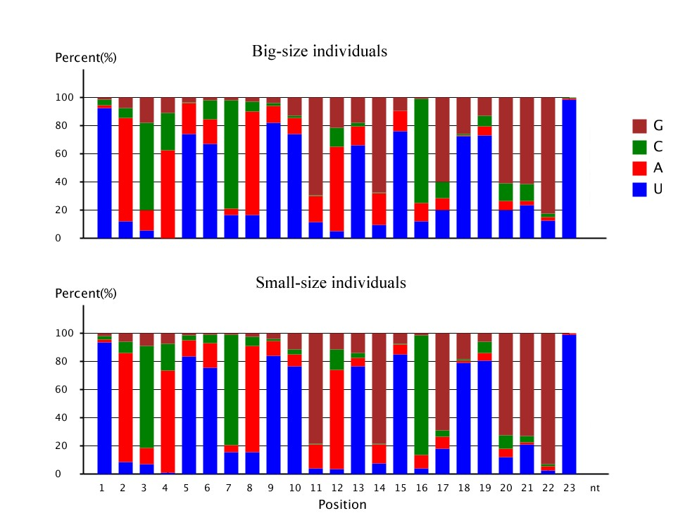
Figure S3 Base bias of the novel miRNA candidates of M. amblycephala at each postion

