Supplementary Figure 1: Verification of sample infection status. Select samples were tested for infection with N. apis (16s) and N. ceranae (SWP32) specific primers. A) PCR of samples for N. apis arrays (2008). Amplification of Nosema apis 16s primers was observed for a subset of tested samples infected with Nosema (indicated by ‘Na’ in sample label) across timepoints (‘7d’ = 7days, ‘48’ = 2 days). A tested subset of control samples did not show Nosema apis infection. No samples showed evidence of Nosema ceranae (SWP32 primers did not amplify for any samples). B) PCR of samples for co-infection arrays (2010). Primers for Nosema apis (16s) and Nosema ceranae (SWP32) amplified for all infected samples (indicated by ‘NaNc’ in sample label). A tested subset of control samples (indicated by ‘C’ in sample label) did not show evidence of infection with either Nosema species.
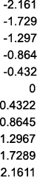
Supplementary Figure 2: Directional expression of transcripts in significant GO categories. We tallied the number of individual transcripts upregulated by control or Nosema spp. infection within each significant GO category. A) Midgut tissue at 1 and 2 days pi: N. apis infection increased expression of transcripts involved in ‘regulation of neurogenesis’, ‘tube morphogenesis’ and ‘multicellular organismal process’ but decreased expression of transcripts involved in ‘sensory perception of chemical stimulus.’ B) Fat body tissue at 1 and 2 days pi: N. apis infection reduced expression of transcripts involved in all significant GO categories, except for those related to ‘lipid processes.’ C) Fat body tissue at 14 days post-infection: Nosema co-infection generally suppressed expression of transcripts with cellular transport and metabolism functions. However, approximately equal numbers of transcripts involved in ‘immune processes’ were upregulated by both treatments.
Controls, 1 day pi

Controls, 2 days pi
Nosema, 1 day pi
Nosema, 2 days pi
Fig. 1a: Midguts
Supplementary Figure 3: Quantitative real-time PCR validation of expression patterns of immune, developmental and nutritional genes. Expression levels of three antimicrobial peptide genes (abaecin, defensin, hymenoptaecin), hexamerin and vitellogenin (relative to actin) from array samples were analysed using quantitative real-time PCR. Mean expression levels for each treatment group were normalized to expression in the control treatment group. Expression was analysed in A) Fat body tissue from 7-day old controls and workers with N. apis infection (n=4, 2008 samples), and B) Fat body tissue from 14-day old controls and workers with N. apis and ceranae co-infections (n=4, 2010 samples). No significant differences in expression levels across the treatment groups were detected with Mann-Whitney U Tests (p>0.05).

Supplementary Figure 1A:
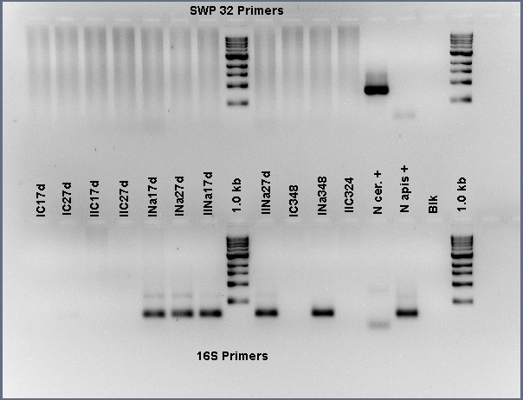

Supplementary Figure 1B:
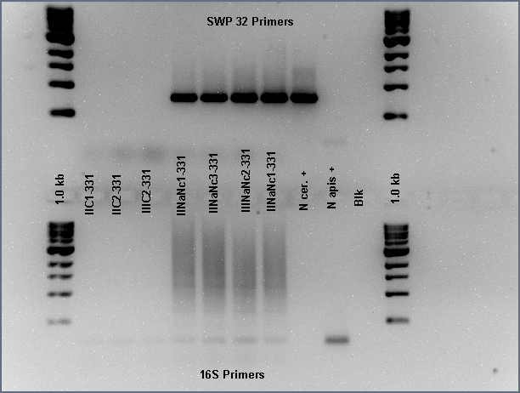

Supplementary Figure 2A:

Supplementary Figure 2B:

Supplementary Figure 2C:

Supplementary Figure 3A:

Supplementary Figure 3B:

Fig. 1a: Midguts
Fig. 1a: Midguts
Fig. 1a: Midguts

