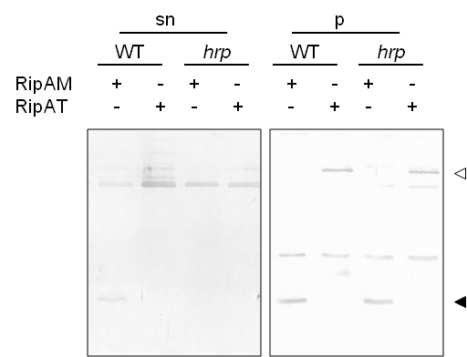

Additional file 10. Experimental validation of type III dependent secretion of RipAM.
GMI1000 and GMI1694 (hrcV mutant [1]) strains were transformed with plasmids carrying RSc3272 RipAM (pACC620) and Rsp1388 RipAT (pACC621), these plasmids were generated by LR-recombining pENTRY vectors (carrying both ORF) into a dedicated destination vector pNP329 derived from pRC [2], allowing the expression of RipAM-3HA and RipAT-3HA under the RipG7 promoter. After secretion assay [1], the supernatant (sn) and bacterial pellet (p) proteins were analyzed by western blot against the HA tag using NBT/BCIP staining. RipAT is annotated as being pseudogene in GMI1000 because of an N-terminal truncation, this status is confirmed here by the absence of secretion of the corresponding protein.
1. Cunnac S, Occhialini A, Barberis P, Boucher C, Genin S: Inventory and functional analysis of the large Hrp regulon in Ralstonia solanacearum: identification of novel effector proteins translocated to plant host cells through the type III secretion system. Mol Microbiol 2004, 53:115–128.
2. Monteiro F, Solé M, van Dijk I, Valls M: A chromosomal insertion toolbox for promoter probing, mutant complementation, and pathogenicity studies in Ralstonia solanacearum. Mol Plant-Microbe Interactions MPMI 2012, 25:557–568.

