a) Sequencing Results Run 1

Length Range | Number of Sequences
0:100 | 96016
100:200 | 115557
200:300 | 146226
300:400 | 220452
400:500 | 268893
500:600 | 86320
600:700 | 57
700:800 | 1

Total number of bases: 305397463
Total GC count: 128579775
GC %: 42.10 %
Total number of sequences: 933522

b) Sequencing Results Set 2 Statistics
Run | Region | SID | Name | HQ Reads | Bases | Avg Read Length | Keypass
RunID26097618 | 1 | 9578 | G.magnirostris | 533,836 | 170,364,996 | 319 | 74.2%
RunID26097618 | 2 | 9578 | G.magnirostris | 459,687 | 140,086,587 | 305 | 63.1%
RunID26098233 | 1 | 9580 | G.difficilis | 586,585 | 221,537,440 | 378 | 74.9%
RunID26098233 | 2 | 9580 | G.difficilis | 516,152 | 199,682,960 | 387 | 79.7%
RunID26128441 | 1 | 9578 | G.magnirostris | 637,913 | 235,013,322 | 368 | 86.2%
RunID26128441 | 2 | 9578 | G.magnirostris | 586,998 | 223,288,245 | 380 | 85.3%
RunID26128452 | 1 | 9578 | G.magnirostris | 600,366 | 249,213,979 | 415 | 82.2%
RunID26128452 | 2 | 9578 | G.magnirostris | 611,533 | 247,086,590 | 404 | 80.1%
RunID26128457 | 1 | 9578 | G.magnirostris | 597,511 | 208,348,475 | 349 | 79.0%
RunID26128457 | 2 | 9578 | G.magnirostris | 617,661 | 223,994,938 | 363 | 81.2%

c) Sequencing Results Set 2 read length distributions for different runs

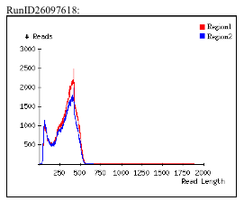

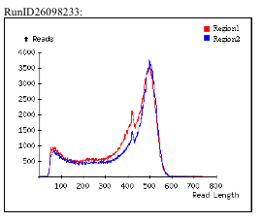

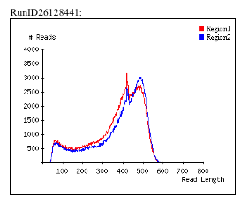

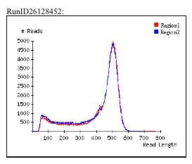
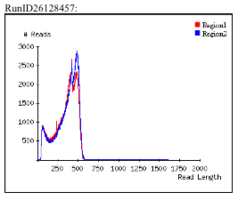

d) Sequencing Results Set 3 Statistics

Run | Region | SID | Name | HQ Reads | Bases | Avg Read Length
RunID26703047 | 1 | 10653 | G.magnirostris | 487,667 | 183,491,936 | 376
RunID26703047 | 2 | 10653 | G.magnirostris | 511,010 | 191,736,388 | 375
RunID26699701 | 1 | 10653 | G.magnirostris | 566,875 | 180,431,221 | 318
RunID26699701 | 2 | 10653 | G.magnirostris | 566,203 | 178,897,605 | 316
RunID26699628 | 1 | 10653 | G.magnirostris | 488,439 | 192,145,285 | 393
RunID26699628 | 2 | 10653 | G.magnirostris | 449,884 | 165,564,988 | 368
RunID26699564 | 1 | 10653 | G.magnirostris | 365,274 | 145,252,121 | 398
RunID26699564 | 2 | 10653 | G.magnirostris | 360,435 | 143,698,100 | 399
RunID26699561 | 1 | 10653 | G.magnirostris | 366,112 | 149,207,137 | 408
RunID26699561 | 2 | 10653 | G.magnirostris | 362,251 | 148,082,461 | 409
RunID26731018 | 1 | 10653 | G.magnirostris | 489,906 | 181,879,314 | 371
RunID26731018 | 2 | 10653 | G.magnirostris | 497,915 | 191,199,753 | 384
RunID26651149 | 1 | 10653 | G.magnirostris | 485,161 | 150,929,173 | 311
RunID26651149 | 2 | 10653 | G.magnirostris | 517,839 | 173,161,226 | 334
RunID26641211 | 1 | 10653 | G.magnirostris | 554,726 | 177,197,271 | 319
RunID26641211 | 2 | 10653 | G.magnirostris | 541,253 | 176,740,305 | 327
RunID26625034 | 1 | 10653 | G.magnirostris | 523,937 | 204,855,319 | 391
RunID26625034 | 2 | 10653 | G.magnirostris | 527,034 | 205,620,475 | 390
SID10653 | 1 | 10653 | G.magnirostris | 573,265 | 186,215,974 | 325
SID10653 | 2 | 10653 | G.magnirostris | 579,094 | 189,950,986 | 328
Summary of all runs | N/A | 10653 | G.magnirostris | 9,814,280 | 3,516,257,038 | N/A

e) Sequencing Results Set 3 read length distributions for different runs

RunID26703047
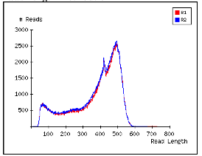

RunID26699701
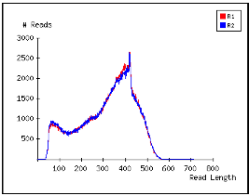

RunID26699628
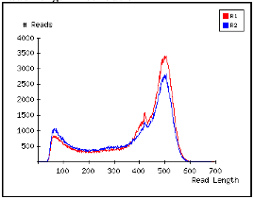

RunID26699564
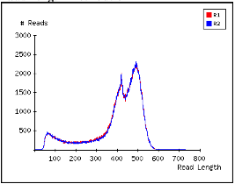

RunID26699561
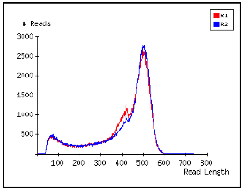

RunID26731018
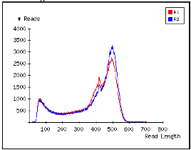

RunID26651149
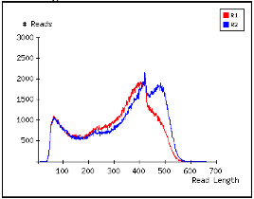

RunID26641211
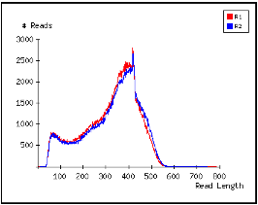

RunID26625034
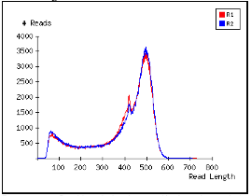

SID10653
