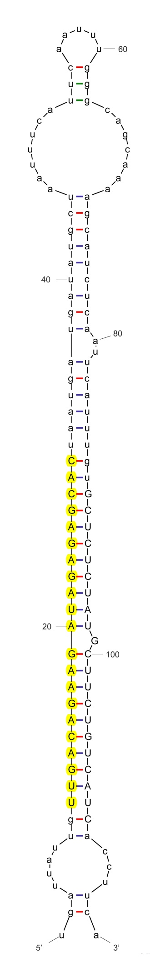

sha-miR156a

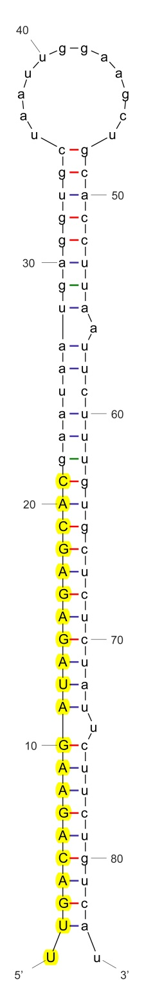

sha-miR156c

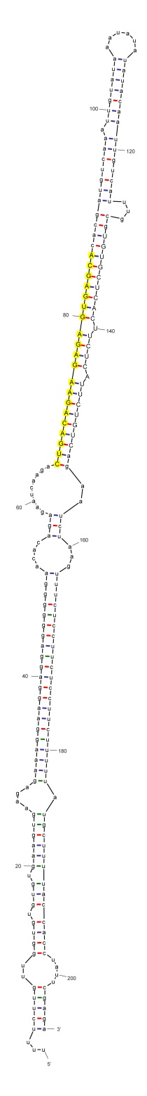

sha-miR156c_nta

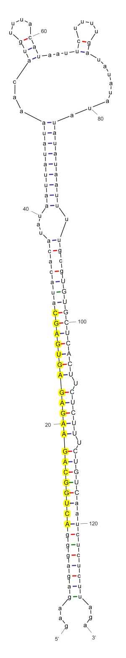

sha-miR156c-p5_nta

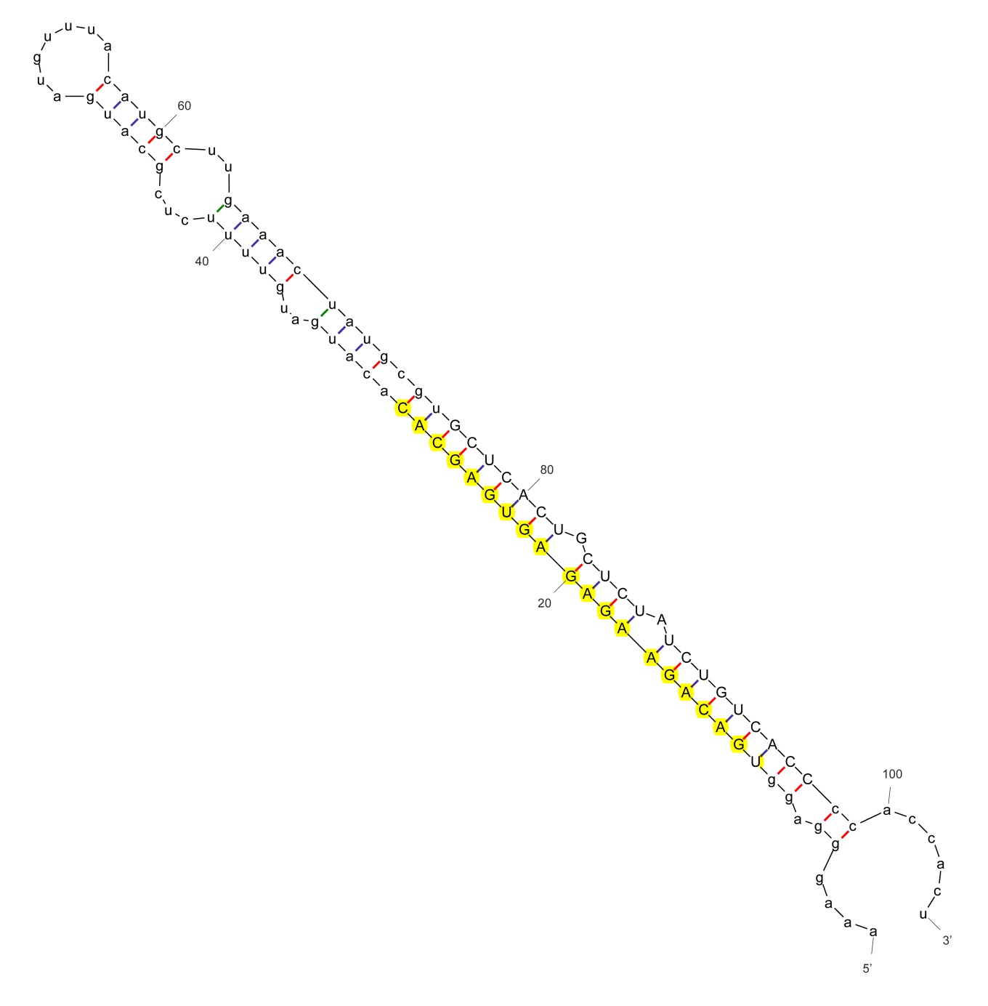

sha-miR156d_nta

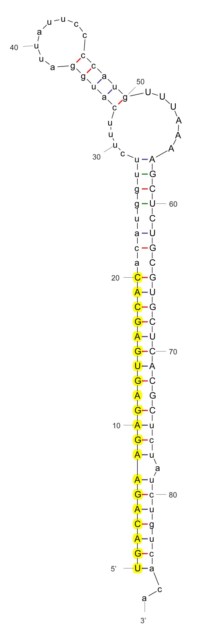

sha-miR156e_stu

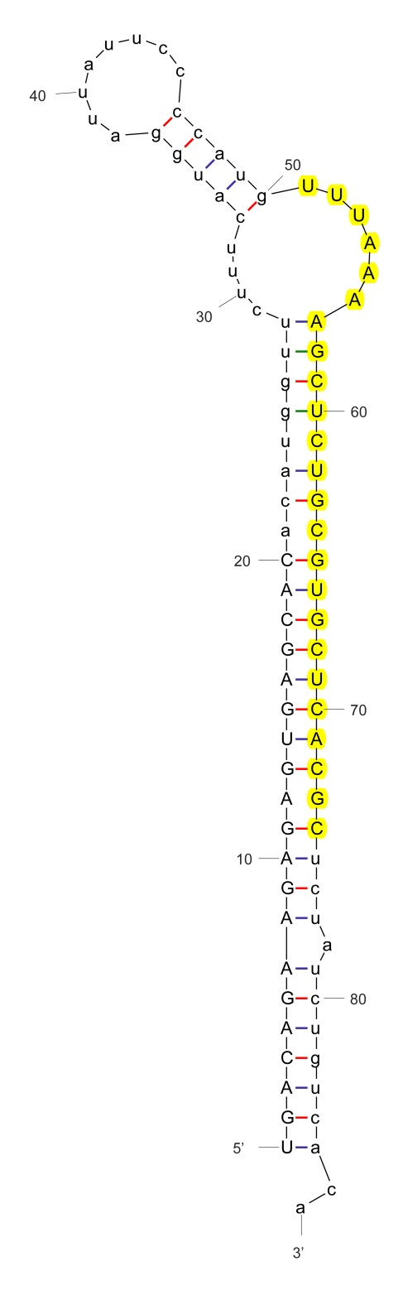

sha-miR156e-p3_stu

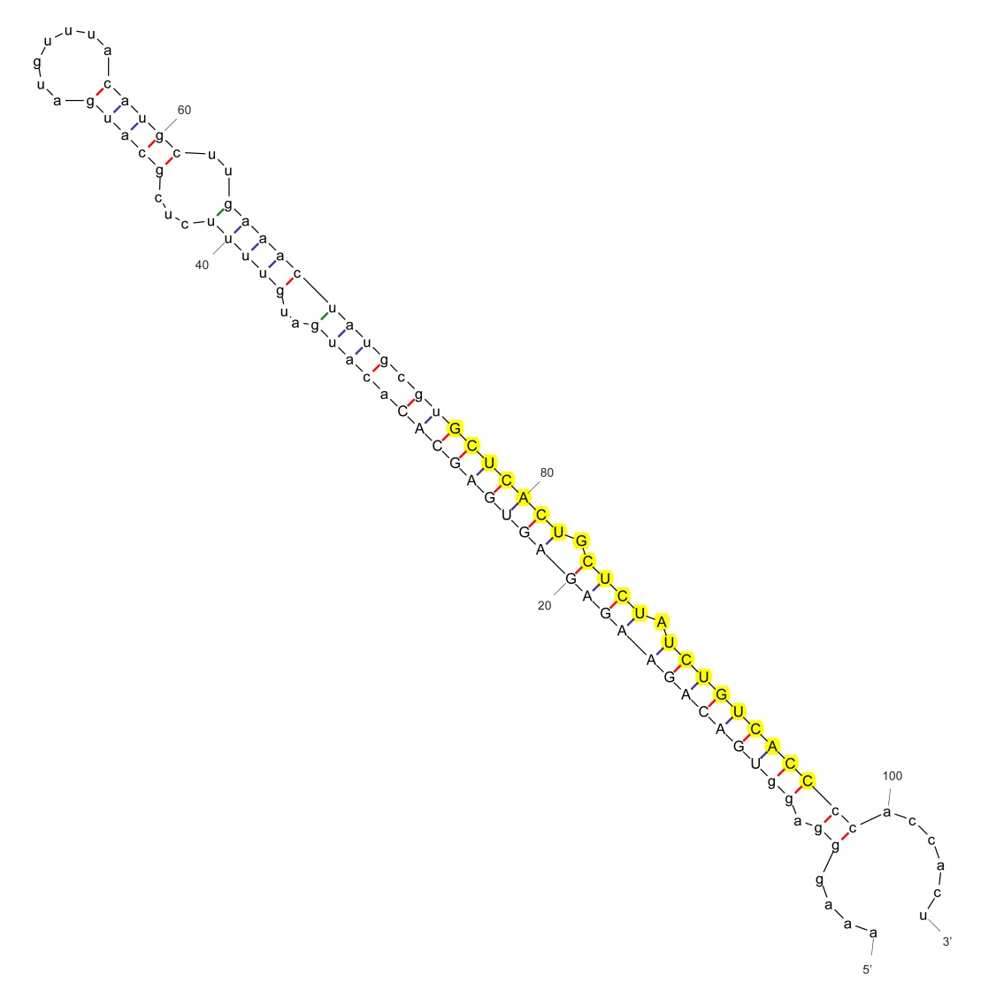

sha-miR156e-p3_nta

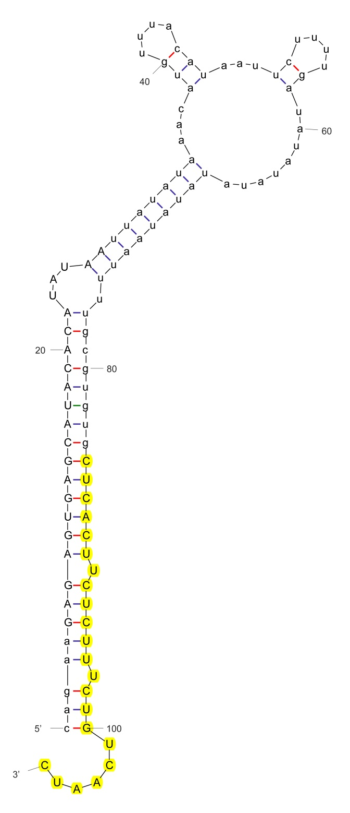

sha-miR156f-3p_stu

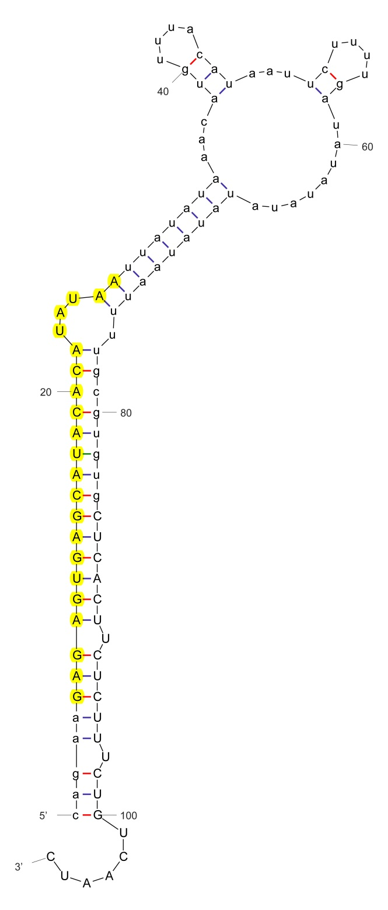

sha-miR156f-p5_stu

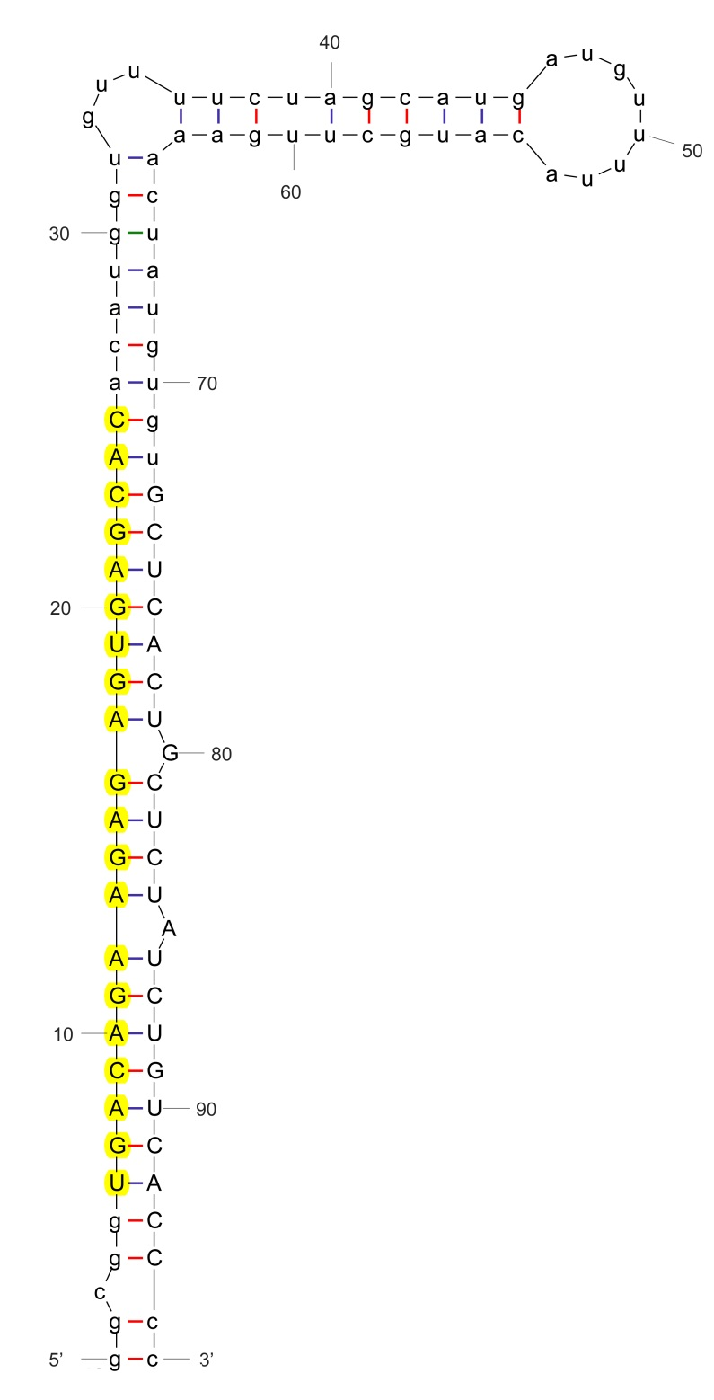

sha-miR156g_stu

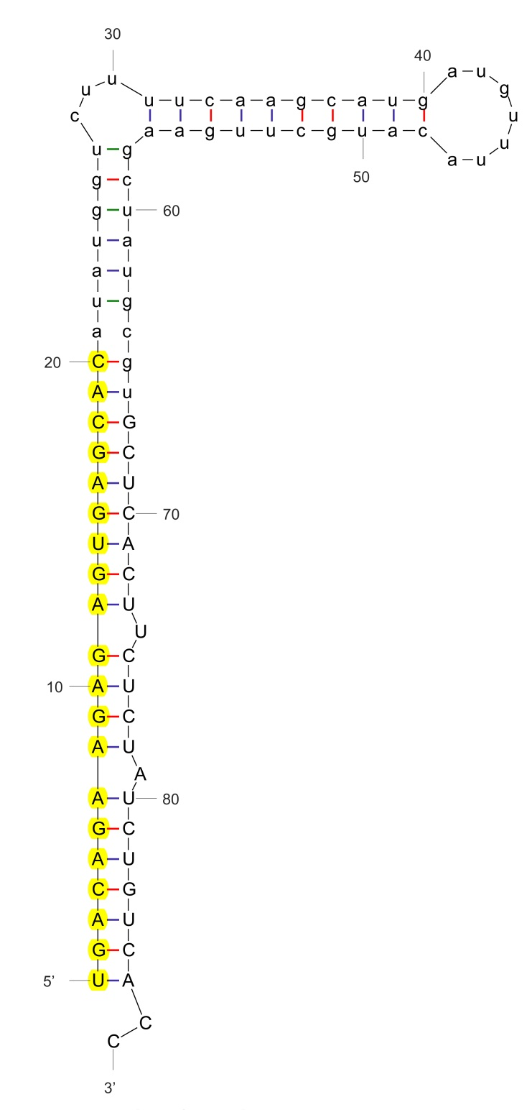

sha-miR156h_stu

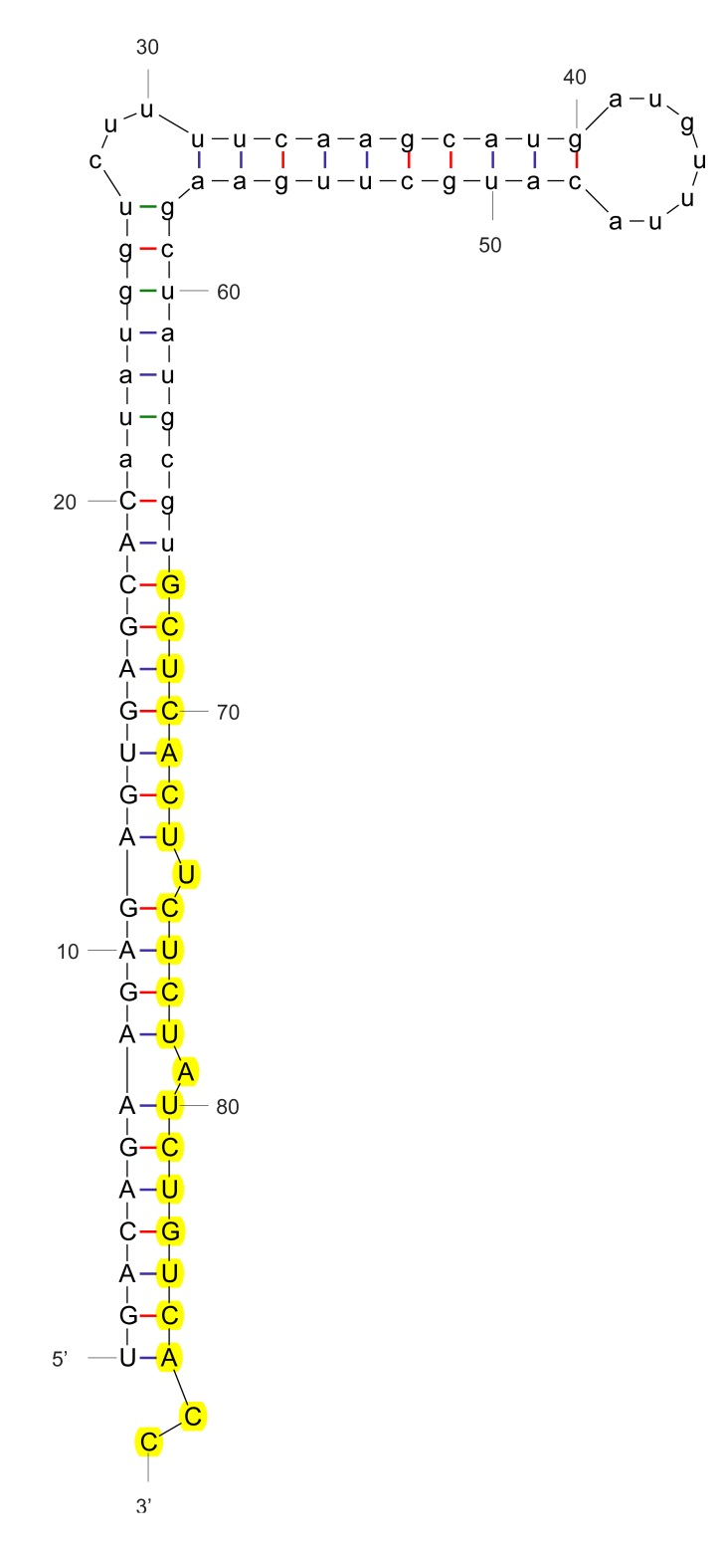

sha-miR156h-3p_stu

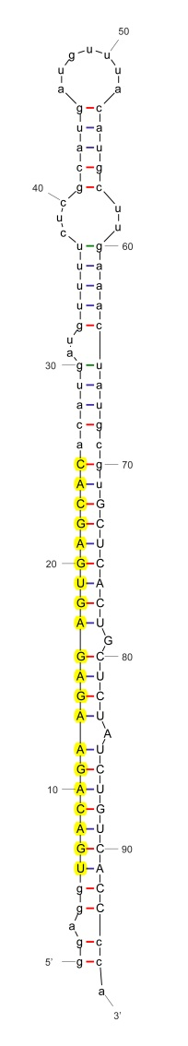

sha-miR156i_stu

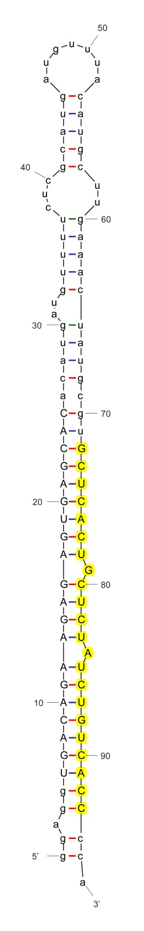

sha-miR156i-3p_stu

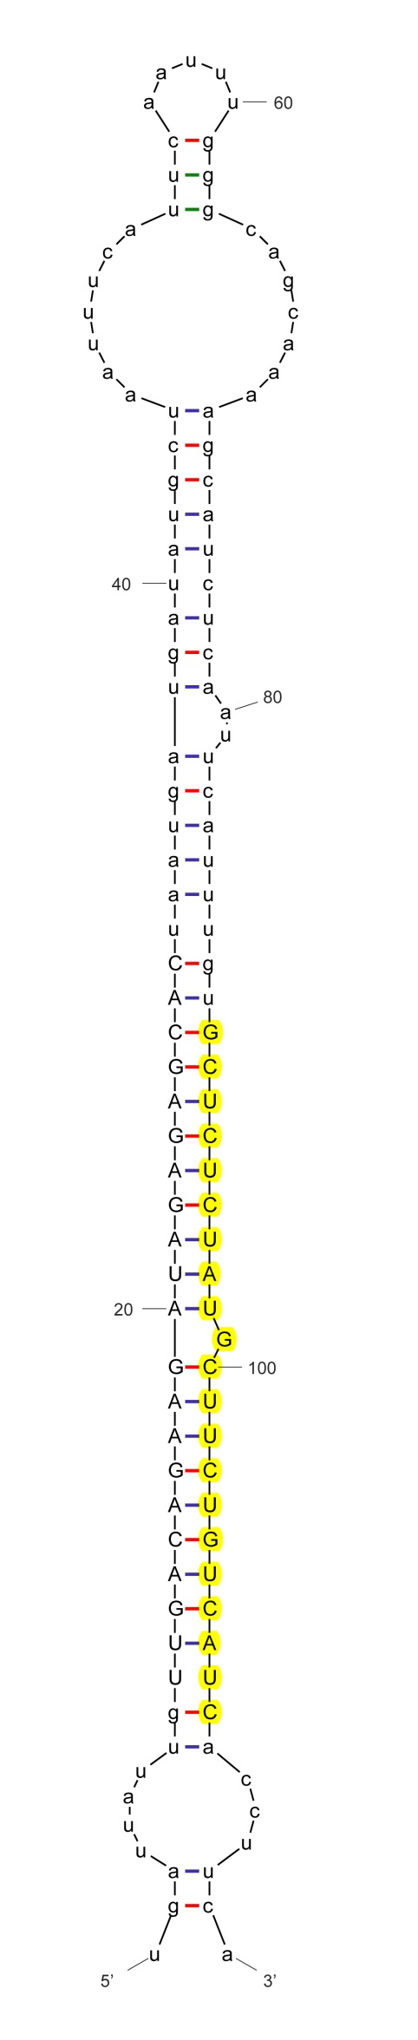

sha-miR156i-p3_nta

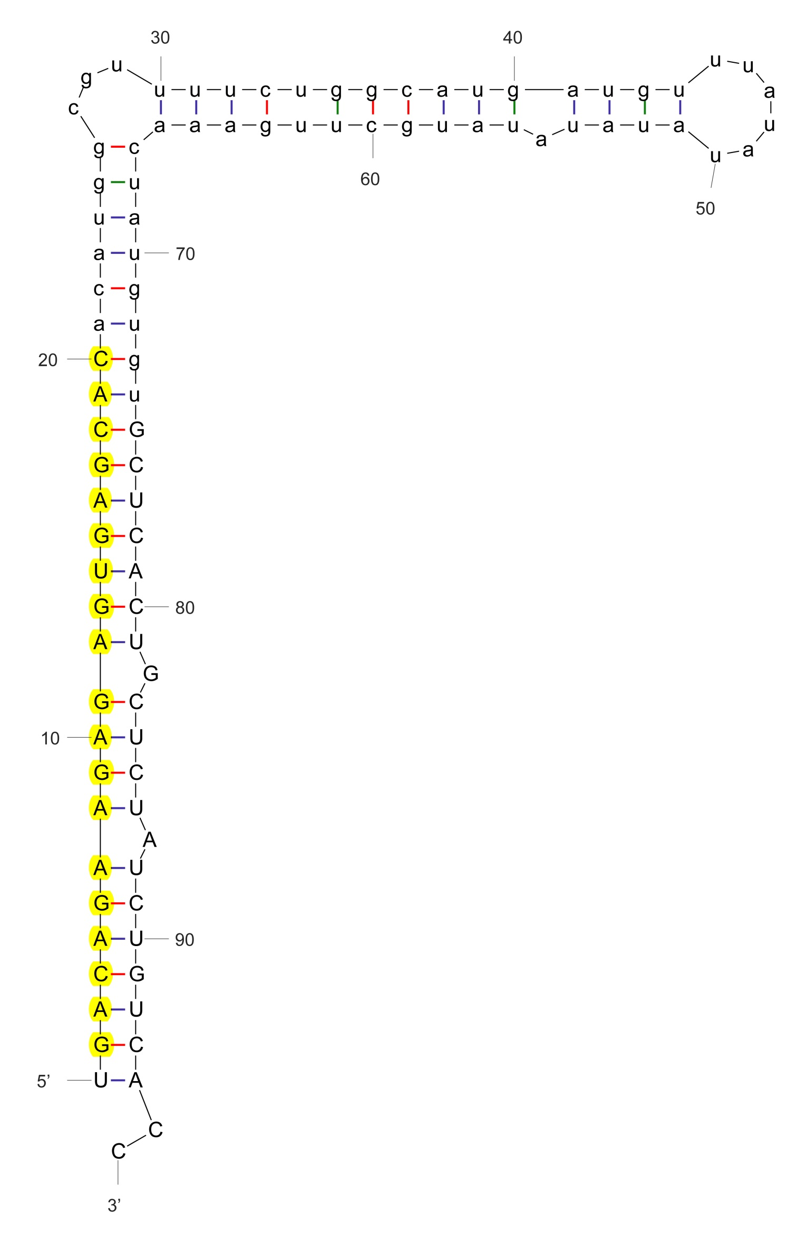

sha-miR156j_stu

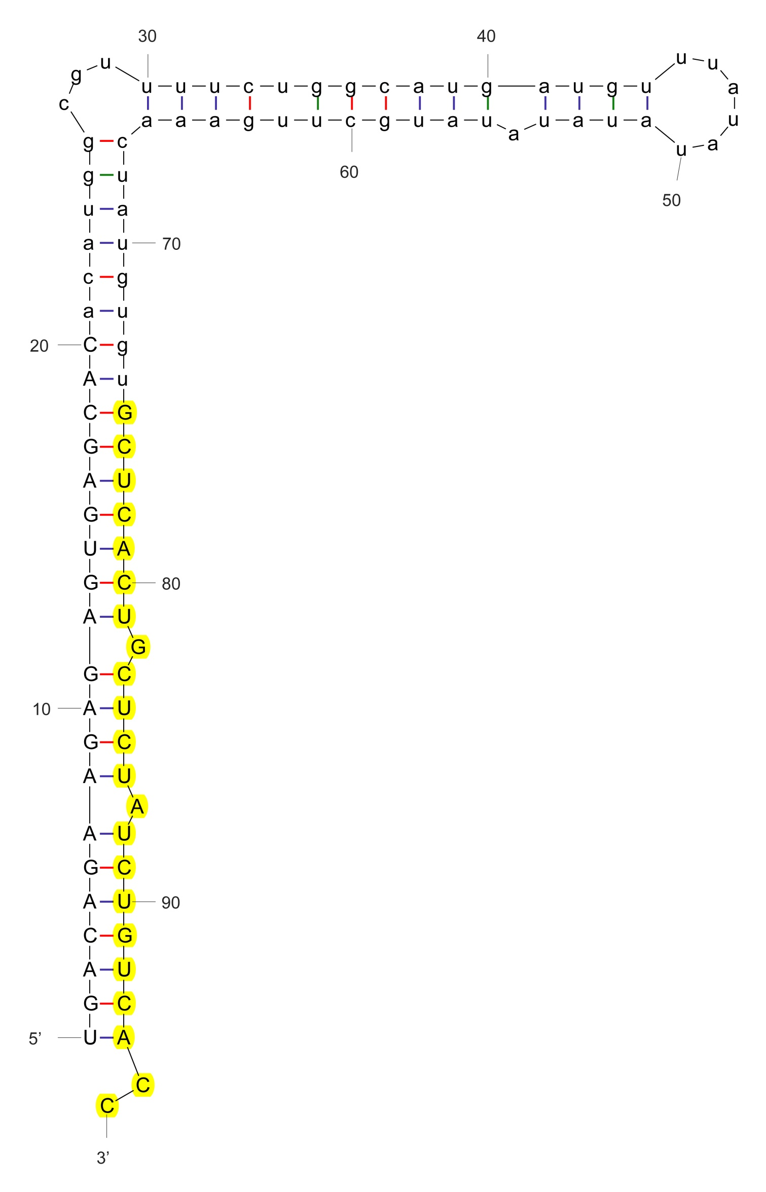

sha-miR156j-3p_stu

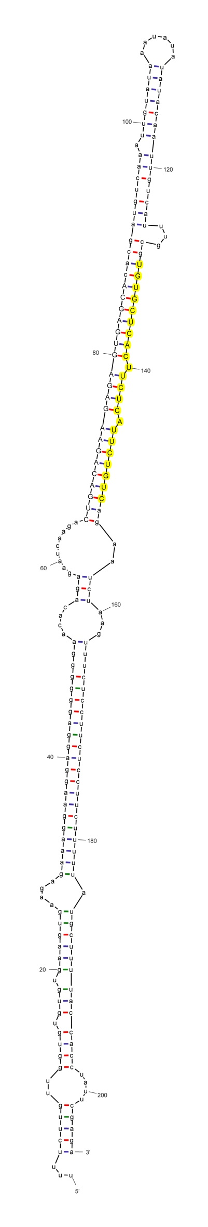

sha-miR156j-p3_cme

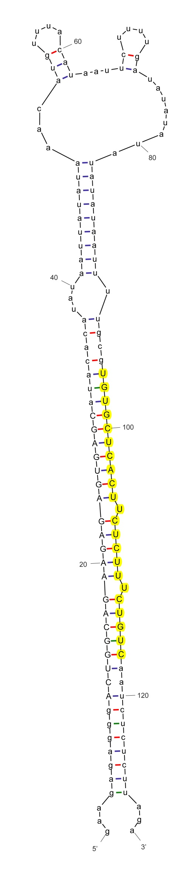

sha-miR156j-p3_cme

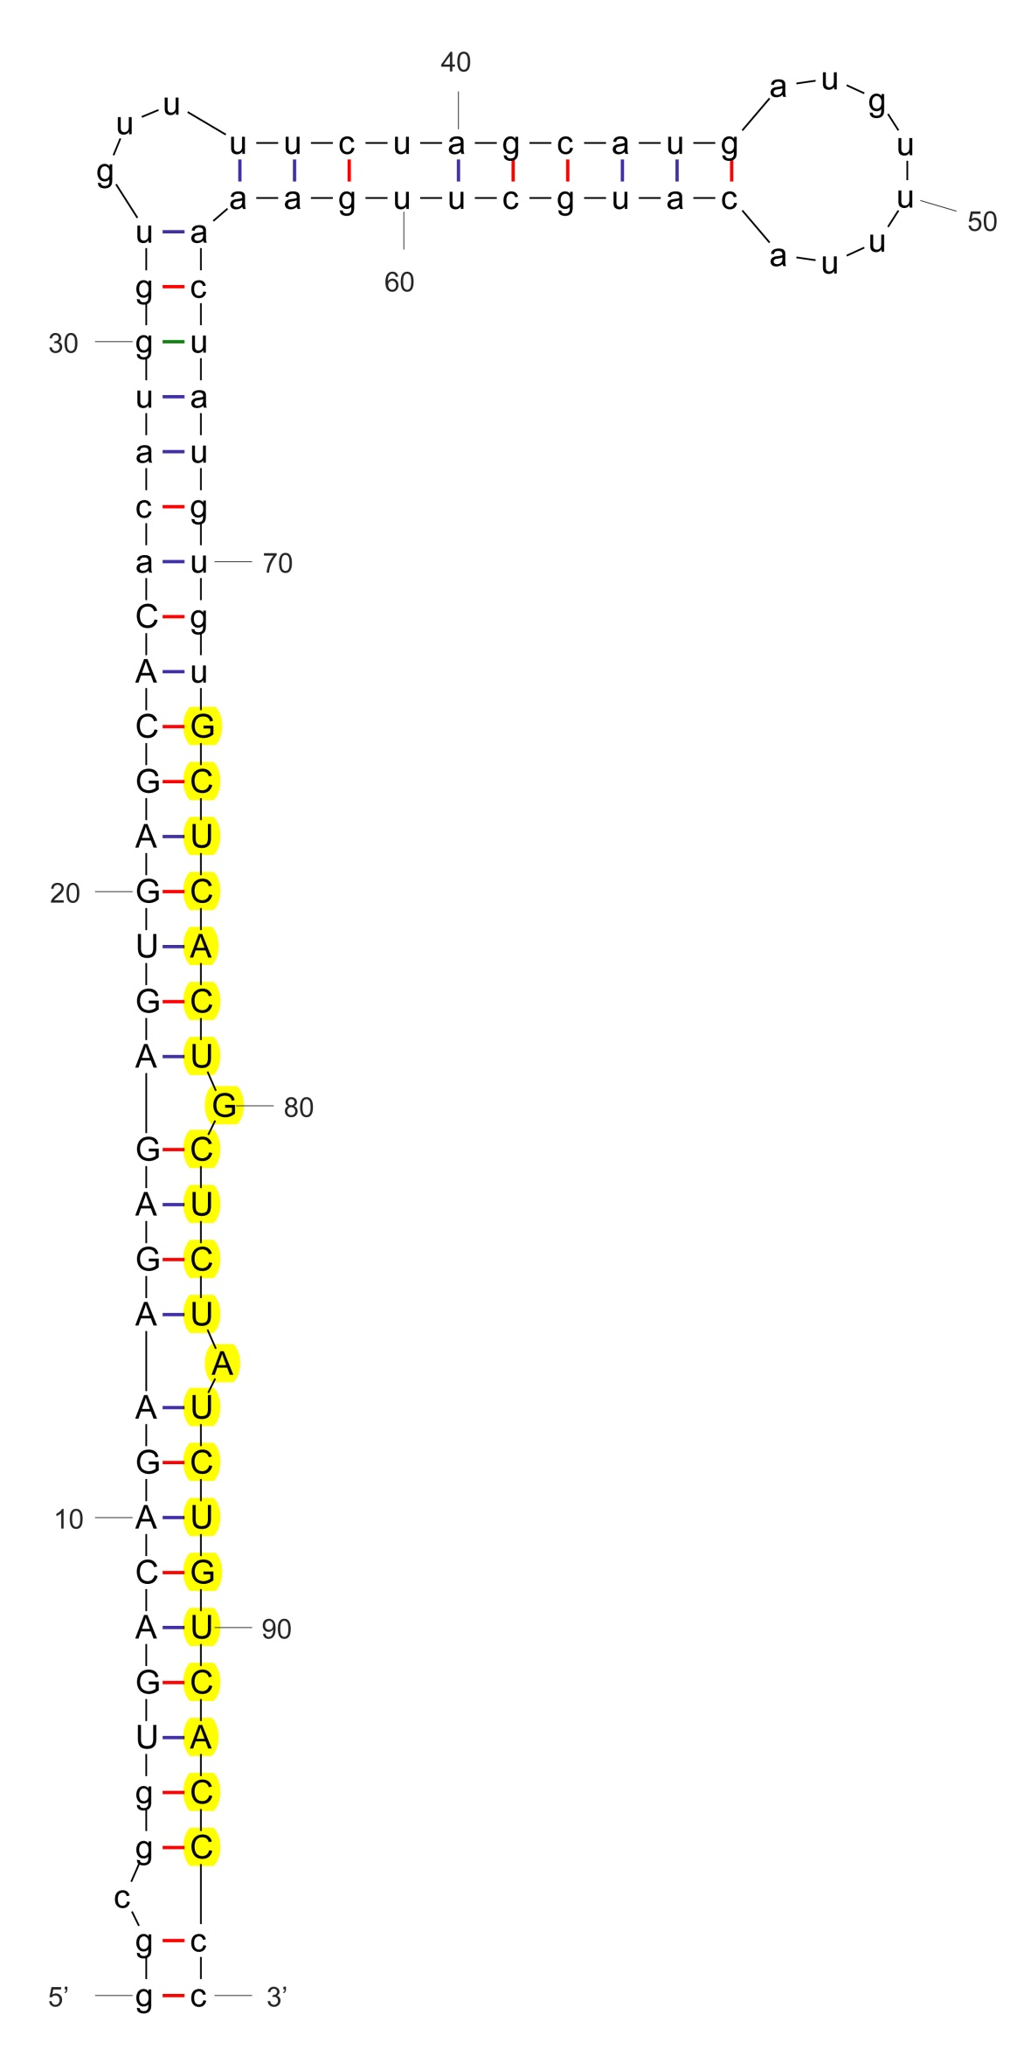

sha-miR156k-3p_stu

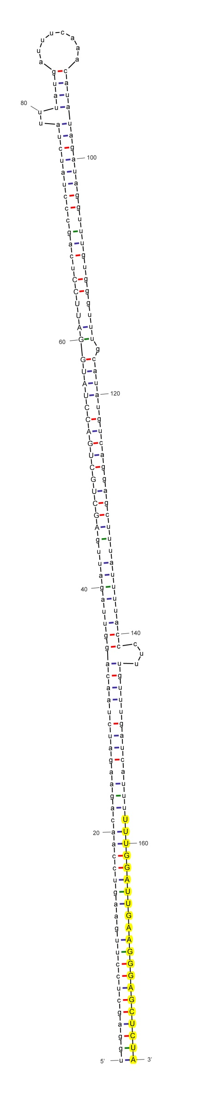

sha-miR159

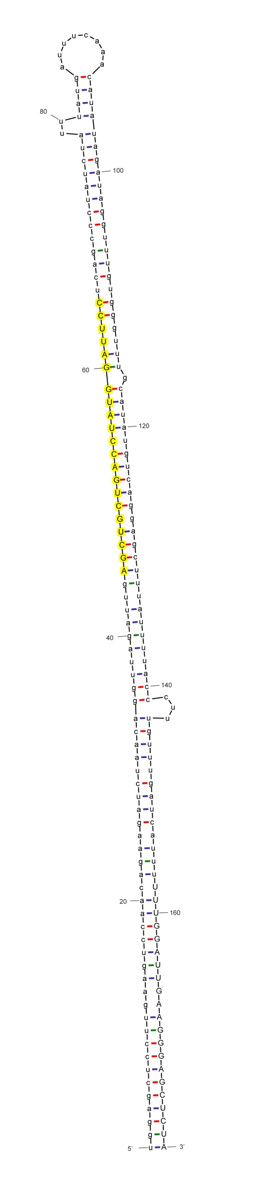

sha-miR159-p5

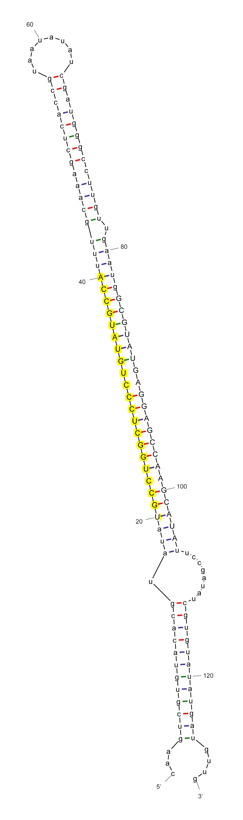

sha-miR160a

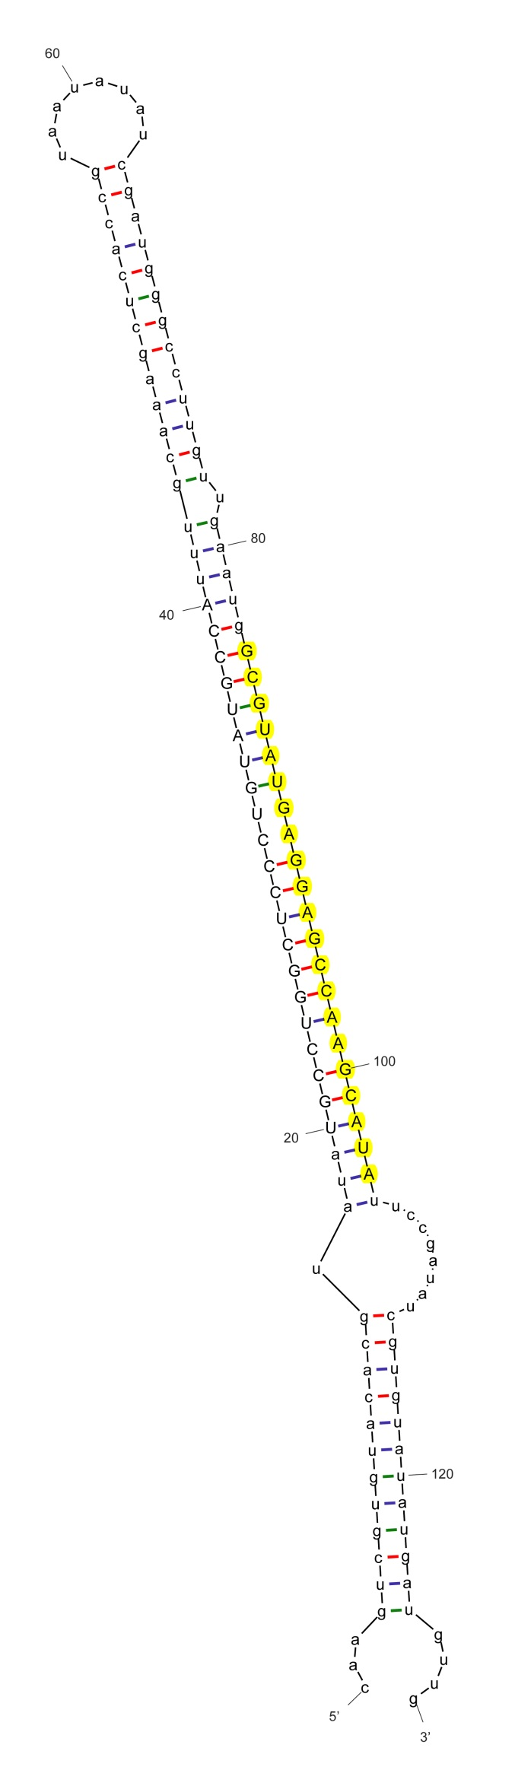

sha-miR160a-3p_stu

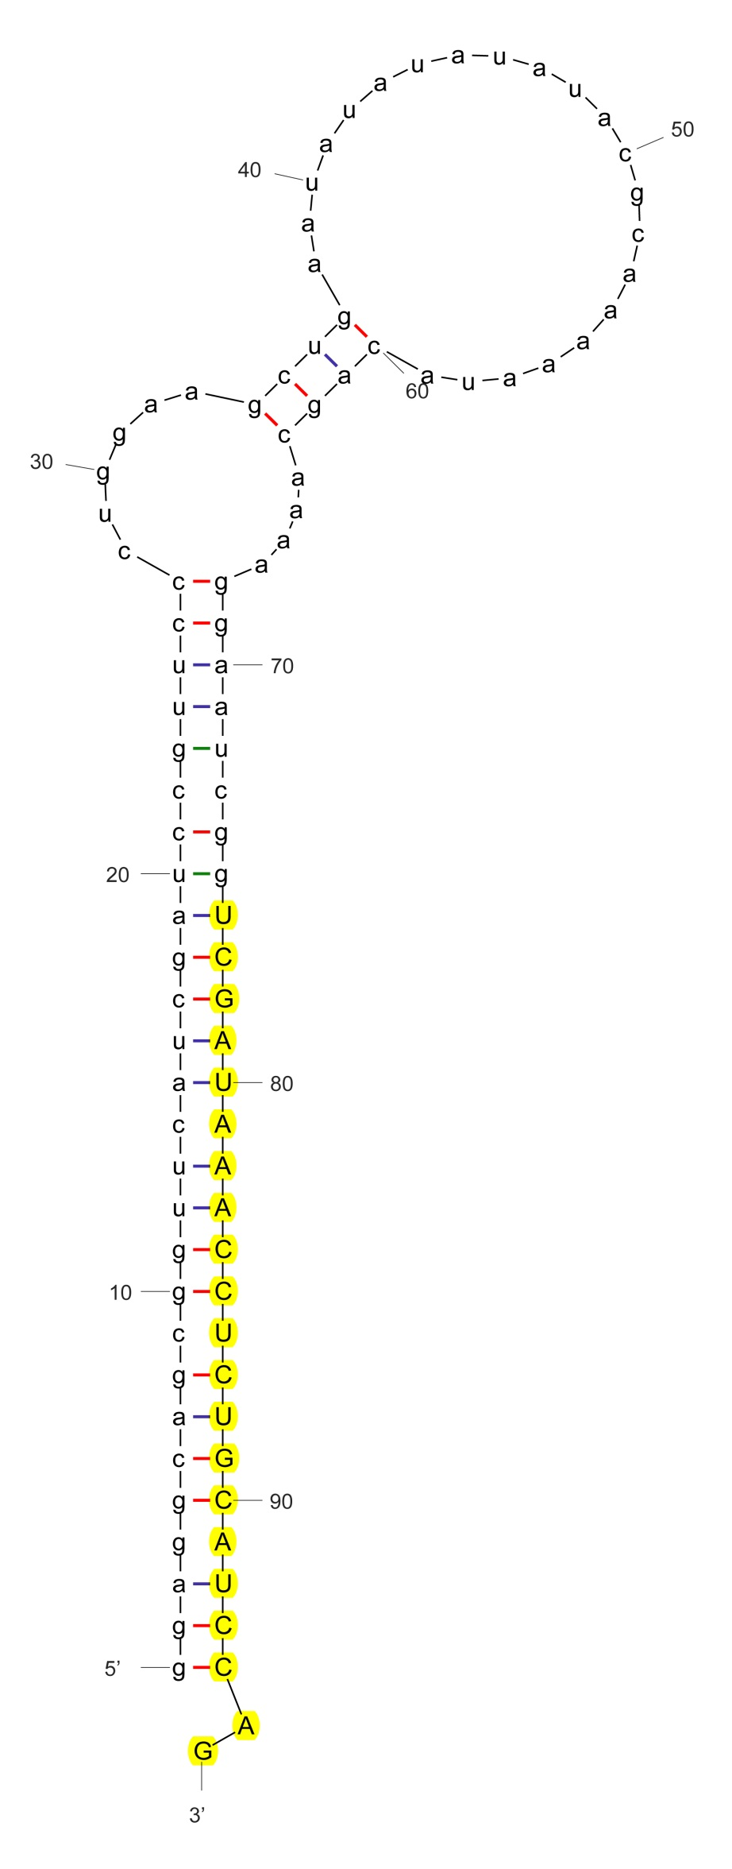

sha-miR162

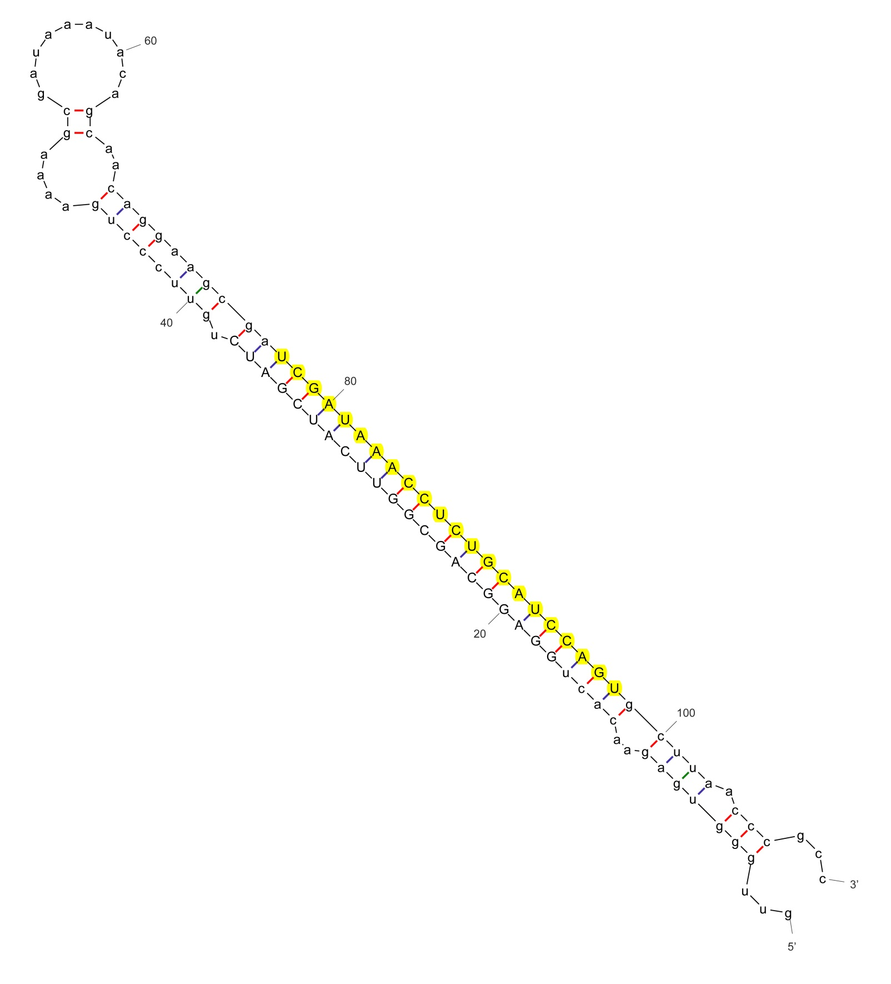

sha-miR162_vvi

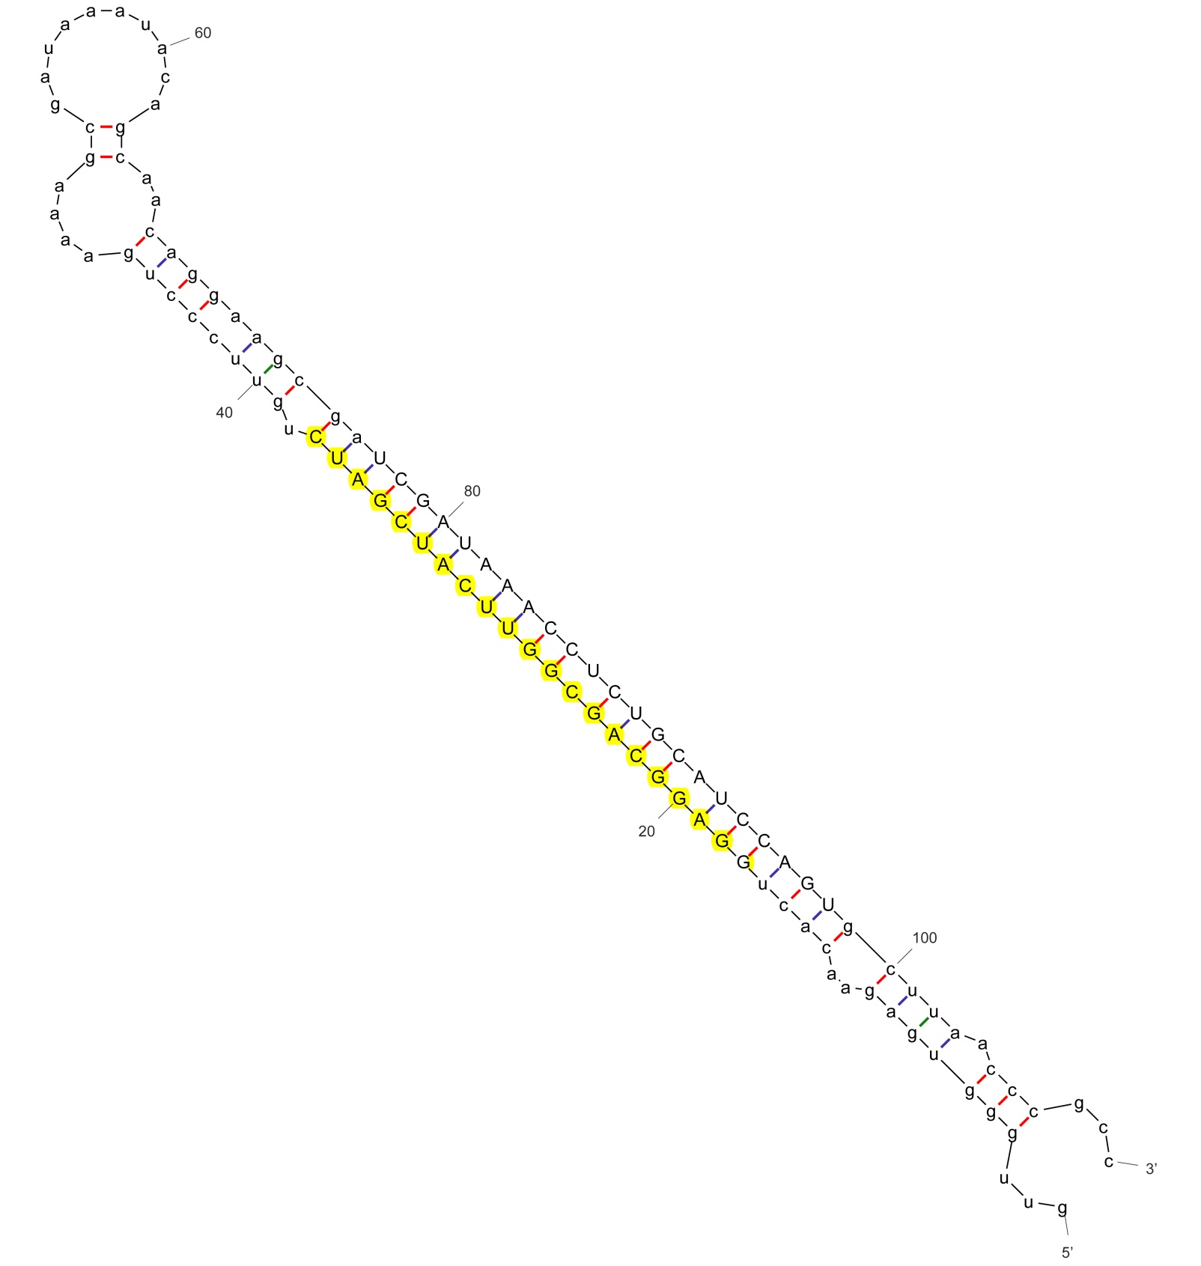

sha-miR162-p5_cme

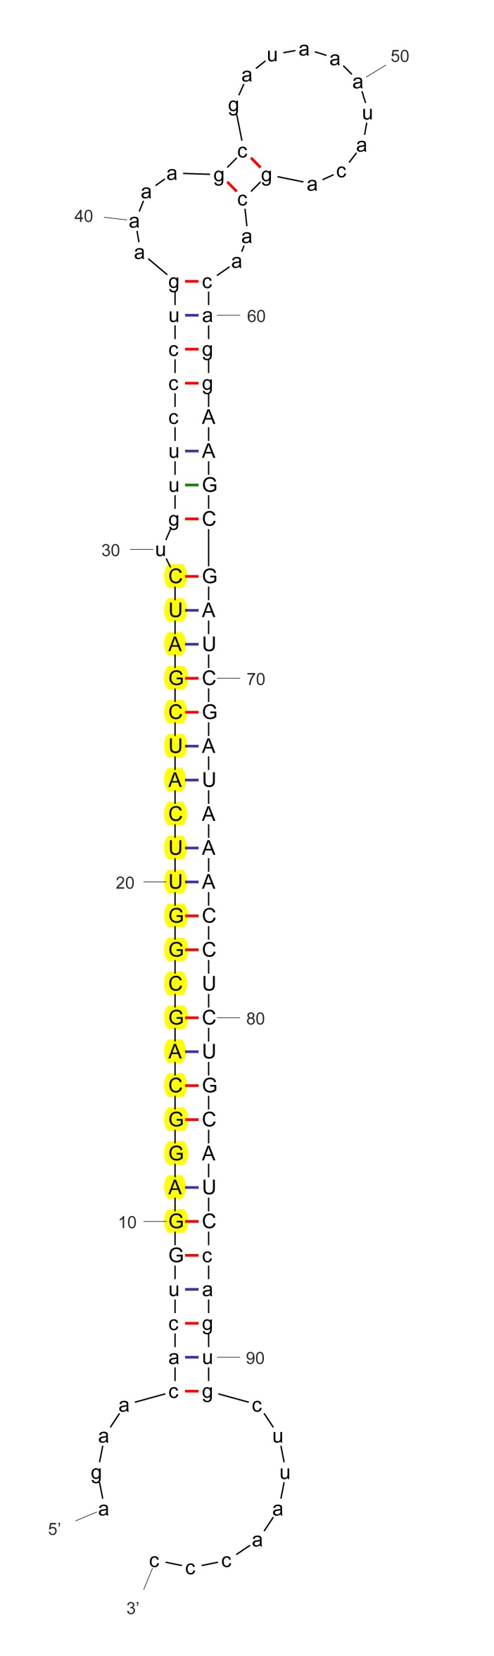

sha-miR162a-5p_stu

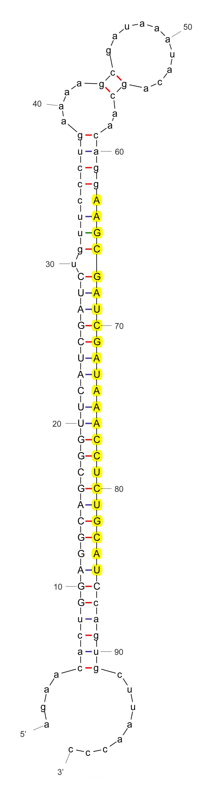

sha-miR162a-p3_stu

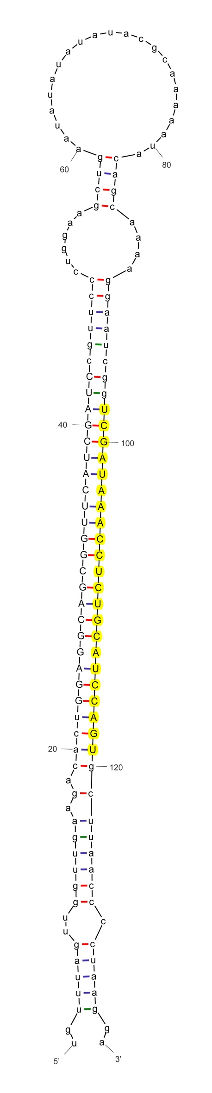

sha-miR162b-3p_stu

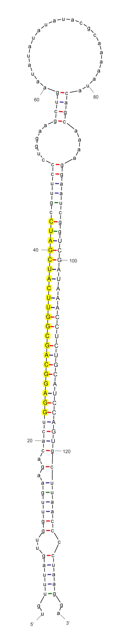

sha-miR162b-5p_stu

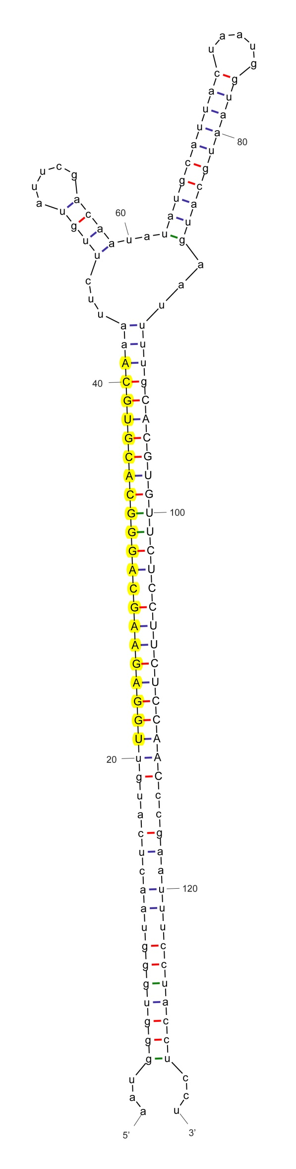

sha-miR164a_nta

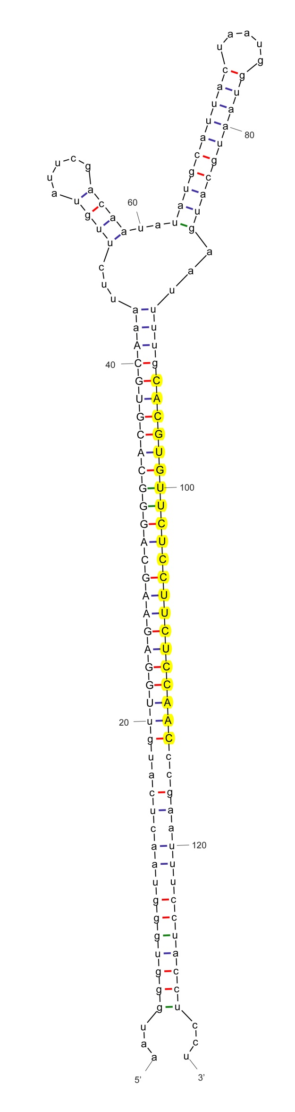

sha-miR164c-3p_aly

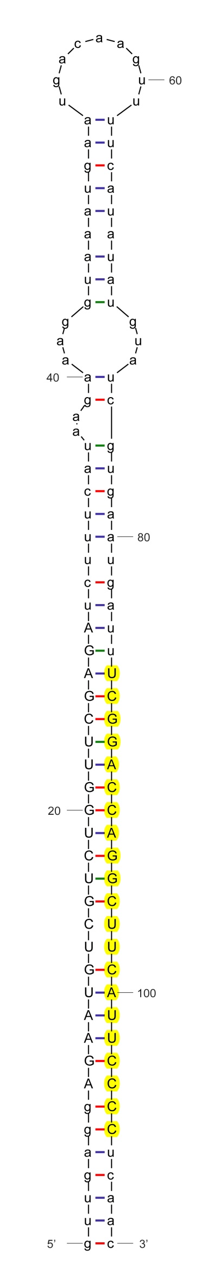

sha-miR166a

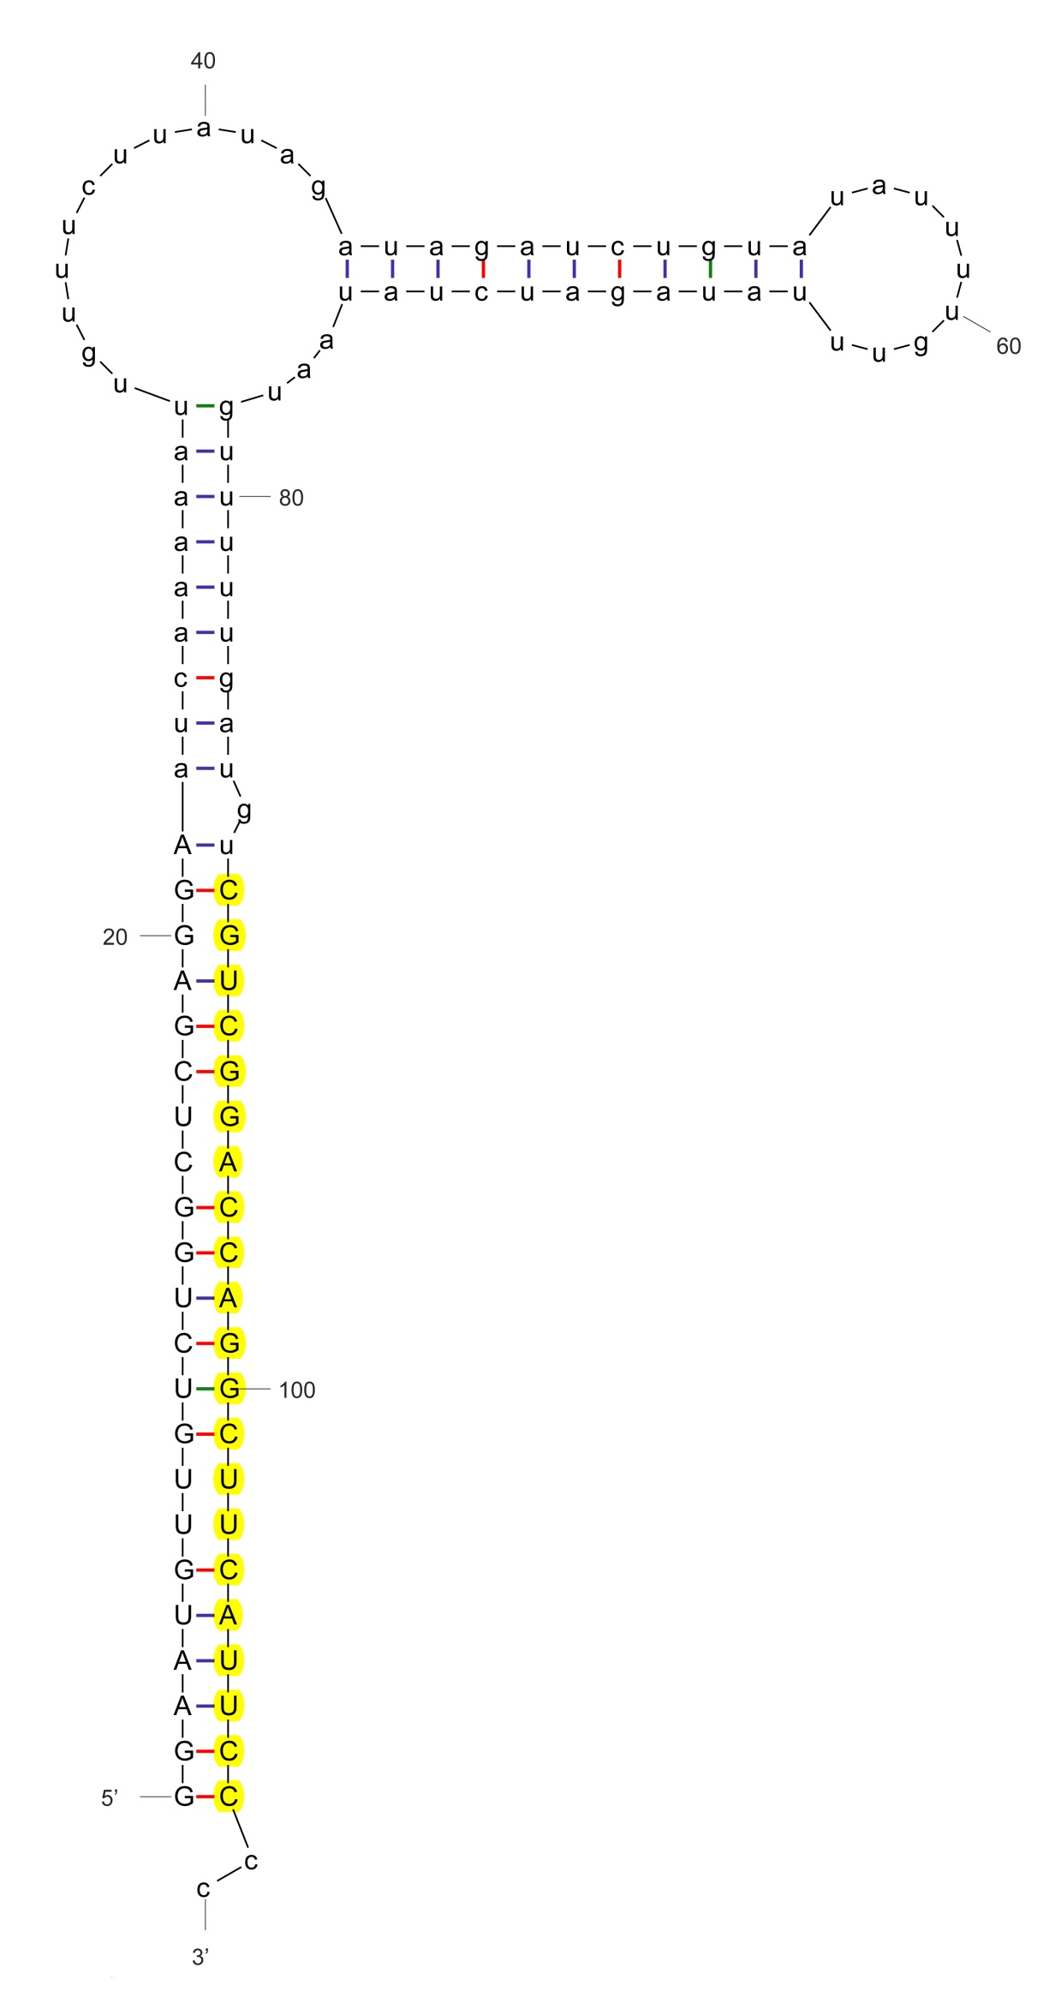

sha-miR166a-3p_stu

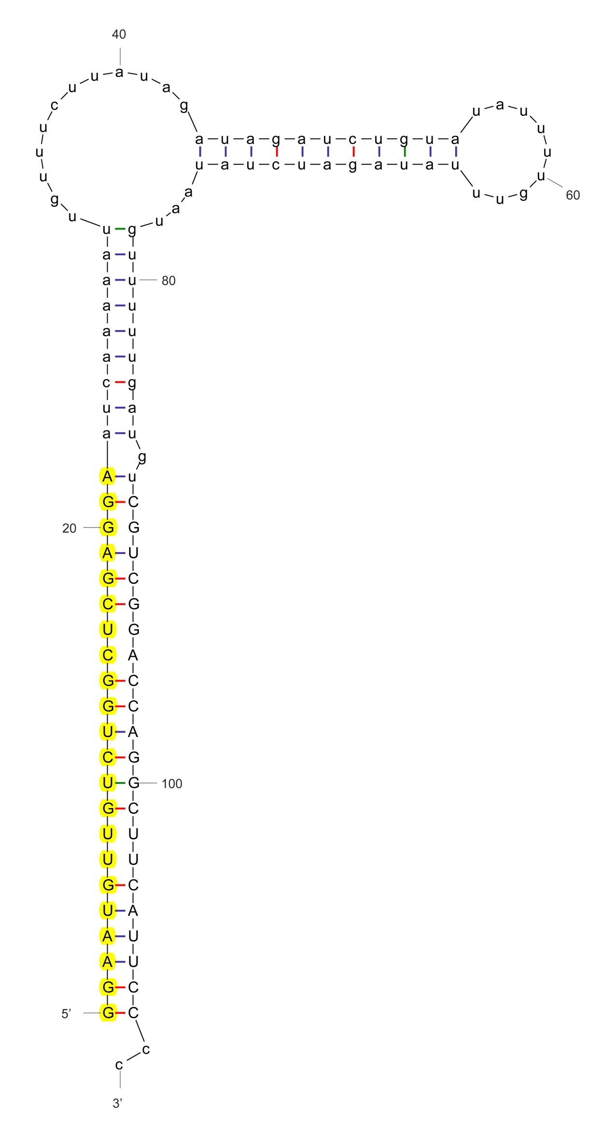

sha-miR166a-5p_stu

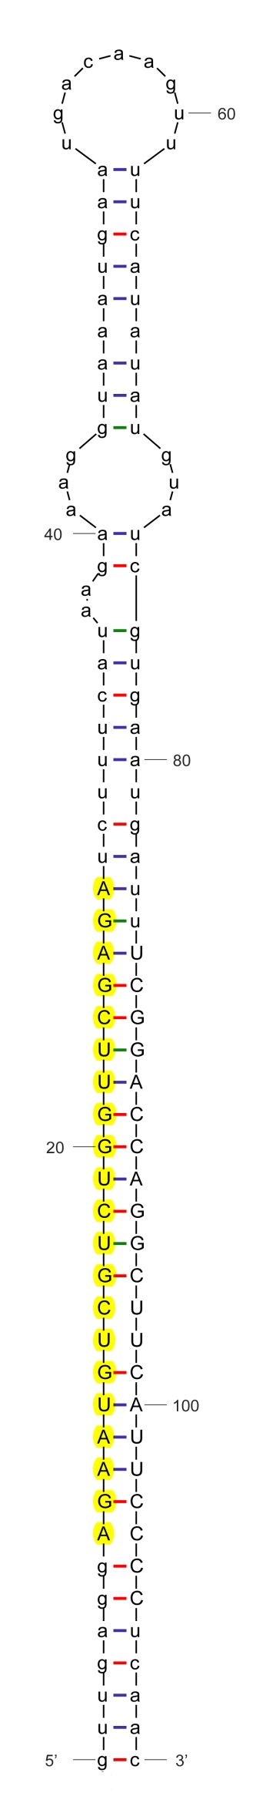

sha-miR166a-p5

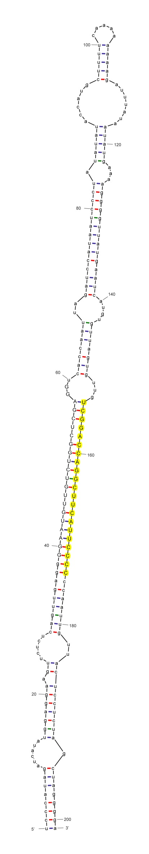

sha-miR166b

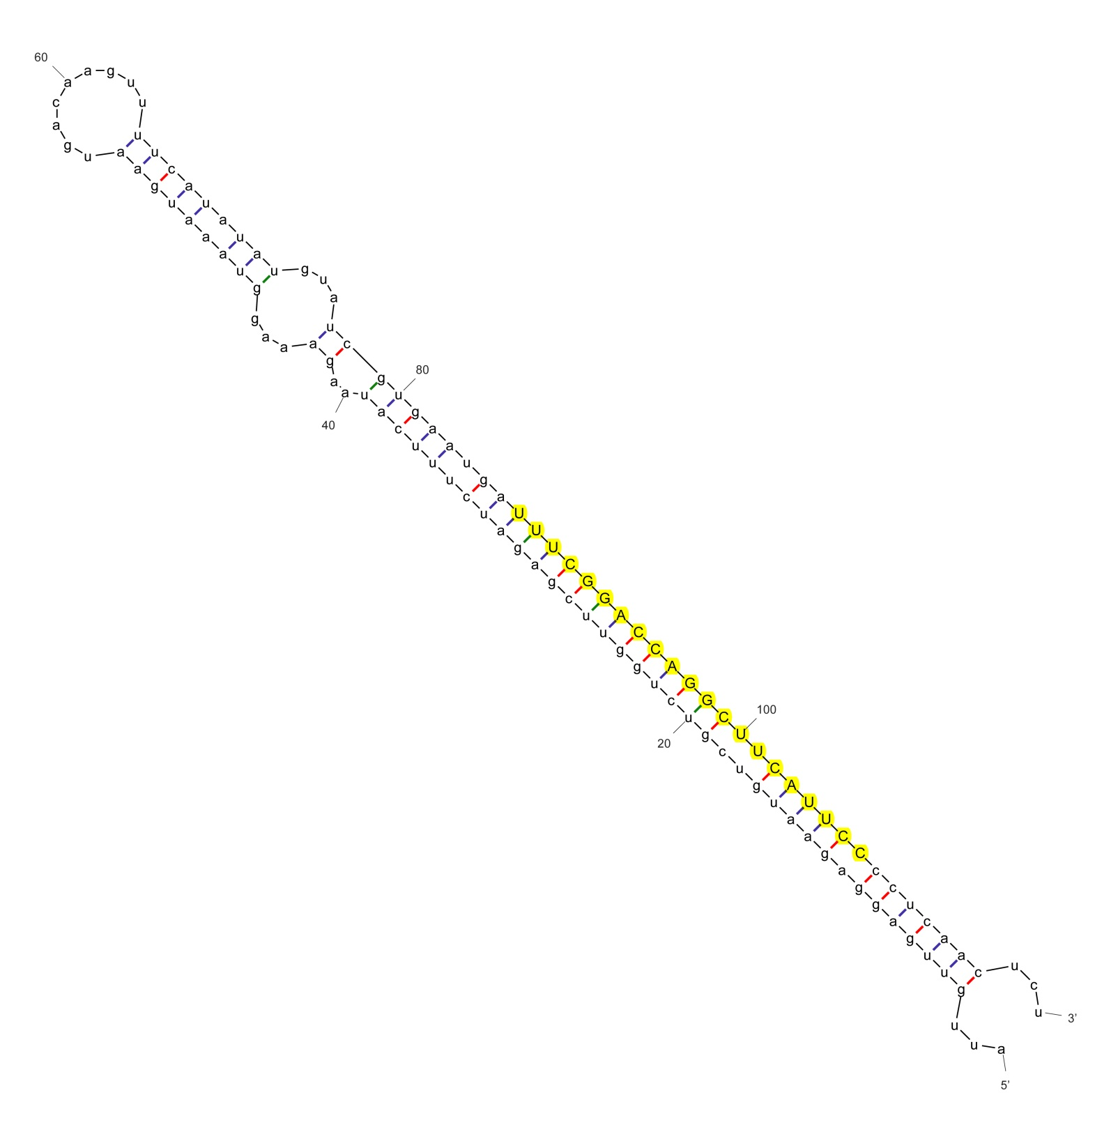

sha-miR166b_stu

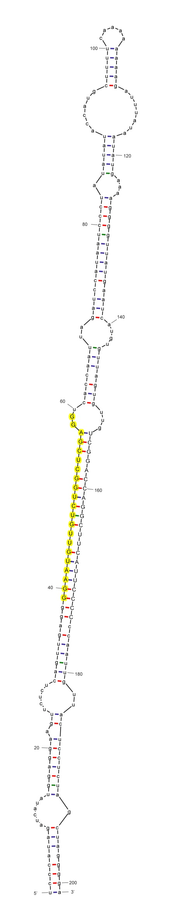

sha-miR166b-p5

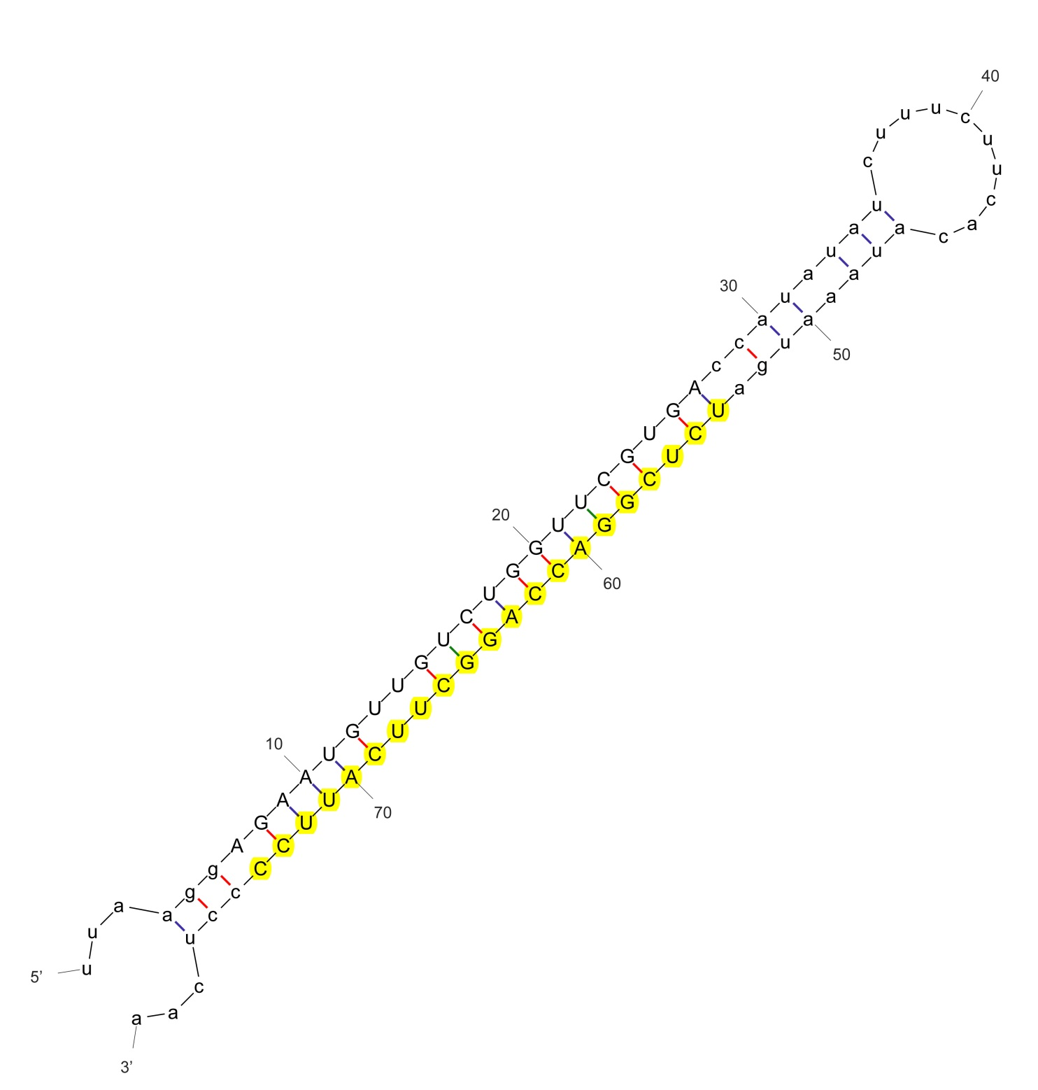

sha-miR166g_nta

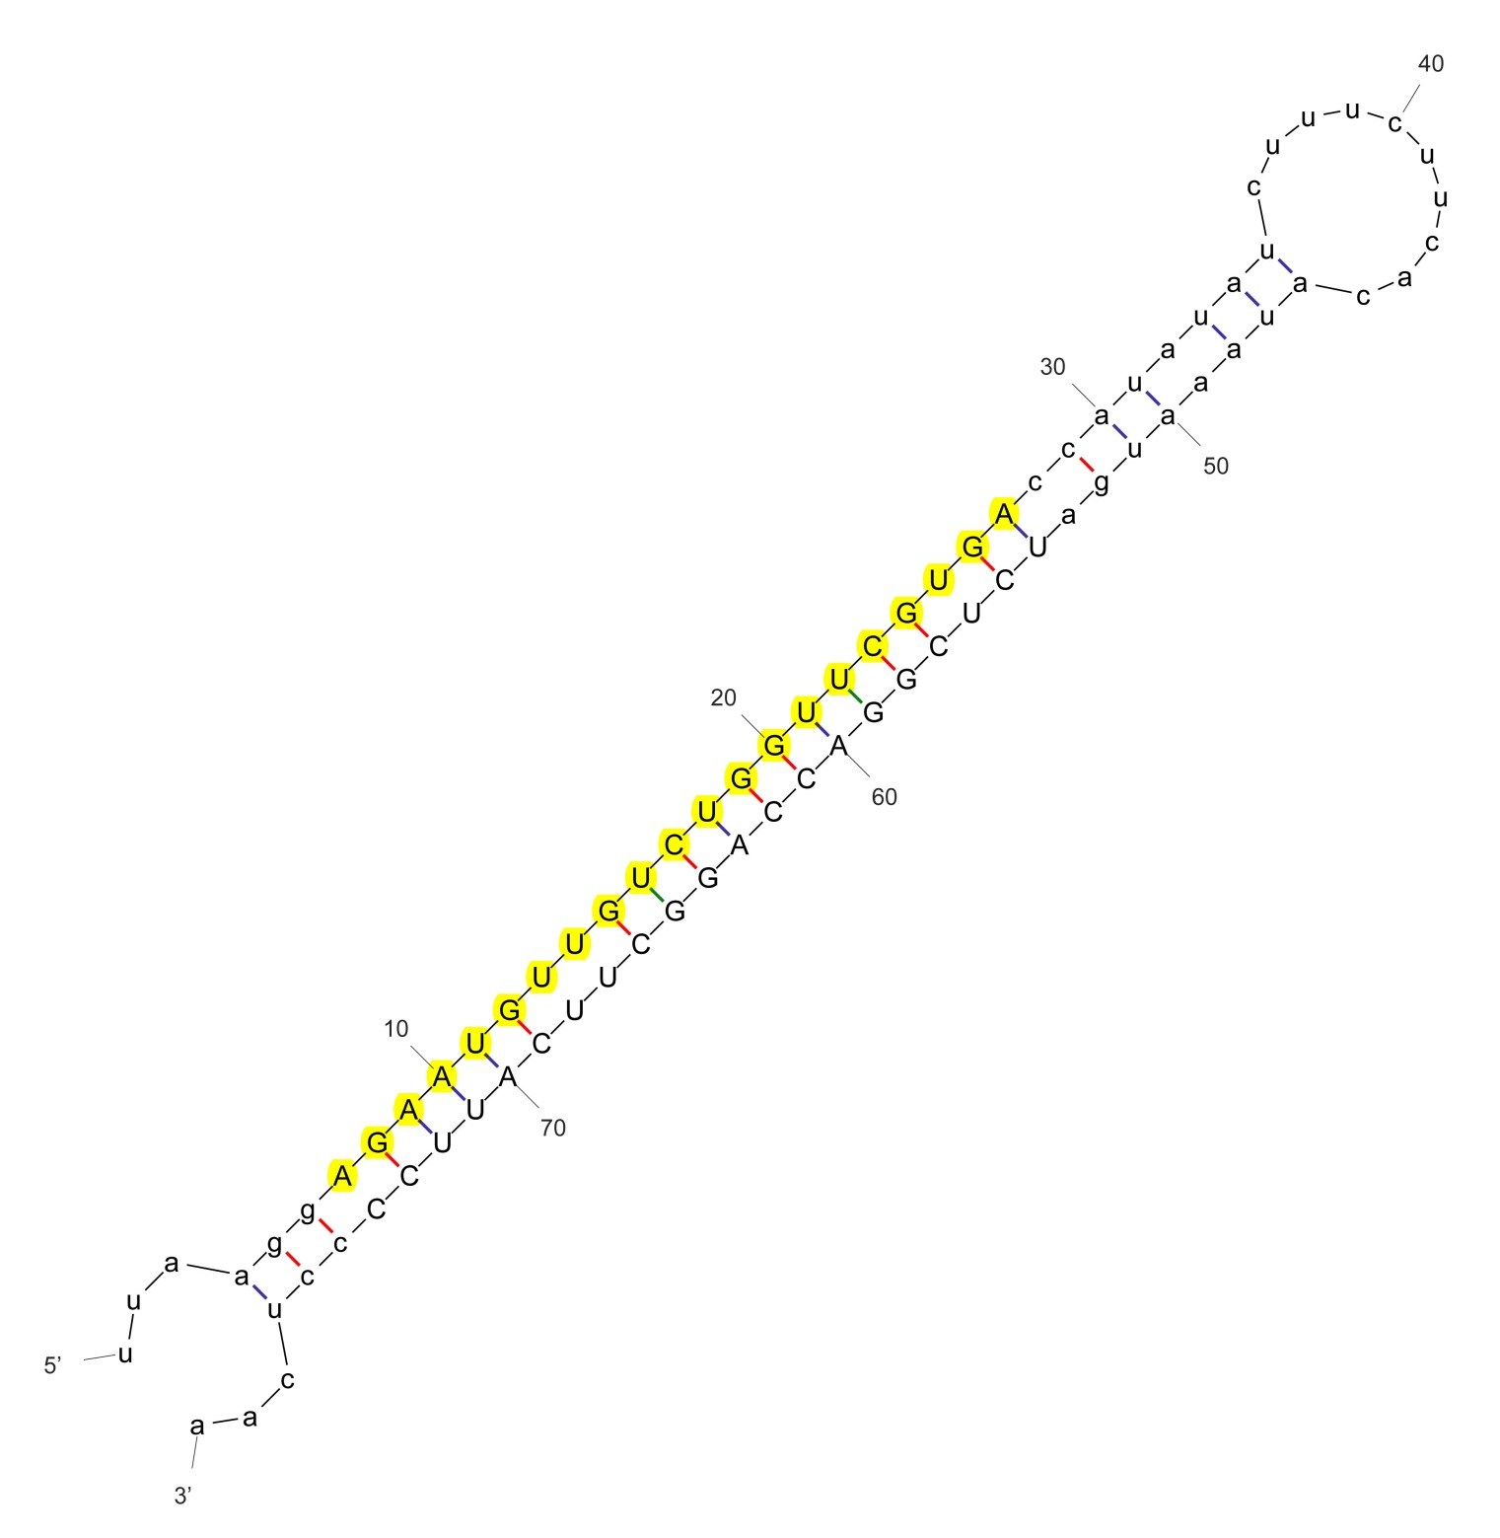

sha-miR166g-p5_nta

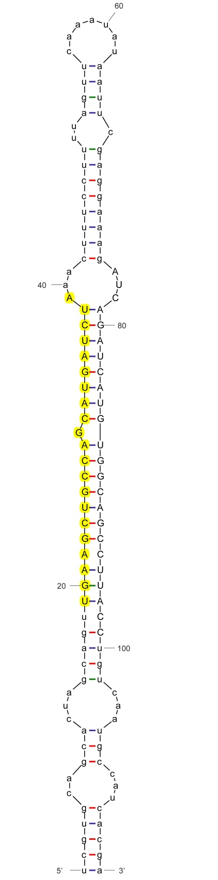

sha-miR167

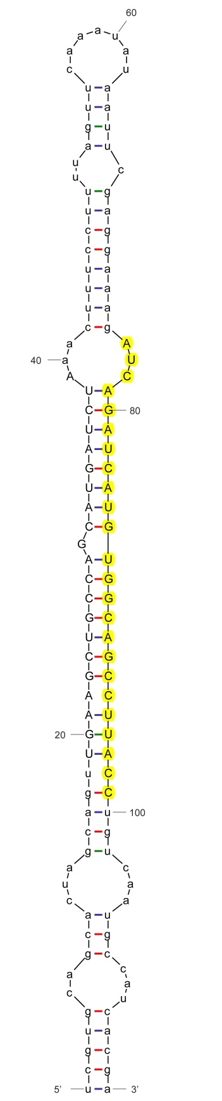

sha-miR167-p3

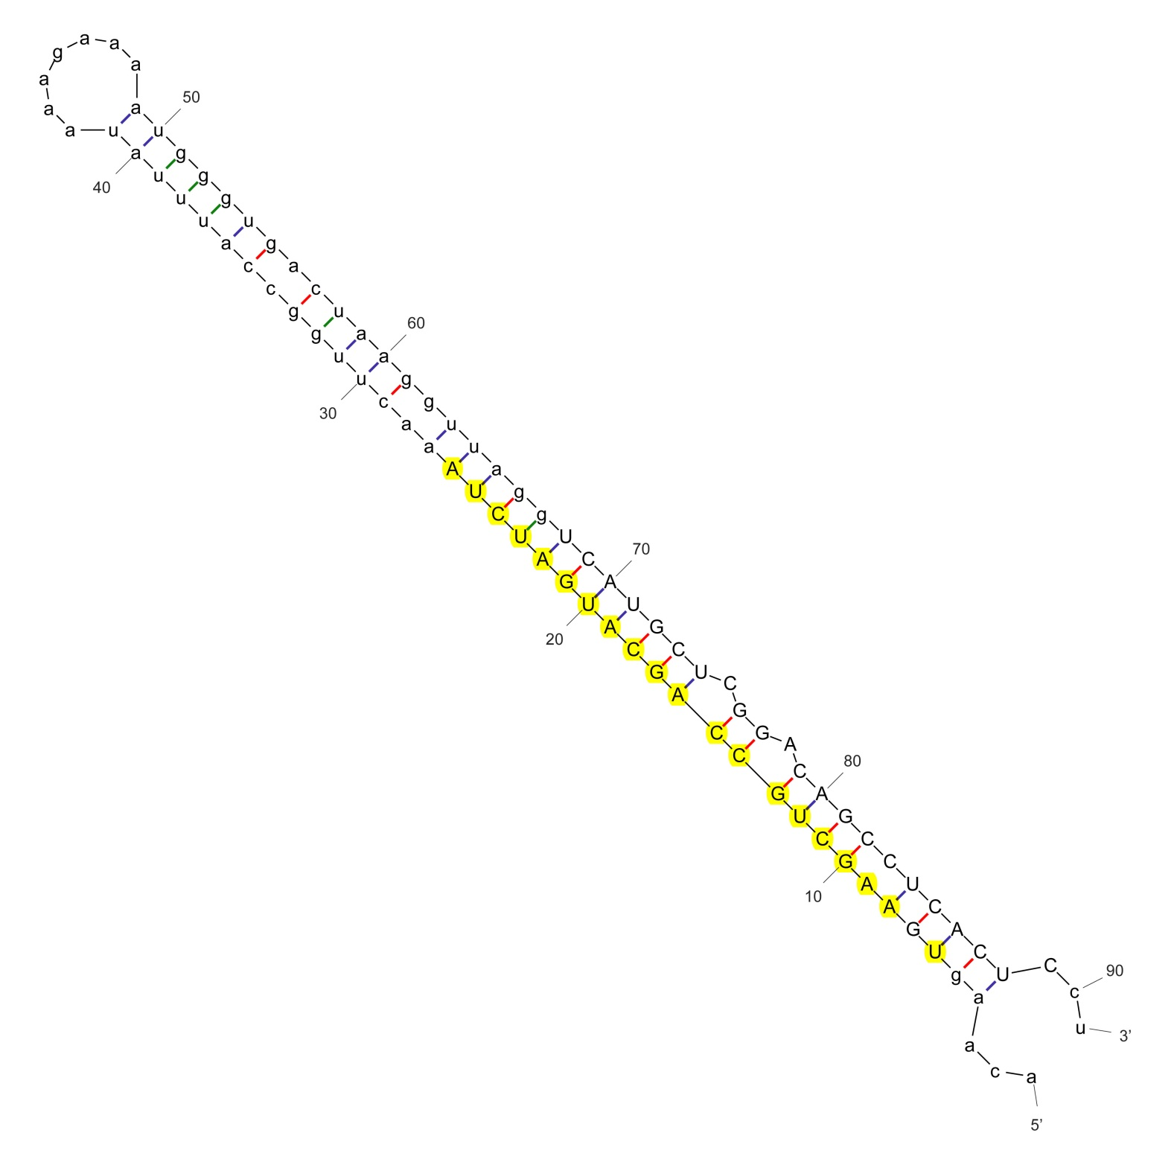

sha-miR167b_nta

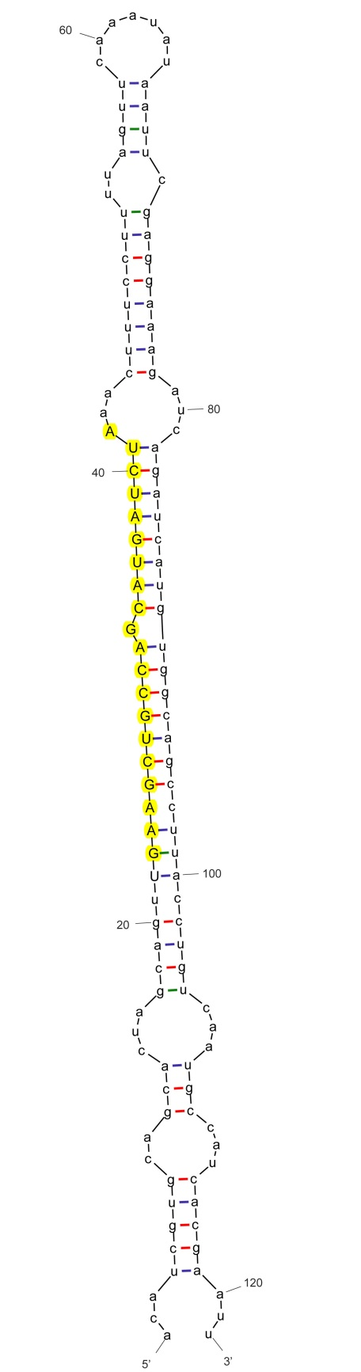

sha-miR167b_nta

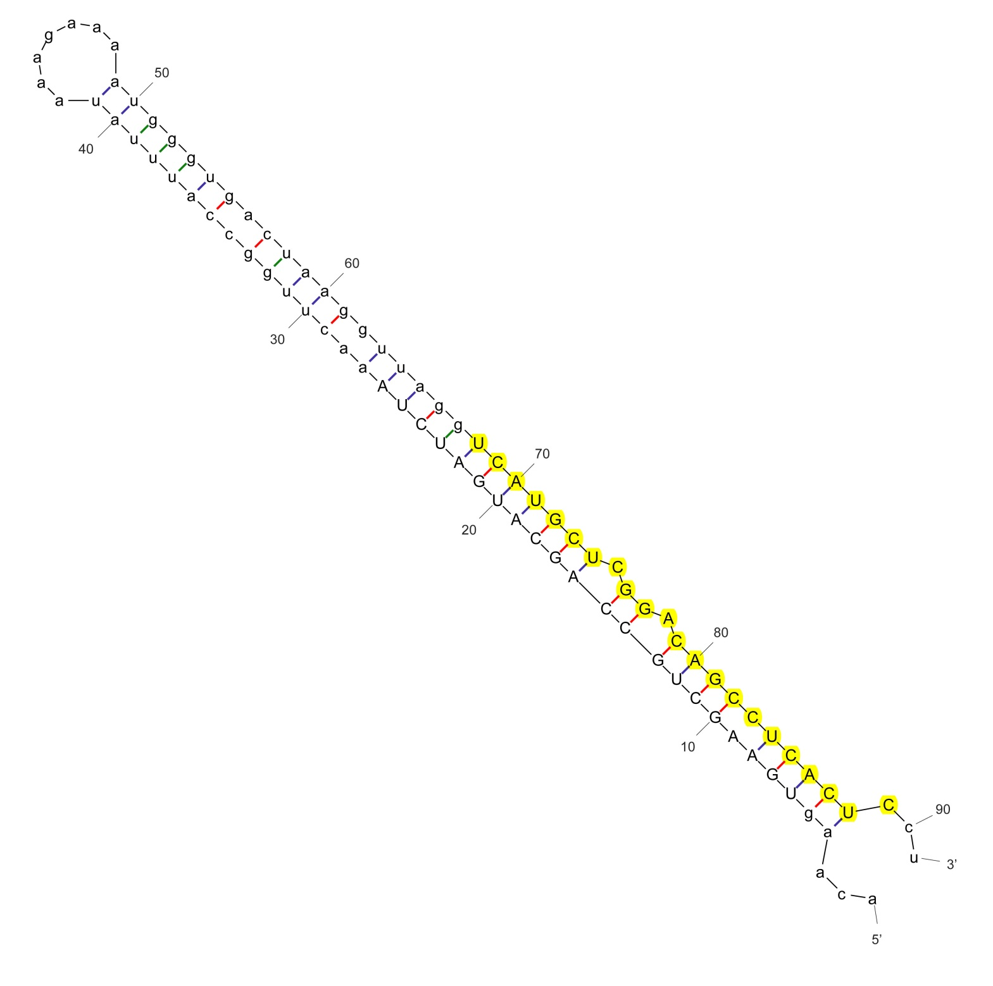

sha-miR167b-3p_aly

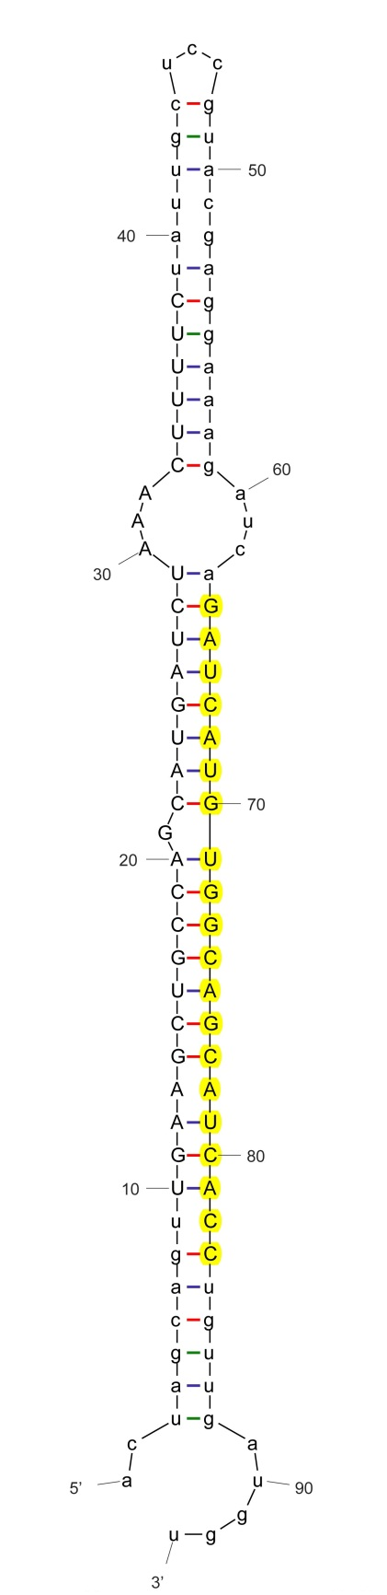

sha-miR167b-3p_stu

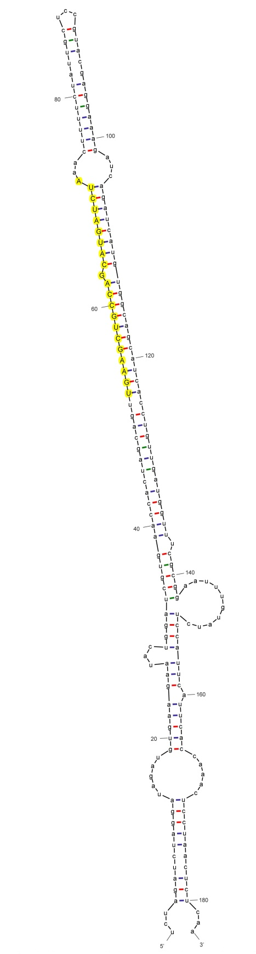

sha-miR167c_vvi

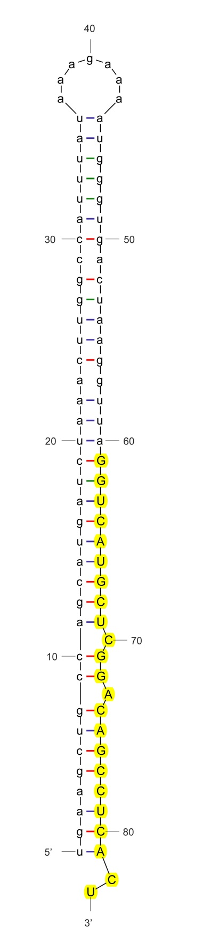

sha-miR167c-3p_stu

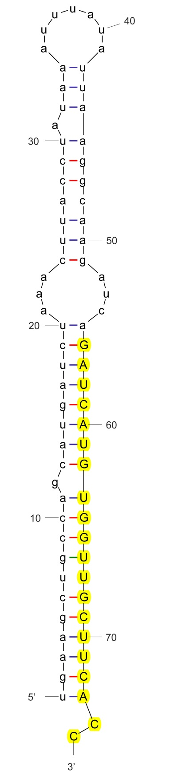

sha-miR167d-3p_stu

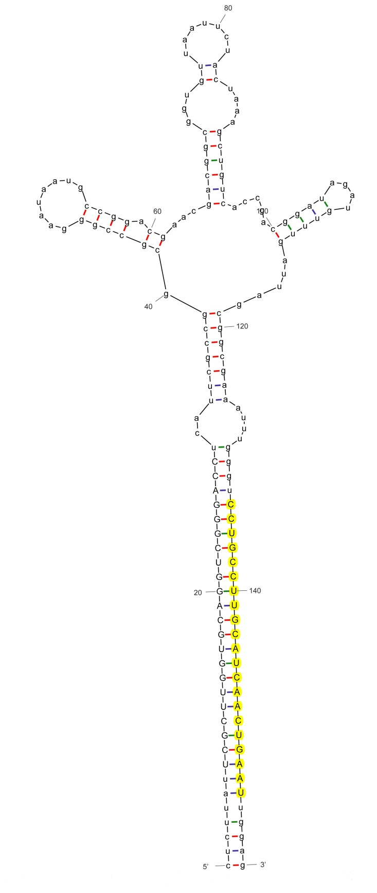

sha-miR168a-3p

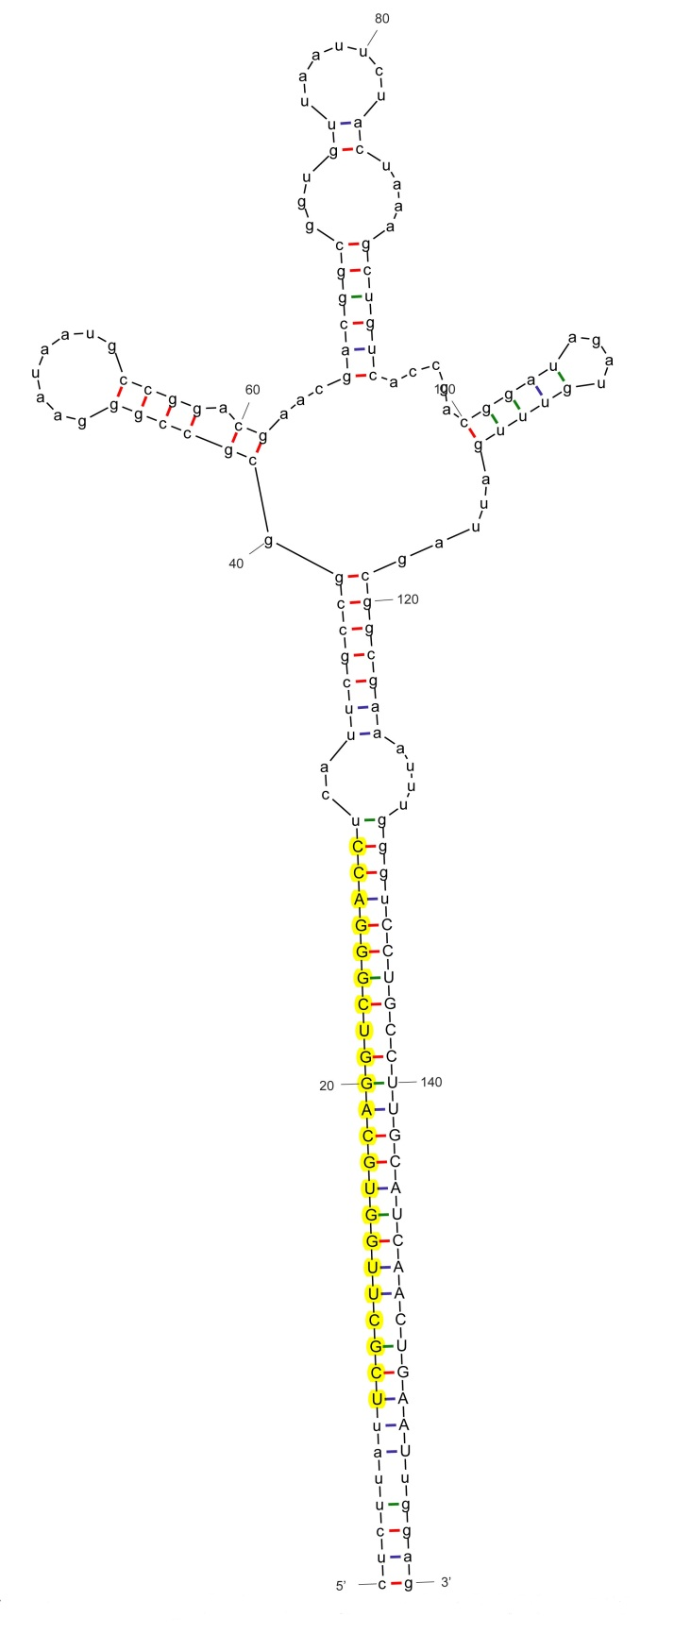

sha-miR168a-5p

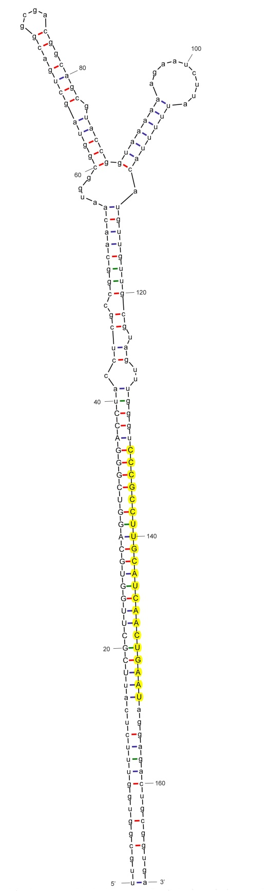

sha-miR168b-3p

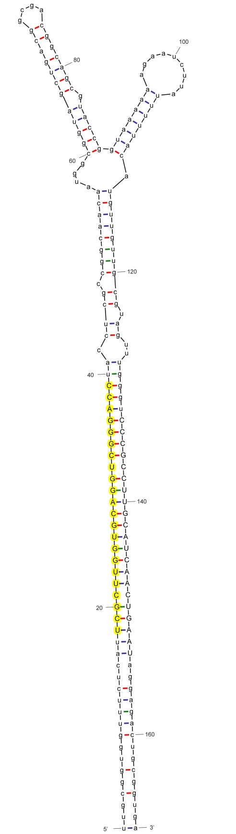

sha-miR168b-5p

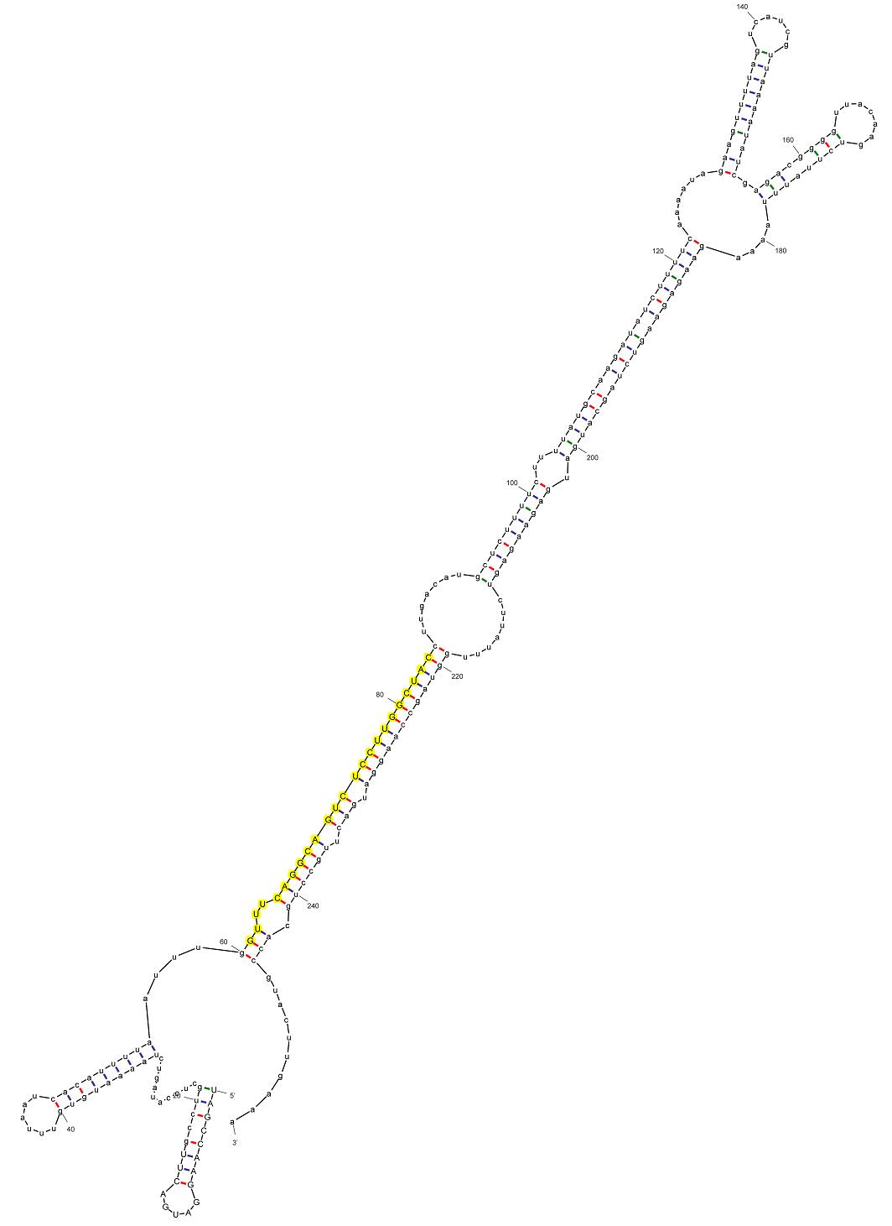

sha-miR169c-3p_stu

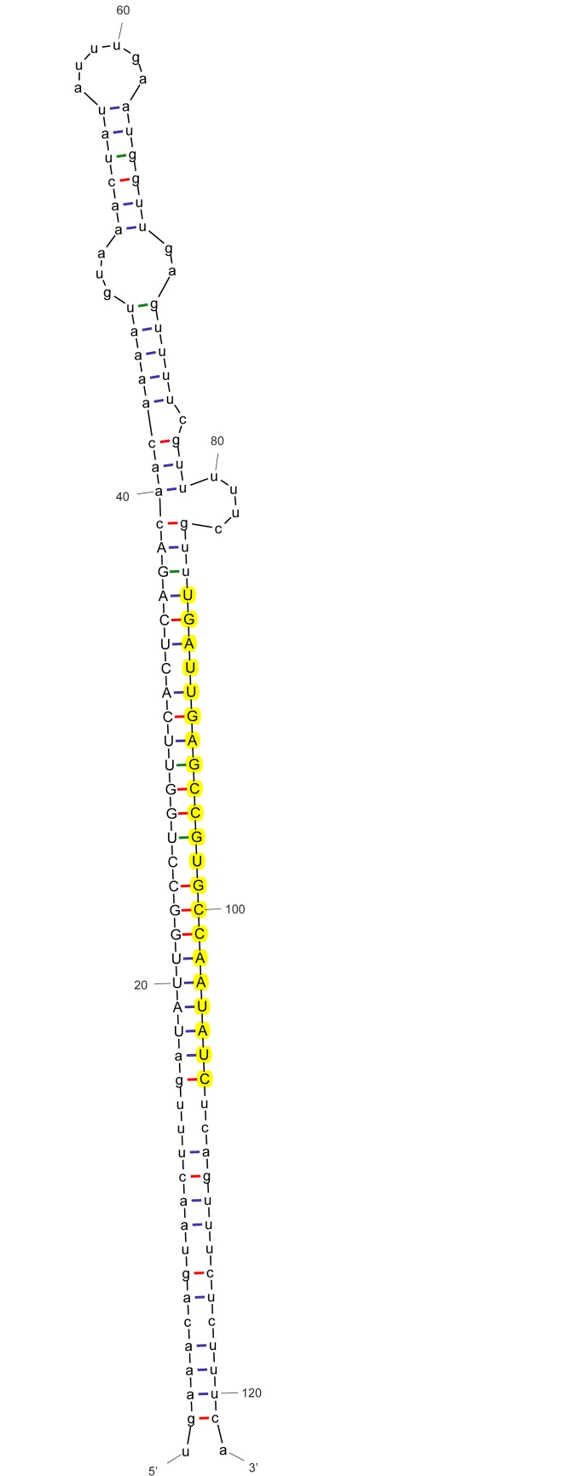

sha-miR171a

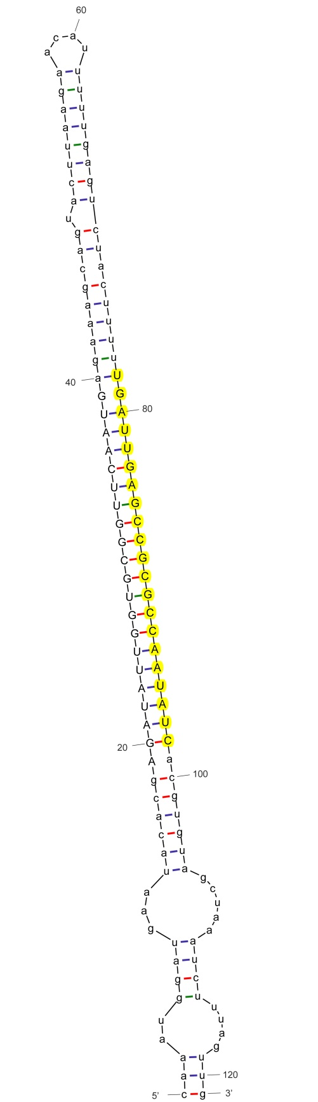

sha-miR171a_nta

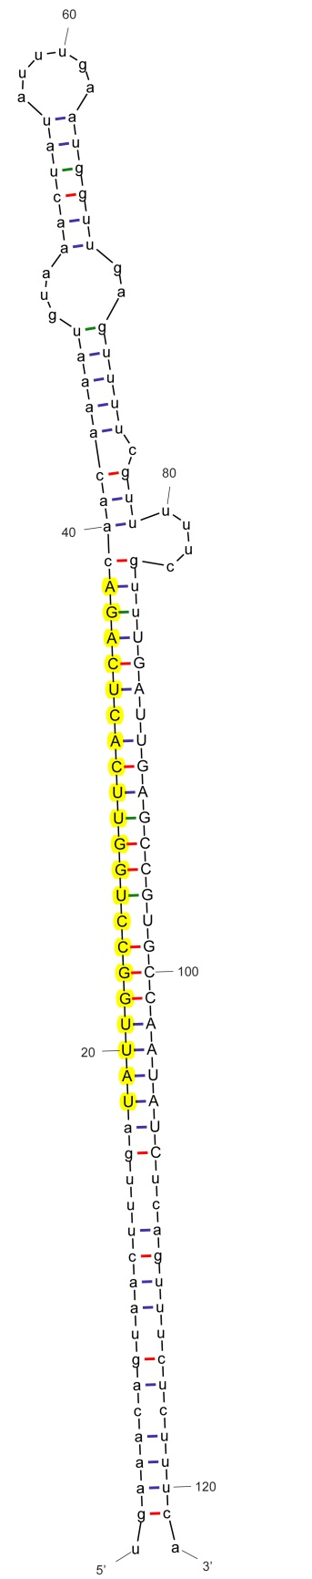

sha-miR171a-5p_stu

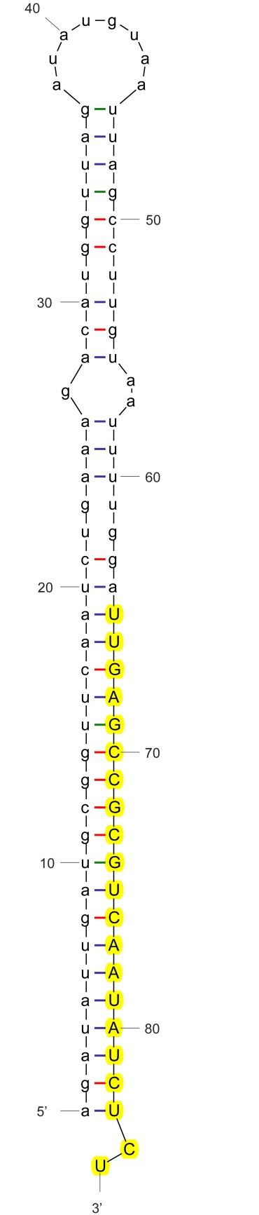

sha-miR171b-3p_stu

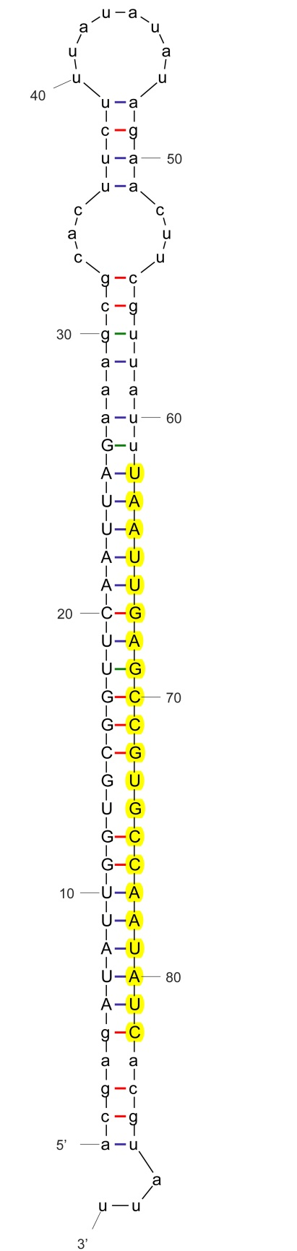

sha-miR171b-p3_mes

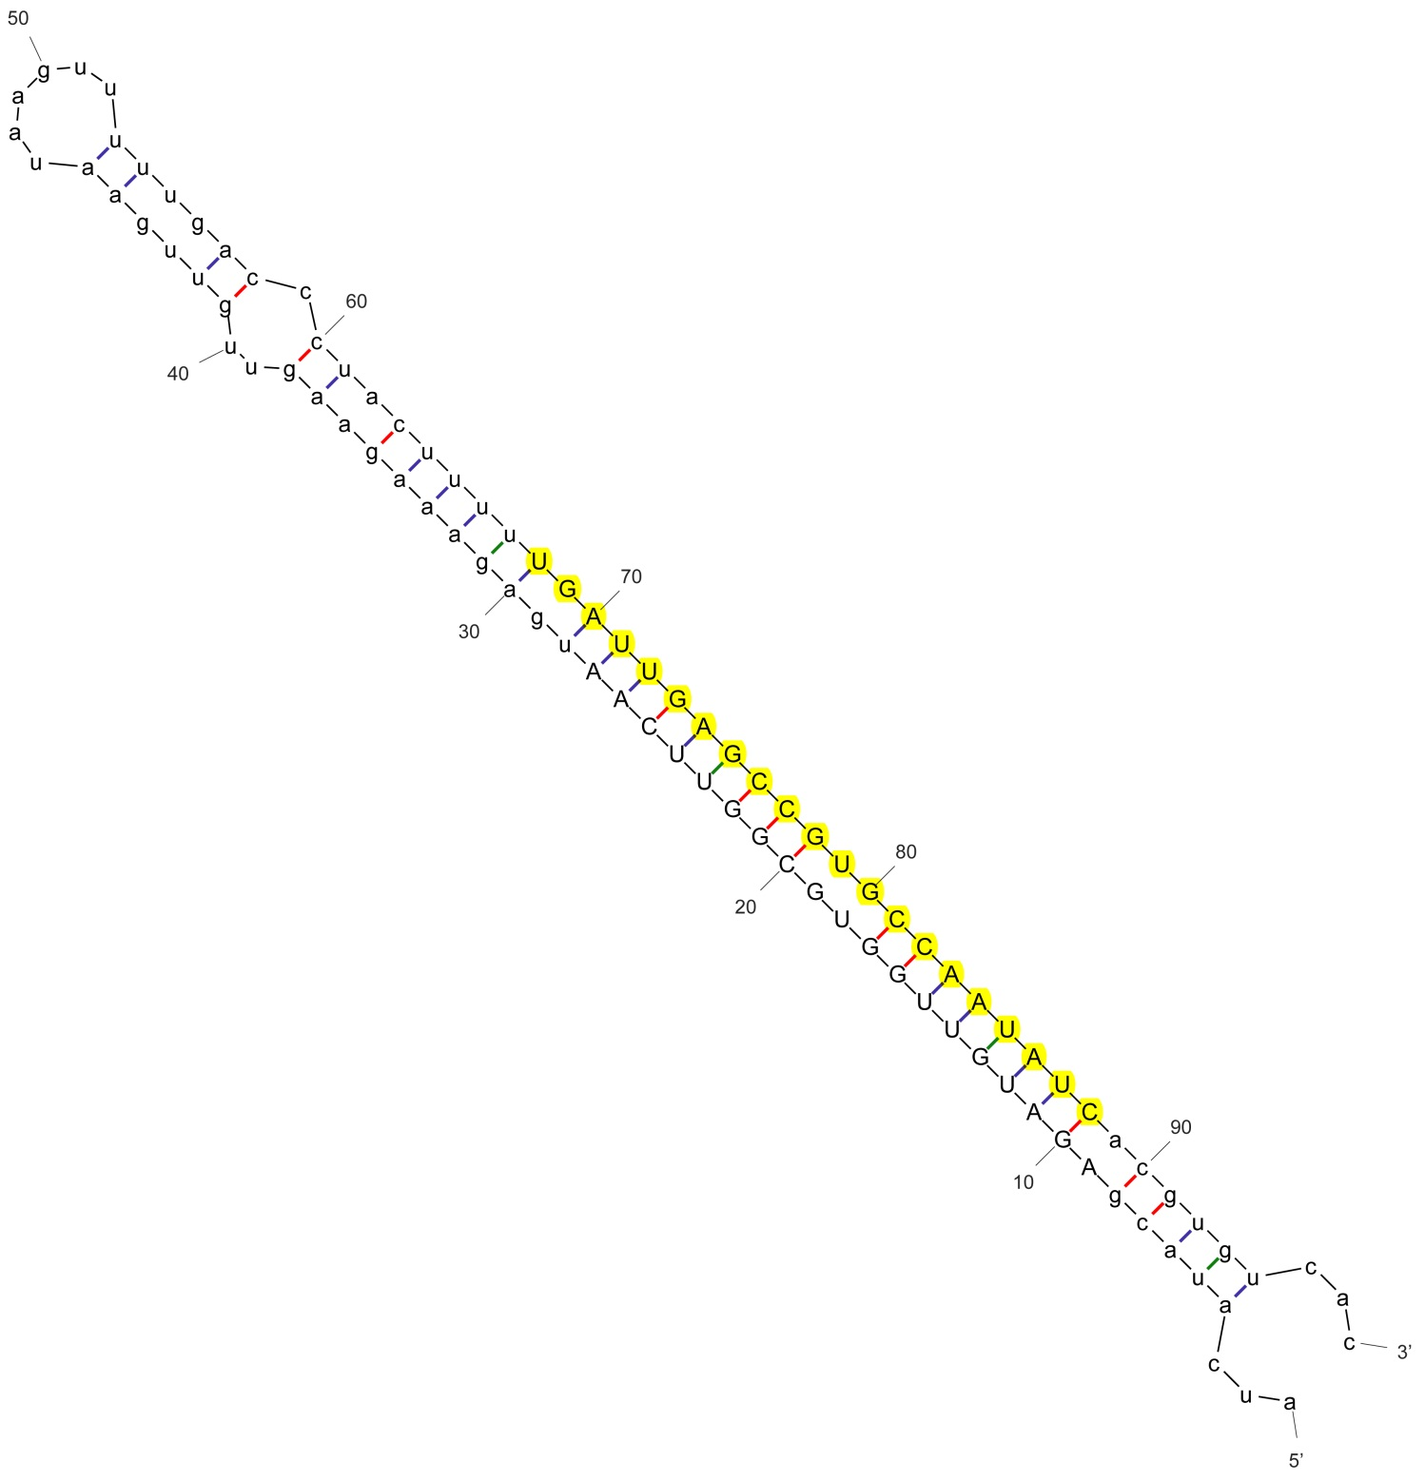

sha-miR171c_mtr

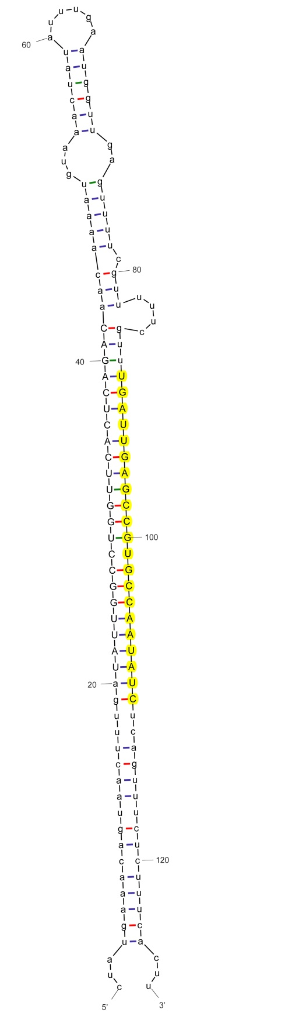

sha-miR171c-3p_stu

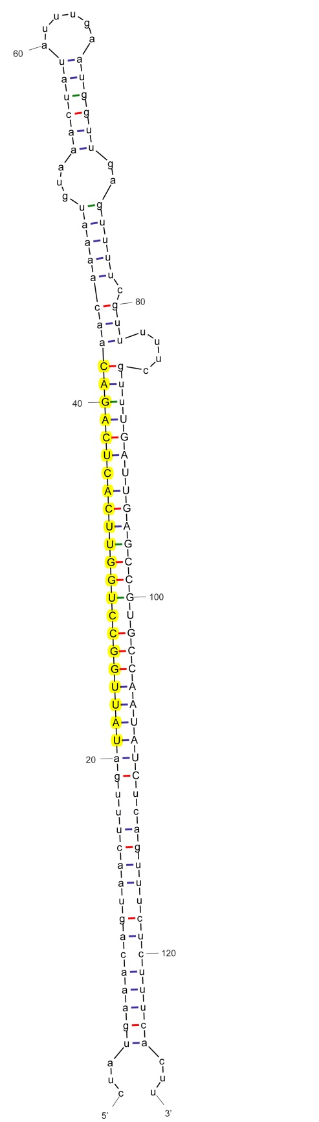

sha-miR171c-5p_stu

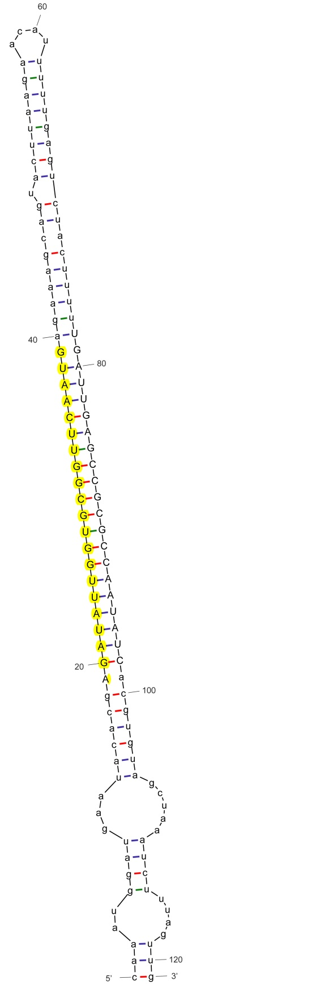

sha-miR171c-p5

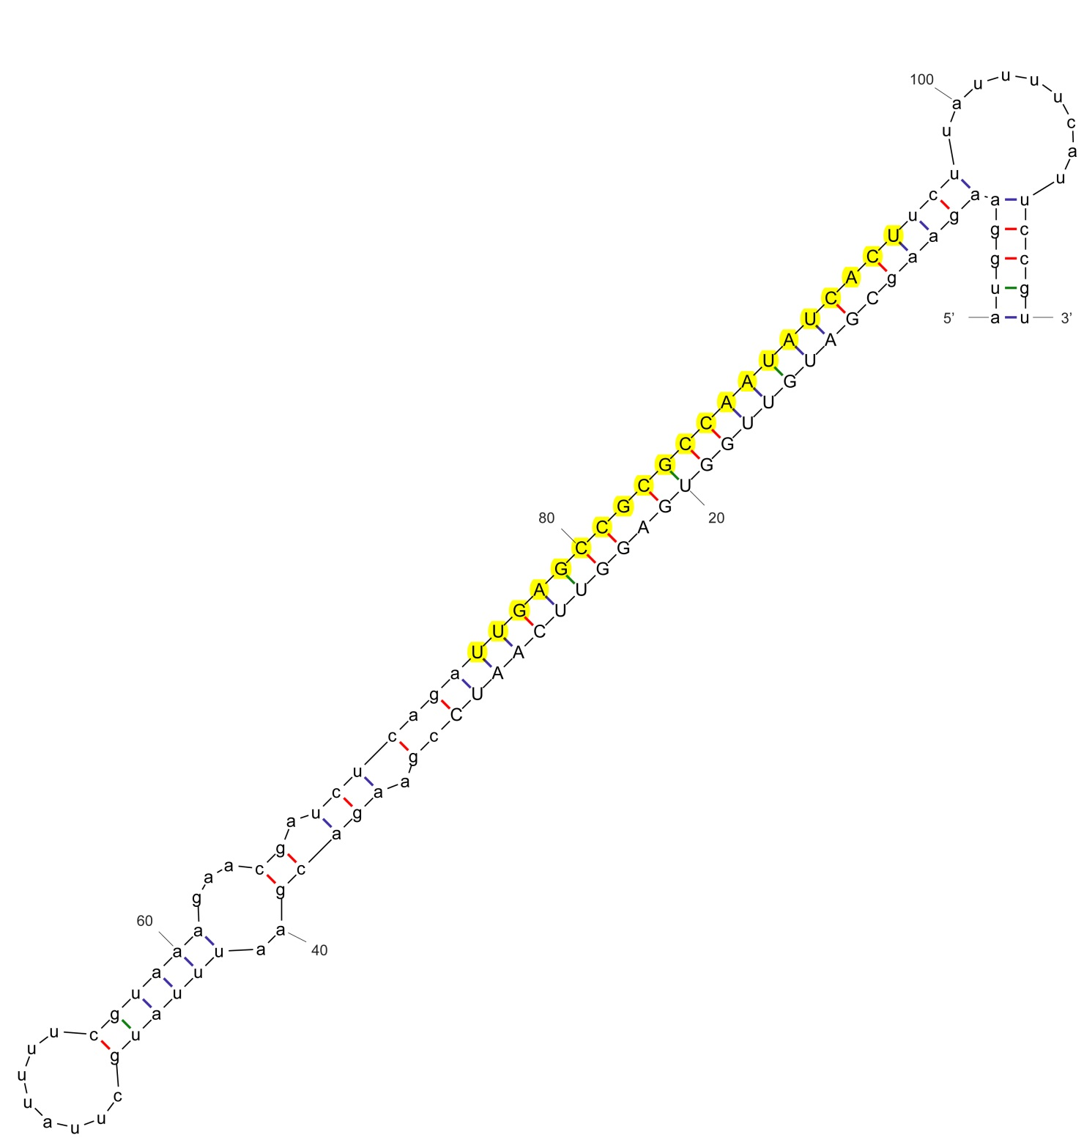

sha-miR171d

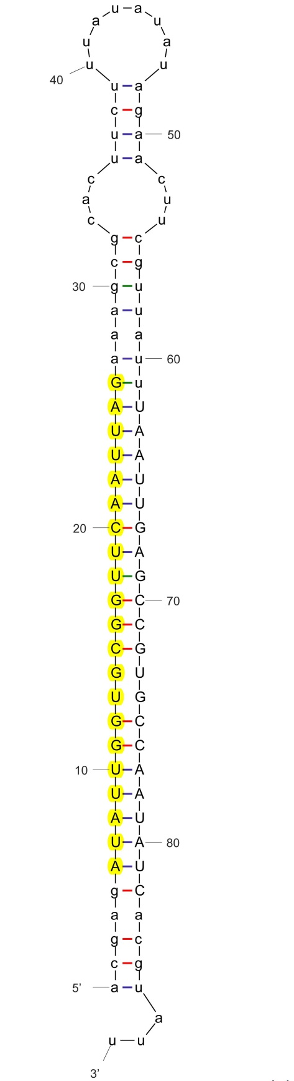

sha-miR171d-5p_stu

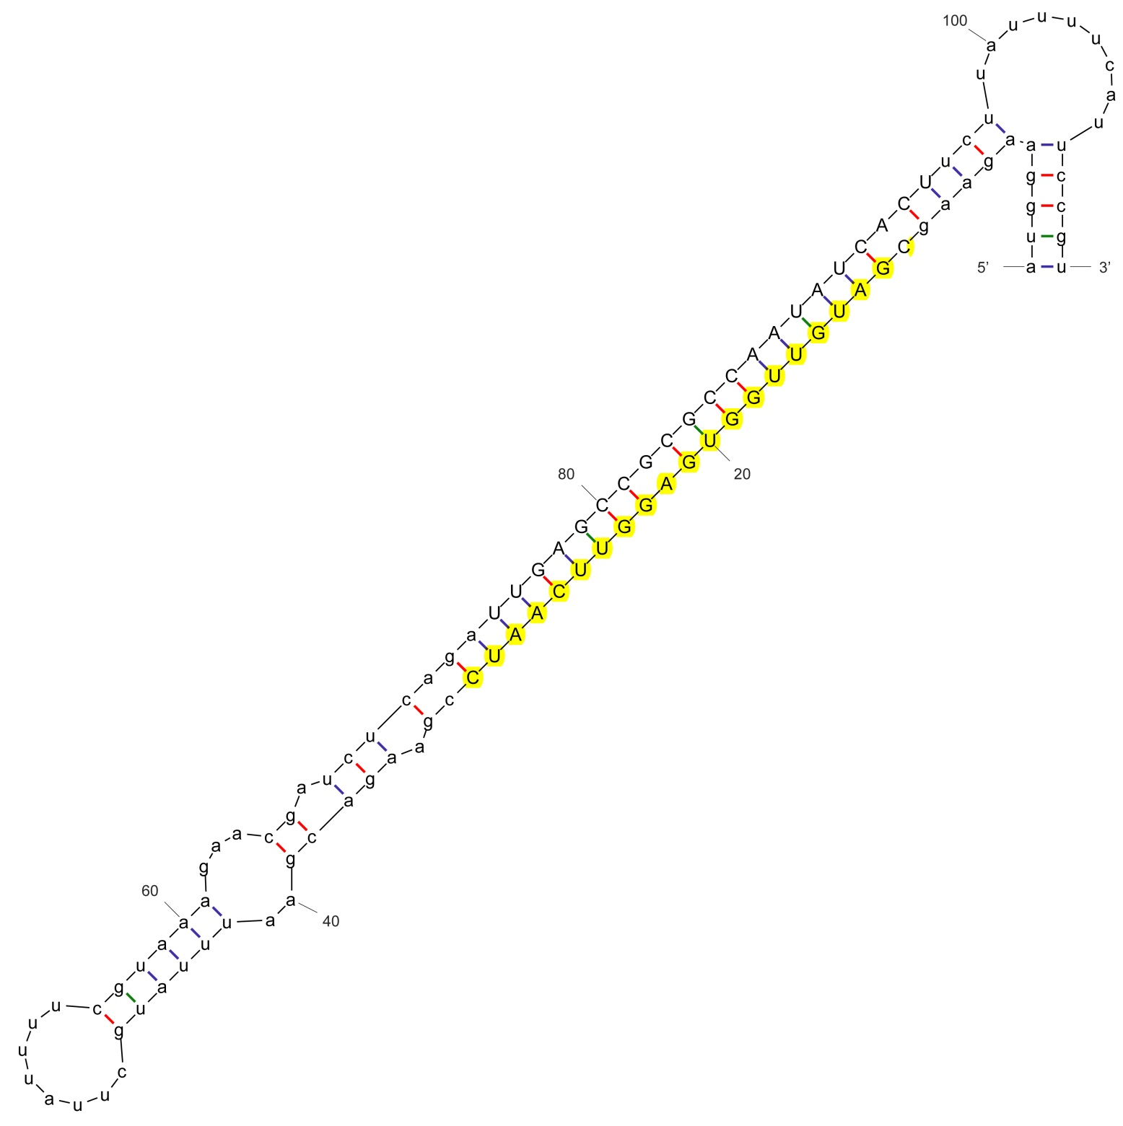

sha-miR171e-5p_mtr

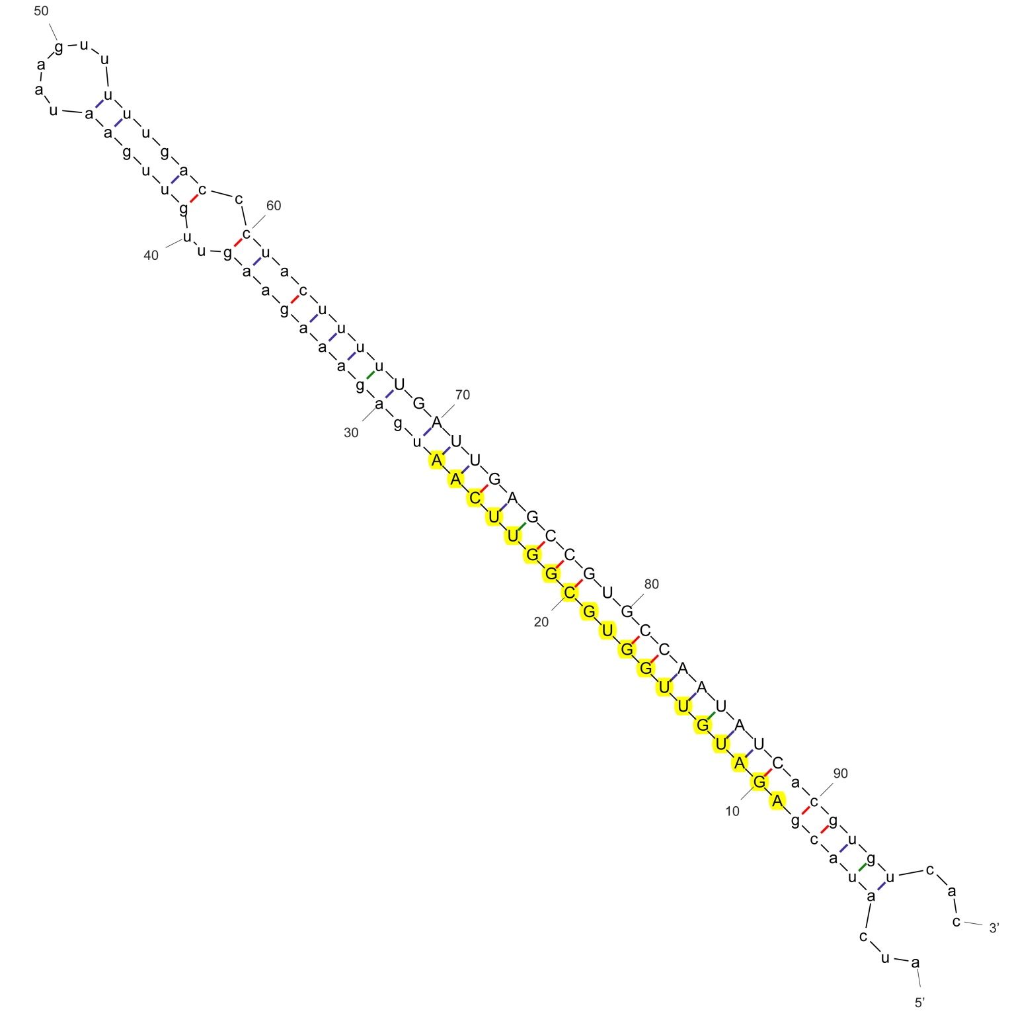

sha-miR171h-p5_vvi

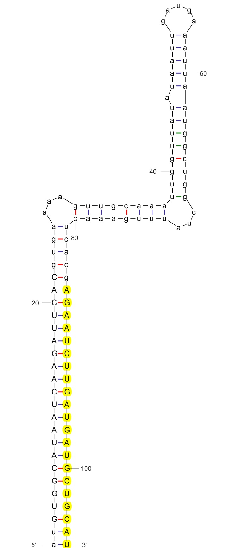

sha-miR172a

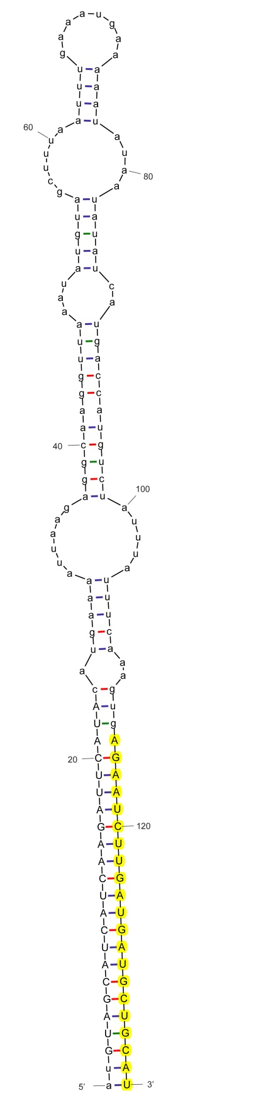

sha-miR172b

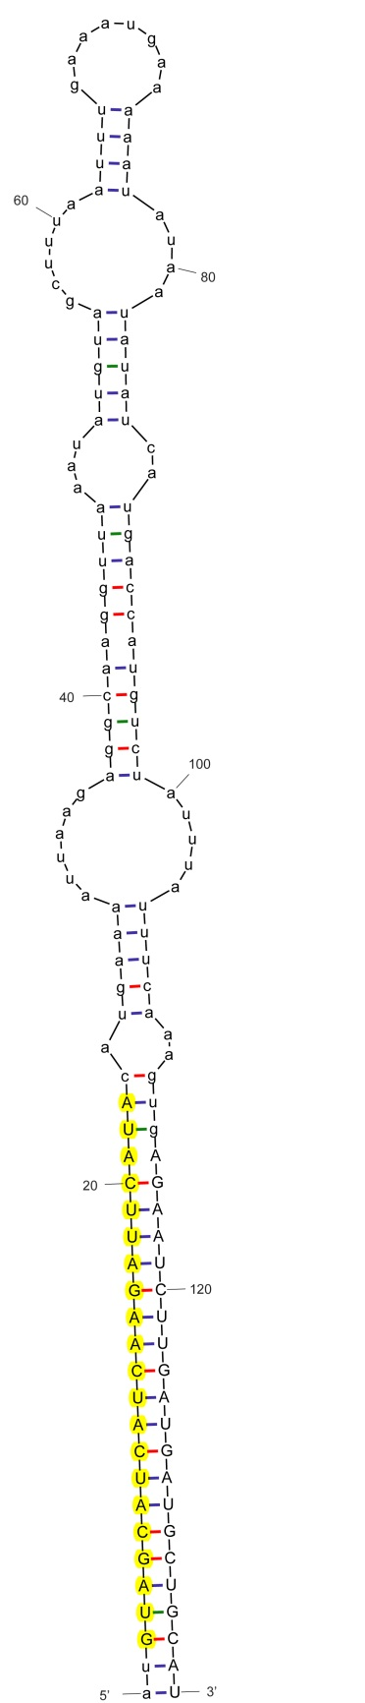

sha-miR172b-p5

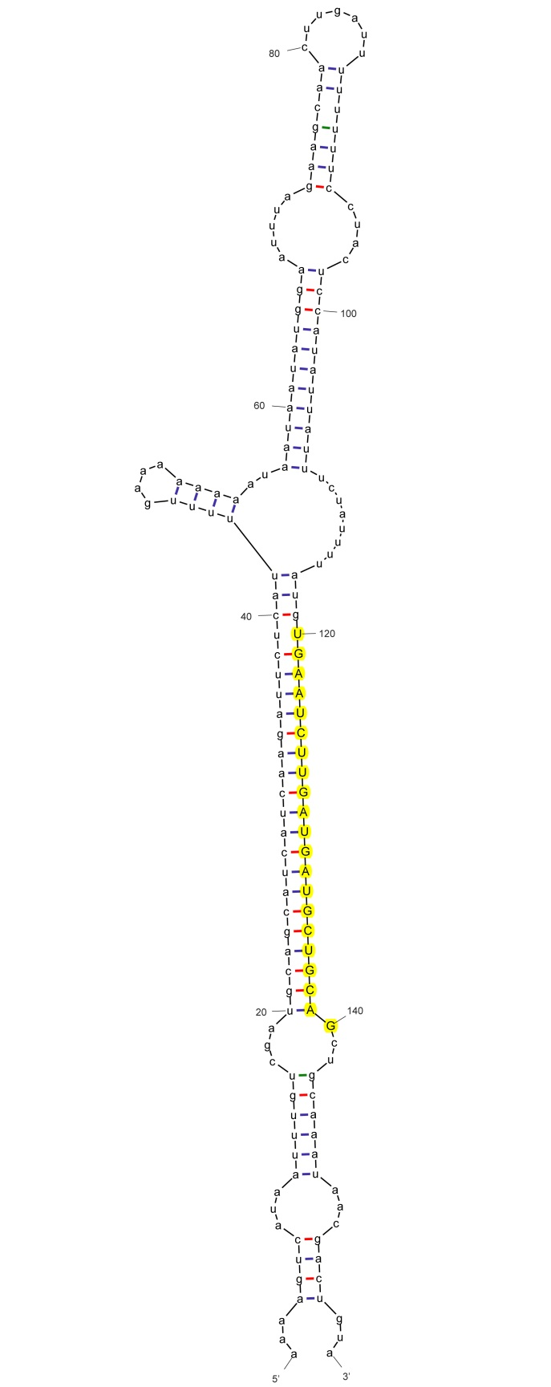

sha-miR172c-3p_aly

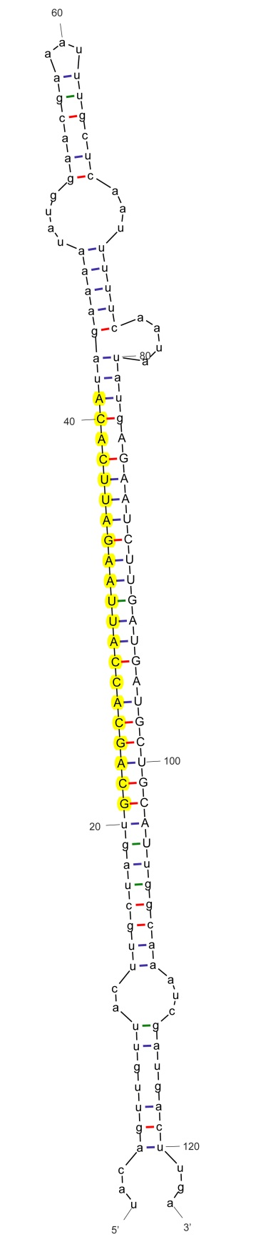

sha-miR172e-5p_aly

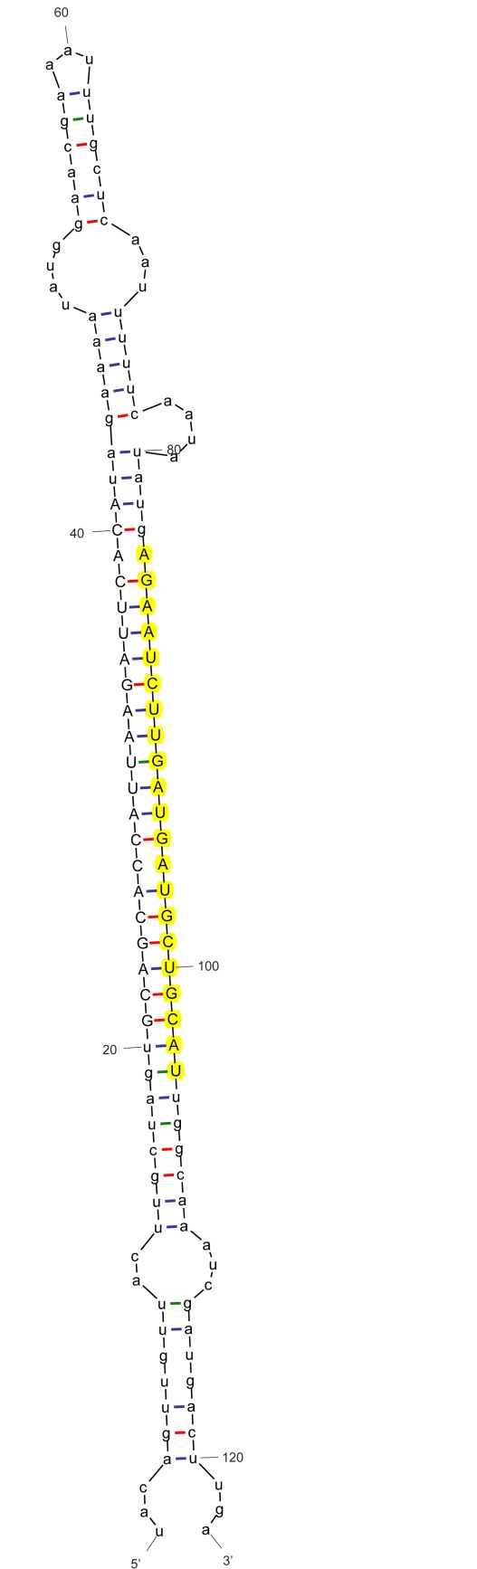

sha-miR172i_nta

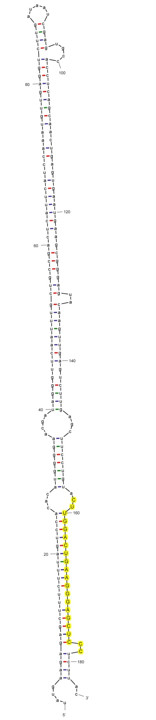

sha-miR319

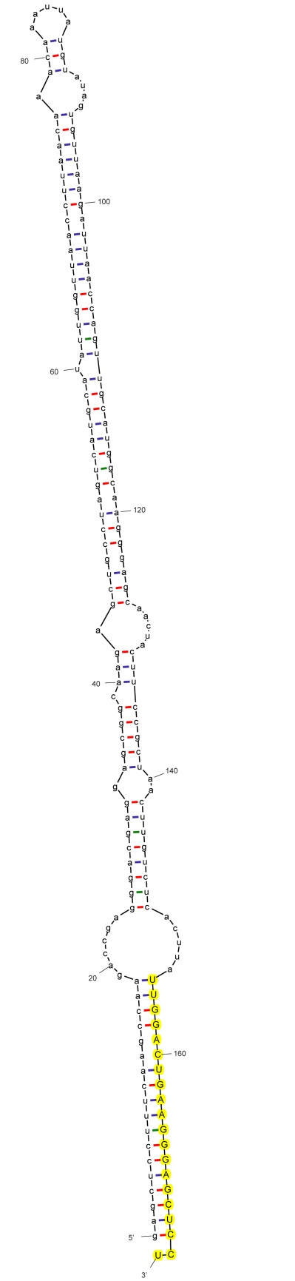

sha-miR319b_stu

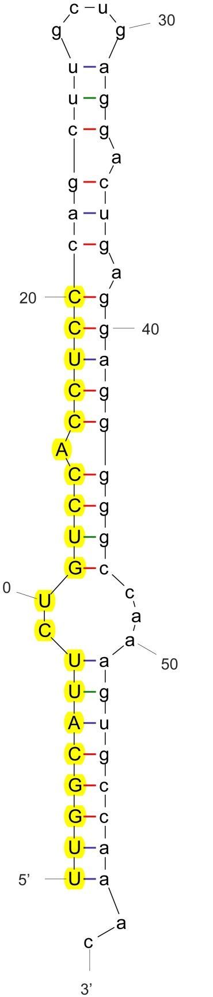

sha-miR384-5p_stu

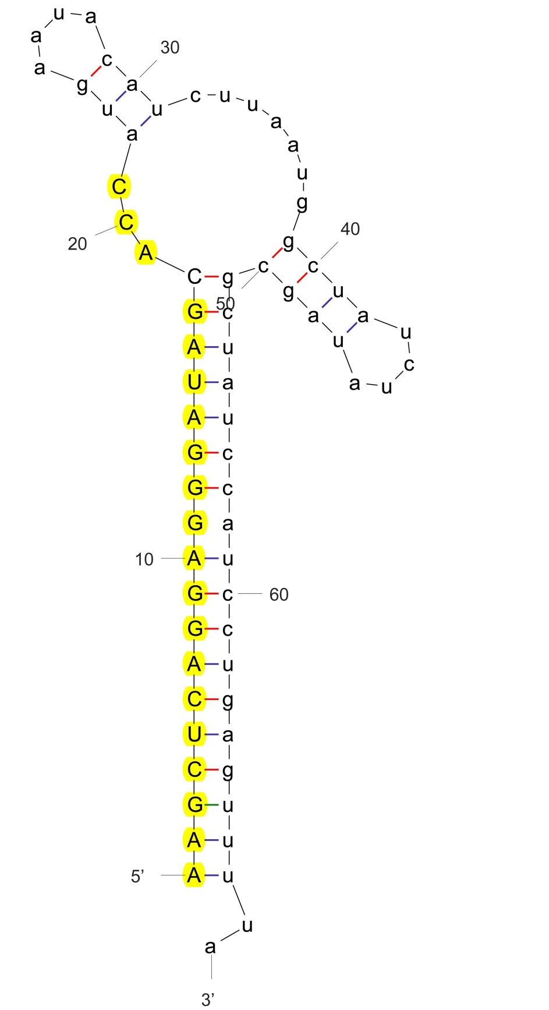

sha-miR390-5p_stus

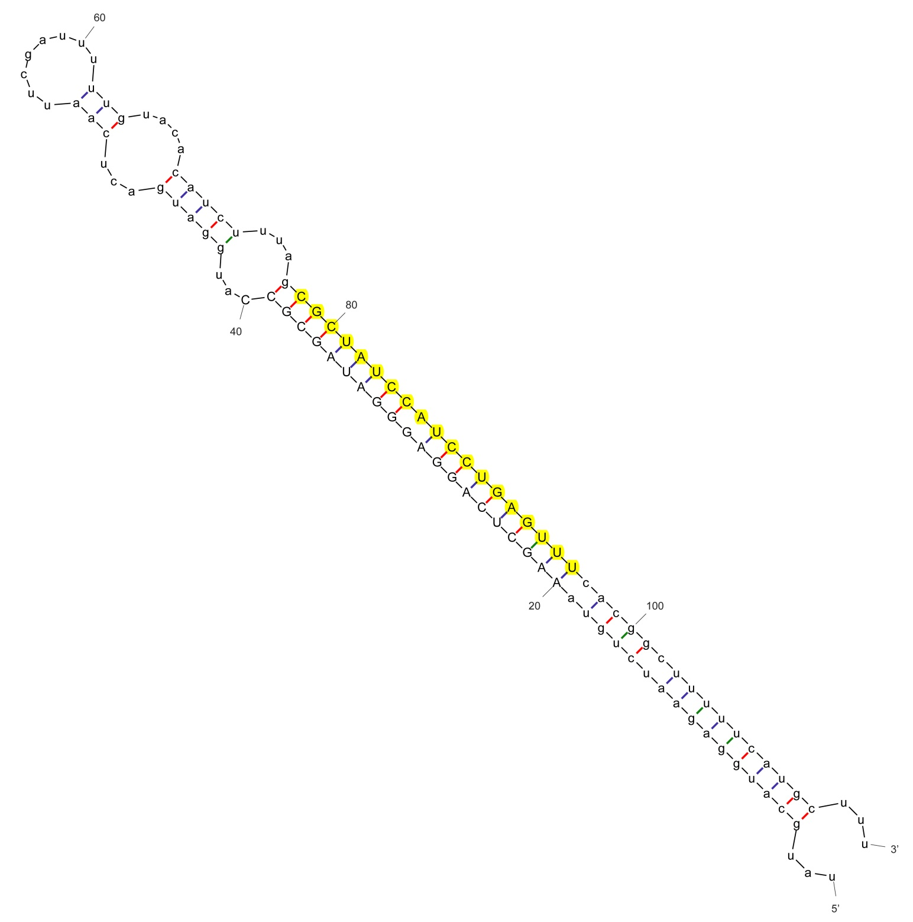

sha-miR390b-3p_aly

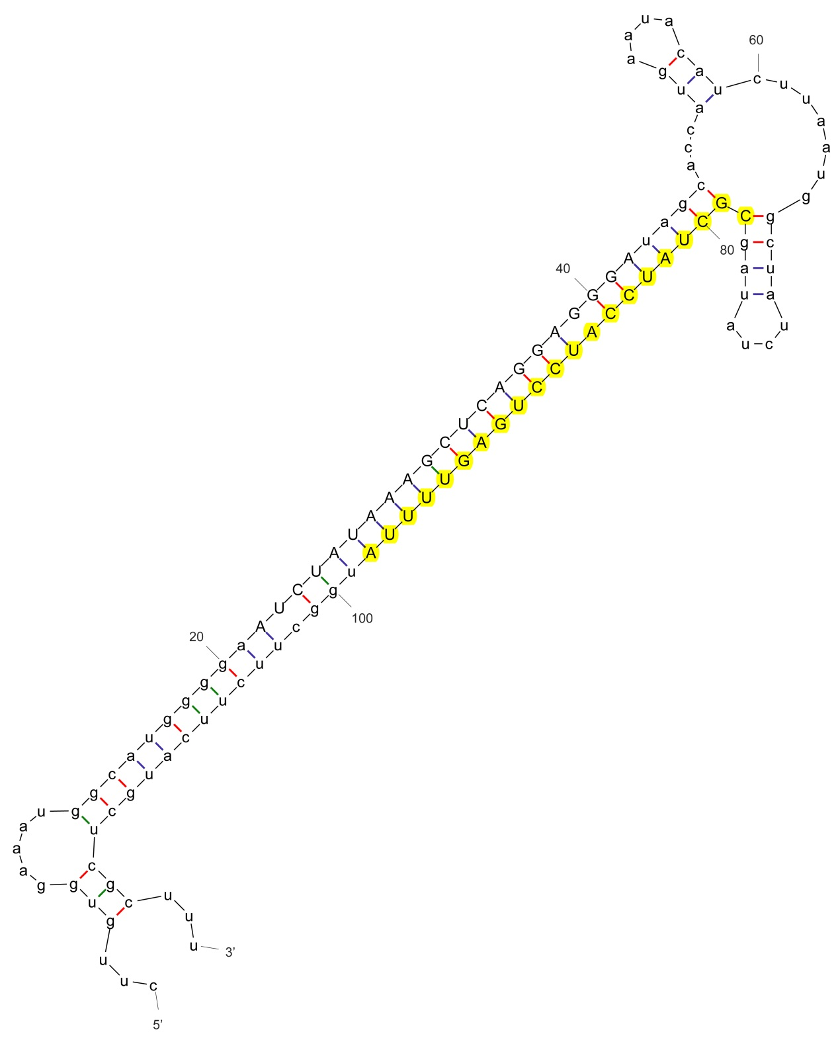

sha-miR390b-3p_aly

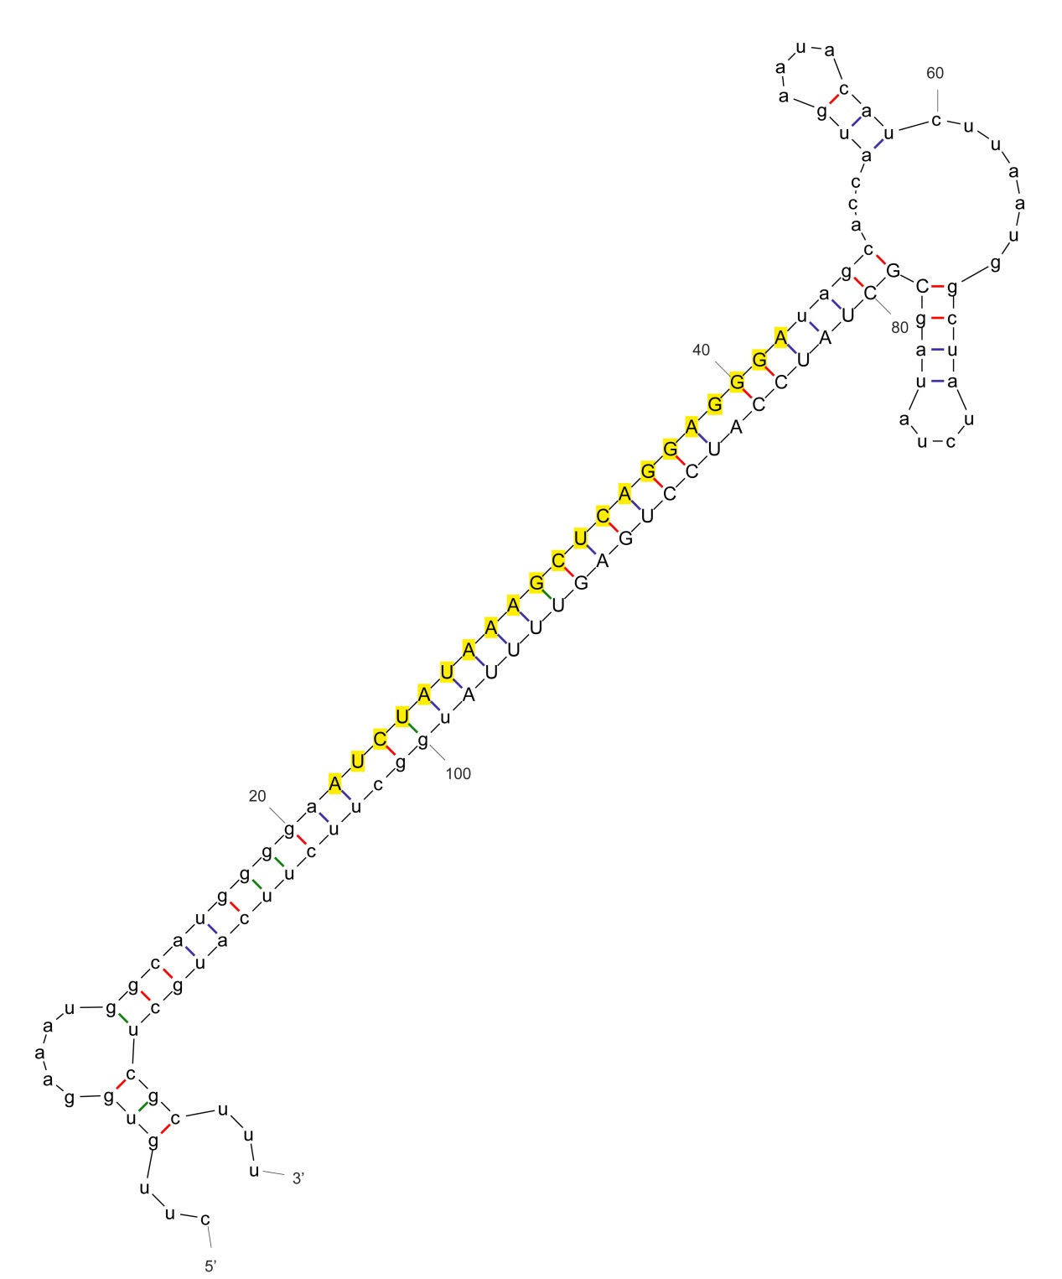

sha-miR390b-p5_nta

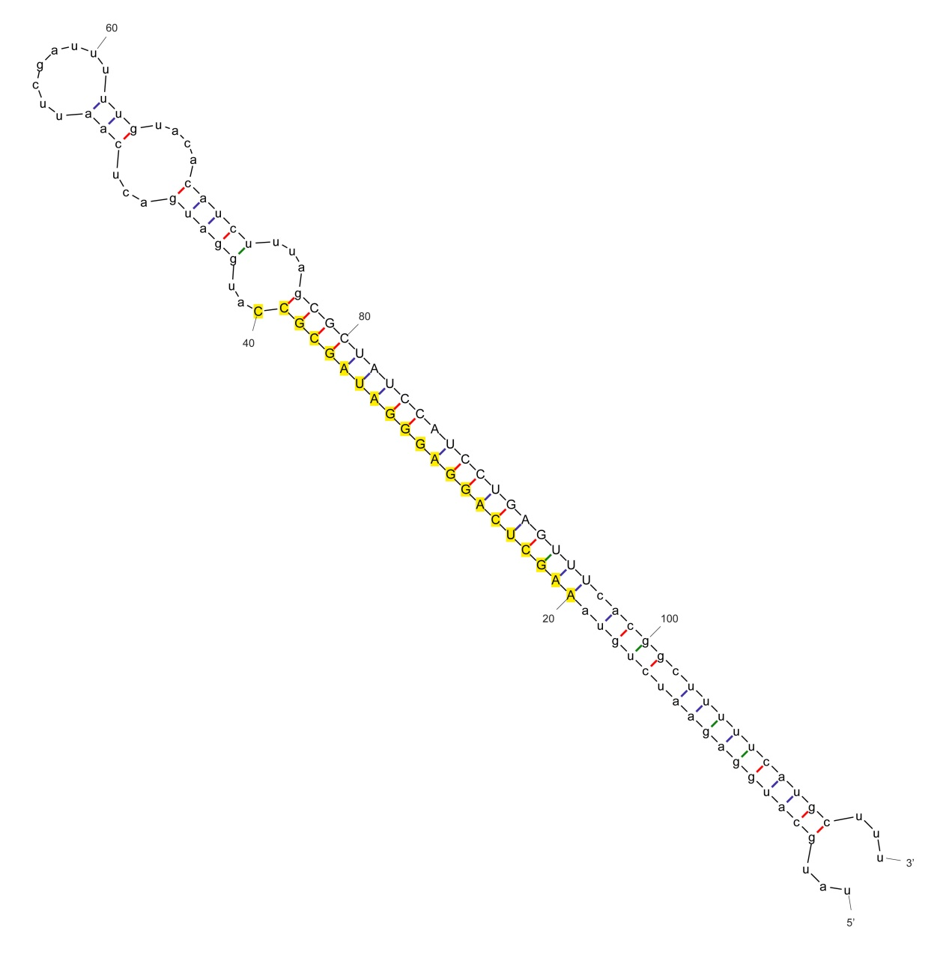
sha-miR390c_nta

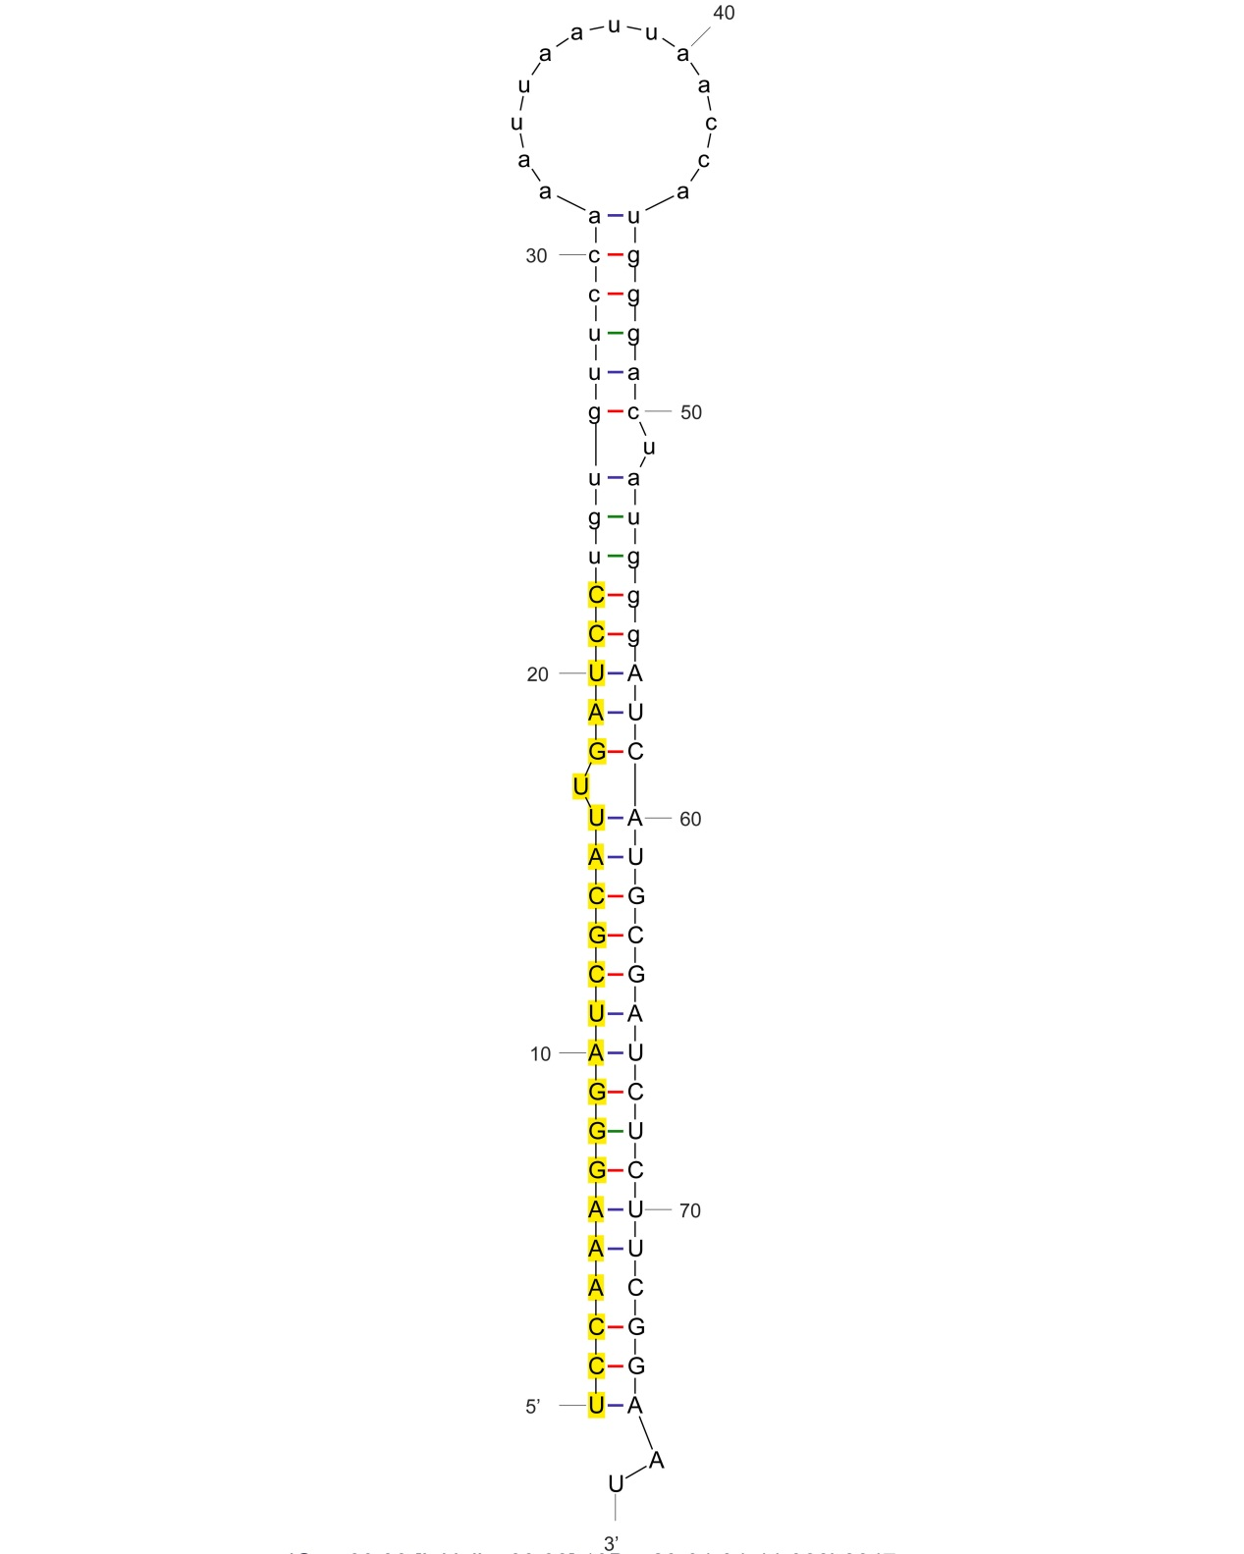
sha-miR393-5p_stu

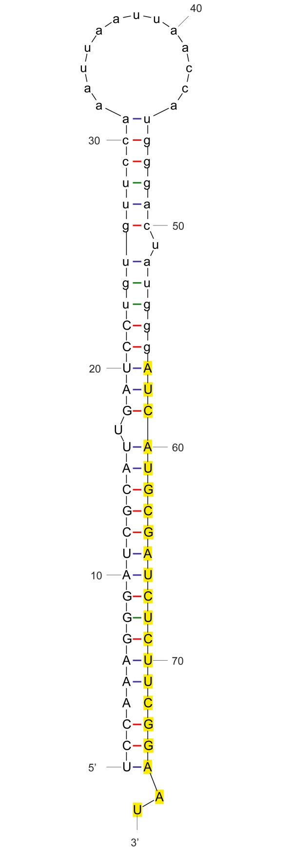

sha-miR393-3p_stu

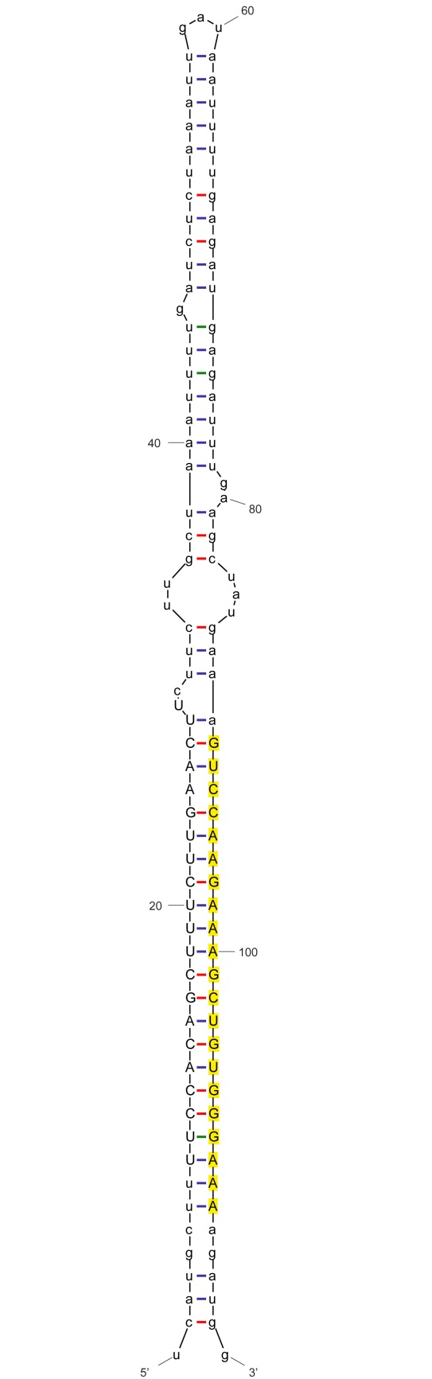

sha-miR396-3p_stu

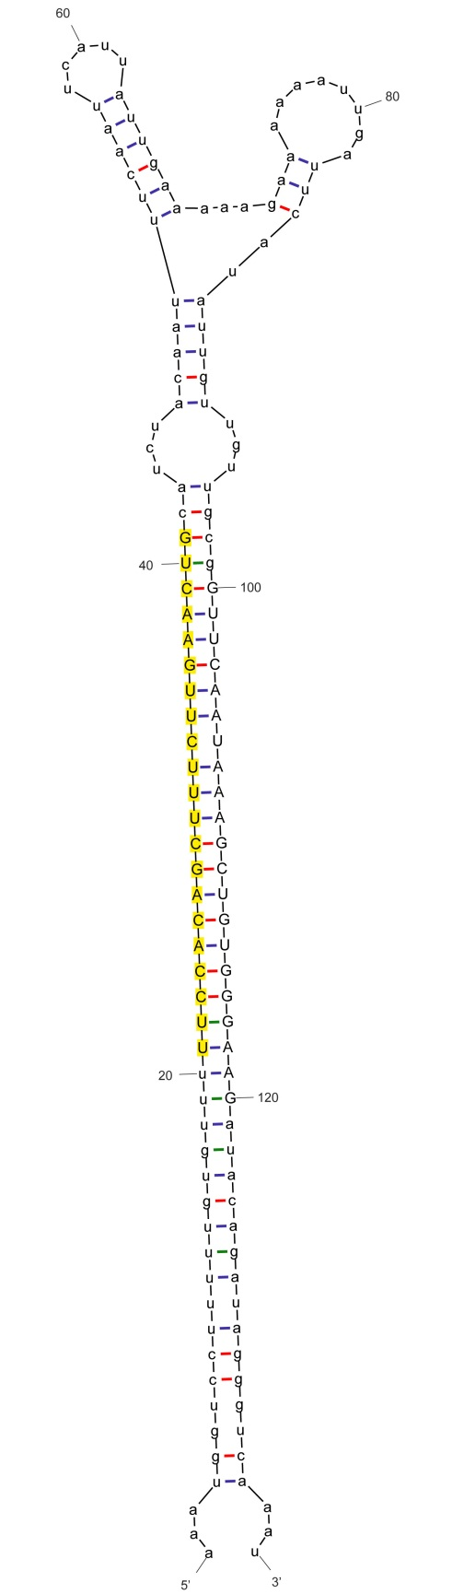

sha-miR396a_nta

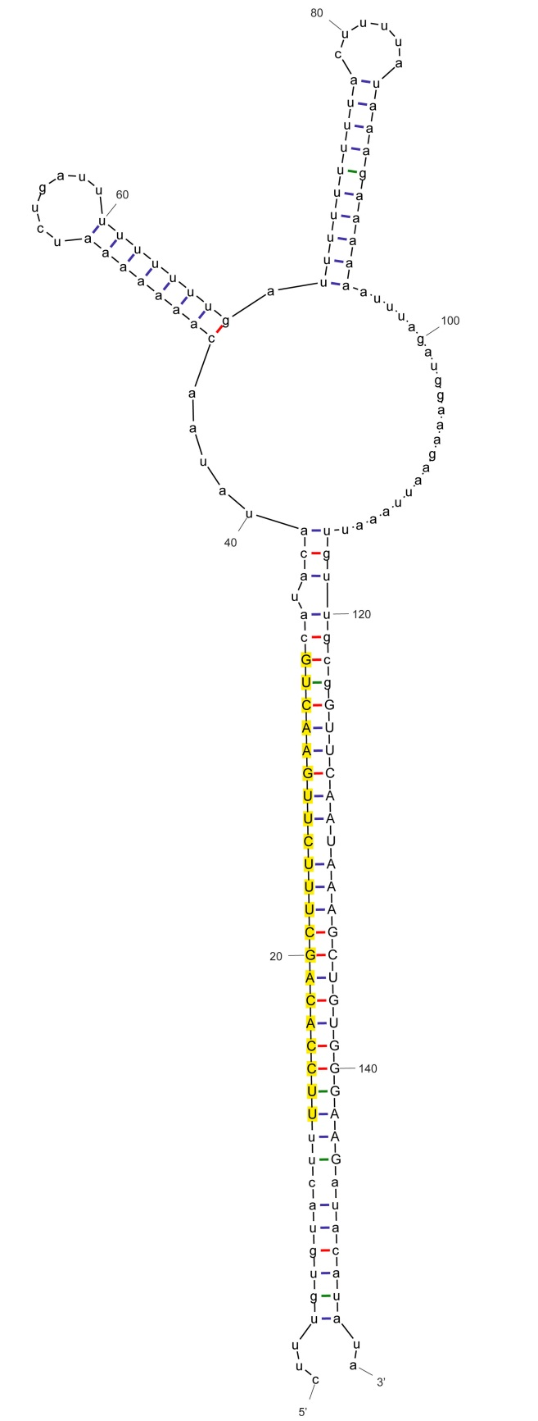

sha-miR396a_nta

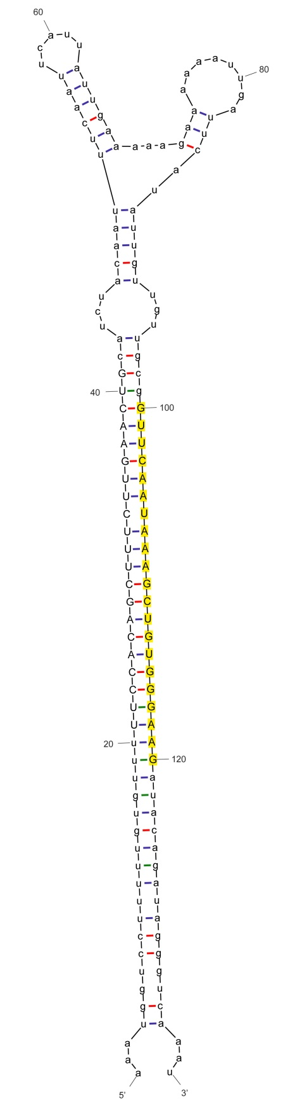

sha-miR396a-3p_aly

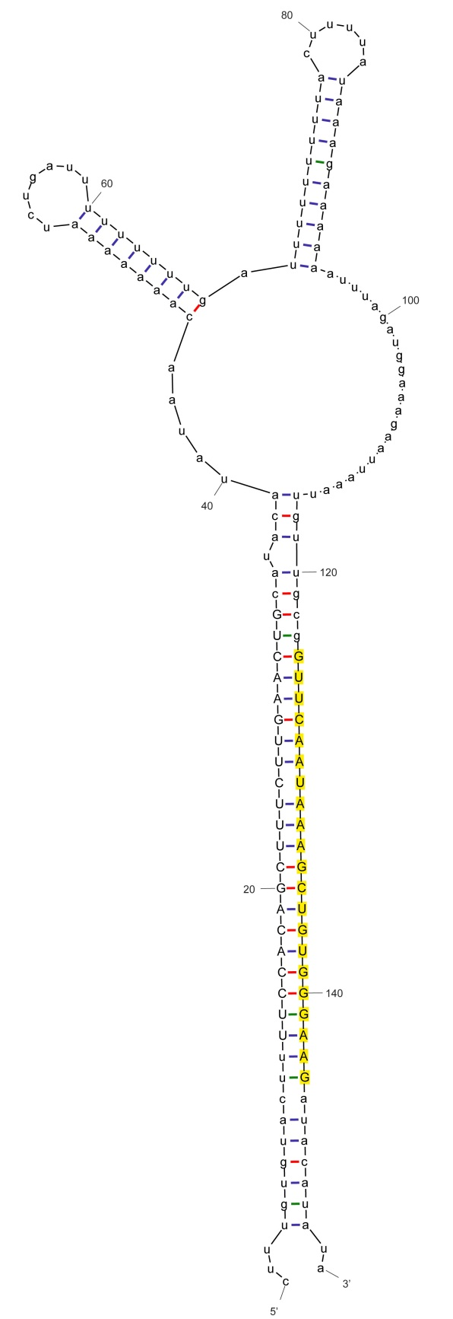

sha-miR396a-3p_aly

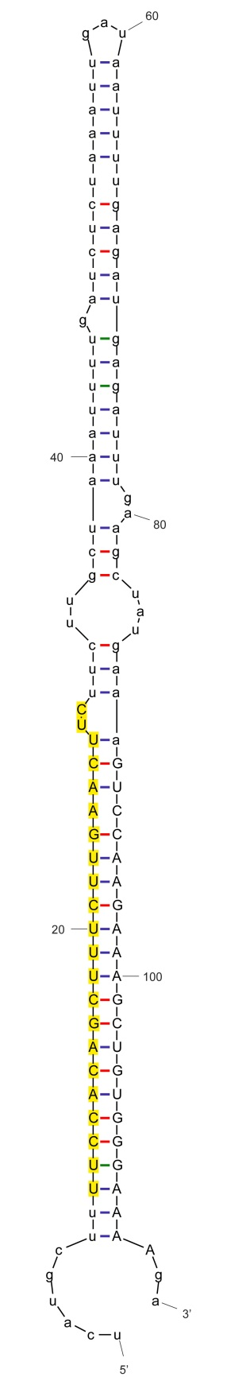

sha-miR396b_nta

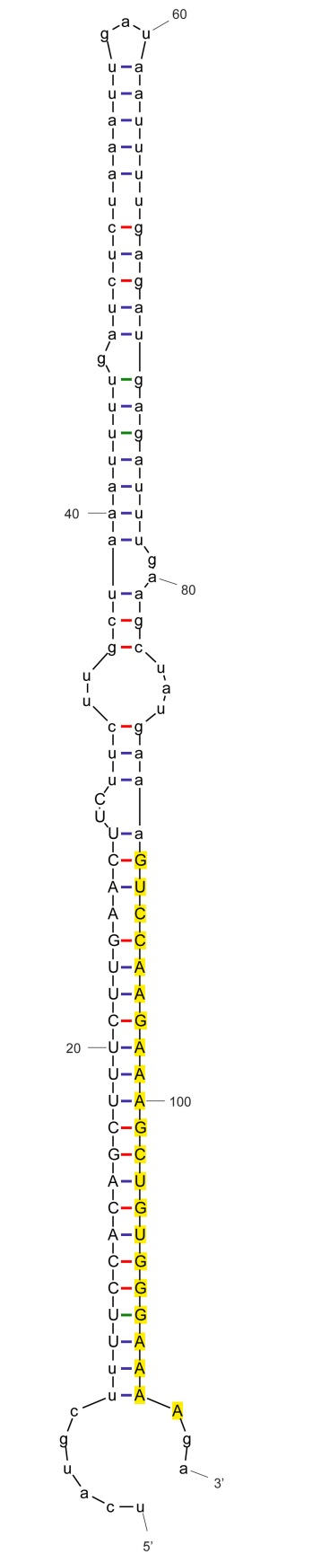

sha-miR396b-3p_aly

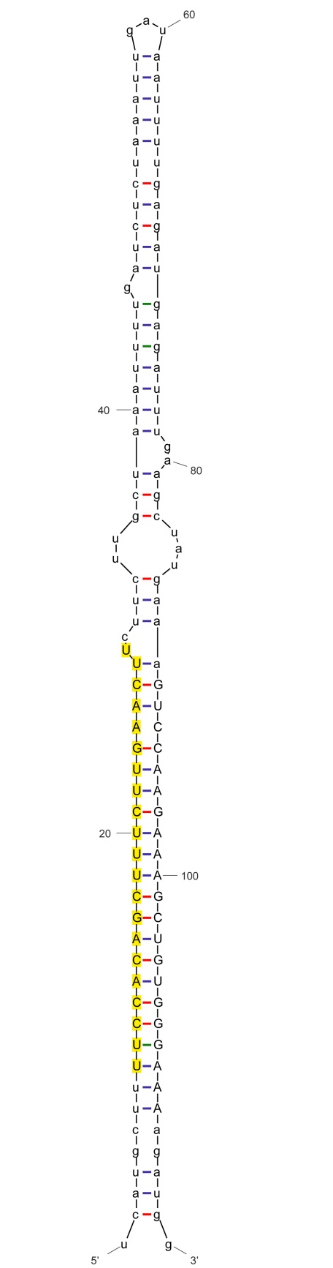

sha-miR396c_nta

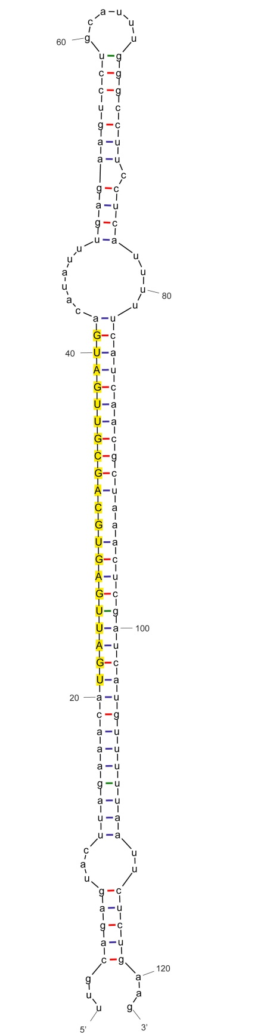

sha-miR397_nta

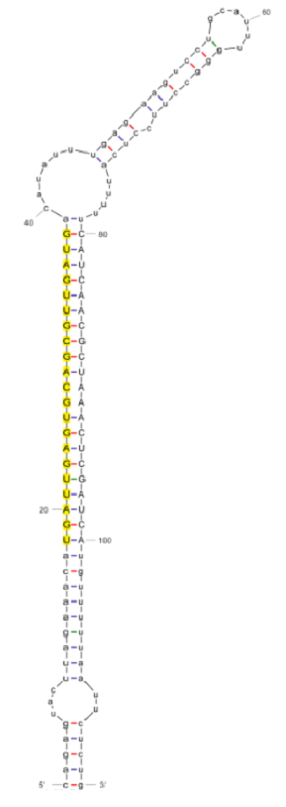

sha-miR397-p5

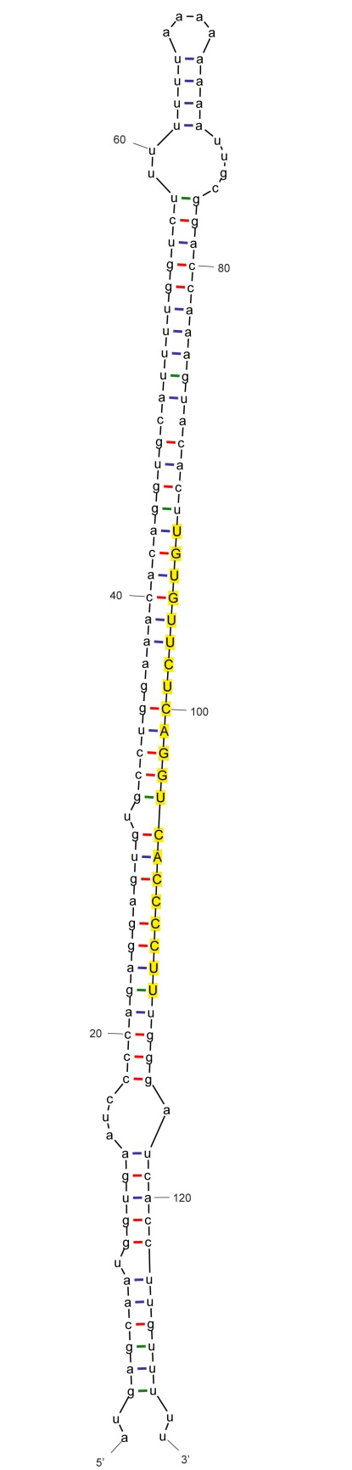

sha-miR398_nta

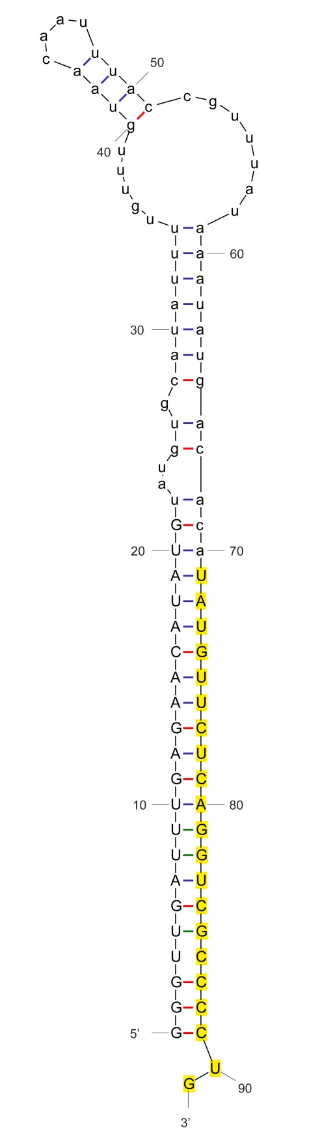

sha-miR398a-3p_stu

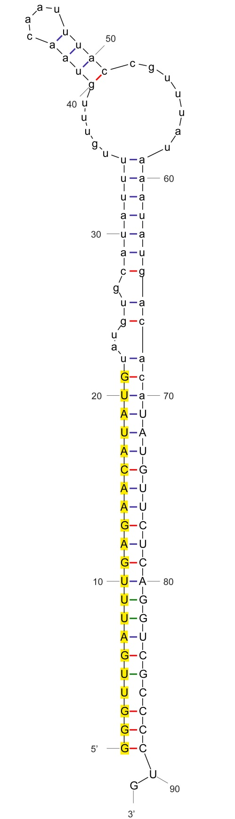

sha-miR398a-5p_stu

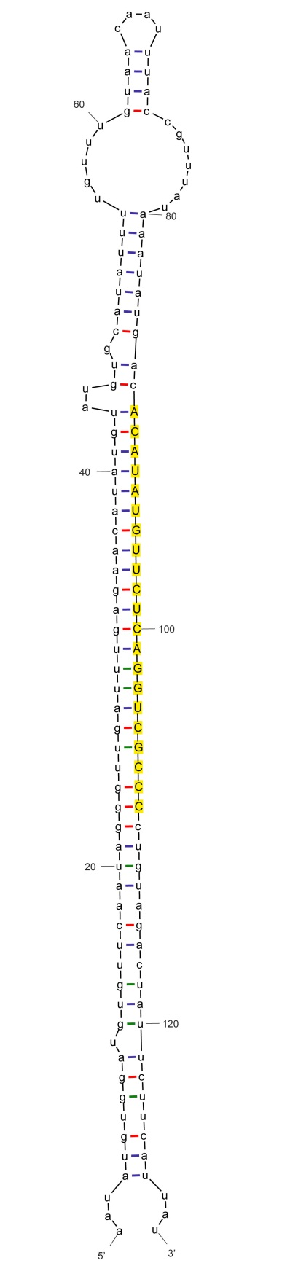

sha-miR398a-p3_cme

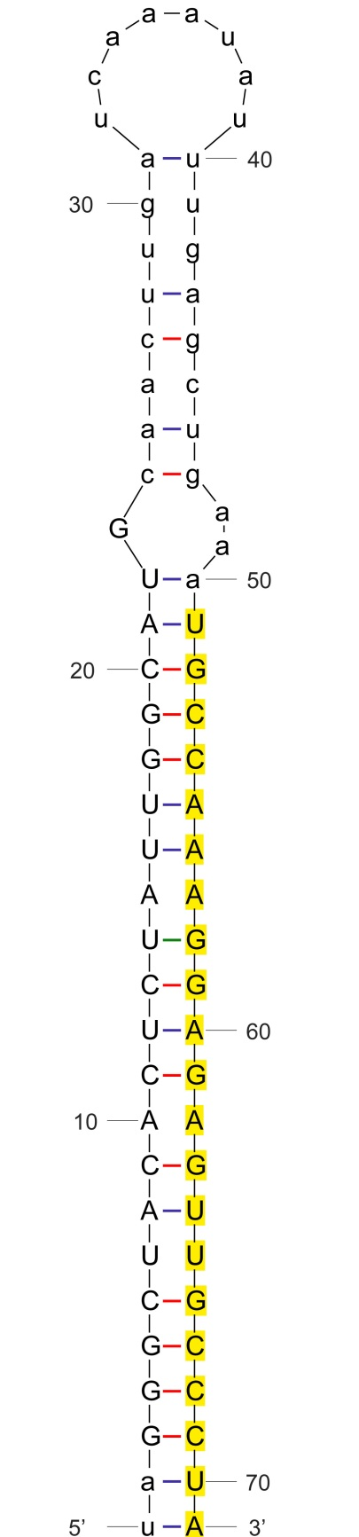

sha-miR399

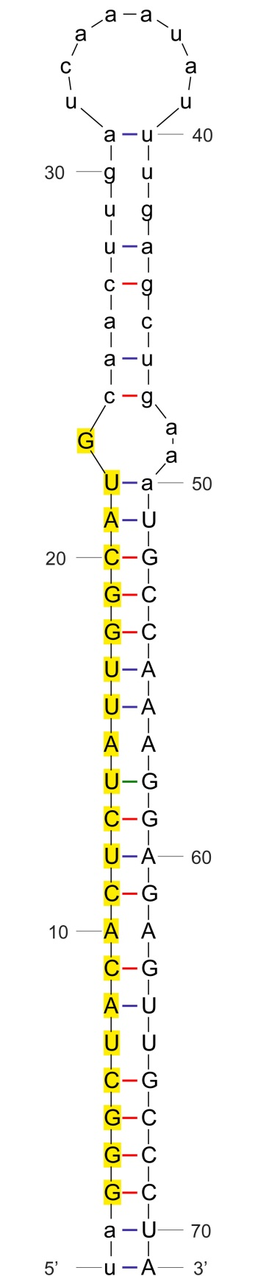

sha-miR399-p5

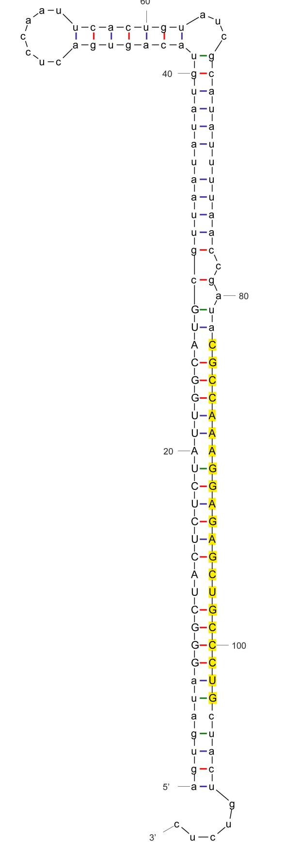

sha-miR399b_nta

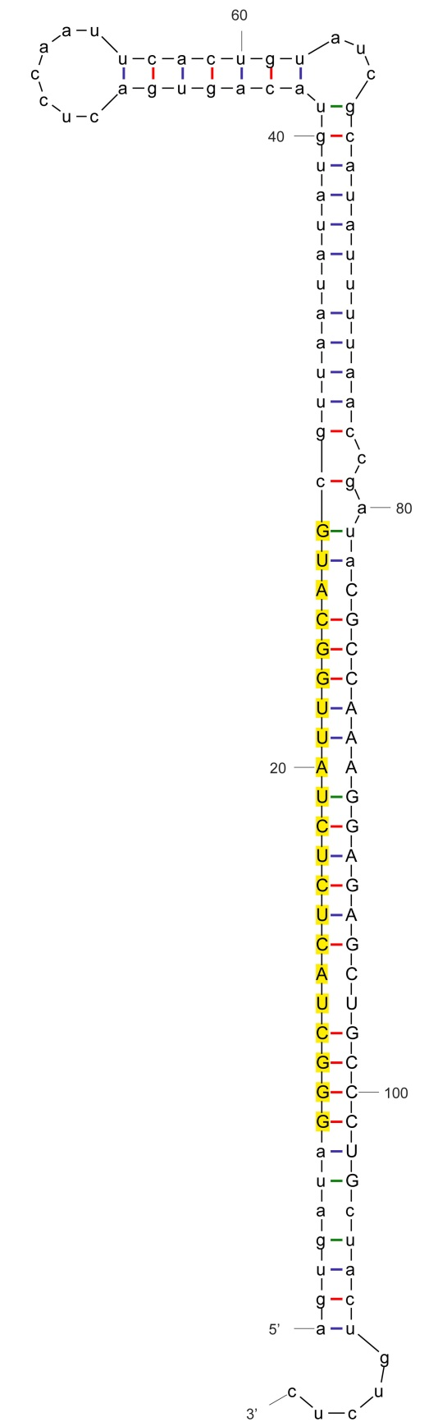

sha-miR399b-p5_nta

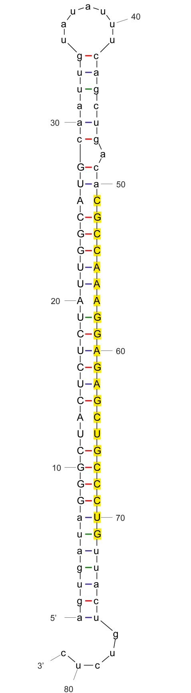

sha-miR399g_nta

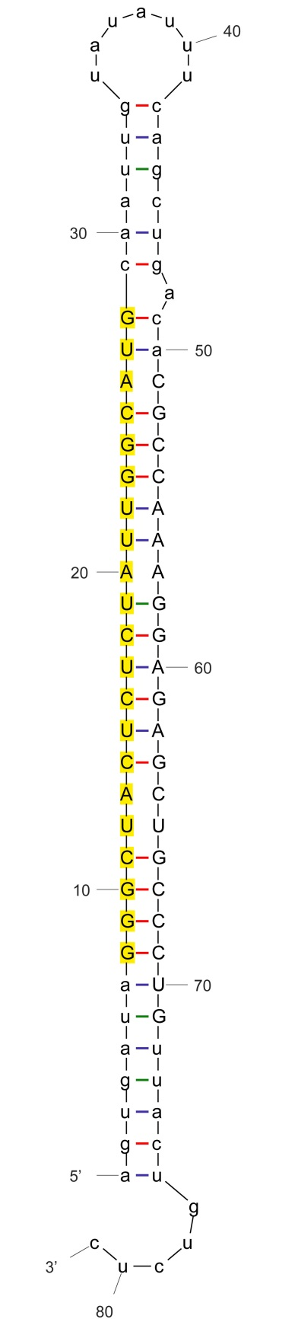

sha-miR399n-5p_stu

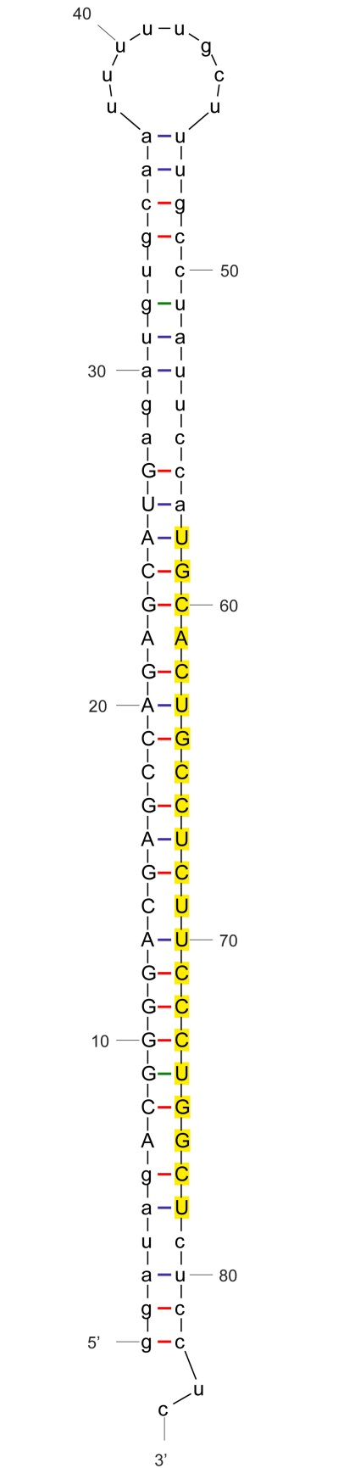

sha-miR408_nta

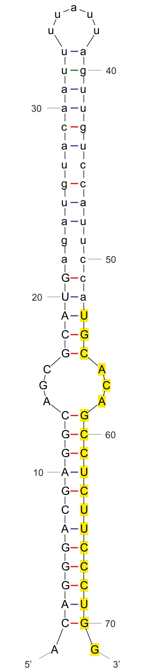

sha-miR408a-3p_stu

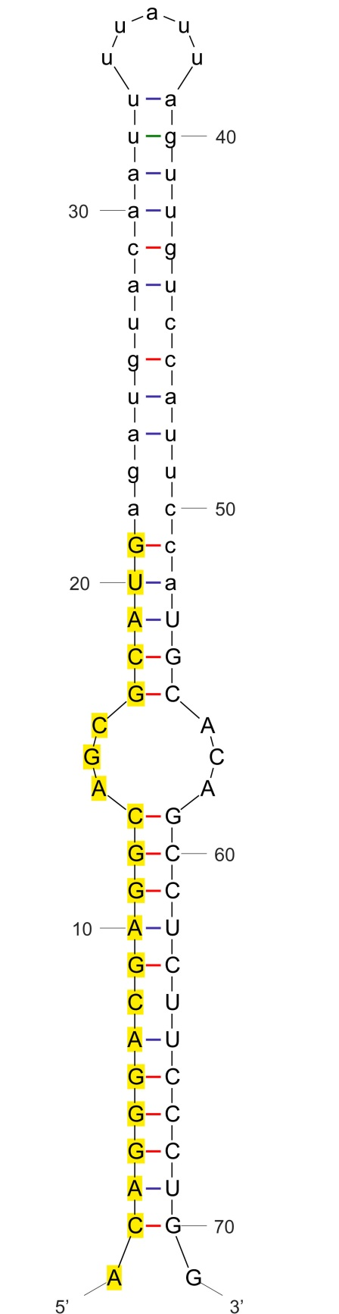

sha-miR408a-5p_stu

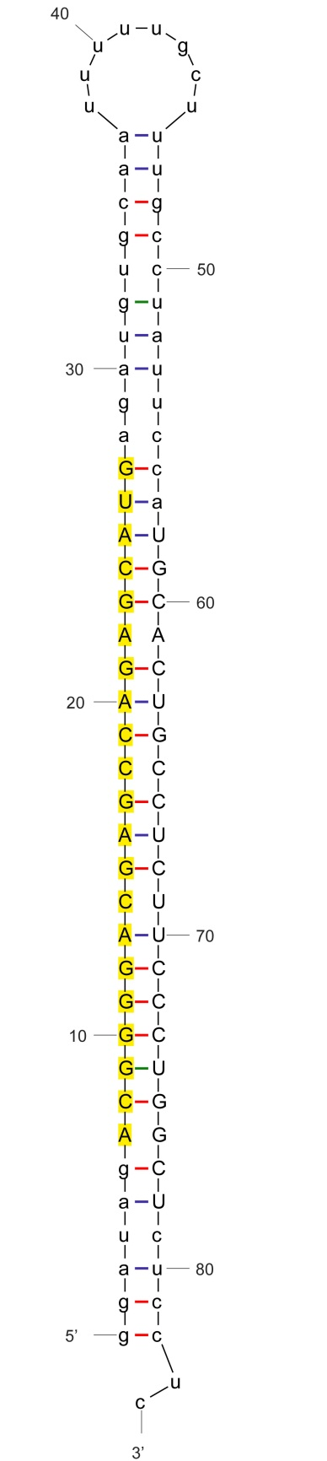

sha-miR408b-5p_stu

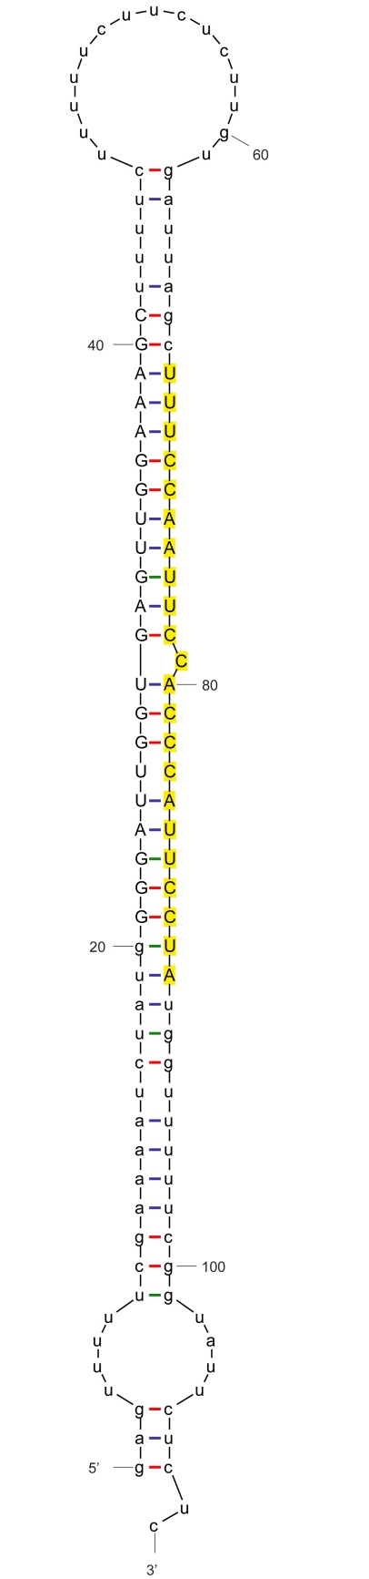

sha-miR482a

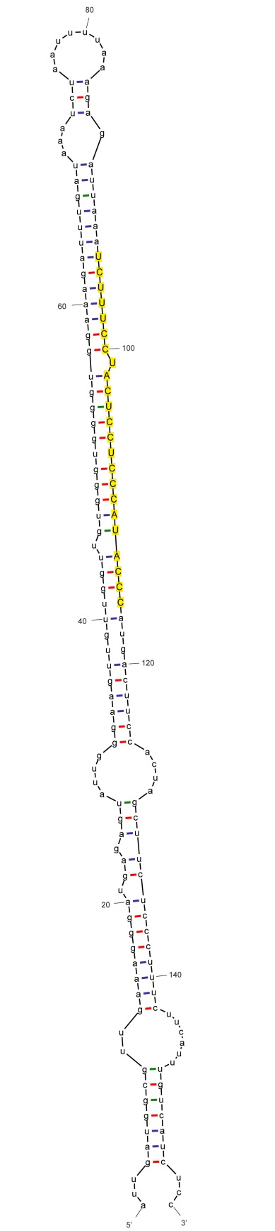

sha-miR482a_ghr

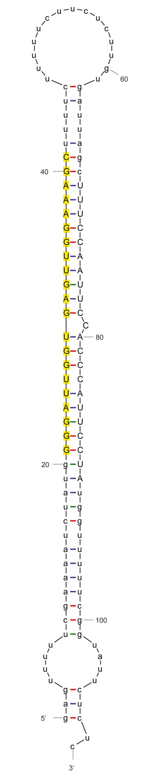

sha-miR482a-5p_stu

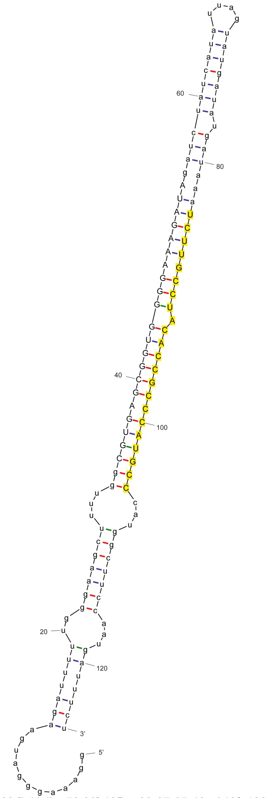

sha-miR482b

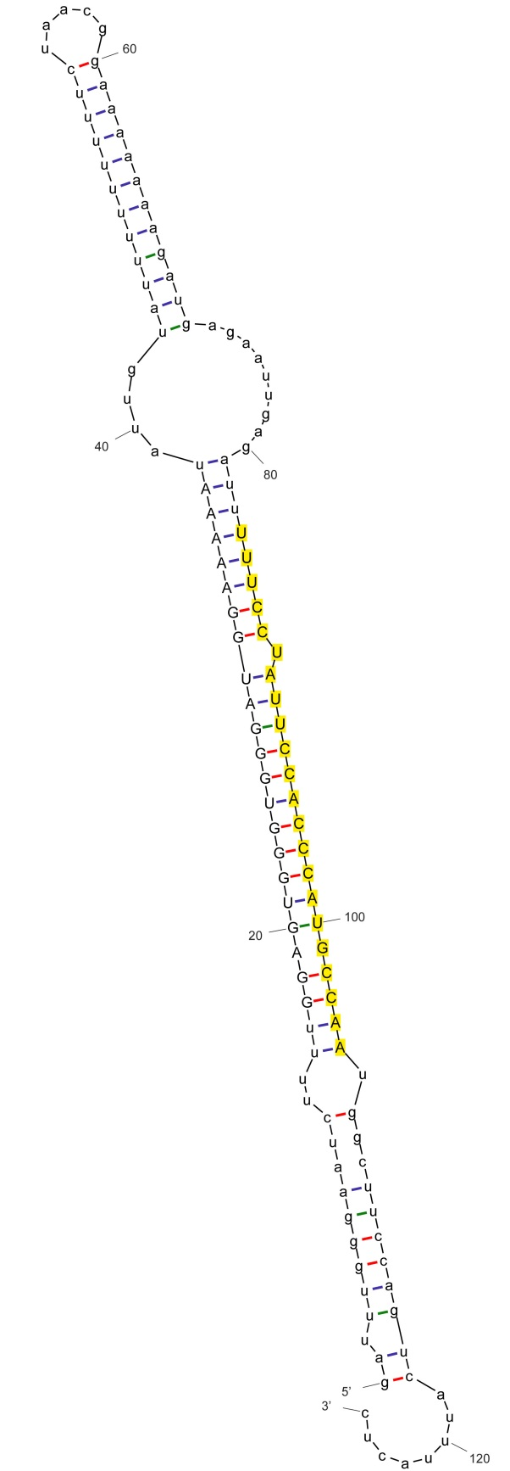

sha-miR482c_stu

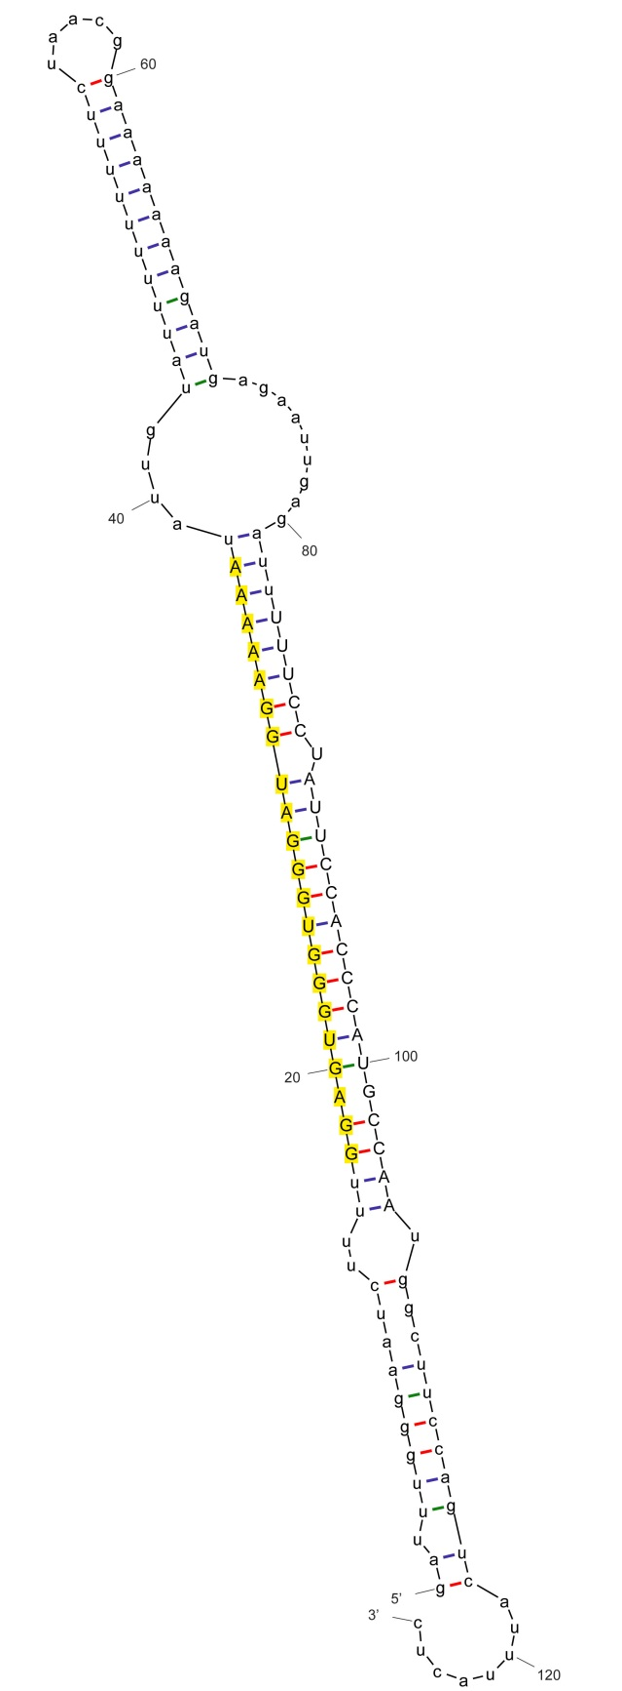

sha-miR482c-p5_stu

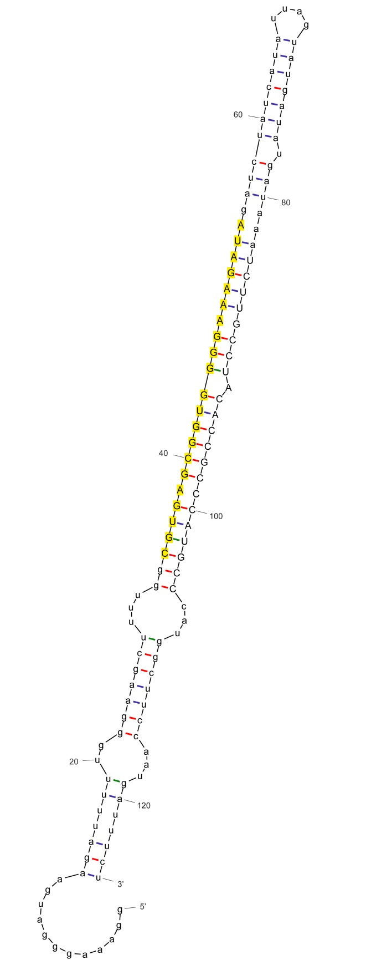

sha-miR482d-5p_stu

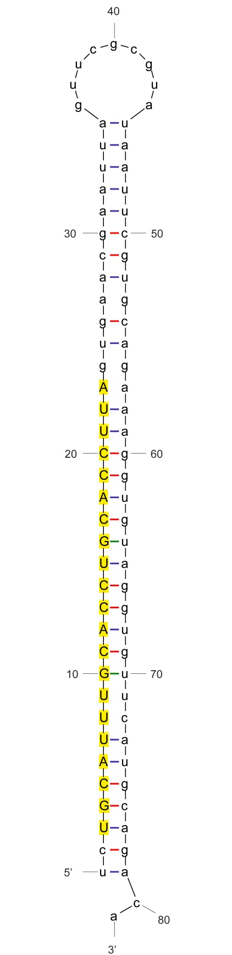

sha-miR530_stu

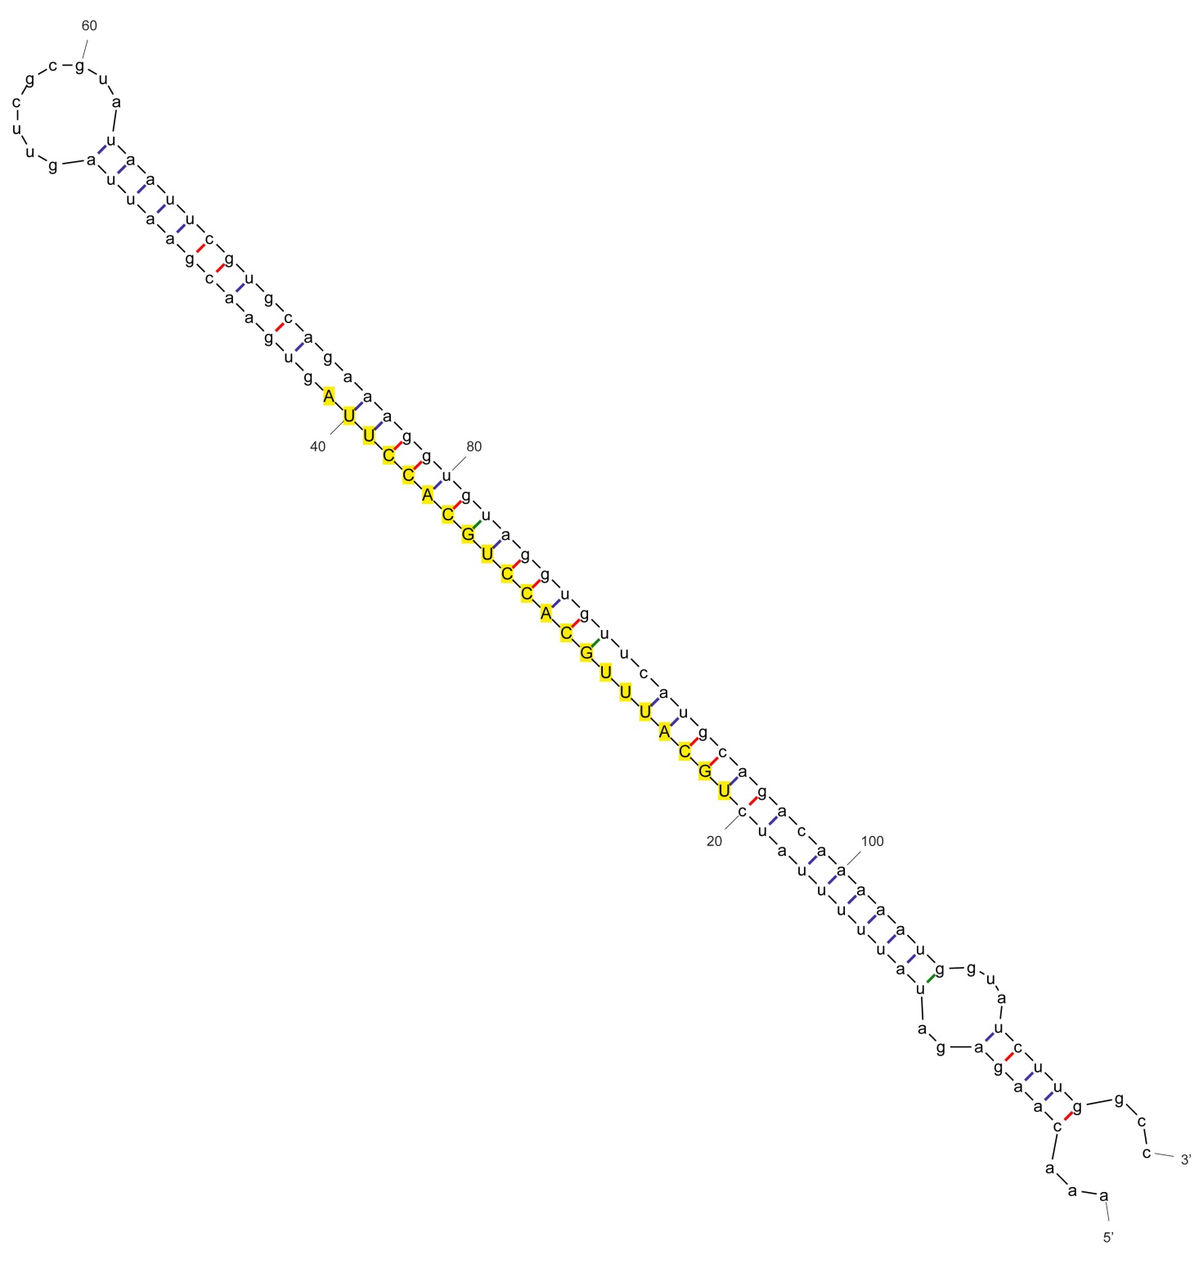

sha-miR530a_cme

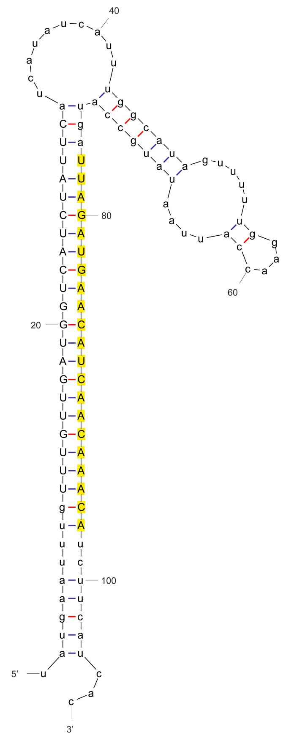

sha-miR827_nta

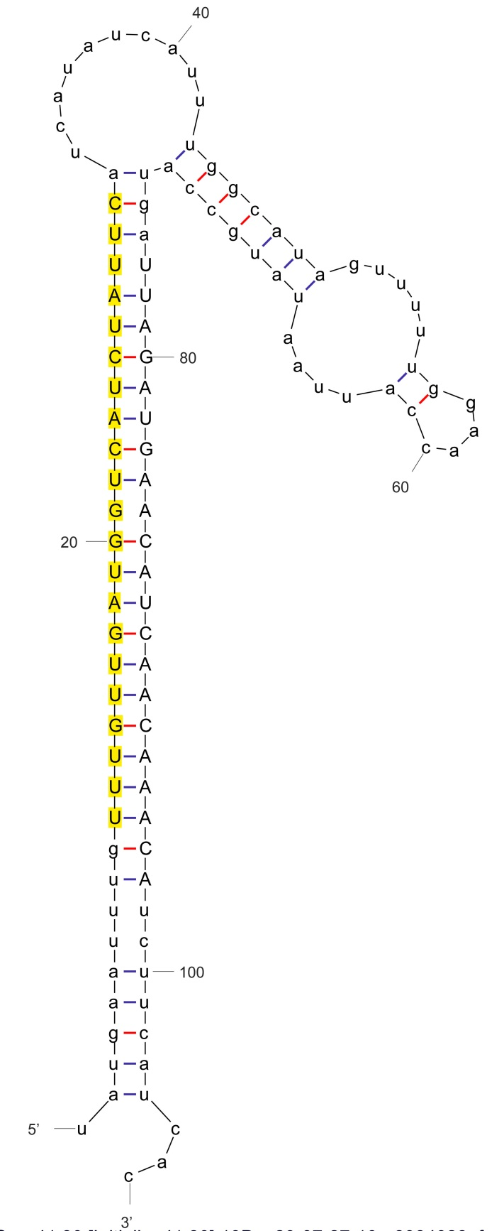

sha-miR827-5p_stu

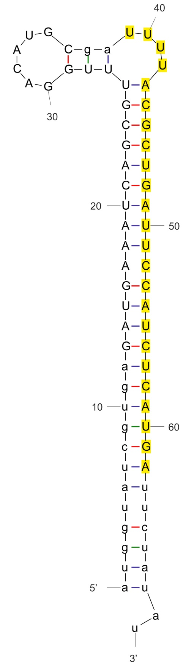

sha-miR1886a-p3_stu

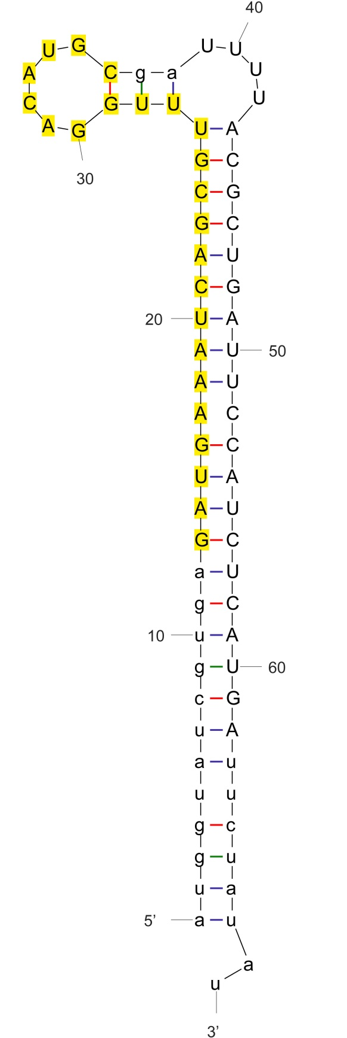

sha-miR1886a-p5_stu

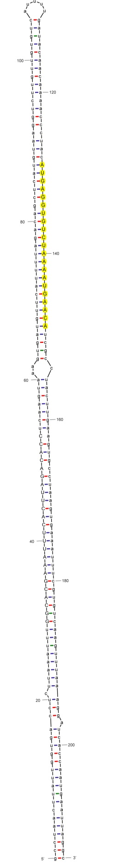

sha-miR1916-p3

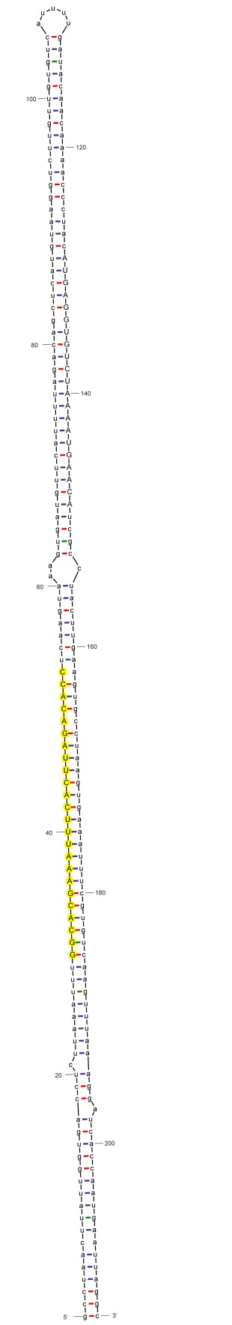

sha-miR1916-p5

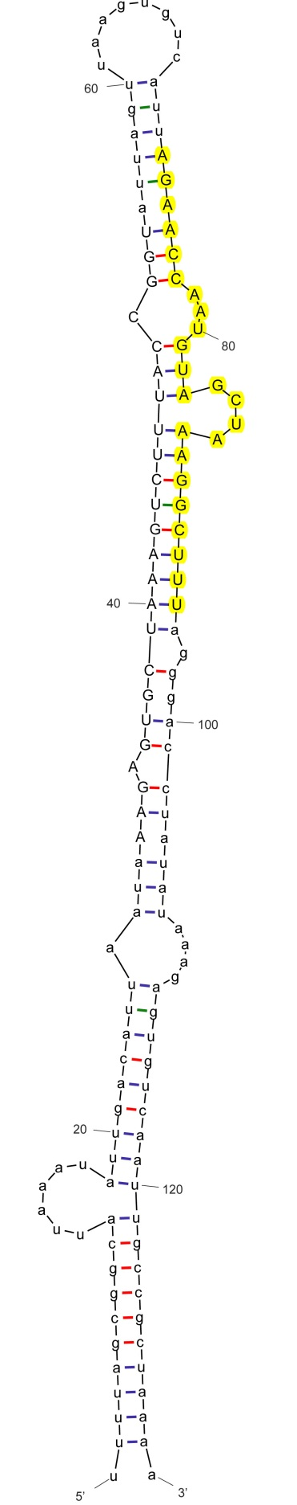

sha-miR1917-p3

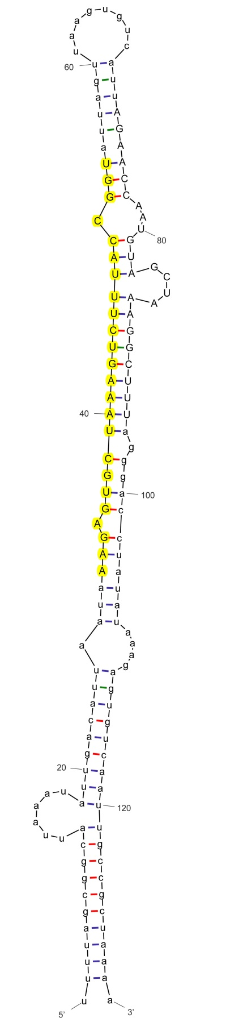

sha-miR1917-p5

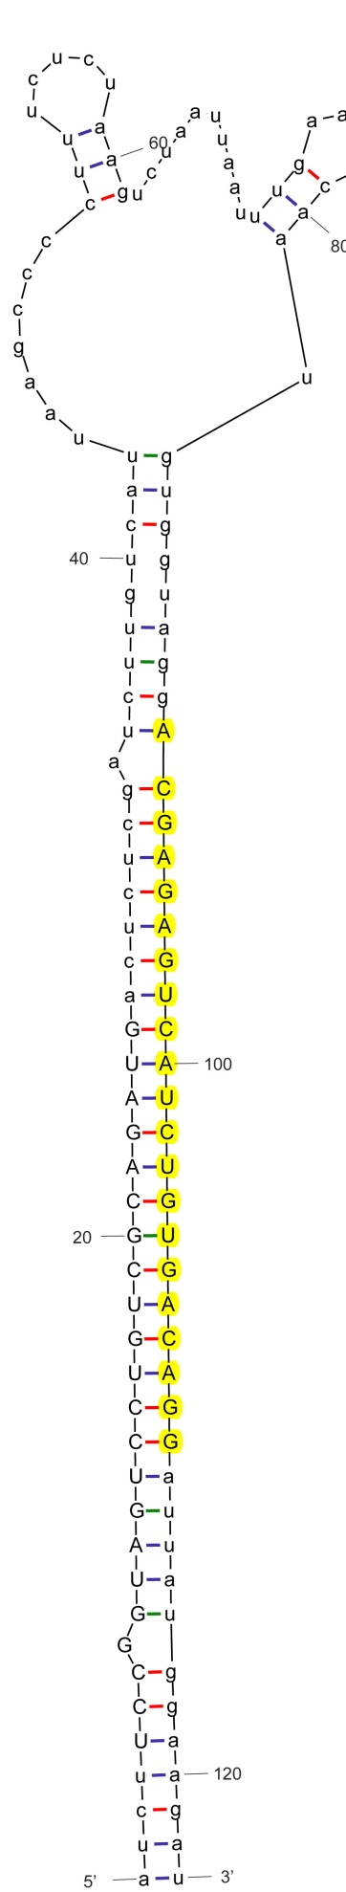

sha-miR1919a

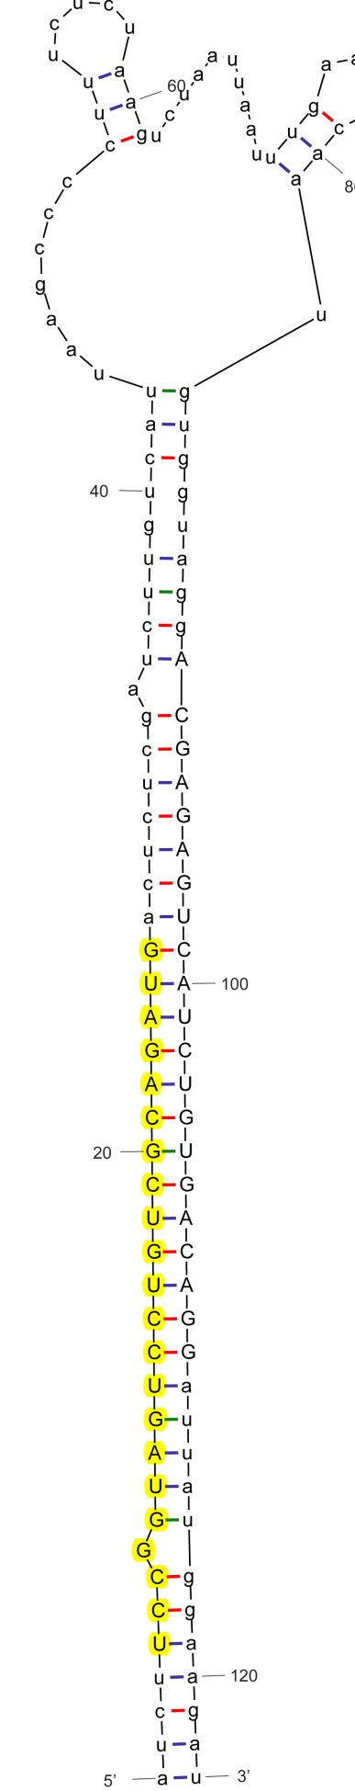
sha-miR1919a-p5
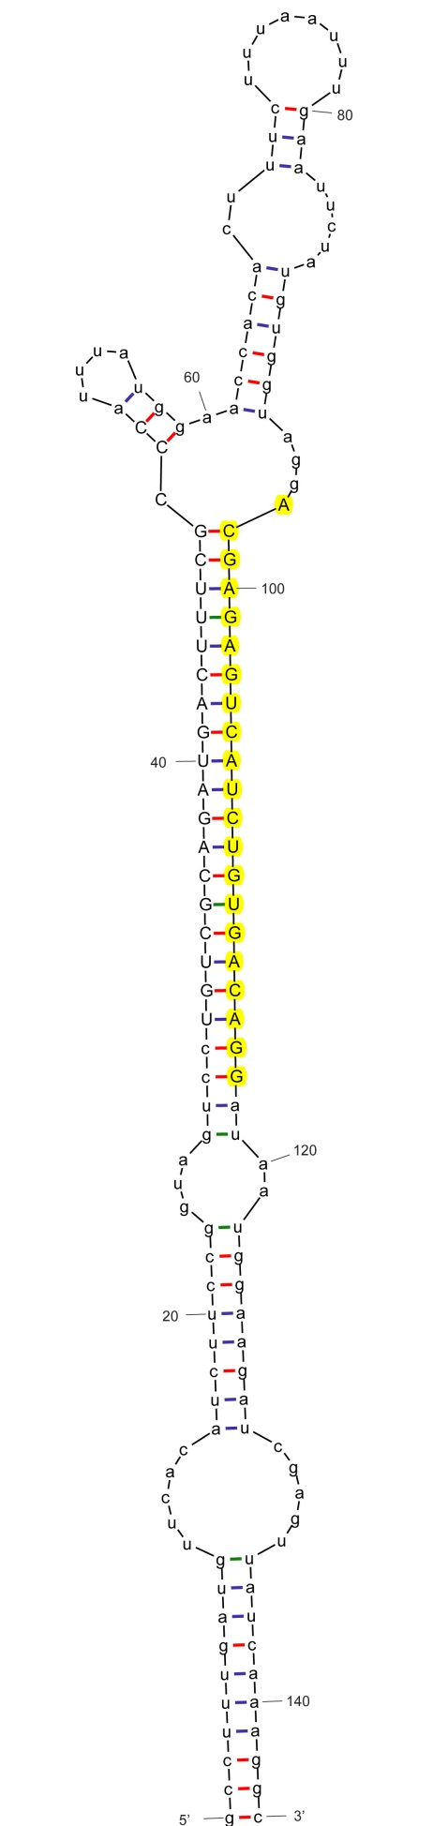

sha-miR1919b
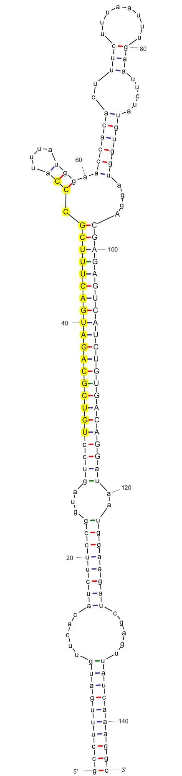
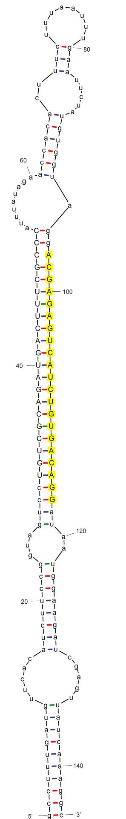
sha-miR1919b-p5

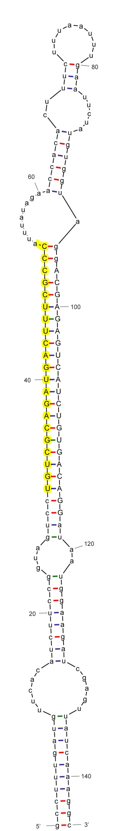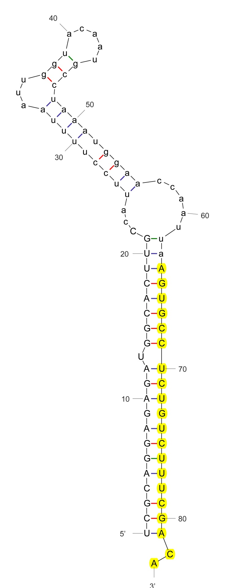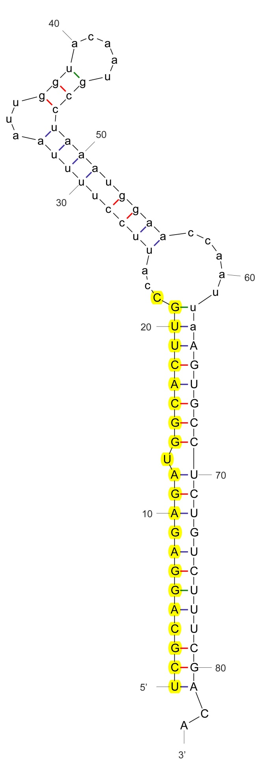
sha-miR1919c
sha-miR1919c-p5
sha-miR3627-3p_stu

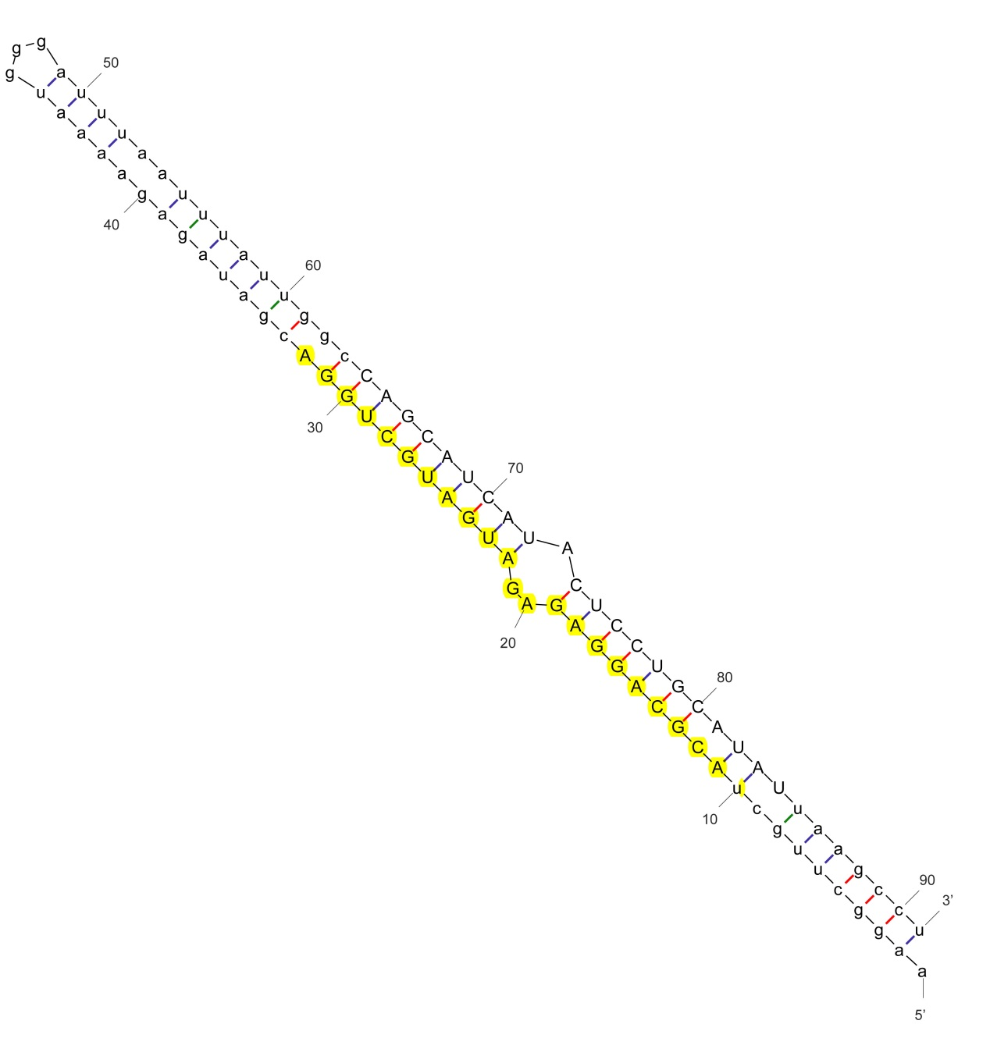
sha-miR3627-5p_stu
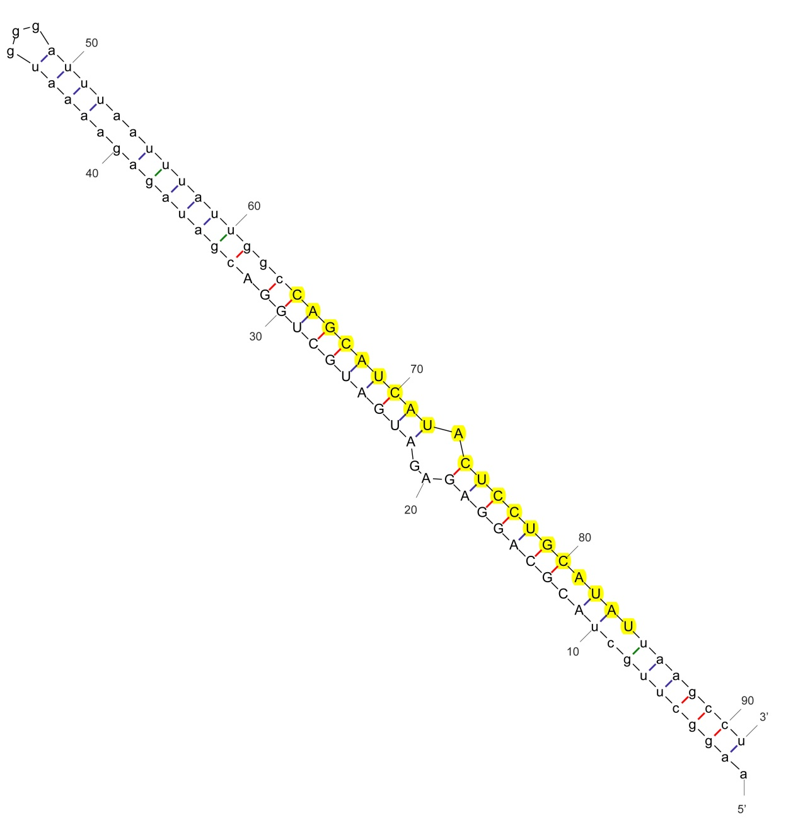
sha-miR4376

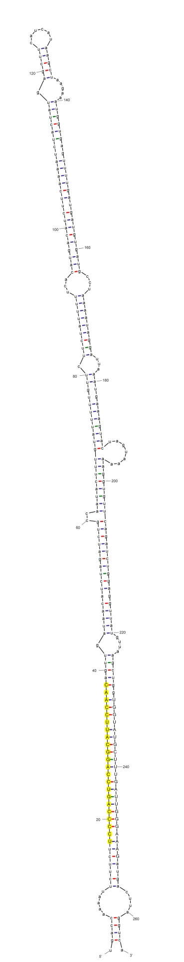
sha-miR4376-p3
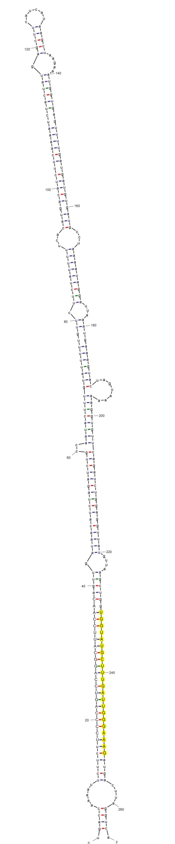
sha-miR5300

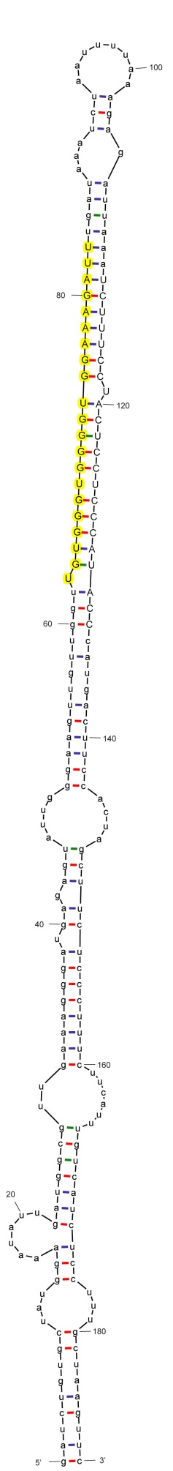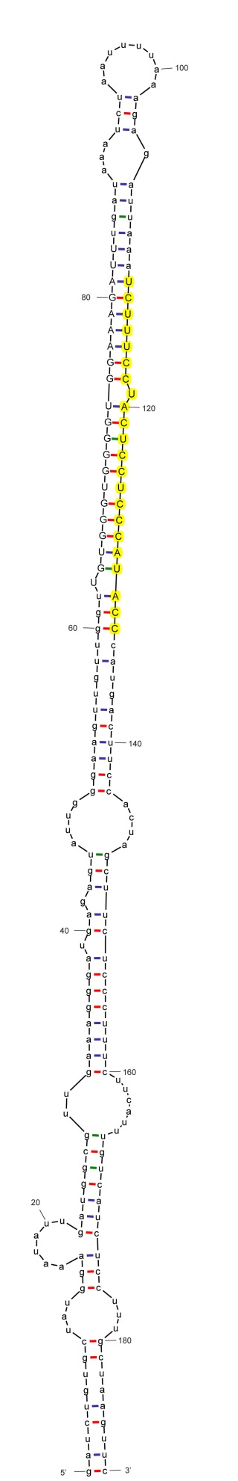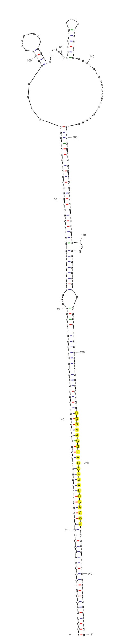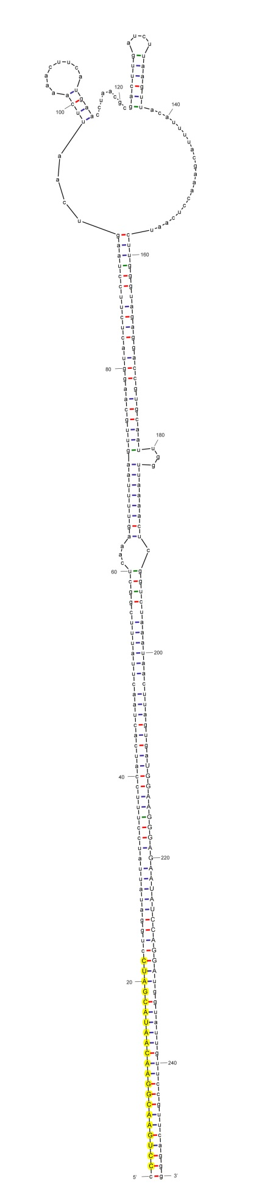
sha-miR5300-p3
sha-miR5301
sha-miR5301-p3
sha-miR6022

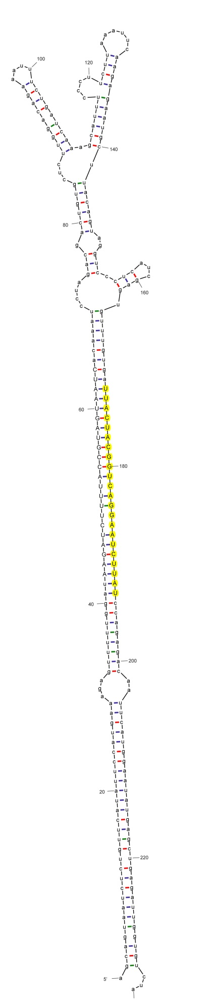
sha-miR6022-p5

sha-miR3627-5p_stu
sha-miR3627-5p_stu
sha-miR6023-p3
sha-miR3627-5p_stu
sha-miR3627-5p_stu
sha-miR6022-p5

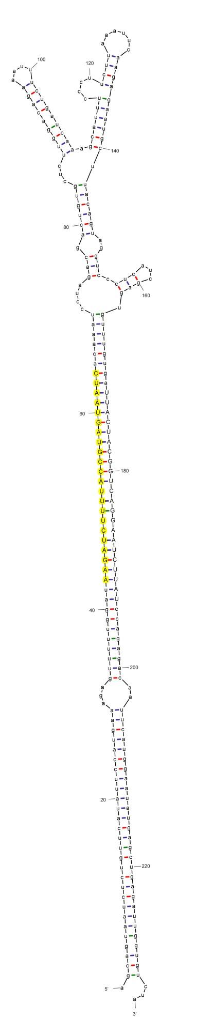

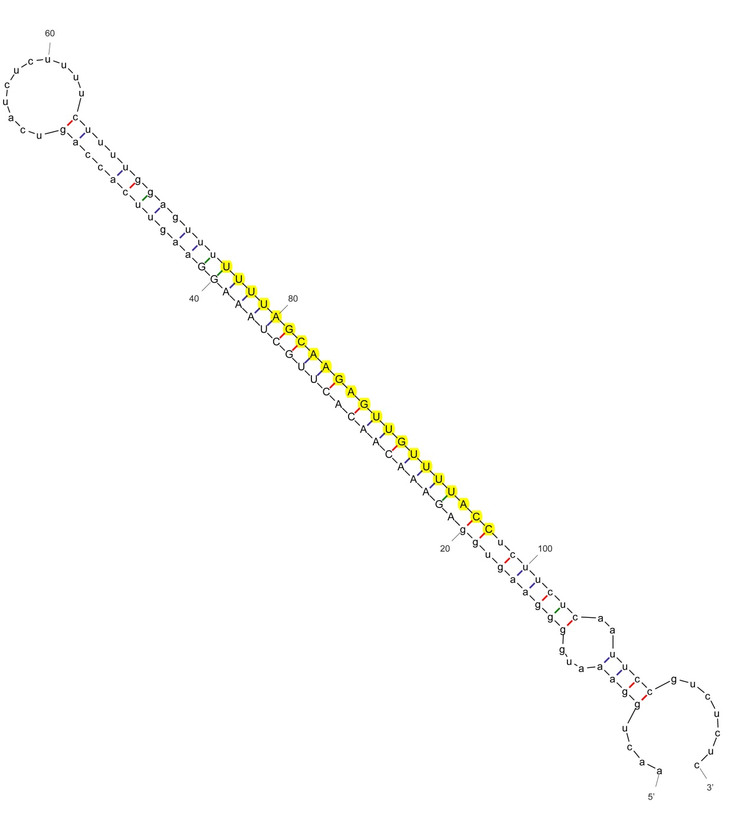
sha-miR6023-p5
sha-miR6024

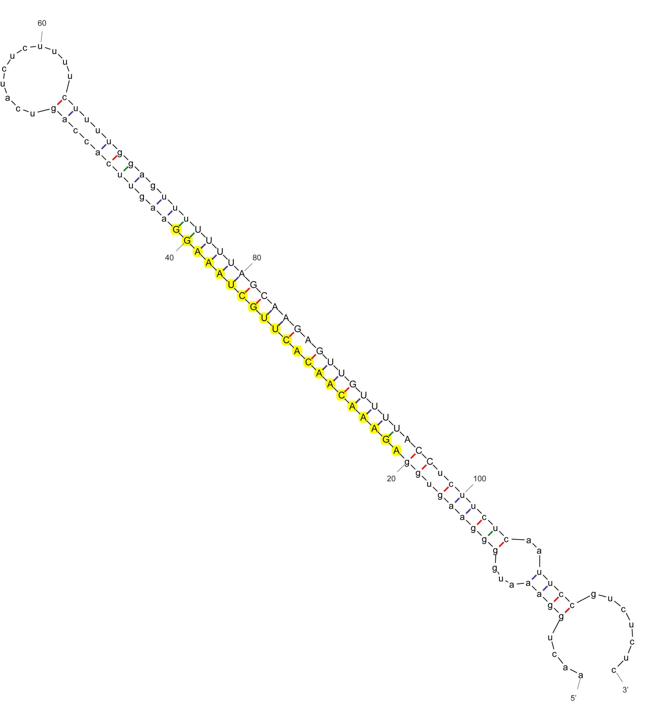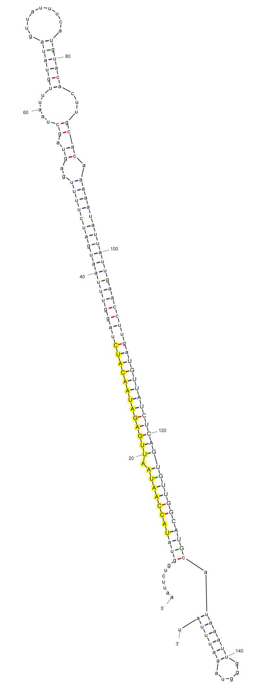
sha-miR6024-5p_stu
sha-miR6025_stu
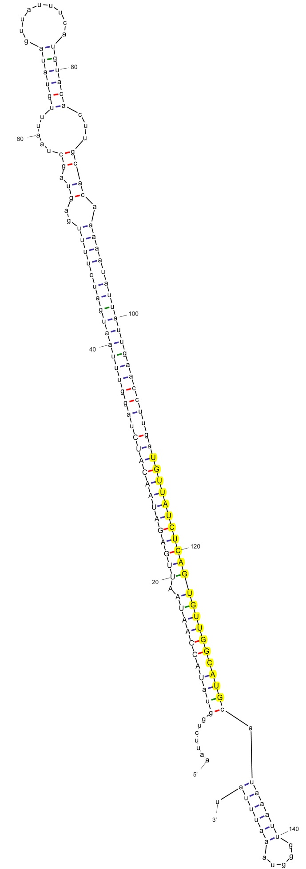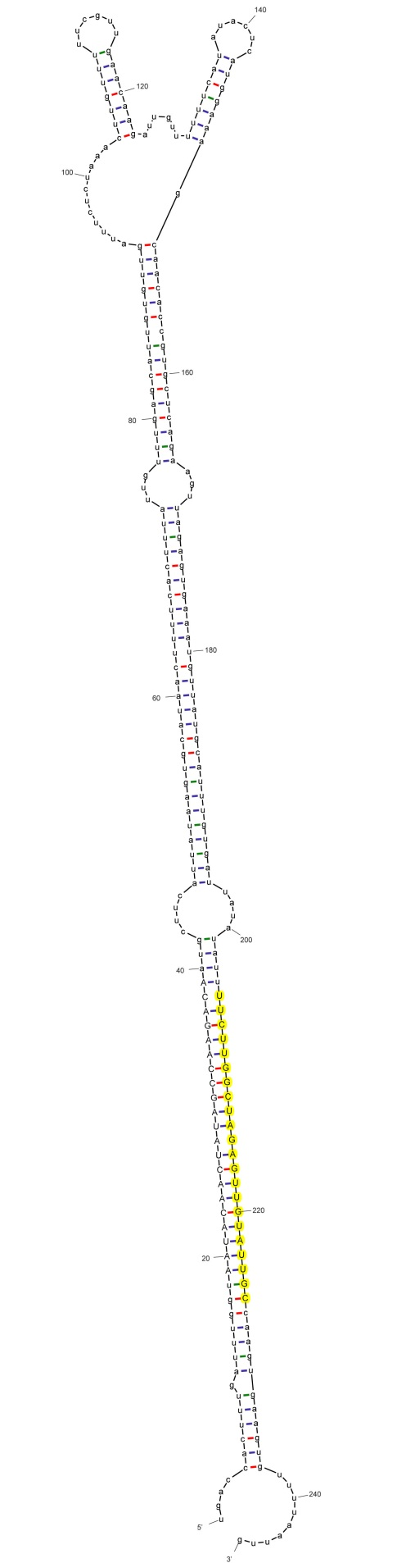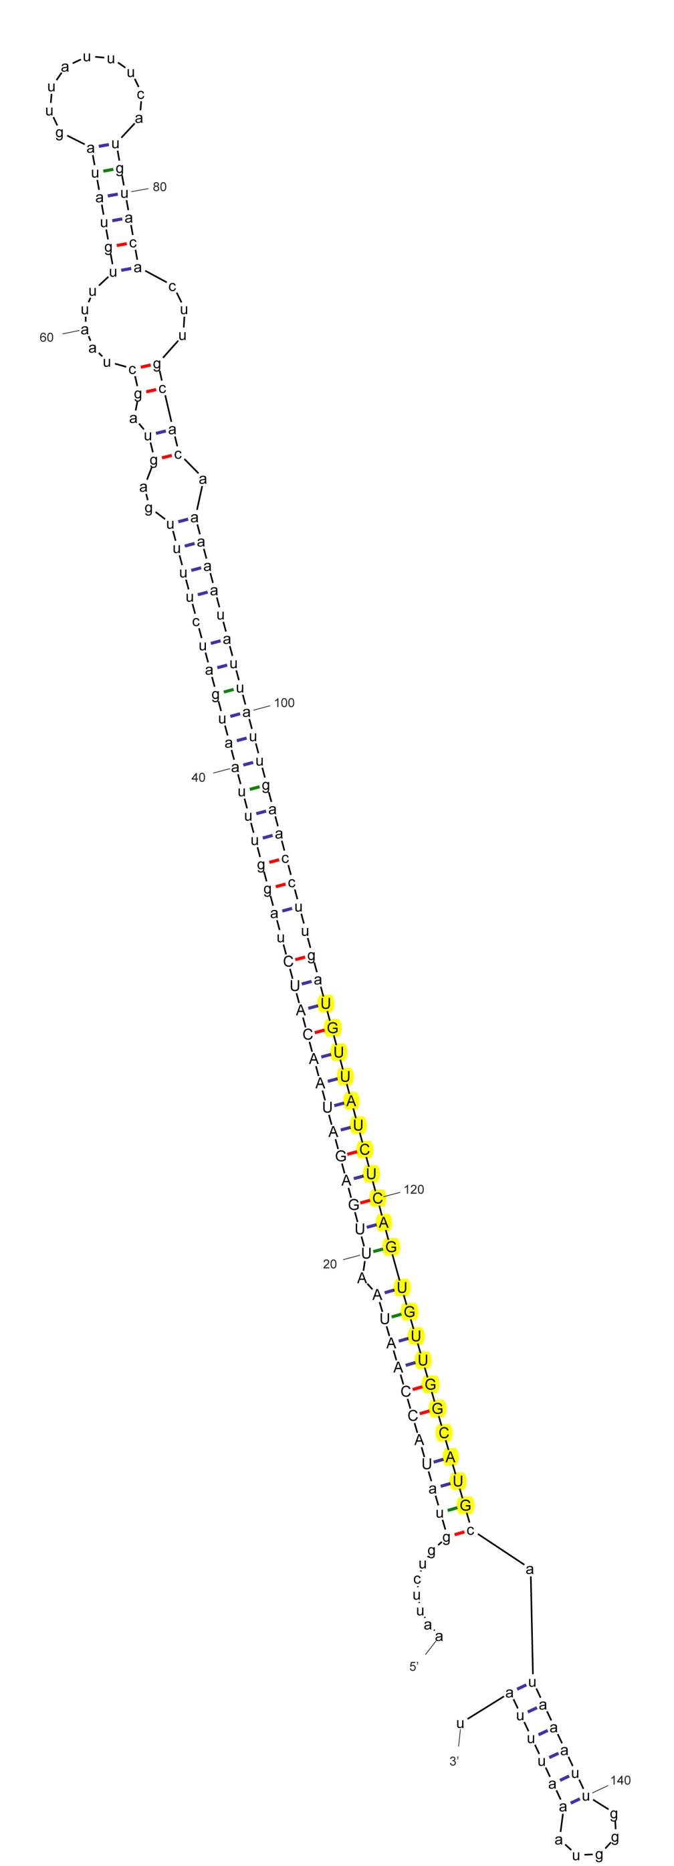
sha-miR6025-p3_stu
sha-miR6026
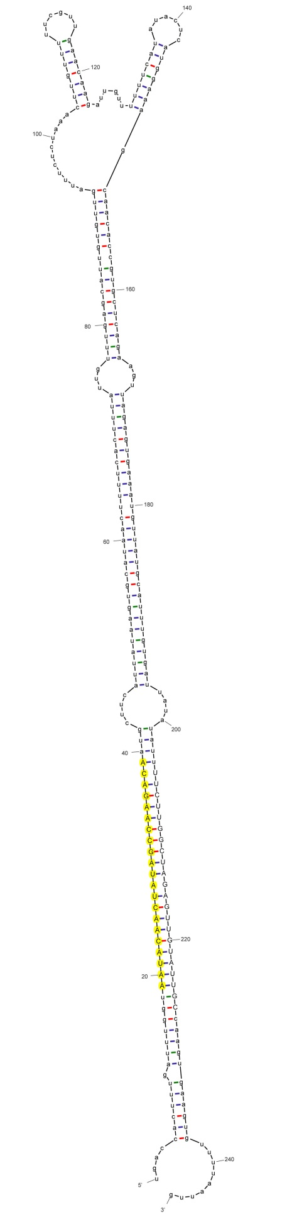
sha-miR6026-5p_stu
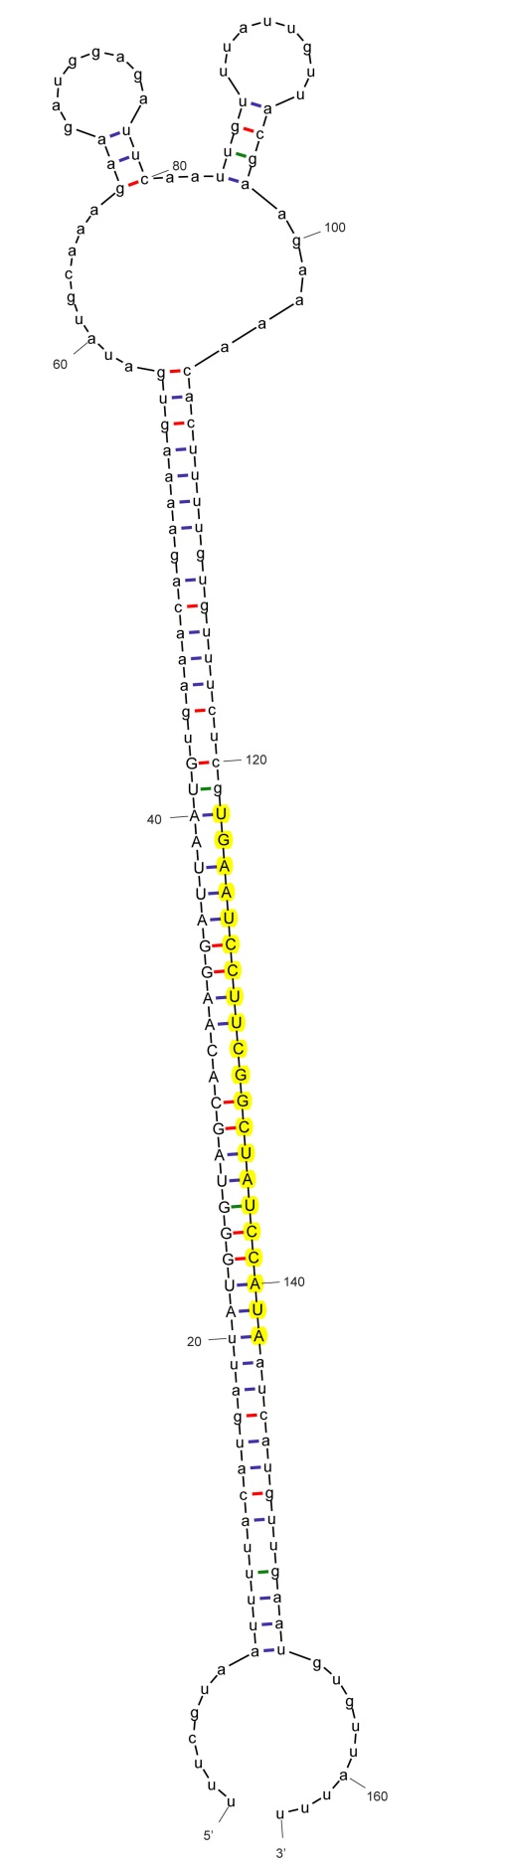
sha-miR6027
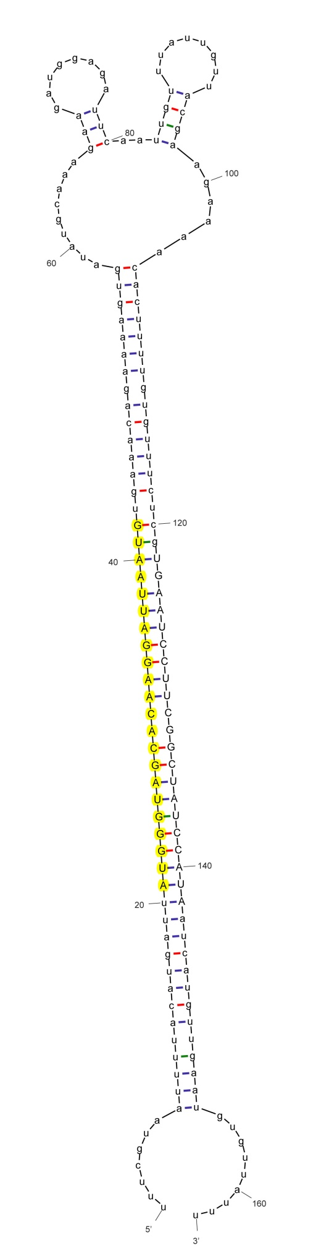
sha-miR6027-p5
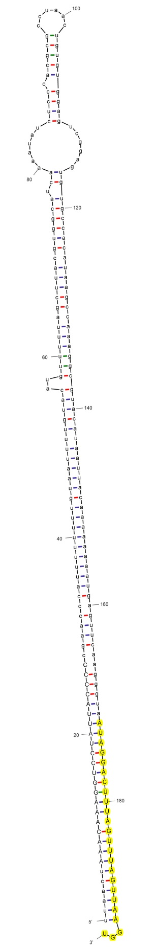
sha-miR7981-3p_stu
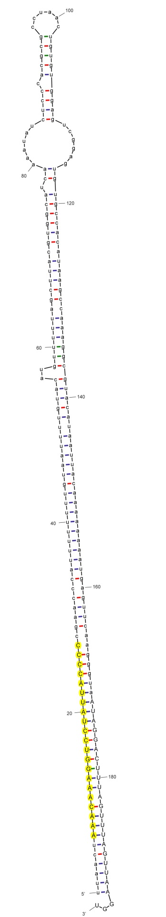
sha-miR7981-p5_stu
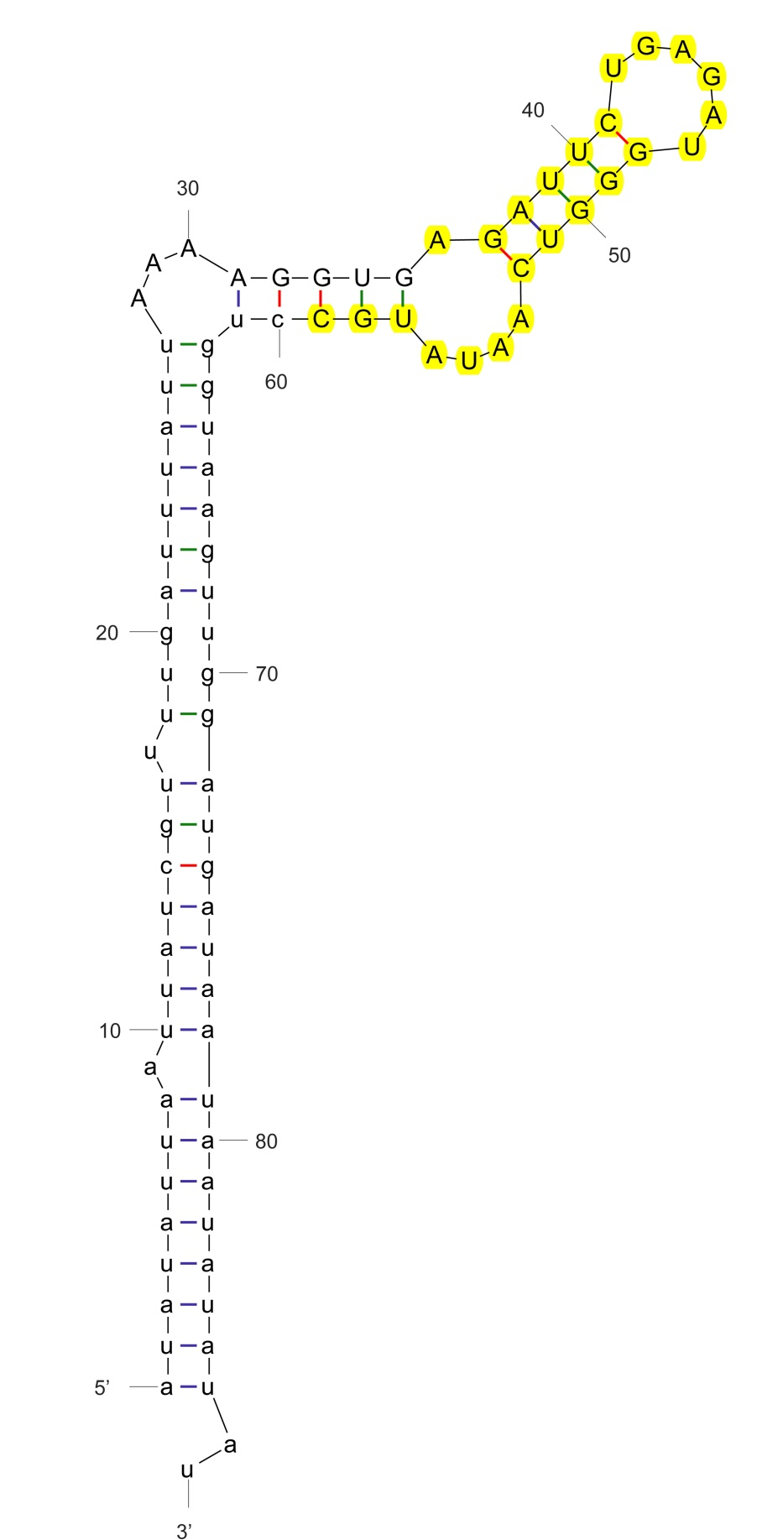
sha-miR7982a-p3_stus
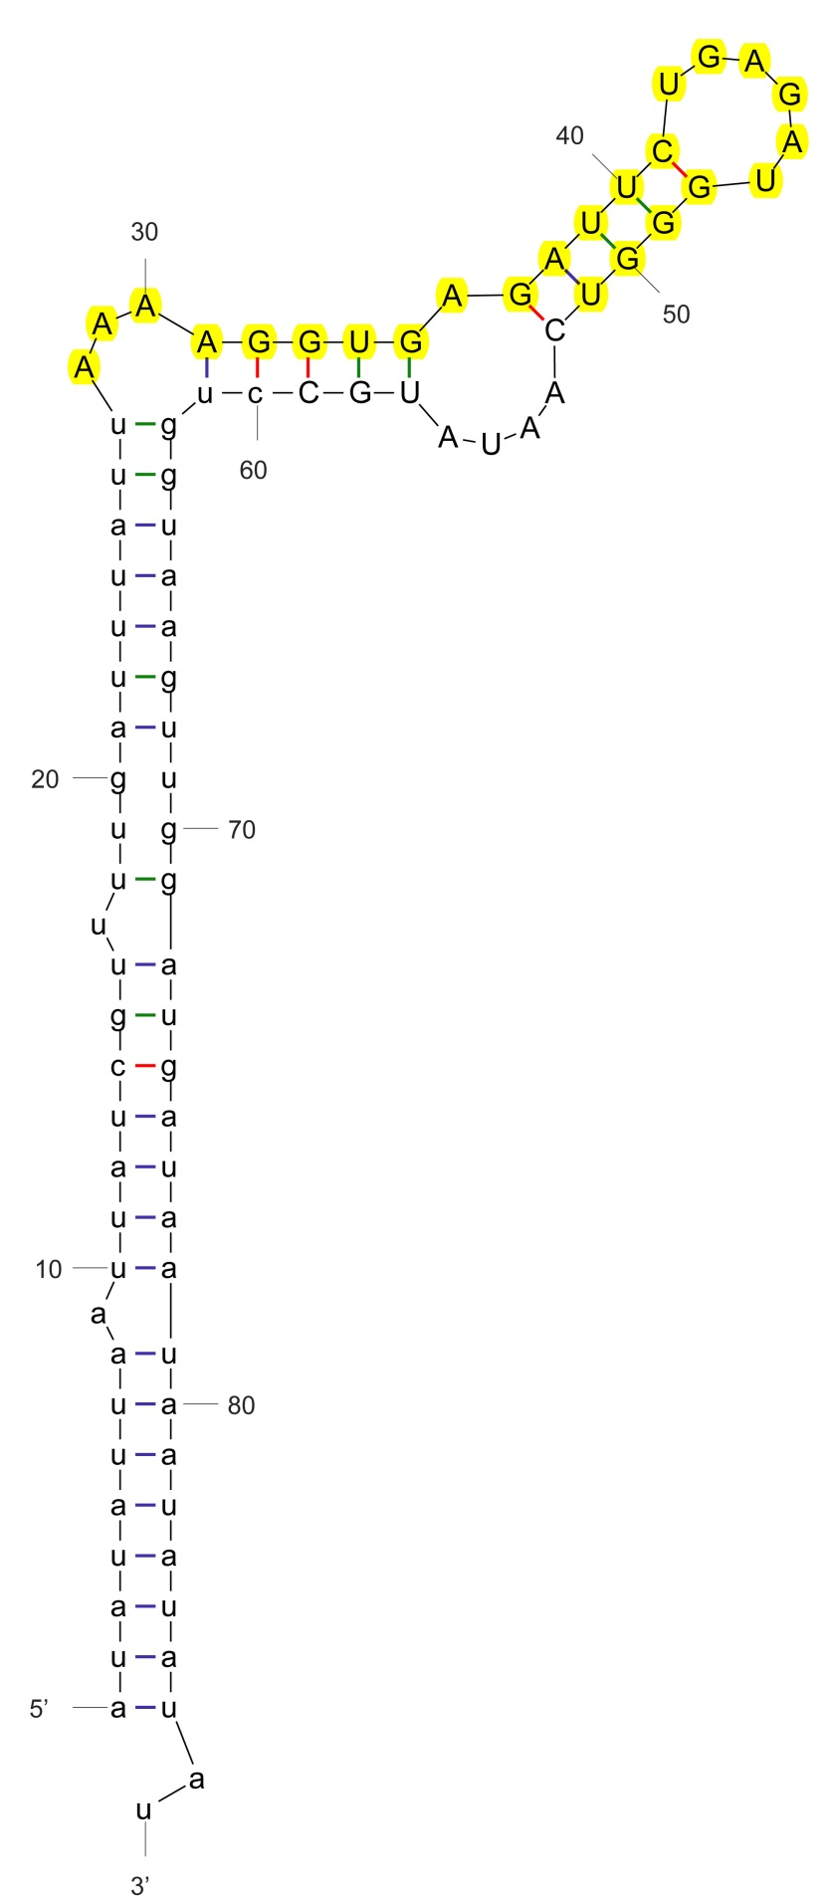
sha-miR7982a-p5_stu
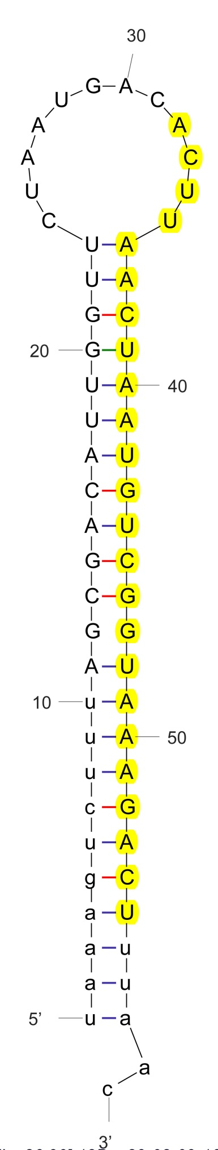
sha-miR7983-p3_stu
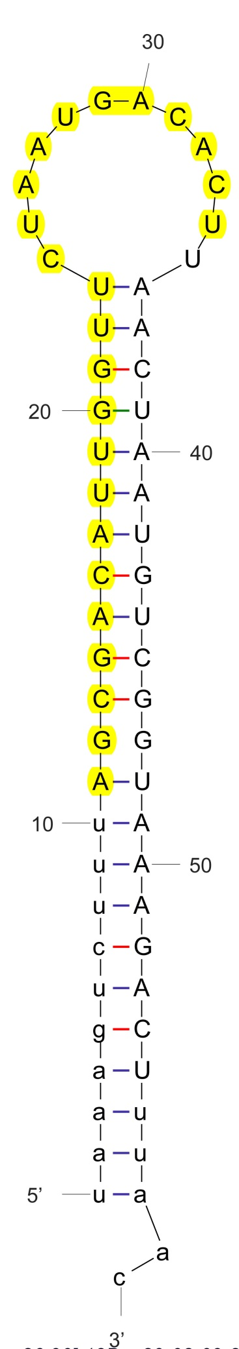
sha-miR7983-p5_stu
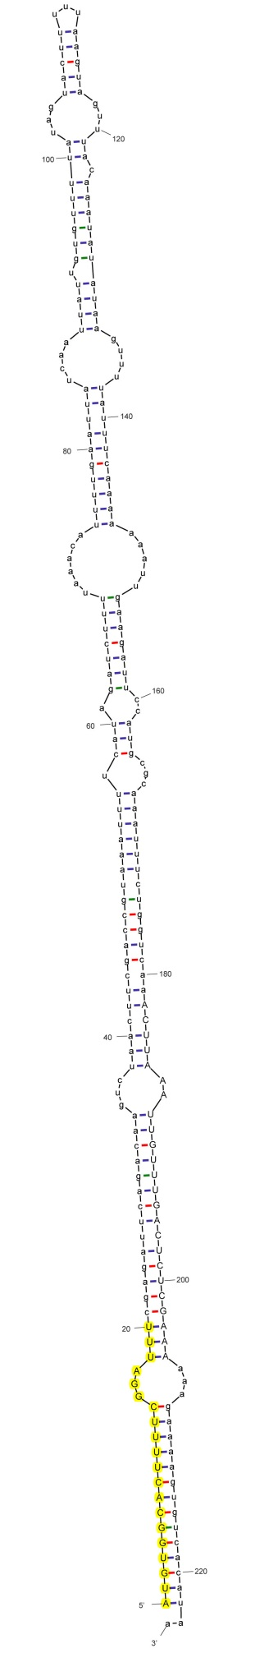
sha-miR8007a-5p_stu
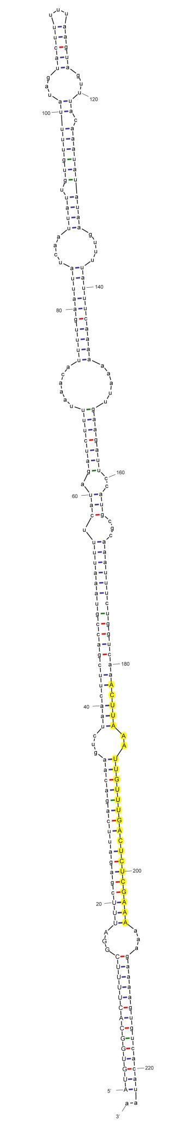
sha-miR8007a-p3_stu

