Additional file 2

Selection for complex traits leaves little or no classic signatures of selection

Kathryn E Kemper^{1§}, Sarah J Saxton ^{1,2}, Sunduimijid Bolormaa³, Benjamin J Hayes^{3,4,5}, Michael E Goddard^{1,3}

¹Department of Agriculture and Food Systems, University of Melbourne, Parkville 3010, Australia
²Australian Dairy Herd Improvement Scheme, 22 William Street, Melbourne 3000, Australia
³Department of Environment and Primary Industries, AgriBio, Bundoora 3068, Australia
⁴La Trobe University, Bundoora 3086, Australia
⁵Dairy Futures Co-operative Research Centre, Bundoora 3068, Australia
§Corresponding author

Email addresses:
KEK: kathryn.kemper@depi.vic.gov.au
SJS: ssaxton@adhis.com.au
SB: bolormaa.sunduimijid@depi.vic.gov.au
BJH: ben.hayes@depi.vic.gov.au
MEG: mike.goddard@depi.vic.gov.au

A.

B.

C.

Figure S1 - Genetic trends for milk (A), fat (B) and protein (C) yield in Holstein and Jersey cattle recorded in the Australian Dairy Herd Improvement scheme.

Note the different base populations for Holstein and Jersey cattle, hence direct comparisons between the breeds does not indicate phenotypic differences.
A.

B.

Figure S2 - Genetic trends for fat (A) and protein (B) percentage in milk for Holstein and Jersey cattle recorded in the Australian Dairy Herd Improvement scheme.

Note the different base populations for Holstein and Jersey cattle, hence direct comparisons between the breeds does not indicate phenotypic differences.

A.

B.

Figure S3 - Genetic trends for fertility (A) and stature (B) for Holstein and Jersey cattle recorded in the Australian Dairy Herd Improvement scheme.

Note the different base populations for Holstein and Jersey cattle, hence direct comparisons between the breeds does not indicate phenotypic differences.

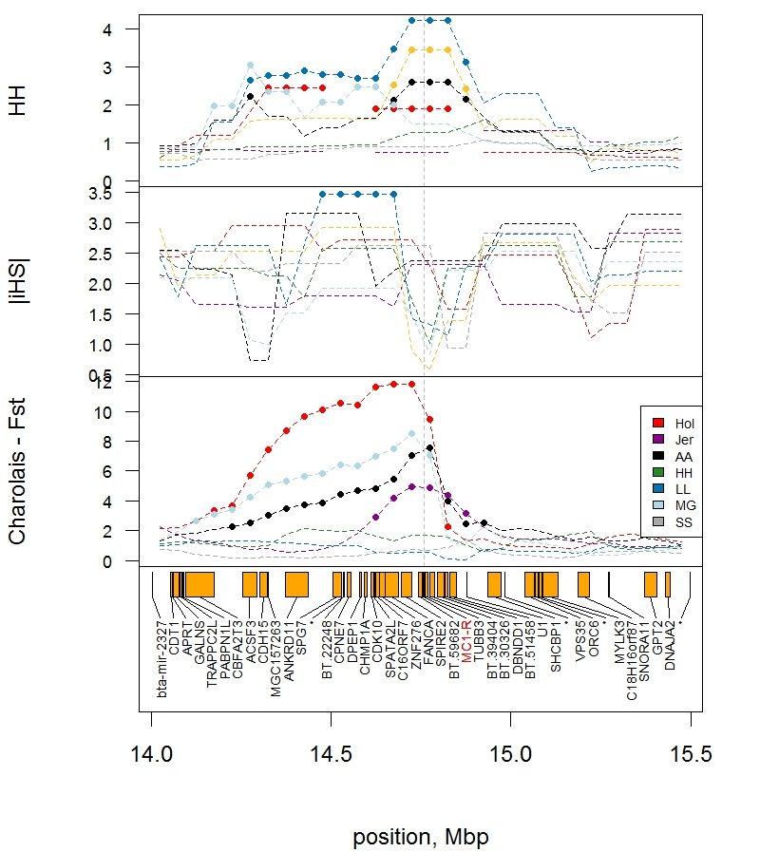

Figure S4 - Haplotype homozygosity (HAPH) and integrated haplotype score |iHS| for all breeds, with F_{ST} for Charolais contrasts at MC1-R.

Although several breeds show within breed selection, F_{ST} indicates haplotype groups for 1. Holstein (Hol), Angus (AA), and Murray Grey (MG) [likely E^{D} allele carriers]; 2. Hereford (HH), Limousin (LL) and Shorthorn (SS) [similar to Charolais and likely e allele breeds] and 3. Jersey [wild-type allele]. Points indicate windows with extreme HAPH, |iHS| or F_{ST} (top 5% of windows).

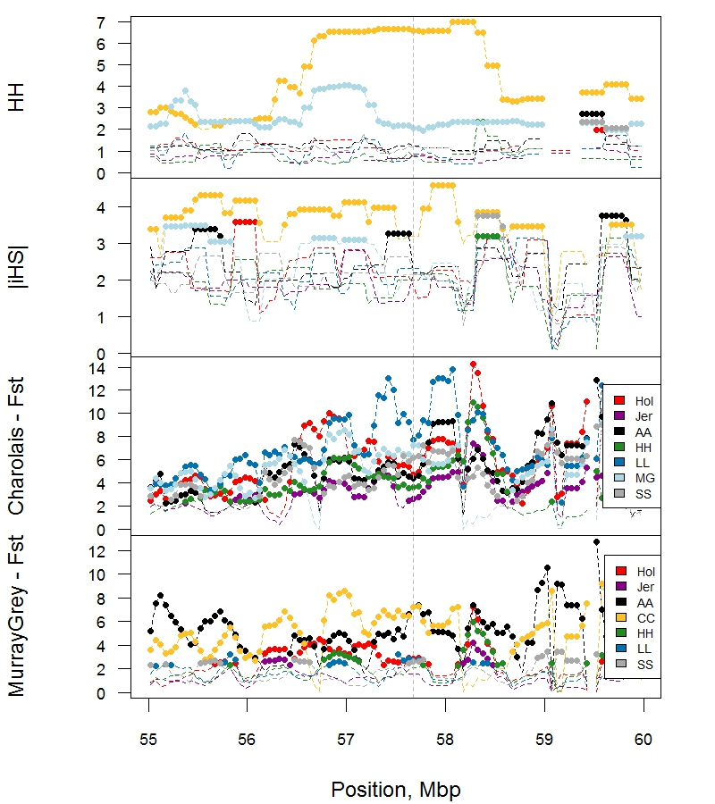

Figure S5 - Haplotype homozygosity (HAPH) and integrated haplotype score (|iHS|) for all breeds near PMEL (57.67 Mbp, as indicated by dashed line), with F_{ST} for Charolais and Murray Grey contrasts.

Both Charolais and Murray Grey indicate selection with HAPH (top 5% of windows, highlighted by points), but show differentiation via F_{ST} near PMEL. Breeds are Hol = Holstein, Jer = Jersey, AA = Angus, CC = Charolais, HH = Hereford, LL = Limousin, MG = Murray Grey, SS = Shorthorn.

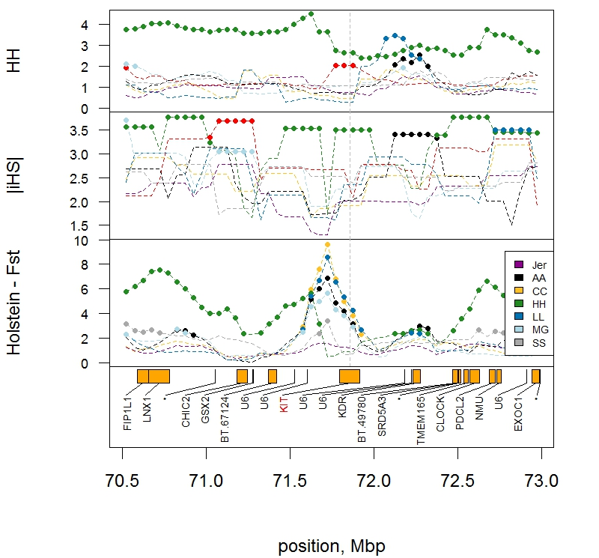

Figure S6 - Haplotype homozygosity (HAPH) and integrated haplotype score (|iHS|) for all breeds, with F_{ST} contrasts with Holstein near KIT.

Both Hereford and Holstein indicate within breed selection (top 5% of windows, highlighted by points) but for different haplotypes near KIT, particularly in the promoter region. Breeds are Jer = Jersey, AA = Angus, CC = Charolais, HH = Hereford, LL = Limousin, MG = Murray Grey, SS = Shorthorn.

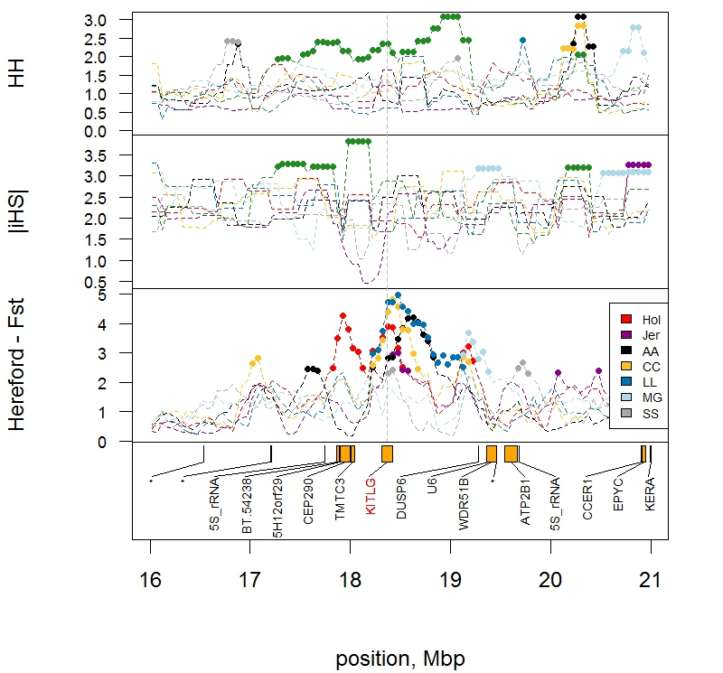Figure S7 - Haplotype homozygosity (HAPH) and integrated haplotype score (|iHS|) for all breeds, with F_{ST} contrasts with Hereford near KITLG.

Hereford indicates within breed selection with HAPH (top 5% of windows, highlighted by points) and differentiation with most other breeds via F_{ST}. Breeds are Hol = Holstein, Jer = Jersey, AA = Angus, CC = Charolais, LL = Limousin, MG = Murray Grey, SS = Shorthorn.

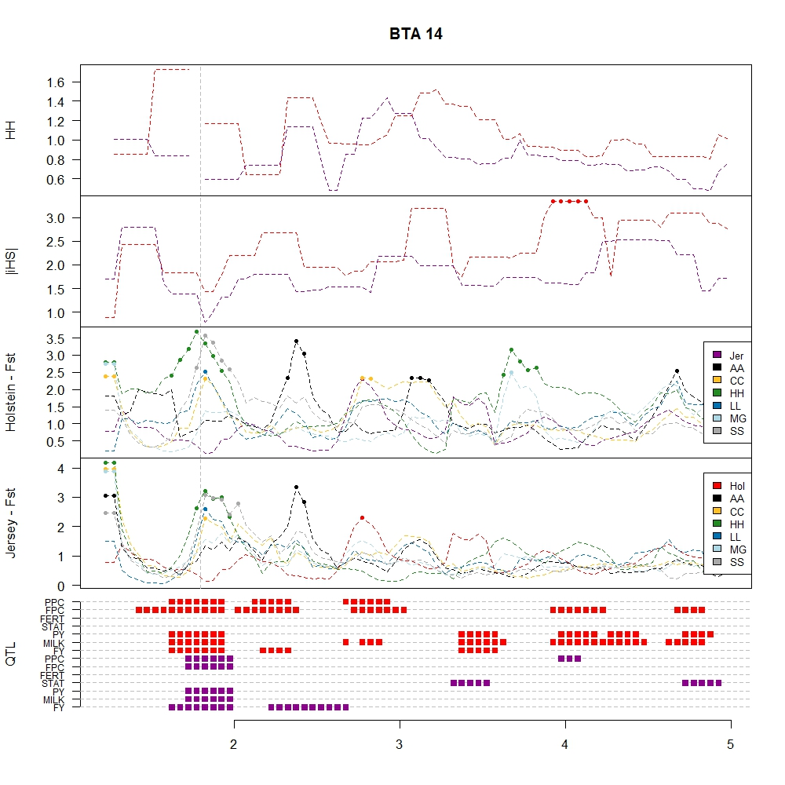Figure S8 - Haplotype homozygosity (HAPH), integrated haplotype score (|iHS|), F_{ST} with Jersey or Holstein and production trait quantitative trait loci (QTL) for Jersey or Holstein near DGAT1 (1.80 Mbp, as indicated by the dashed vertical line).

Breeds are Hol = Holstein, Jer = Jersey, AA = Angus, CC = Charolais, HH = Hereford, LL = Limousin, MG = Murray Grey, SS = Shorthorn. QTL traits are for fat (FY), milk (MILK) and protein (PY) yield, stature (STAT), fertility (FERT), and fat (FPC) and protein (PPC) percentage in milk for Jersey (purple) and Holstein (red). Windows with extreme values (in the top 5% per trait or statistic) are highlighted with points.

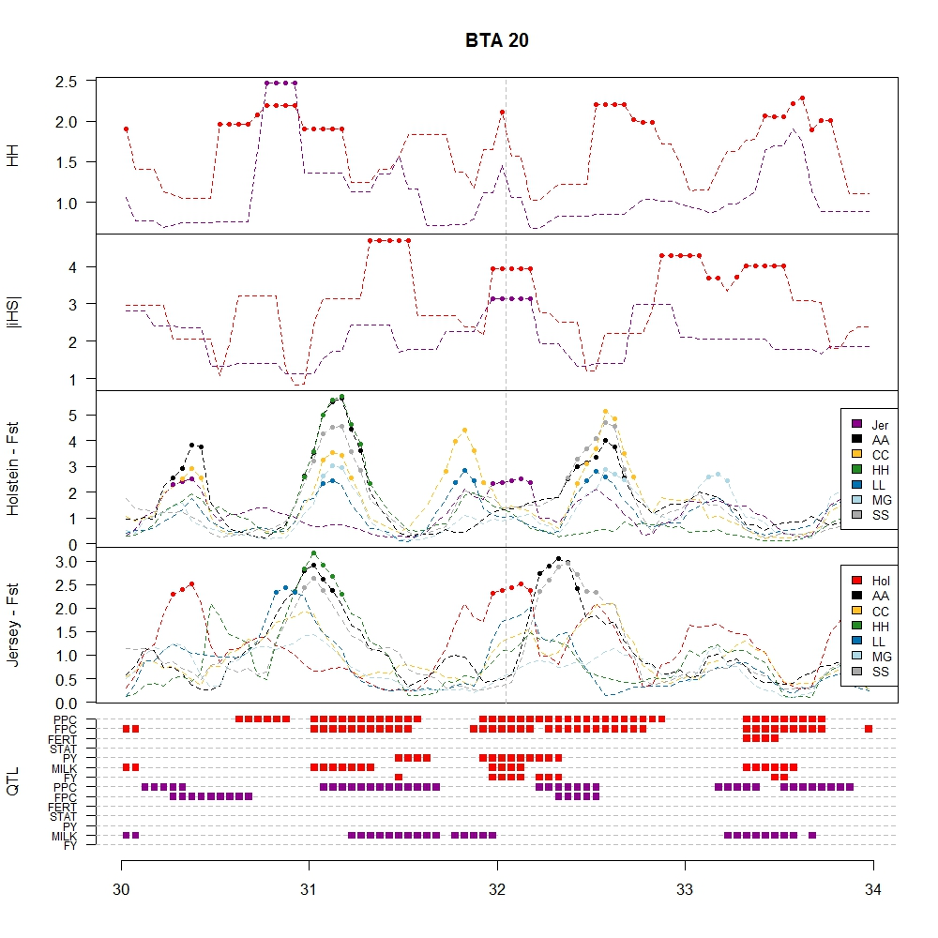Figure S9 - Haplotype homozygosity (HAPH), integrated haplotype score (|iHS|), F_{ST} with Jersey or Holstein and production trait quantitative trait loci (QTL) for Jersey or Holstein near the GHR locus (32.05 Mbp, as indicated by the vertical dashed line).

Breeds are Hol = Holstein, Jer = Jersey, AA = Angus, CC = Charolais, HH = Hereford, LL = Limousin, MG = Murray Grey, SS = Shorthorn. QTL traits are for fat (FY), milk (MILK) and protein (PY) yield, stature (STAT), fertility (FERT), and fat (FPC) and protein (PPC) percentage in milk for Jersey (purple) and Holstein (red) cattle. Windows with extreme values (in the top 5% per trait or statistic) are highlighted with points.

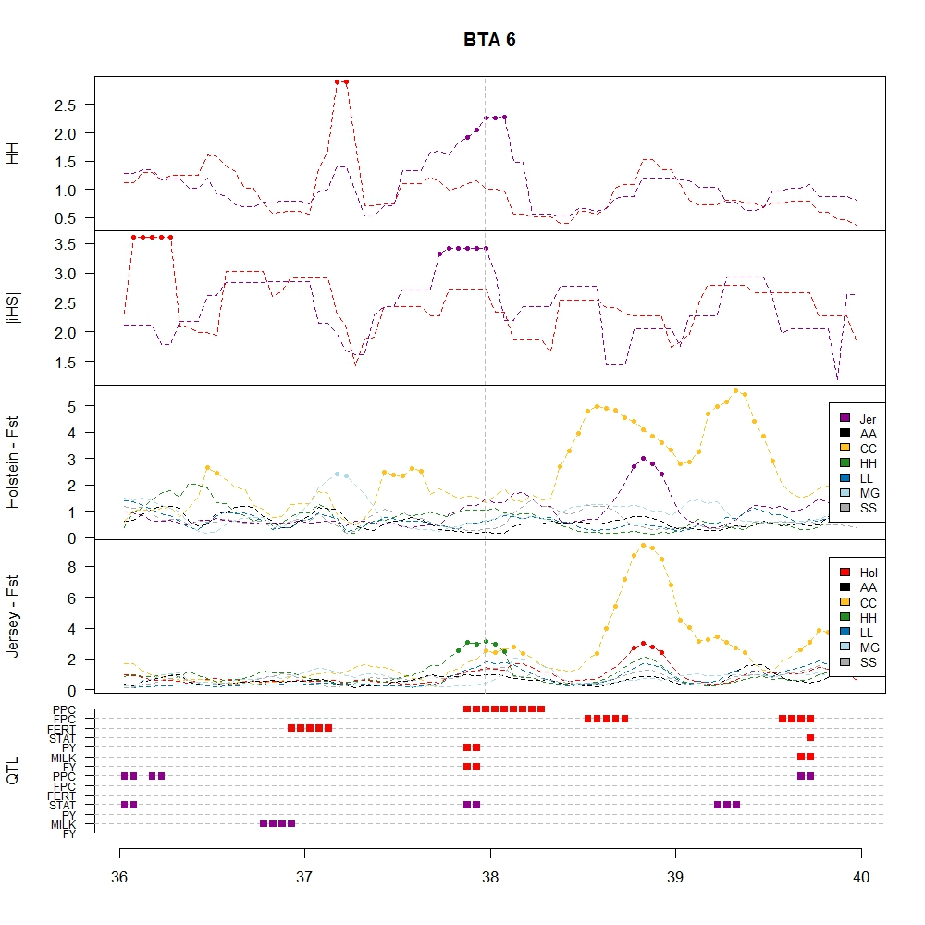Figure S10 - Haplotype homozygosity (HAPH), integrated haplotype score (|iHS|), F_{ST} with Jersey or Holstein and production trait quantitative trait loci (QTL) for Jersey or Holstein near ABCG2 (37.97 Mbp).

Breeds are Hol = Holstein, Jer = Jersey, AA = Angus, CC = Charolais, HH = Hereford, LL = Limousin, MG = Murray Grey, SS = Shorthorn. QTL traits are for fat (FY), milk (MILK) and protein (PY) yield, stature (STAT), fertility (FERT), and fat (FPC) and protein (PPC) percentage in milk for Jersey (purple) and Holstein (red) cattle. Windows with extreme values (in the top 5% per trait or statistic) are highlighted with points. Note that NCAPG (Non-SMC condensin I complex, subunit G) is at 38.78 Mbp and is probably responsible for the differentiation in Charolais.

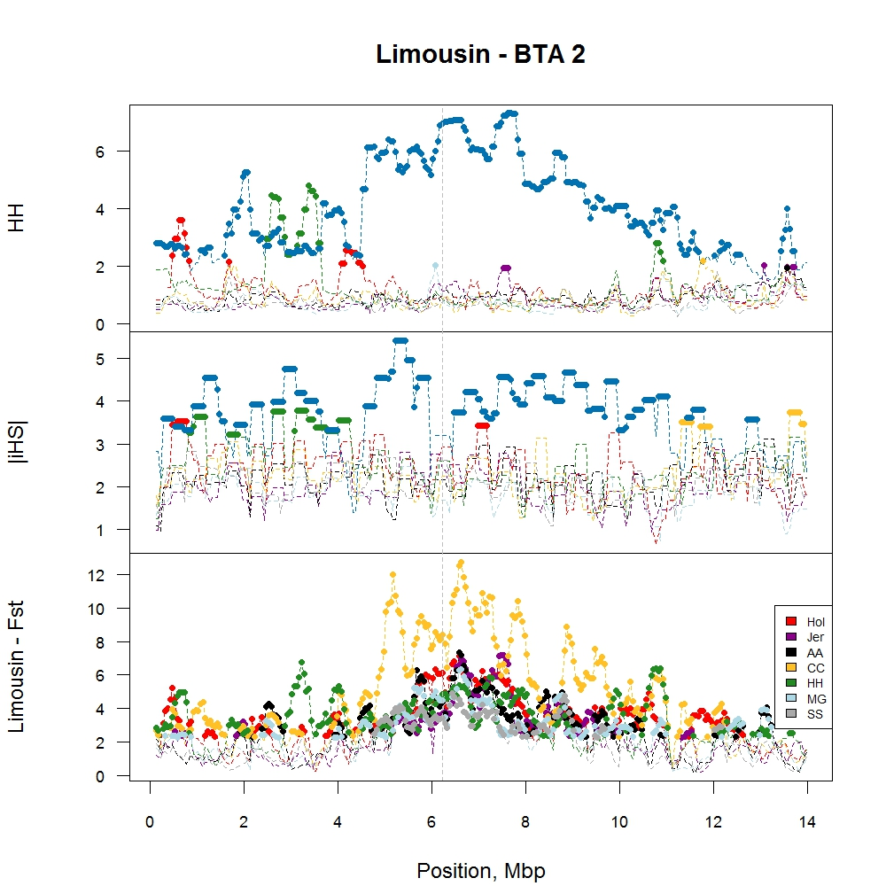

Figure S11 - Haplotype homozygosity (HAPH) and integrated haplotype score (|iHS|) for all breeds with F_{ST} contrasts with Limousin.

Windows with extreme values (in the top 5%) are highlighted with points. Breeds are Hol = Holstein, Jer = Jersey, AA = Angus, CC = Charolais, HH = Hereford, LL = Limousin, MG = Murray Grey, SS = Shorthorn.

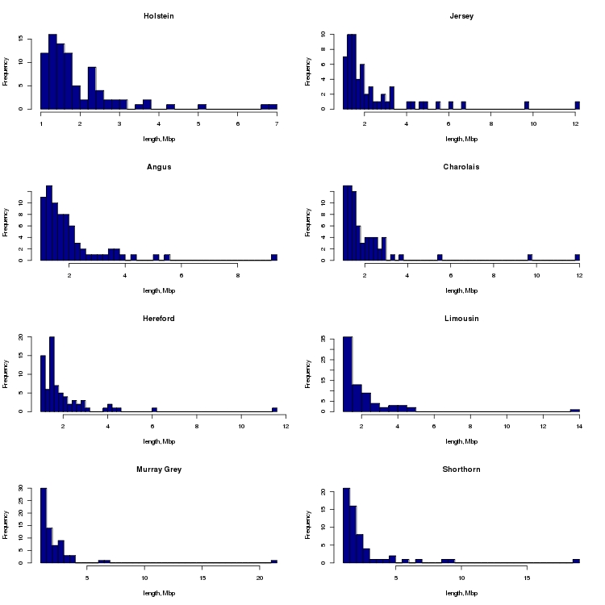

Figure S12 - Distribution of hard sweep lengths (> 1 Mbp) identified as with extreme (top 5%) haplotype homozygosity (HAPH) for Holstein, Jersey, Angus, Charolais, Hereford, Limousin, Murray Grey and Shorthorn breeds (L-R, top-bottom).

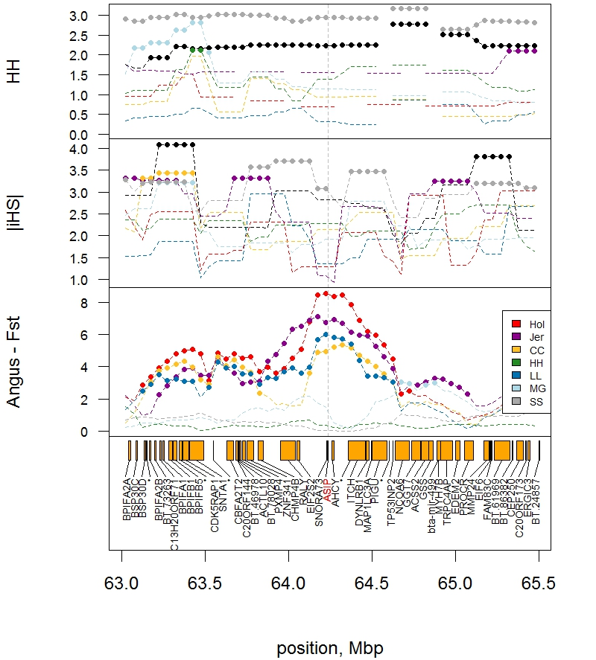Figure S13 - Haplotype homozygosity (HAPH) and integrated haplotype score (|iHS|) for all breeds with F_{ST} contrasts with Angus.

Windows with extreme values (in the top 5%) are highlighted with points. Breeds are Hol = Holstein, Jer = Jersey, AA = Angus, CC = Charolais, HH = Hereford, LL = Limousin, MG = Murray Grey, SS = Shorthorn.

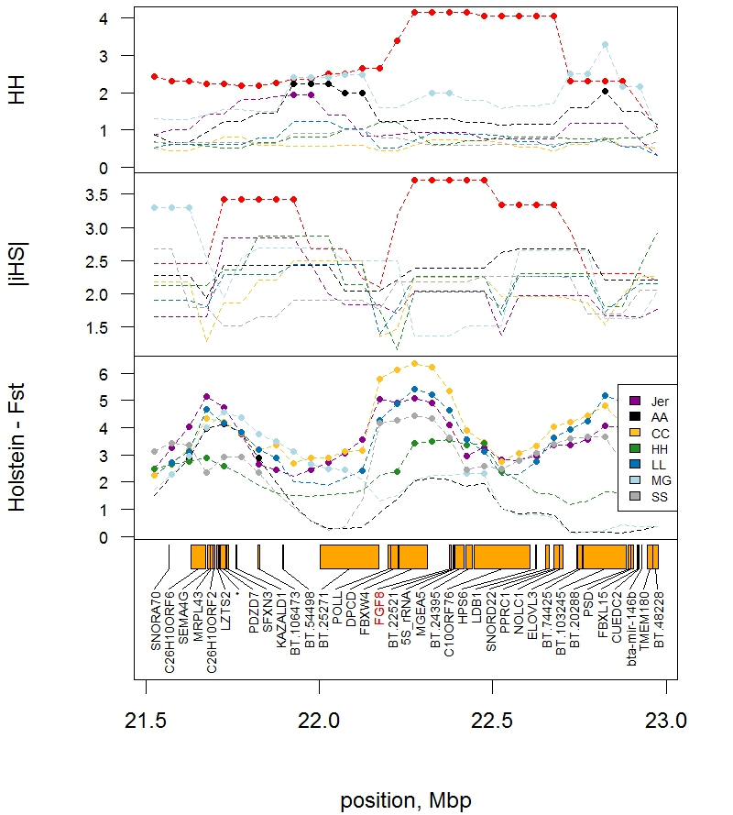Figure S14 - Haplotype homozygosity (HAPH) and integrated haplotype score (|iHS|) for all breeds with F_{ST} contrasts with Holstein.

Windows with extreme values (in the top 5%) are highlighted with points. Breeds are Hol = Holstein, Jer = Jersey, AA = Angus, CC = Charolais, HH = Hereford, LL = Limousin, MG = Murray Grey, SS = Shorthorn.

Table S1 - Chi-squared tests for over-representation of measures of selection (haplotype homozygosity, HAPH; integrated haplotype score, |iHS|) with Holstein QTL for fat, milk and protein yield (FY, MILK, PY), stature (STAT), fertility (FERT) and precent of fat and protein in milk (FPC, PPC). The final row tests the overlap between the two measures.

Grp1 | Grp2 | Observed |  |  |  | Expected |  |  |  | $$\sum{\frac{{\left(obs-Exp\right)}^{2}}{Exp}}$$ | P-val | Bonf. Corr.
Grp1 | Grp2 | Gp1+Gp2 | Gp1 | Gp2 | Total | Gp1+G2 | Gp1 | Gp2 | Total | $$\sum{\frac{{\left(obs-Exp\right)}^{2}}{Exp}}$$ | P-val | Bonf. Corr.
H.FY | H.HAPH | 31.4 | 499.2 | 633.4 | 9871.8 | 32.0 | 601.4 | 467.2 | 8771.2 | 0.014 | 0.9060
H.FY | H.iHS | 40.0 | 499.8 | 526.2 | 9994.0 | 26.3 | 499.9 | 473.5 | 8994.3 | 7.907 | 0.0049
H.MILK | H.HAPH | 32.8 | 499.6 | 633.4 | 9871.8 | 32.1 | 601.3 | 467.5 | 8770.9 | 0.019 | 0.8891
H.MILK | H.iHS | 39.0 | 499.8 | 526.2 | 9994.0 | 26.3 | 499.9 | 473.5 | 8994.3 | 6.794 | 0.0091
H.PY | H.HAPH | 35.6 | 499.2 | 633.4 | 9871.8 | 32.0 | 601.4 | 467.2 | 8771.2 | 0.448 | 0.5034
H.PY | H.iHS | 47.0 | 499.8 | 526.2 | 9994.0 | 26.3 | 499.9 | 473.5 | 8994.3 | 18.066 | 0.0000 | Sig.
H.STAT | H.HAPH | 34.0 | 498.0 | 633.4 | 9871.8 | 32.0 | 601.4 | 466.0 | 8772.4 | 0.148 | 0.7009
H.STAT | H.iHS | 40.2 | 499.8 | 526.2 | 9994.0 | 26.3 | 499.9 | 473.5 | 8994.3 | 8.140 | 0.0043
H.FERT | H.HAPH | 31.0 | 499.4 | 633.4 | 9871.8 | 32.0 | 601.4 | 467.4 | 8771.0 | 0.038 | 0.8451
H.FERT | H.iHS | 39.6 | 499.8 | 526.2 | 9994.0 | 26.3 | 499.9 | 473.5 | 8994.3 | 7.452 | 0.0063
H.FPC | H.HAPH | 30.6 | 498.6 | 633.4 | 9871.8 | 32.0 | 601.4 | 466.6 | 8771.8 | 0.068 | 0.7941
H.FPC | H.iHS | 36.0 | 499.8 | 526.2 | 9994.0 | 26.3 | 499.9 | 473.5 | 8994.3 | 3.960 | 0.0466
H.PPC | H.HAPH | 30.8 | 497.6 | 633.4 | 9871.8 | 31.9 | 601.5 | 465.7 | 8772.7 | 0.045 | 0.8324
H.PPC | H.iHS | 34.6 | 499.8 | 526.2 | 9994.0 | 26.3 | 499.9 | 473.5 | 8994.3 | 2.898 | 0.0887
H.HH | H.iHS | 75.6 | 494.0 | 526.2 | 9871.8 | 26.3 | 499.9 | 467.7 | 8877.9 | 102.503 | 0.0000 | Sig.

Table S2 - Chi-squared tests for over-representation of measures of selection (haplotype homozygosity, HAPH; integrated haplotype score, |iHS|) with Jersey QTL for fat, milk and protein yield (FY, MILK, PY), stature (STAT), fertility (FERT) and precent of fat and protein in milk (FPC, PPC). The final row tests the overlap between the two measures.

Grp1 | Grp2 | Observed |  |  |  | Expected |  |  |  | $$\sum{\frac{{\left(obs-Exp\right)}^{2}}{Exp}}$$ | P-val | Bonf. Corr.
Grp1 | Grp2 | Gp1+Gp2 | Gp1 | Gp2 | Total | Gp1+G2 | Gp1 | Gp2 | Total | $$\sum{\frac{{\left(obs-Exp\right)}^{2}}{Exp}}$$ | P-val | Bonf. Corr.
J.FY | J.HAPH | 21.4 | 499.6 | 633.6 | 9871.8 | 32.1 | 601.5 | 467.5 | 8770.7 | 3.993 | 0.0457
J.FY | J.iHS | 31.8 | 499.8 | 526.6 | 9994.0 | 26.3 | 500.3 | 473.5 | 8993.9 | 1.260 | 0.2616
J.MILK | J.HAPH | 25.2 | 499.6 | 633.6 | 9871.8 | 32.1 | 601.5 | 467.5 | 8770.7 | 1.655 | 0.1983
J.MILK | J.iHS | 36.4 | 499.8 | 526.6 | 9994.0 | 26.3 | 500.3 | 473.5 | 8993.9 | 4.274 | 0.0387
J.PY | J.HAPH | 29.2 | 499.2 | 633.6 | 9871.8 | 32.0 | 601.6 | 467.2 | 8771.0 | 0.283 | 0.5945
J.PY | J.iHS | 35.0 | 499.8 | 526.6 | 9994.0 | 26.3 | 500.3 | 473.5 | 8993.9 | 3.168 | 0.0751
J.STAT | J.HAPH | 22.6 | 499.8 | 633.6 | 9871.8 | 32.1 | 601.5 | 467.7 | 8770.5 | 3.152 | 0.0758
J.STAT | J.iHS | 43.0 | 499.8 | 526.6 | 9994.0 | 26.3 | 500.3 | 473.5 | 8993.9 | 11.718 | 0.0006 | Sig.
J.FERT | J.HAPH | 20.4 | 499.6 | 633.6 | 9871.8 | 32.1 | 601.5 | 467.5 | 8770.7 | 4.777 | 0.0288
J.FERT | J.iHS | 34.2 | 499.8 | 526.6 | 9994.0 | 26.3 | 500.3 | 473.5 | 8993.9 | 2.610 | 0.1062
J.FPC | J.HAPH | 16.6 | 498.8 | 633.6 | 9871.8 | 32.0 | 601.6 | 466.8 | 8771.4 | 8.353 | 0.0039
J.FPC | J.iHS | 28.6 | 499.8 | 526.6 | 9994.0 | 26.3 | 500.3 | 473.5 | 8993.9 | 0.216 | 0.6418
J.PPC | J.HAPH | 19.8 | 498.8 | 633.6 | 9871.8 | 32.0 | 601.6 | 466.8 | 8771.4 | 5.245 | 0.0220
J.PPC | J.iHS | 27.6 | 499.8 | 526.6 | 9994.0 | 26.3 | 500.3 | 473.5 | 8993.9 | 0.067 | 0.7950
J.HH | J.iHS | 130.4 | 494.2 | 526.6 | 9871.8 | 26.4 | 500.2 | 467.8 | 8877.4 | 456.567 | 0.0000 | Sig.

Table S3 - Chi-squared tests for over-representation of selection between dairy and beef breeds (F_{ST}) with Holstein or Jersey QTL for fat, milk and protein yield (FY, MILK, PY), stature (STAT), fertility (FERT) and precent of fat and protein in milk (FPC, PPC). The final rows test the overlap between the QTL in Holstein and Jersey.

Grp1 | Grp2 | Observed |  |  |  | Expected |  |  |  | $$\sum{\frac{{\left(obs-Exp\right)}^{2}}{Exp}}$$ | P-val | Bonf. Corr.
Grp1 | Grp2 | Gp1+Gp2 | Gp1 | Gp2 | Total | Gp1+G2 | Gp1 | Gp2 | Total | $$\sum{\frac{{\left(obs-Exp\right)}^{2}}{Exp}}$$ | P-val | Bonf. Corr.
H/J.FY | Fst | 55.2 | 943.4 | 472.8 | 9979.4 | 44.7 | 428.1 | 898.7 | 8607.9 | 2.862 | 0.0907
H/J.MILK | Fst | 47.0 | 958.6 | 472.8 | 9979.4 | 45.4 | 427.4 | 913.2 | 8593.4 | 0.064 | 0.8001
H/J.PY | Fst | 48.0 | 956.2 | 472.8 | 9979.4 | 45.3 | 427.5 | 910.9 | 8595.7 | 0.186 | 0.6659
H/J.STAT | Fst | 42.6 | 947.4 | 472.8 | 9979.4 | 44.9 | 427.9 | 902.5 | 8604.1 | 0.135 | 0.7133
H/J.FERT | Fst | 44.0 | 949.0 | 472.8 | 9979.4 | 45.0 | 427.8 | 904.0 | 8602.6 | 0.024 | 0.8773
H/J.FPC | Fst | 44.0 | 956.8 | 472.8 | 9979.4 | 45.3 | 427.5 | 911.5 | 8595.1 | 0.045 | 0.8313
H/J.PPC | Fst | 45.8 | 967.2 | 472.8 | 9979.4 | 45.8 | 427.0 | 921.4 | 8585.2 | 0.000 | 0.9970
H.FY | J.FY | 46.0 | 499.8 | 527.0 | 9994.0 | 26.4 | 500.6 | 473.4 | 8993.6 | 16.272 | 0.0001 | Sig.
H.MILK | J.MILK | 47.6 | 499.8 | 527.0 | 9994.0 | 26.4 | 500.6 | 473.4 | 8993.6 | 19.030 | 0.0000 | Sig.
H.PY | J.PY | 47.6 | 499.8 | 527.0 | 9994.0 | 26.4 | 500.6 | 473.4 | 8993.6 | 19.030 | 0.0000 | Sig.
H.STAT | J.STAT | 51.6 | 499.8 | 527.0 | 9994.0 | 26.4 | 500.6 | 473.4 | 8993.6 | 26.871 | 0.0000 | Sig.
H.FERT | J.FERT | 34.2 | 499.8 | 527.0 | 9994.0 | 26.4 | 500.6 | 473.4 | 8993.6 | 2.595 | 0.1072
H.FPC | J.FPC | 50.4 | 499.8 | 527.0 | 9994.0 | 26.4 | 500.6 | 473.4 | 8993.6 | 24.377 | 0.0000 | Sig.
H.PPC | J.PPC | 55.2 | 499.8 | 527.0 | 9994.0 | 26.4 | 500.6 | 473.4 | 8993.6 | 35.081 | 0.0000 | Sig.

