Supplemental Table 3. The fold change of jasmonate responsive Arabidopsis WRKY TFs from five microarray datasets.

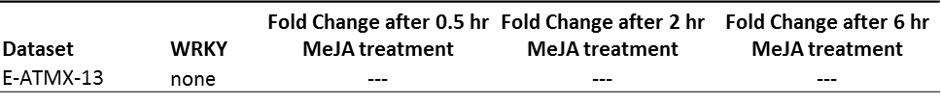
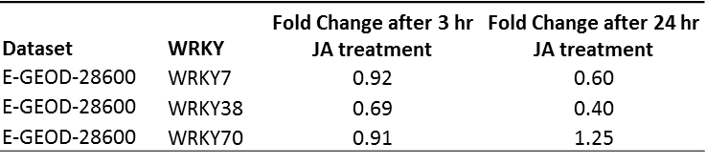
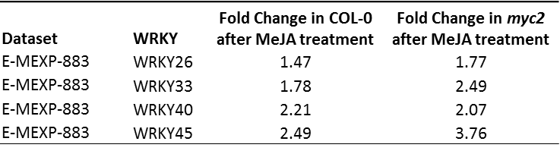
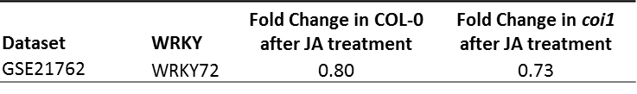
A.
B.
C.
D.
E.
Only those jasmonate responsive AtWRKYs which survived application of the B-H FDR are included.

