Supplemental Table 4. Arabidopsis WRKY TFs were analyzed for differential expression by genotype in A) coi1 and B) myc2 mutants or C) by time.
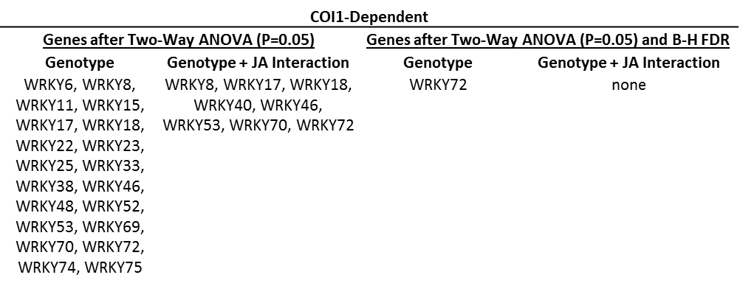
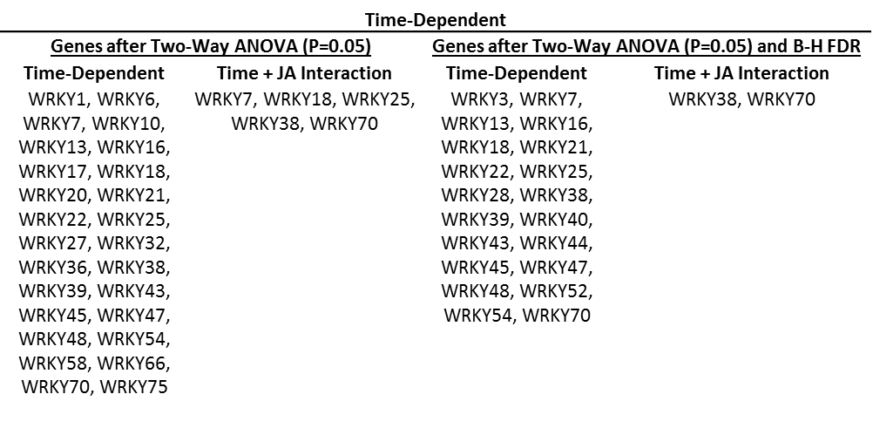
B
A
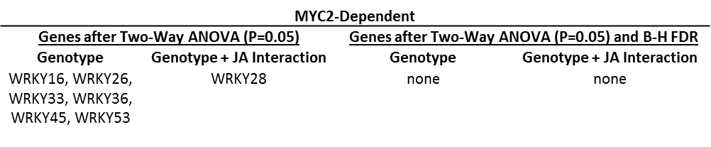
C

Analysis was performed using a two-way ANOVA. WRKYs before and after the application of the B-H FDR are presented.

