Supporting Information

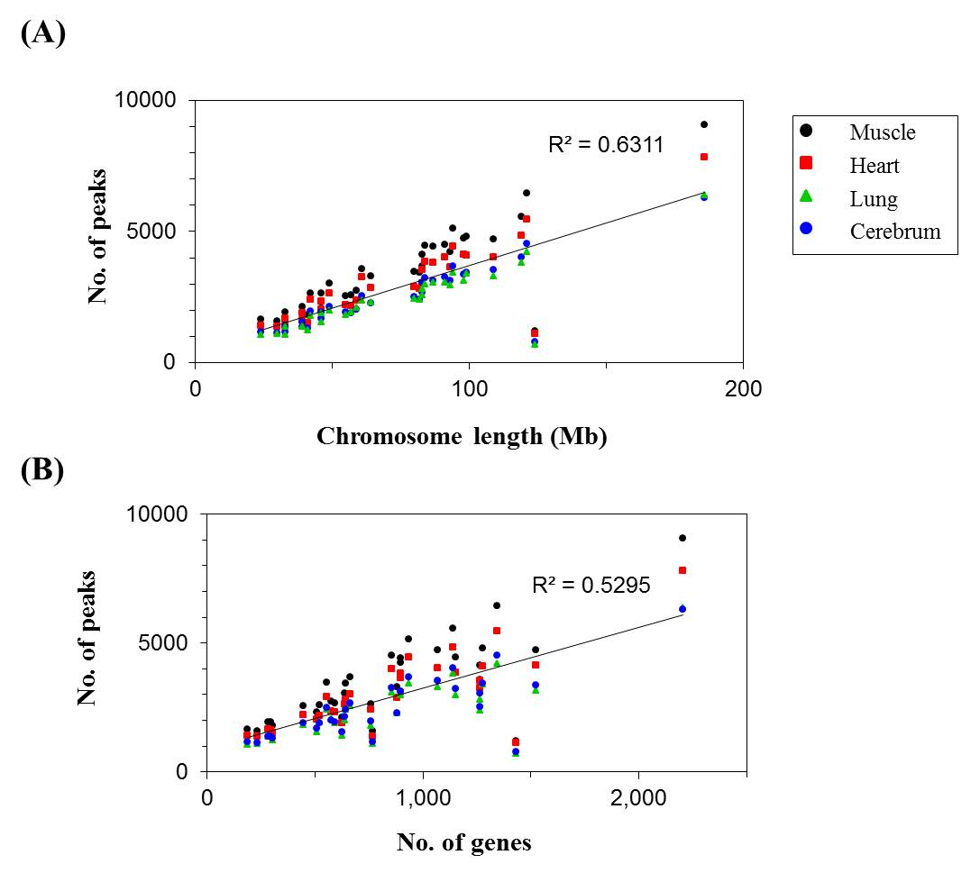
Figure S1. Pearson’s correlation between methylated peaks, chromosome length, and gene number. The peaks were plotted against chromosome length (A) and gene number (B).

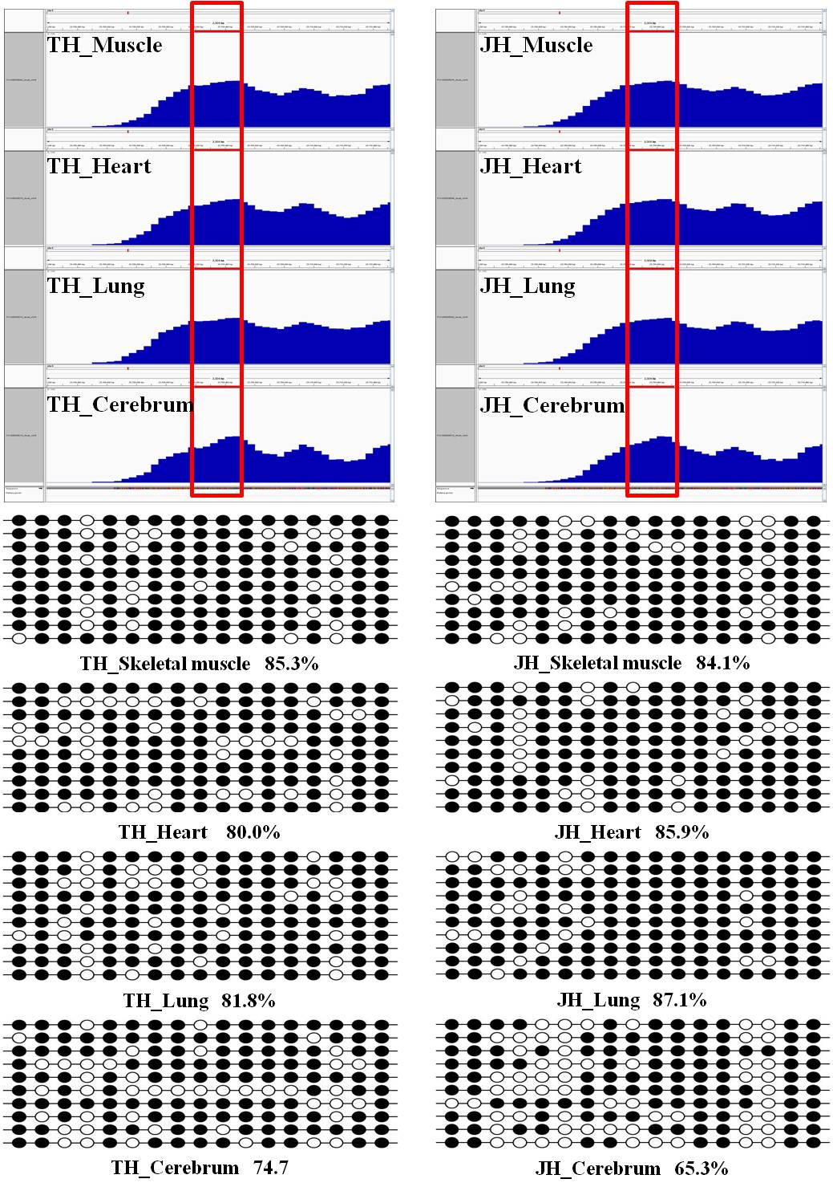
Figure S2. Validation of MeDIP-seq data by bisulfite sequencing with relatively moderate methylated region. Box indicated amplification regions. CpG dinucleotides are represented by circles on vertical bars. Each line represented an independent clone, and methylated CpGs are marked by filled circles, unmethylated CpGs by open circles.

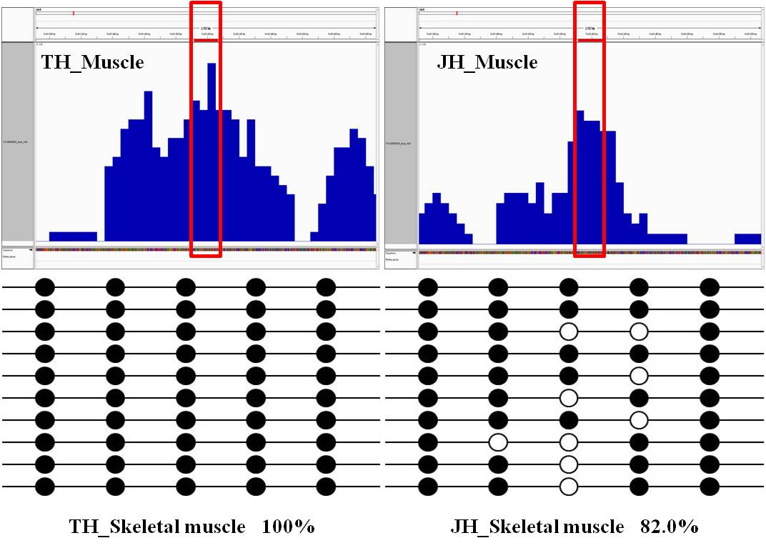
Figure S3. Validation of MeDIP-seq data by bisulfite sequencing with differentially methylated region in skeletal muscle. Box indicated amplification regions. CpG dinucleotides are represented by circles on vertical bars. Each line represented an independent clone, and methylated CpGs are marked by filled circles, unmethylated CpGs by open circles.

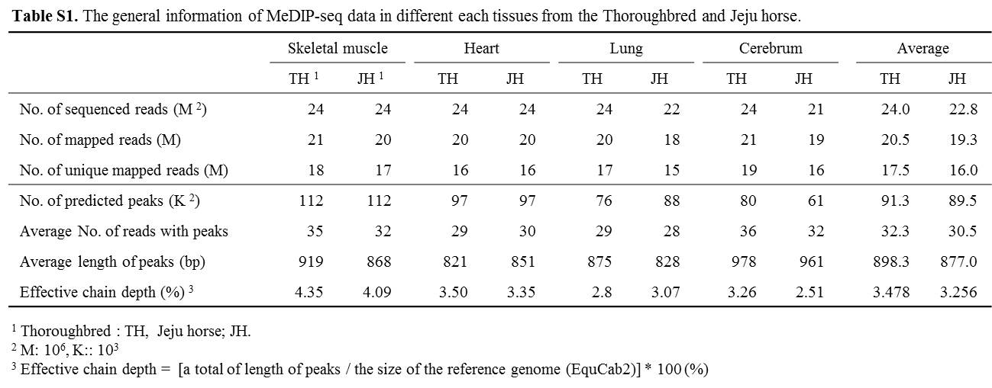

Table S2. Comparison of the number of differentially methylated regions in thoroughbred and Jeju horses.
 |  | Gene | Genome | Total
Hypermethylation | Skeletal muscle | 2542 | 4451 | 6993
Hypermethylation | Heart | 1405 | 2370 | 3775
Hypermethylation | Lung | 790 | 1386 | 2176
Hypermethylation | Cerebrum | 858 | 1669 | 2527
Hypomethylation | Skeletal muscle | 1787 | 3126 | 4913
Hypomethylation | Heart | 2659 | 4487 | 7146
Hypomethylation | Lung | 1721 | 2712 | 4433
Hypomethylation | Cerebrum | 1376 | 2128 | 3504

Table S3. The information of primers for BSP.
Primers | Primer sequence | Length (bp) | GpG  site | AT¹  (℃) | Location
P1 | F: 5'-AAG GAT ATT TAG ATA GTA TTT TAG GA-3' | 219 | 13 | 51 | chr11:37,716,808-37,717,026
P1 | R: 5'-ATT CTA ATC ACC AAT TTC CAC C-3'
P2 | F: 5'-TTT GGT TAA GAT TTG GTT GGT A-3' | 327 | 17 | 51 | chr4:25,709,192-25,709,518
P2 | R: 5'-AAC CCA AAC CTA AAA CAC ATA TCT AC-3'
P3 | F: 5'-TGG TTT AAA TAT ATT TTA AGA GGA A-3' | 148 | 5 | 55 | chr8:10,411,920-10,412,067
P3 | R: 5'-AAA CCC AAA TAA AAA ACC AC-3'
¹ Anealing temperature.

