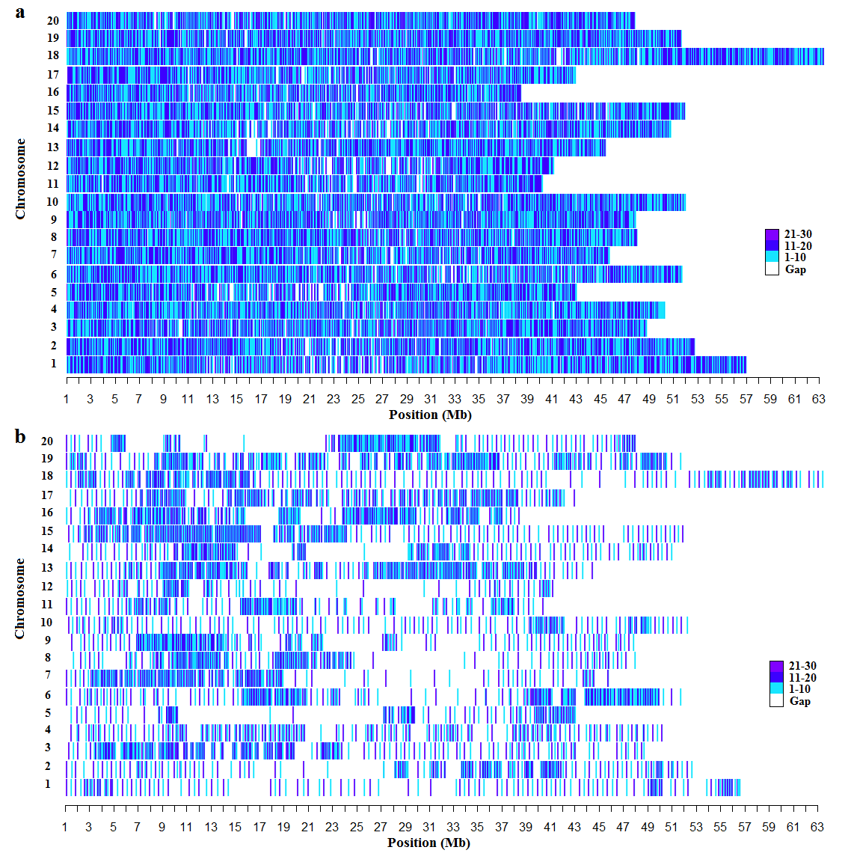
Additional file 2. SNPs Distribution of each chromosome on SoySNP 50k (a) and SoySNP 6k(b)-chip used in genotyping for panel P1 and P2 respectively. The number of SNP per 10 kb is shown as color index.

