SUPPLEMENTARY INFORMATION
Evaluation of viral genome assembly and diversity estimation in deep metagenomes
Daniel Aguirre de Cárcer, Florent E Angly & Antonio Alcamí
Suppl. Table 1. Maximum and overall contig coverage statistics.
High co. datasets | 454- CAMERA | 454- CLC |  | GAIIx- CLC |  | GAIIx- IDBA |  | GAIIx- IDBA*
Overall | 74 ±34 | 65 ±36 |  | 69 ±35 |  | 83 ±26 |  | 83 ±26
Maximum | 57.0 ±40.7 | 46.3 ±38.7 |  | 56.5 ±38.7 |  | 65.61 ±39.6 |  | 64.6 ±39.5
Maximum 95/50ª | 114/165 | 71/137 |  | 121/158 |  | 148/194 |  | 143/191
Low co. datasets | 454- CAMERA | GAIIx- IDBA |  | GAIIx- IDBA* |  | Miseq- IDBA |  | Hiseq- IDBA
Overall | 18 ±26 | 83 ±28 |  | 83 ±28 |  | 79 ±28 |  | 85 ±23
Maximum | 12.9 ±24.6 | 68.7 ±39.6 |  | 67.6 ±39.8 |  | 62.7 ±39.4 |  | 66.2 ±38.0
Maximum 95/50ª | 11/30 | 162/207 |  | 159/202 |  | 122/190 |  | 131/200
*No scaffolding. ªNumber of genomes with max contig >95% / 50%.

Suppl. Table 2. Paired Mann-Whitney tests
 |  |  | Overall contig coverage |  | Maximum contig coverage
454- CAMERA vs 454- CAMERA ^{S} |  |  | *** |  | ***
454- CAMERA vs 454- CLC |  |  | *** |  | ***
454- CAMERA vs GAIIx- CLC |  |  | ** |  | -
454- CAMERA vs GAIIx- IDBA |  |  | *** |  | ***
454- CAMERA ^{S} vs GAIIx- IDBA ^{S} |  |  | *** |  | ***
454- CAMERA ^{S} vs Miseq- IDBA ^{S} |  |  | *** |  | ***
454- CAMERA ^{S} vs Hiseq- IDBA ^{S} |  |  | *** |  | ***
454- CLC vs GAIIx- CLC |  |  | * |  | ***
454- CLC vs GAIIx- IDBA |  |  | *** |  | ***
GAIIx- CLC vs GAIIx- IDBA |  |  | *** |  | ***
GAIIx- IDBA vs GAIIx- IDBA ^{S} |  |  | - |  | ***
GAIIx- IDBA vs GAIIx- IDBAª |  |  | ** |  | ***
GAIIx- IDBA vs GAIIx- IDBA ^{S} |  |  | - |  | **
Miseq- IDBA ^{S} vs Hiseq- IDBA ^{S} |  |  | *** |  | ***
ªNo scaffolding. ^{S}Low coverage dataset. *pval<0.05. **pval<0.005. ***pval<0.0005.

Suppl. Table 3. Richness estimates. Number of species estimated for sub-samples of the GAIIx dataset using dedicated software.
#Reads | PHACCS | CatchAll(Discount)ª
2,485,933 | 11,959 | 1,417,908
248,525 | 1,874 | 239,535
24,658 | 481 | 7,612
ªBest Discounted model.

Suppl. Table 4. Design of the simulated community; including for each family relative abundance (%), total number of genomes (# genomes), and distribution of genomes into evolved siblings categories (Genome distribution).
Family | % | # genomes | Genome distribution
Microviridae | 16.67% | 50 | 10 unmodified + (2 X α [0.01/0.0025] X groups [2/8])
Circoviridae | 16.67% | 50 | 10 unmodified + (2 X α [0.01/0.0025] X groups [2/8])
Nanoviridae | 16.67% | 50 | 10 unmodified + (2 X α [0.01/0.0025] X groups [2/8])
Myoviridae | 16.67% | 50 | 10 unmodified + (2 X α [0.01/0.0025] X groups [2/8])
Siphoviridae | 16.67% | 50 | 10 unmodified + (2 X α [0.01/0.0025] X groups [2/8])
Podoviridae | 16.67% | 50 | 10 unmodified + (2 X α [0.01/0.0025] X groups [2/8])

Suppl. Figure 1. Effect of intra-group genetic similarity on genome recovery. The panels show the first two axis of principal coordinates analysis based on pairwise nucleotide similarities between sibling genomes. Only results for the intra-species groups of eight genomes where a single genome was reconstructed are shown. In the labels, the value after the letter represent maximum contig coverage values.

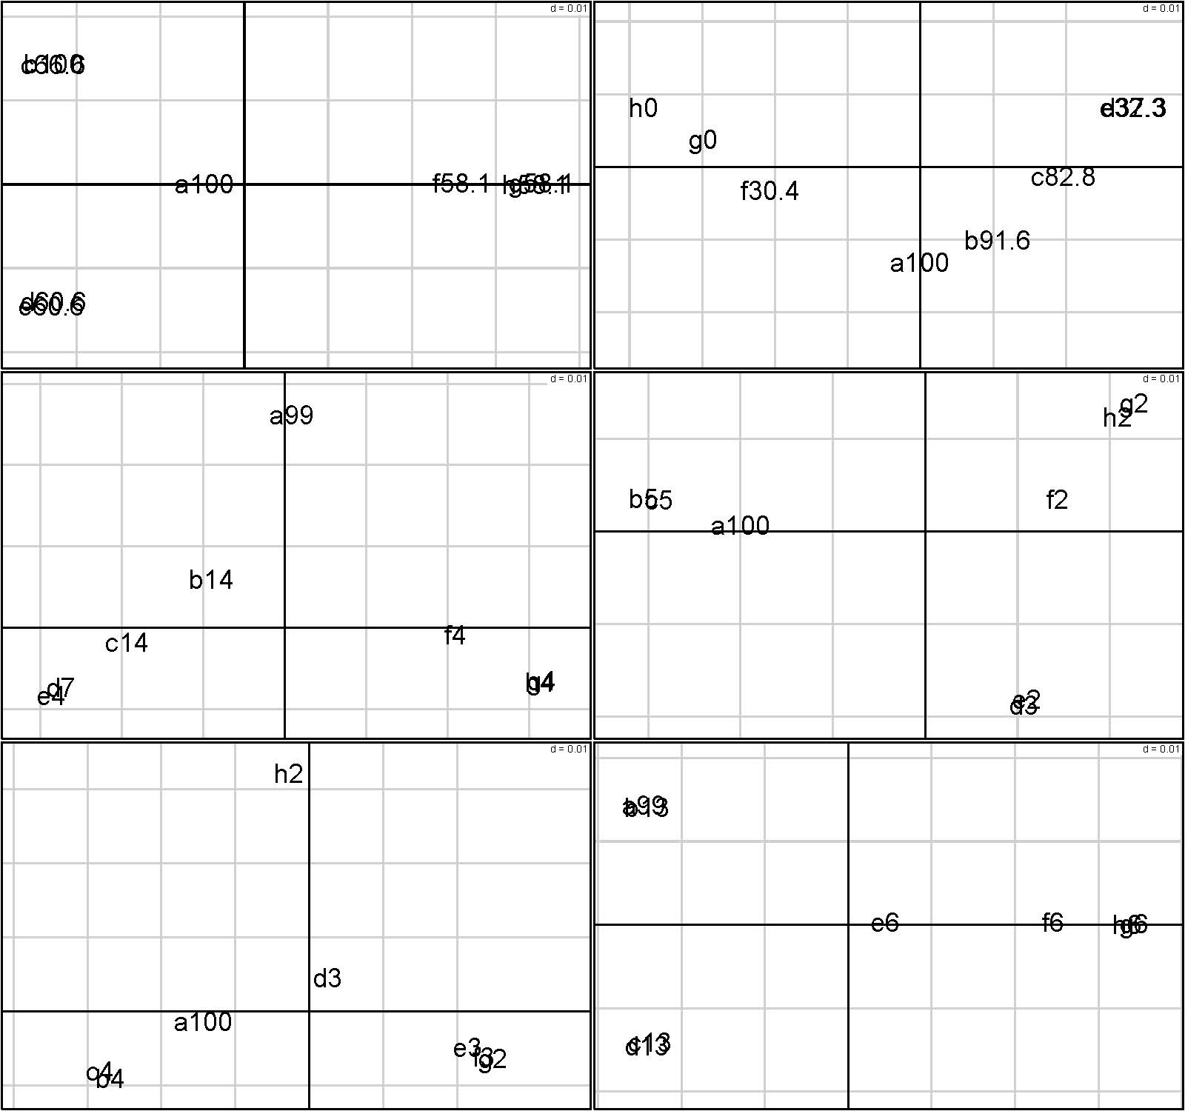

Suppl. Figure 2. PHACCS evenness estimates.
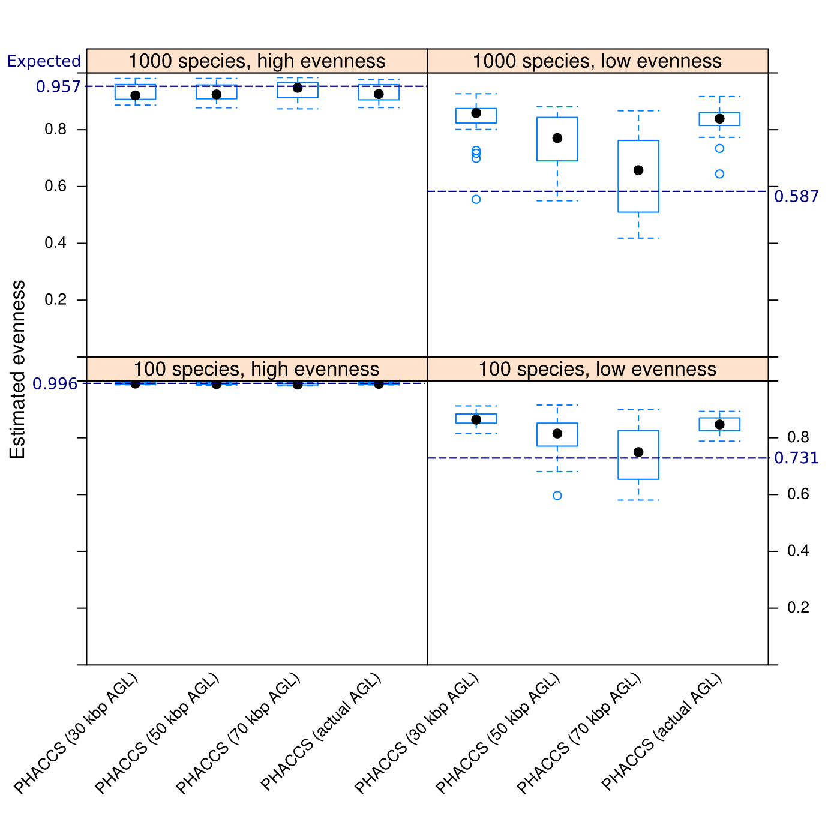

Suppl. Figure 3. CatchAll and UCLUST richness estimates corrected for genome length.
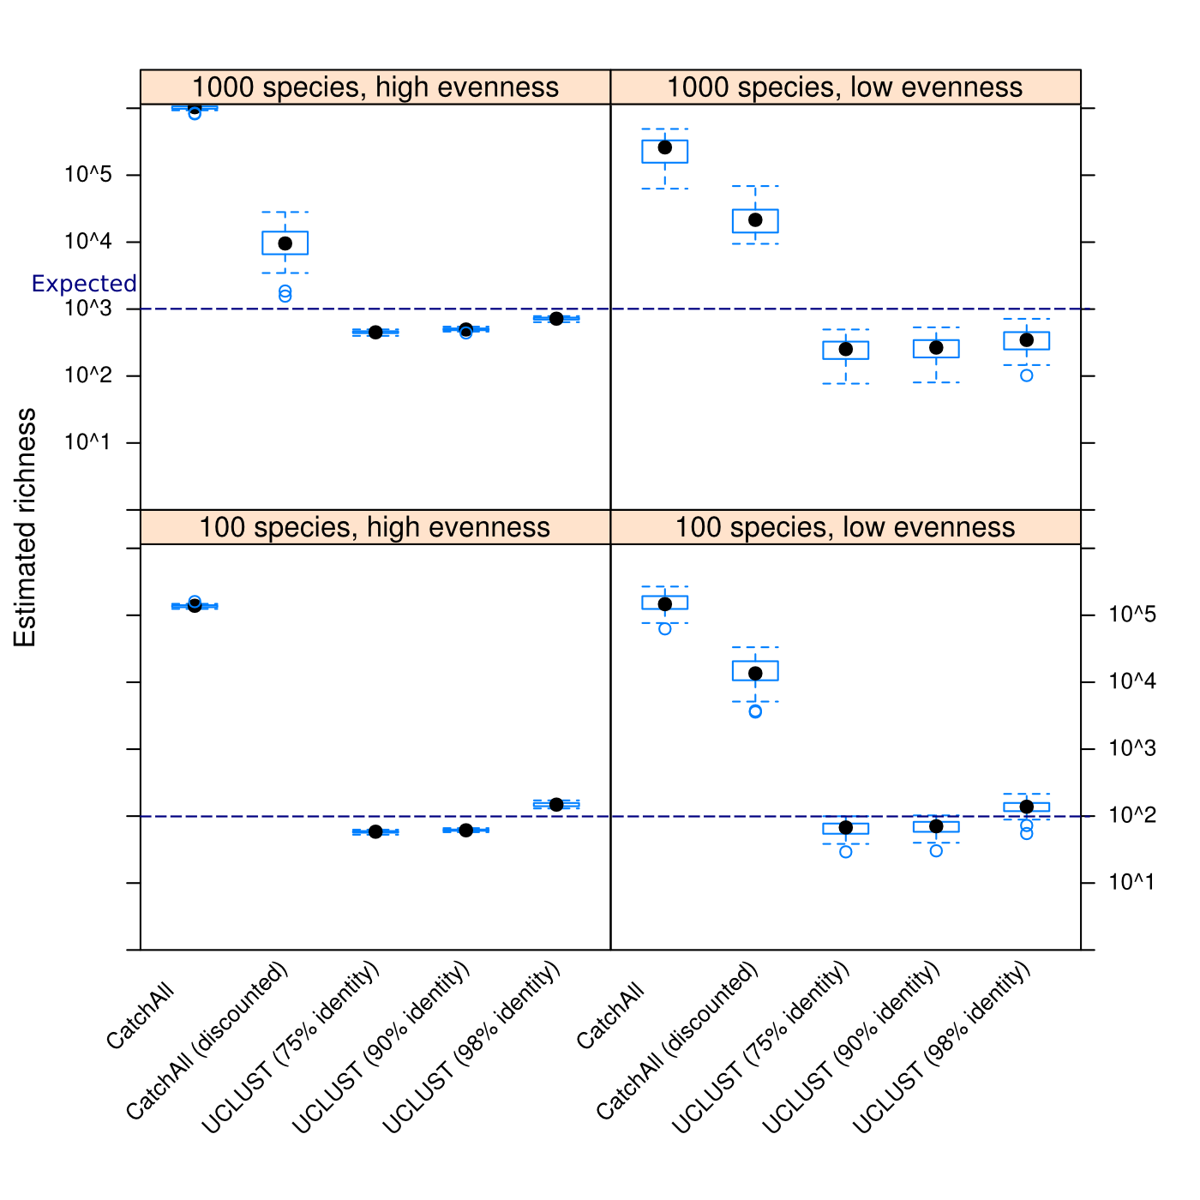

Suppl. Figure 4. Shape of the Rank-abundance curve employed for each family.

