Supporting information

Table S1: Structures and anticancer activity values of arylthioindole derivatives used in this study.
S.No. | Molecule | Structure | Actual activity (pIC50) | Predicted activity
1 | 16 | 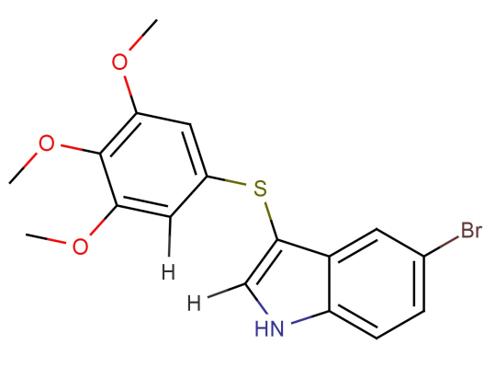 | 5.79 | 5.59086
2 | 26 | 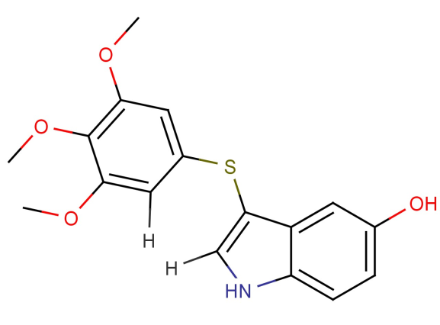 | 5.2 | 5.42972
3 | 23 | 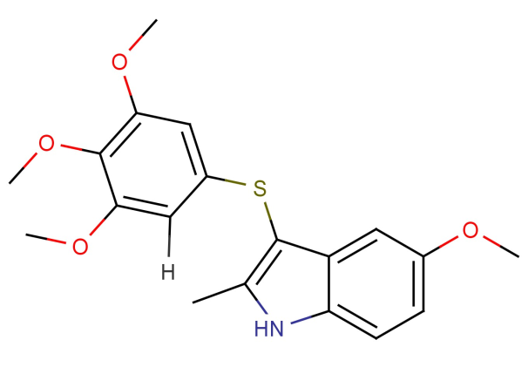 | 5.48 | 5.25563
4 | 11 | 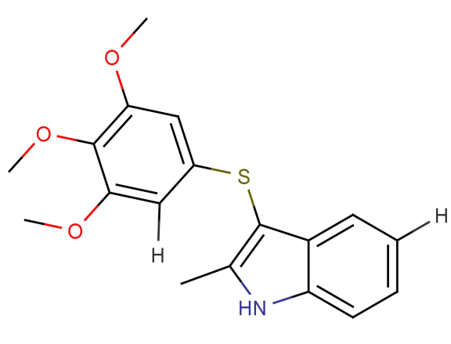 | 5.16 | 5.1787
5 | 19 | 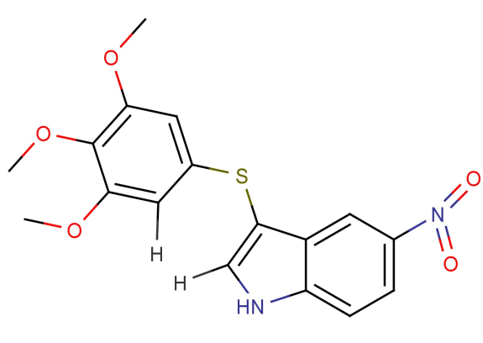 | 4.79 | 4.84748
6 | 25 | 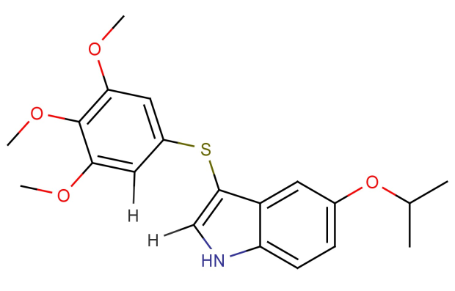 | 4.72 | 4.82379
7 | 15b | 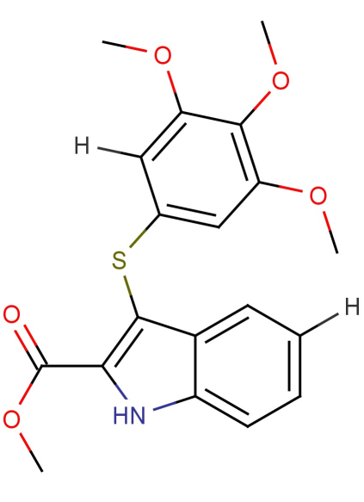 | 5.53 | 5.63467
8 | 26b | 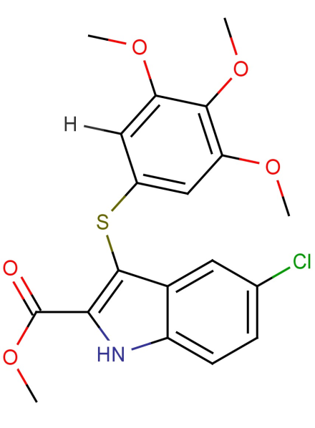 | 5.6 | 5.72292
9 | 36b | 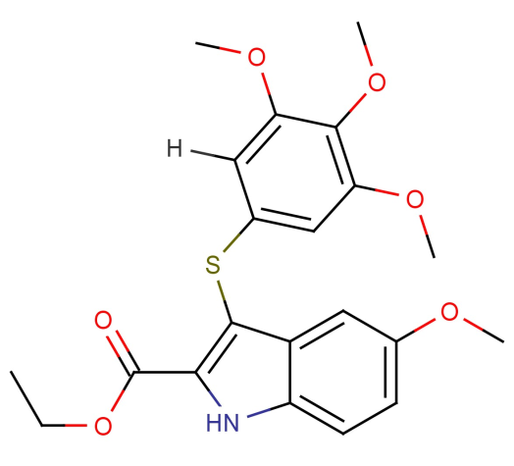 | 5.61 | 5.50157
10 | 16b | 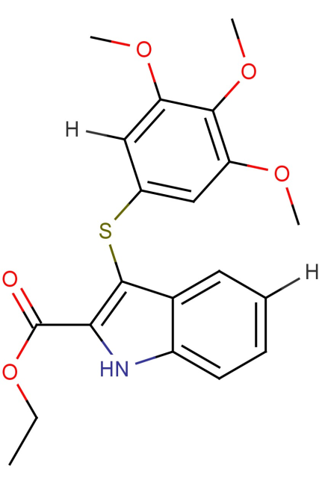 | 5.53 | 5.42464
11 | 37b | 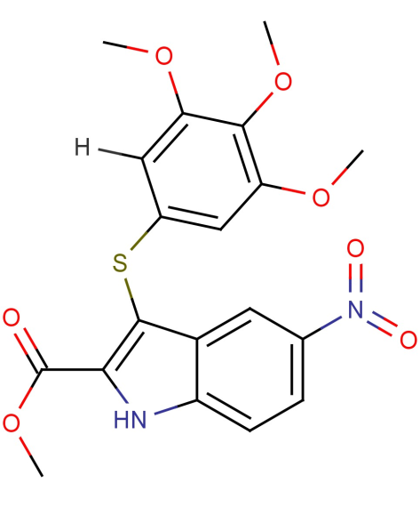 | 5.34 | 5.09342
12 | 25b | 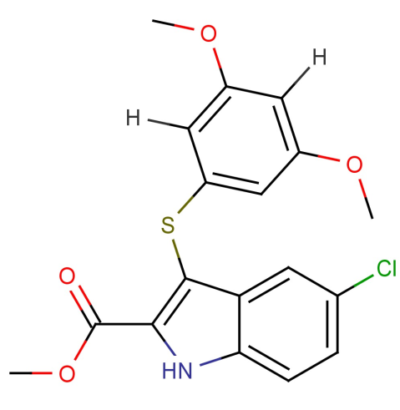 | 5.65 | 5.72292
13 | 19b | 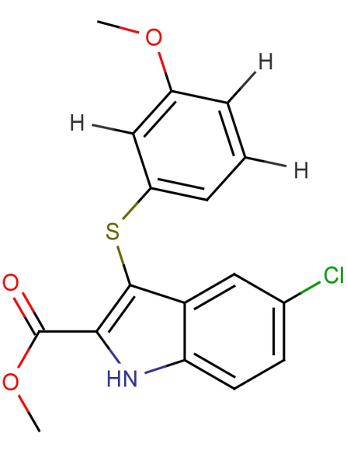 | 5.74 | 5.72292
14 | 13b | 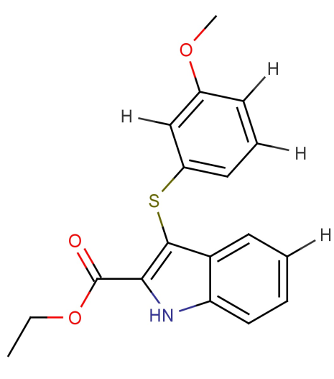 | 5.53 | 5.42464
15 | 33b | 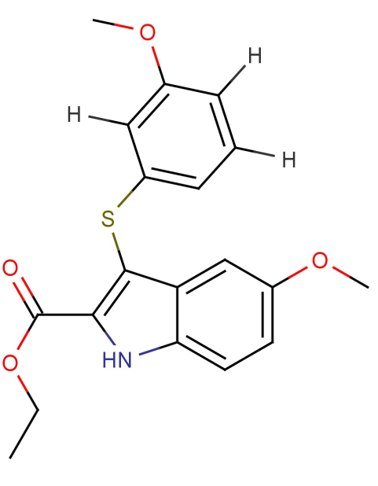 | 5.5 | 5.50157
16 | 38b | 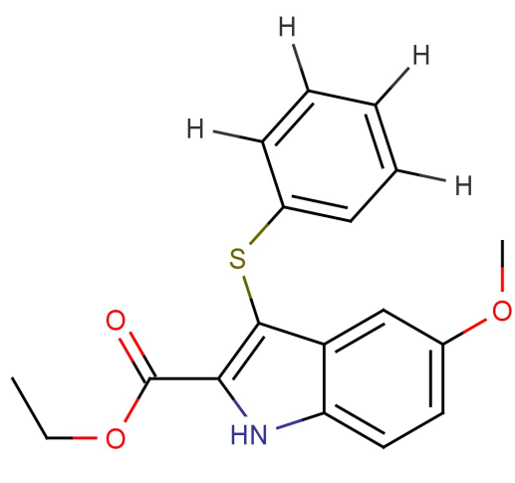 | 4.85 | 4.96478
17 | 29b | 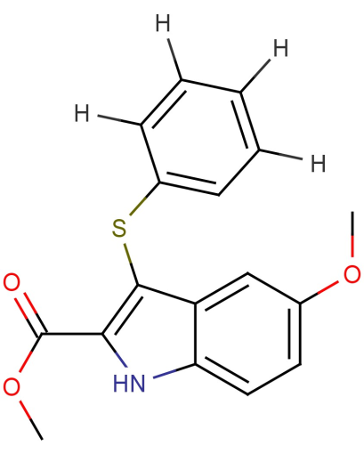 | 5.2 | 5.17481
18 | 12b | 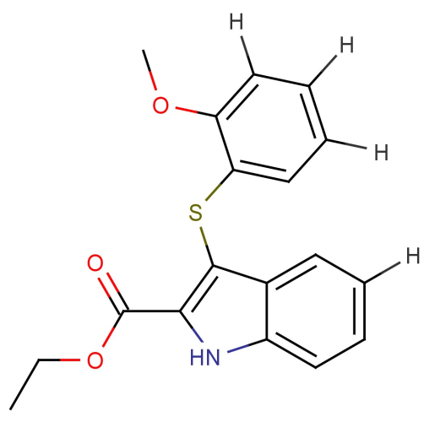 | 4.92 | 4.88785
19 | 17b | 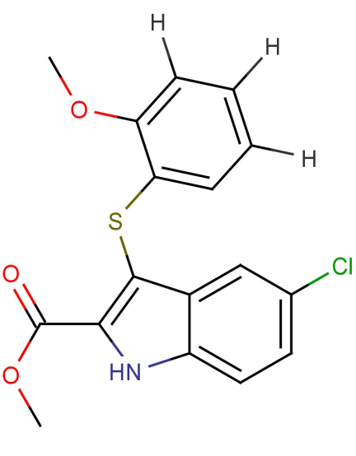 | 5.37 | 5.18613
20 | 12 | 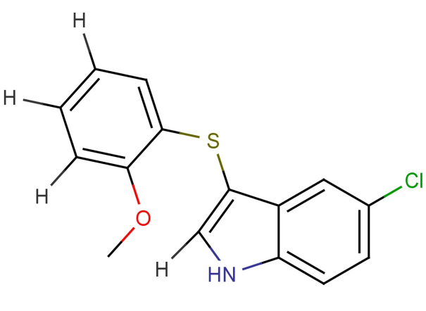 | 4.95 | 4.94019
21 | 9 | 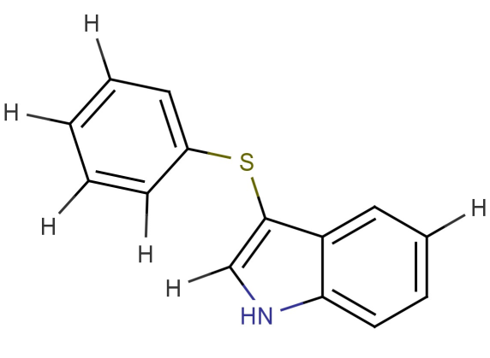 | 4.82 | 4.85194
22 | 13 | 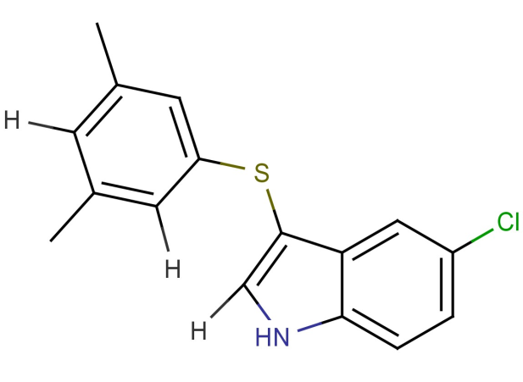 | 5.02 | 4.94019
23 | 17 | 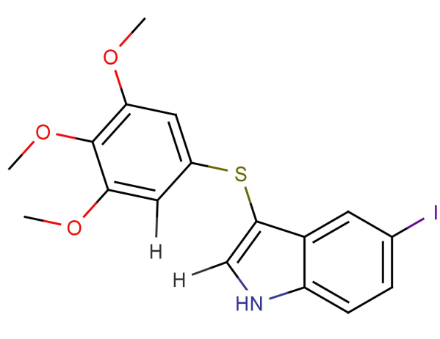 | 5.56 | 5.71129
24 | 20 | 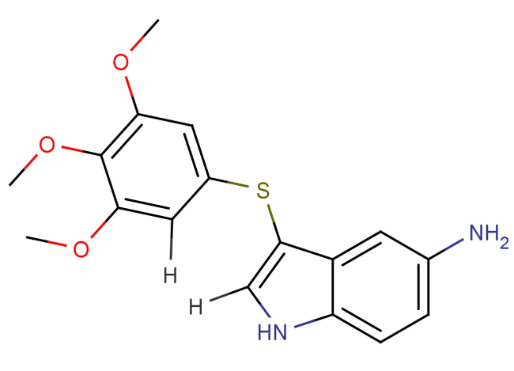 | 4.88 | 5.06205
25 | 27 | 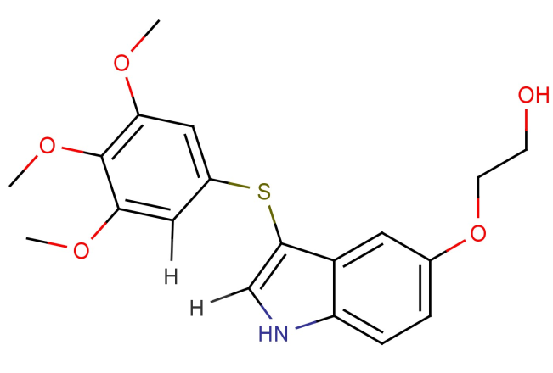 | 5.16 | 5.1305
26 | 32b | 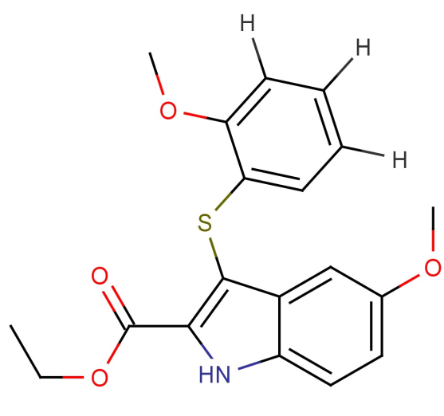 | 4.79 | 4.96478
27 | 10 | 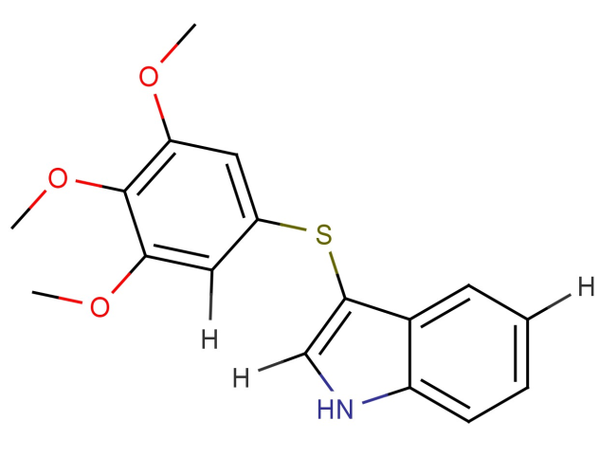 | 5.58 | 5.38873
28 | 14 | 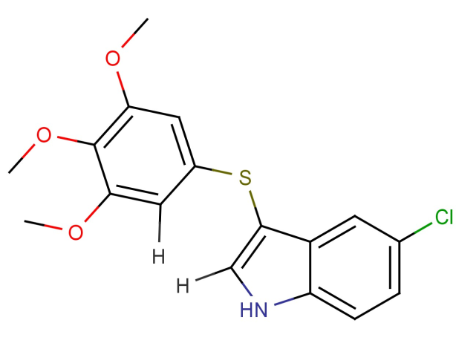 | 5.58 | 5.47698
29 | 21 | 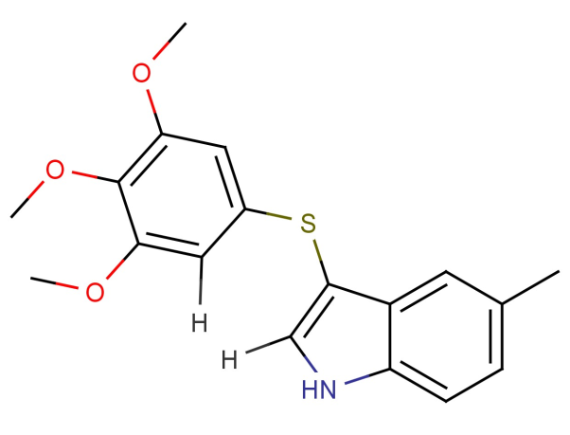 | 5.56 | 5.42467
30 | 18 | 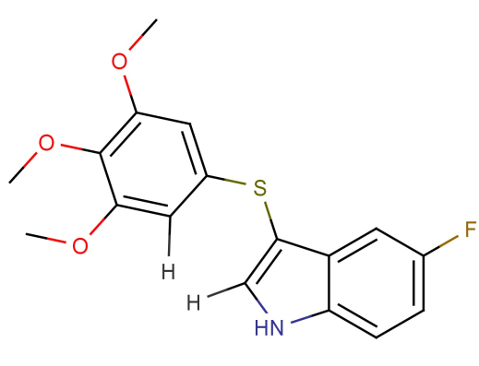 | 5.48 | 5.43482
31 | 22 | 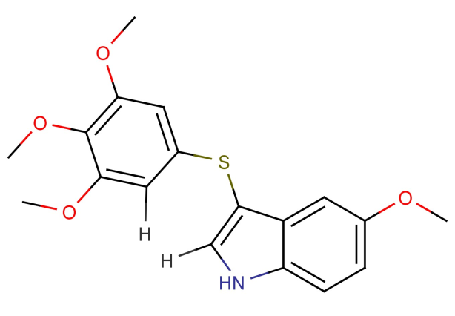 | 5.38 | 5.46566
32 | 29 | 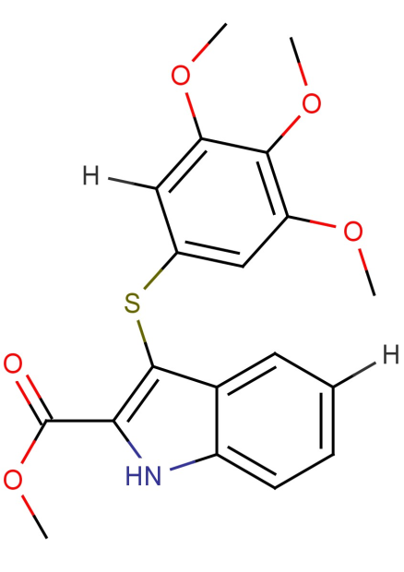 | 5.53 | 5.63467
33 | 30 | 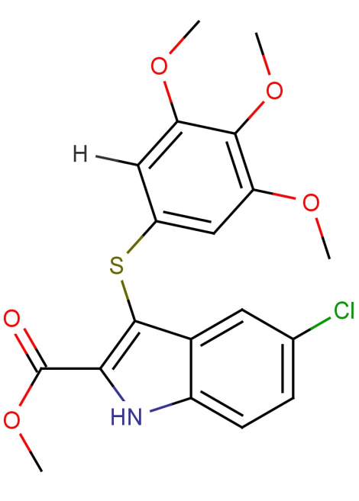 | 5.63 | 5.72292
34 | 35b | 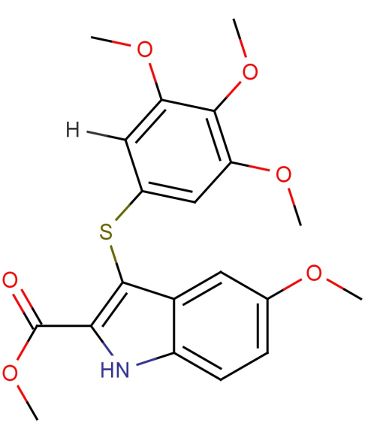 | 5.69 | 5.7116
35 | 27b | 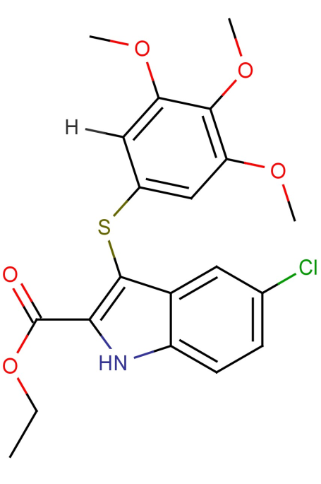 | 5.65 | 5.51289
36 | 31 | 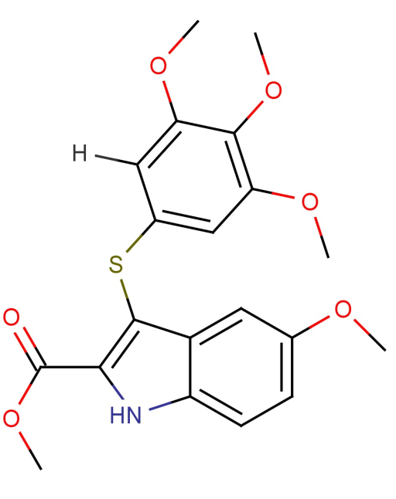 | 5.69 | 5.7116

