Additional file 1 – Flow chart

Isolate and sort cells
FACSAria cell sorter, BD Biosciences
mRNA isolation
µMACS technology, Miltenyi Biotec
Amplification (input 5µl)
Ovation pico WTA system, NuGEN
Concentrate mRNA
SpeedVac Concentrator, Eppendorf
Purify amplified anti-sence cDNA
QIAquick PCR purification, Qiagen
Exon array only: Convert to
sence cDNA (input 3µg)
WT-Ovation exon, NuGEN
(WT-Ovation Exon module)
Fragmentation/labelling (input 5 µg)
Encore biotin, NuGEN
Hybridization to gene chip array
Human Exon 1.0 ST or HG U133 Plus 2.0
Affymetrix

Selection of storage buffer for sorted cells
Gene specific amplification determined by qPCR
Comparing NuGEN protocol to standard protocol
Concordance between the pre-defined CD marker and array-based transcript expression
Biological validation
Amplified yield from FACS tonsil B-cell subsets
Tissue-independent yield and QC on microarray data
Experiments conducted

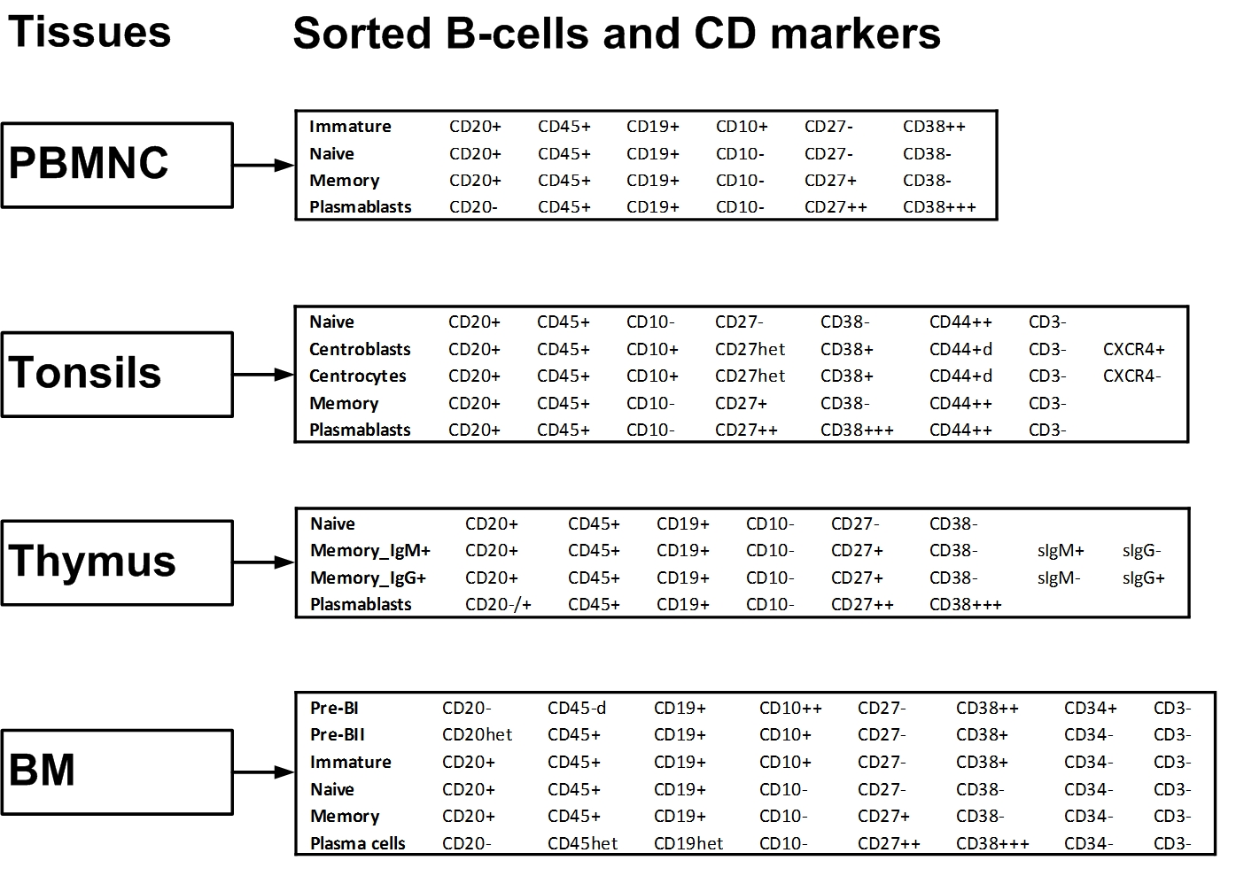

B-cell subsets in PBMNC
• Immature | CD20+ | CD45+ | CD19+ | CD10+ | CD27- | CD38++
• Naive | CD20+ | CD45+ | CD19+ | CD10- | CD27- | CD38-
• Memory | CD20+ | CD45+ | CD19+ | CD10- | CD27+ | CD38-
• Plasmablasts | CD20- | CD45+ | CD19+ | CD10- | CD27++ | CD38+++
B-cell subsets in tonsil
• Naive | CD20+ | CD45+ | CD10- | CD27- | CD38- | CD44++ | CD3-
• Centroblasts | CD20+ | CD45+ | CD10+ | CD27het | CD38+ | CD44 + d | CD3- | CXCR4+
• Ccentrocytes | CD20+ | CD45+ | CD10+ | CD27het | CD38+ | CD44 + d | CD3- | CXCR4-
• Memory | CD20+ | CD45+ | CD10- | CD27+ | CD38- | CD44++ | CD3-
• Plasmablasts | CD20+ | CD45+ | CD10- | CD27++ | CD38+++ | CD44++ | CD3-
B-cell subsets in thymus
• Naive | CD20+ | CD45+ | CD19+ | CD10- | CD27- | CD38-
• Memory_IgM+ | CD20+ | CD45+ | CD19+ | CD10- | CD27+ | CD38- | sIgM+ | sIgG-
• Memory_IgG+ | CD20+ | CD45+ | CD19+ | CD10- | CD27+ | CD38- | sIgM- | sIgG+
• Plasmablasts | CD20−/+ | CD45+ | CD19+ | CD10- | CD27++ | CD38+++
B-cell subsets in BM
• Pre-BI | CD20- | CD45-d | CD19+ | CD10++ | CD27- | CD38++ | CD34+ | CD3-
• Pre-BII | CD20het | CD45+ | CD19+ | CD10+ | CD27- | CD38+ | CD34- | CD3-
• Immature | CD20+ | CD45+ | CD19+ | CD10+ | CD27- | CD38+ | CD34- | CD3-
• Naive | CD20+ | CD45+ | CD19+ | CD10- | CD27- | CD38- | CD34- | CD3-
• Memory | CD20+ | CD45+ | CD19+ | CD10- | CD27+ | CD38- | CD34- | CD3-
• Plasma cells | CD20- | CD45het | CD19het | CD10- | CD27++ | CD38+++ | CD34- | CD3-

