Additional file 9 - Biological validation in tonsils on the U133 array
Figure 1
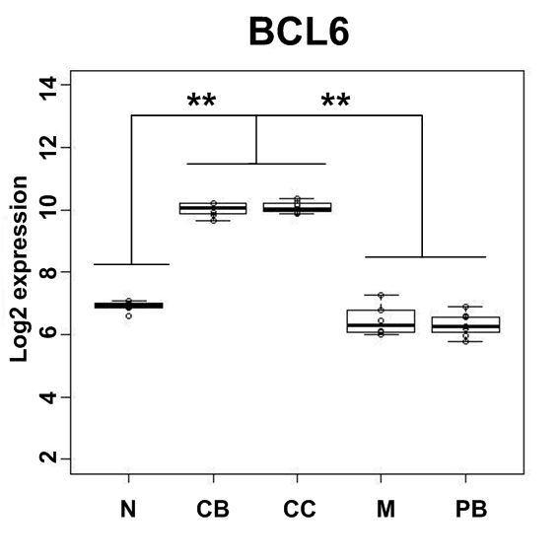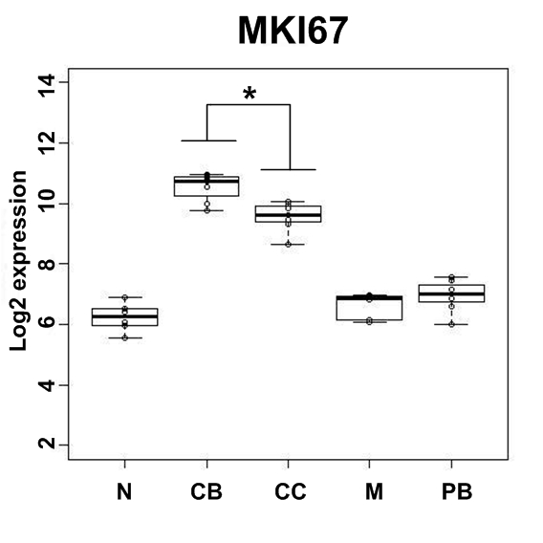
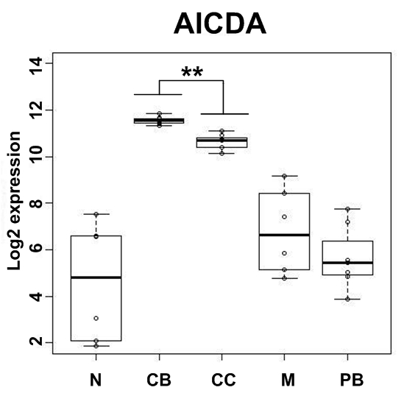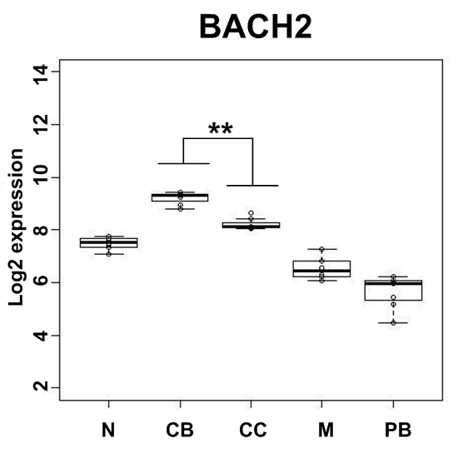
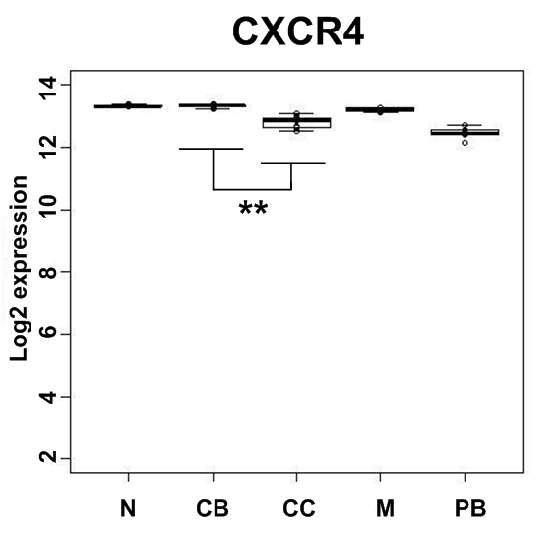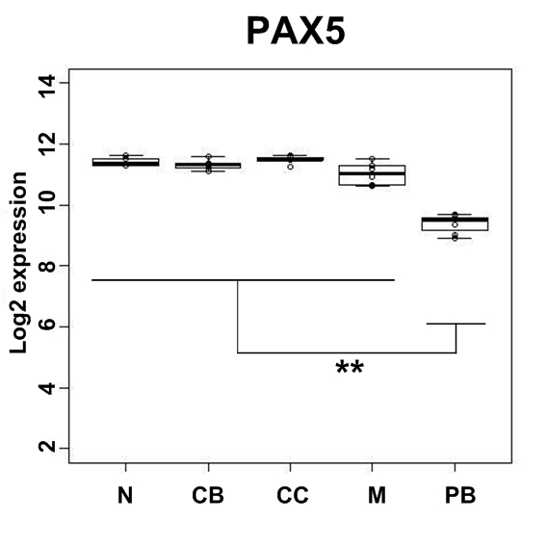
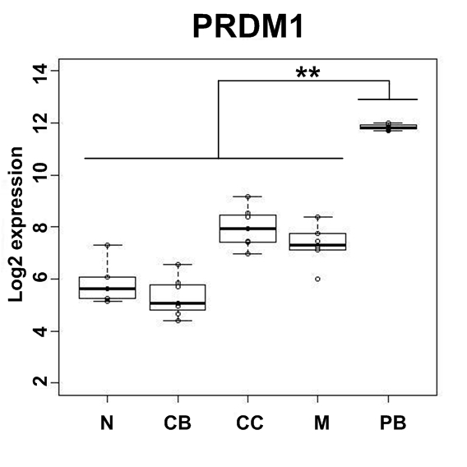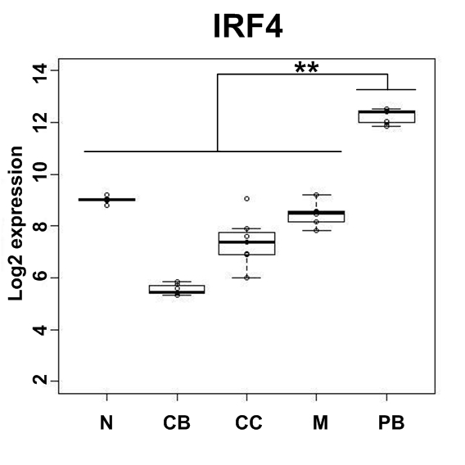
BCL6 is the master regulator of the GC reaction [1] and were significantly up-regulated in CB and CC compared to the other B-cell subsets.
MKI67 is a proliferation marker and were significantly up-regulated in CB compared to CC as expected [2,3].
AICDA involved in somatic hypermutation (SHM) and isotype class switch recombination (CSR) in GC B-cells [4] were significantly up-regulated in CB and CC compared to the other B-cell subsets. In addition, AICDA were significantly higher expressed in CB compared to CC.
BACH2 required for SHM and CSR [1] were significantly up-regulated in CB and CC compared to the other B-cell subsets. In addition, BACH2 were significantly higher expressed in CB compared to CC.
CXCR4 used to discriminate between CB and CC in the FACS purification step was significantly higher expressed in CB.
PAX5, which is essential for early commitment to the B-cell lineage and maintained in all B-cell subsets, except in PB/PC [5], was significantly up-regulated in the four B-cell subsets compared to the PB.
The TFs PRDM1 and XBP1, which promote and facilitate PC differentiation [6], were significantly up-regulated in PC.

Reference List

1. Schmidlin H, Diehl SA, Blom B: New insights into the regulation of human B-cell differentiation. Trends Immunol 2009, 30: 277-285.
2. Caron G, Le GS, Lamy T, Tarte K, Fest T: CXCR4 expression functionally discriminates centroblasts versus centrocytes within human germinal center B cells. J Immunol 2009, 182: 7595-7602.
3. Victora GD, Schwickert TA, Fooksman DR, Kamphorst AO, Meyer-Hermann M, Dustin ML et al.: Germinal center dynamics revealed by multiphoton microscopy with a photoactivatable fluorescent reporter. Cell 2010, 143: 592-605.
4. Gazumyan A, Bothmer A, Klein IA, Nussenzweig MC, McBride KM: Activation-induced cytidine deaminase in antibody diversification and chromosome translocation. Adv Cancer Res 2012, 113: 167-190.
5. Cattoretti G, Shaknovich R, Smith PM, Jack HM, Murty VV, Alobeid B: Stages of germinal center transit are defined by B cell transcription factor coexpression and relative abundance. J Immunol 2006, 177: 6930-6939.
6. Matthias P, Rolink AG: Transcriptional networks in developing and mature B cells. Nat Rev Immunol 2005, 5: 497-508.

