Supplemental Figure – 1 E. histolytica LCAT gene family

A
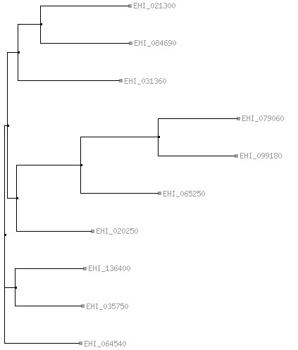

B

EHI_079060+300_|length=1089rev -------------------------------------------------- EHI_099180reversecomplement TCAATTGCAAACATAAGAATAAACTTCTTCATATACTGCTTTACTATCTA EHI_065250reversecomplement TCAATTGCAAACAAAAGGATAAACTGCTTTATATGATGCTTTACTATCTA

EHI_079060+300_|length=1089rev -------------------------------------------------- EHI_099180reversecomplement ATATTCCCGTGTGTGTATATTTTCCTAAATTTTTAAATGTTGTTGCTCCA EHI_065250reversecomplement ATATTCCTGTGTGTGTATATTTTCCTAAATTCTCAAATGTCTCTGCTCCA

EHI_079060+300_|length=1089rev ------------------------------------------------TC EHI_099180reversecomplement ATATTCTTACAAAATTCTAATGAGTTCAAATTTACTGTTTCATCTCCATC EHI_065250reversecomplement ATATTTTGACAAAATTCTAATGAATTCAAATTAACCGTACCATCTCCATC
**

EHI_079060+300_|length=1089rev ACTATATAAAAGTTTACTGTCACTATCATAACTTTCATTTTCCATTTCTA EHI_099180reversecomplement ACTATATAAAAGTTTACTGTCACTATCATAACTTTCATTTTCCATTTCTA EHI_065250reversecomplement ACTATATAAAAGTTTACTGTCACTATCATAACTTTCATTTTCCATTTCTA
**************************************************

EHI_079060+300_|length=1089rev CACCTTTAATACTTTCATATCCTGATGATATCATACATTGCATTTTAATA EHI_099180reversecomplement CACCTTTAATACTTTCATATCCTGATGATATCATACATTGCATTTTAATA EHI_065250reversecomplement CTCCATCAATGCTTTCATGTCCTGATGATATTAAACAATGCATTTTAATA
* ** * *** ******* ************ * *** ************

A) Dendogram illustrating the similarity of the 10 gene LCAT family with EHI_065250 B) LCAT EHI_065250 sequences targeted for amplification (using the underlined primer sequences) aligned with the most similar members of the gene family. Mismatches highlighted in red. A double underline indicates the location LCAT EHI_065250 SNPs.

