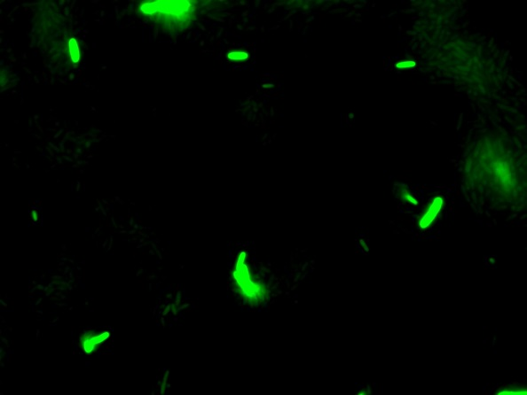
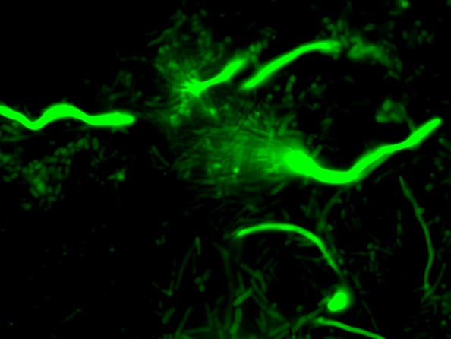
B
A
C
Fig. 6
flhD::gfp in AJW678
flhD::gfp in AJW2050

