Support Information
Diffusible signal factor (DSF) quorum sensing signal and its structurally related moleculesenhance the antimicrobial efficacy of antibiotics against some bacterial pathogens

Yinyue Deng^{1, 2}, Amy Lim¹, Jasmine Lee¹, Shaohua Chen², Chao Wang¹, Shuwen An¹, Yi-Hu Dong¹, and Lian-Hui Zhang^{1, 2}*

¹Institute of Molecular and Cell Biology, Proteos, 61 Biopolis Drive, Singapore 138673, Singapore
²Guangdong Province Key Laboratory of Microbial Signals and Disease Control, College of Natural Resources and Environment, South China Agricultural University, Guangzhou, People's Republic of China

Experimental methods:
RNA extraction and Microarray analysis
B. cereus 10987 was grown in LB medium in the absence and presence of 50 μM DSF till OD₆₀₀ of 1.5. Total RNA was isolated using the RNeasy mini kit (Qiagen) according to the manufacturer’s instructions. The concentration and purity of RNA were determined by agarose gel electrophoresis and spectrometry. Microarray assay experiment was finished by the Genomax company under a commercial contact, which is briefly described as followed.
cDNA was synthesized from total RNA samples by using random primers (Invitrogen). SuperScript II (Invitrogen) and biotin-ddUTP was used to label the product according to the protocol from Affymetrix (Affymetrix). Target hybridization, washing and staining were performed according to the manufacture’s instructions. Genechip arrays were scanned with an Affymetrix probe array scanner. The microarray analysis for each bacterial strain was repeated for two times and the data were analyzed using a statistics software MAS-5.0 from Affymetrix.

qRT-PCR analysis
qRT-PCR quantifications were performed with a LightCycler® (Roche™) and QuantiFast SYBR Green (Qiagen™) according to the manufacturers’ instructions. The experiments were performed in triplicate, and the data were determined from two independent experiments. Expression levels were normalized to levels of the 16S RNA gene transcript in each experiment.

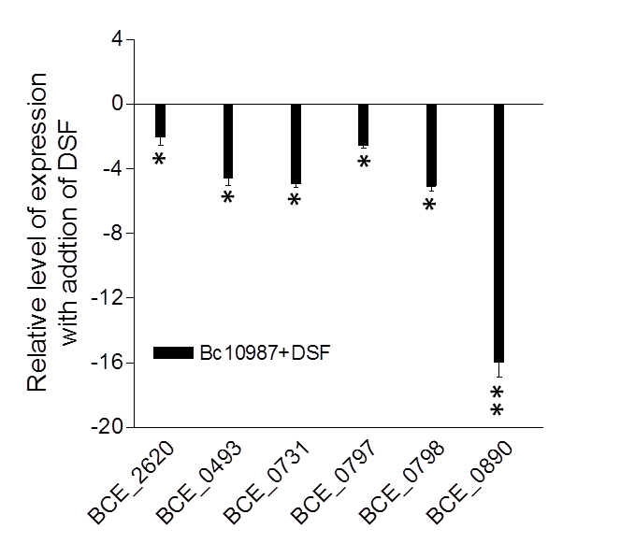
Figure S1. Real-time PCR analysis of DSF effect on transcriptional expression of selected genes in B. cereus 10987. Data shown are means of two replicates and error bars indicate the standard deviations. The differences between the sample with addition of 50 μM DSF and control are statistically significant with *p<0.05, ** p<0.01 as determined by using the Student t test.

Table S1. The genes with increased or decreased expression in B. cereus after treatment with 50 μM DSF

Gene |  | Accession No. | Function |  |  | Fold Change
BCE_4746 |  | AAS43647.1 | Hypothetical protein |  |  | -24.3
BCE_0723 |  | AAS39656.1 | Hypothetical protein |  |  | -17.1
BCE_0890 |  | AAS39821.1 | periplasmic component of efflux system |  |  | -10.1
BCE_4985 |  | AAS43886.1 | ABC transporter |  |  | -9.5
BCE_4107 |  | AAS43009.1 | Hypothetical protein |  |  | -9.3
MmgD |  | AAS41294.1 | citrate synthase 3 |  |  | -6.7
Sph |  | AAS39678.1 | sphingomyelin phosphodiesterase |  |  | -5.9
BCE_3622 |  | AAS42527.1 | anaerobic ribonucleoside triphosphate reductase |  |  | -4.6
BCE_3280 |  | AAS42188.1 | Hypothetical protein |  |  | -3.7
BCE_4566 |  | AAS43467.1 | Hypothetical protein |  |  | -3.5
BCE_2376 |  | AAS41294.1 | citrate synthase 3 |  |  | -3.4
BCE_5189 |  | AAS44090.1 | Hypothetical protein |  |  | -3.4
BCE_5156 |  | AAS44057.1 | chloramphenicol resistance protein |  |  | -3.3
BCE_3792 |  | AAS42697.1 | Hypothetical protein |  |  | -3.2
BCE_0797 |  | AAS39729.1 | ABC transporter permease |  |  | -3.2
BCE_0225 |  | AAS39161.1 | Hypothetical protein |  |  | -3.2
BCE_5195 |  | AAS44096.1 | cell surface protein |  |  | -3.1
BCE_0798 |  | AAS39730.1 | ABC transporter |  |  | -3.0
BCE_2763 |  | AAS41675.1 | Hypothetical protein |  |  | -3.0
BCE_0928 |  | AAS39859.1 | Multidrug resistance protein B |  |  | -2.9
BCE_3793 |  | AAS42698.1 | 1-phosphatidylinositol phosphodiesterase |  |  | -2.9
BCE_4973 |  | AAS43874.1 | Hypothetical protein |  |  | -2.9
BCE_0747 |  | AAS39680.1 | flavin-dependent dehydrogenase |  |  | -2.8
BCE_3793 |  | AAS42698.1 | 1-phosphatidylinositol phosphodiesterase precursor |  |  | -2.6
BCE_1951 |  | AAS40875.1 | chlorohydrolase |  |  | -2.5
BCE_4973 |  | AAS43874.1 | Hypothetical protein |  |  | -2.5
BCE_1914 |  | AAS40838.1 | 3-oxoacyl-(acyl carrier protein) synthase III |  |  | -2.5
BCE_0817 |  | AAS39749.1 | guanine-hypoxanthine permease |  |  | -2.4
BCE_4751 |  | AAS43652.1 | Hypothetical protein |  |  | -2.4
BCE_2880 |  | AAS41791.1 | Tc resistance protein |  |  | -2.4
BCE_0762 |  | AAS39695.1 | amino acid permease family protein |  |  | -2.4
BCE_A0228 |  | AAS45076.1 | Hypothetical protein |  |  | -2.3
BCE_0486 |  | AAS39421.1 | hydroxyethylthiazole kinase |  |  | -2.2
BCE_0731 |  | AAS39664.1 | Multidrug resistance protein B |  |  | -2.2
BCE_0817 |  | AAS39749.1 | xanthine/uracil permease family protein |  |  | -2.2
BCE_1296 |  | AAS40225.1 | Hypothetical protein |  |  | -2.1
BCE_0800 |  | AAS39732.1 | glycine oxidase |  |  | -2.1
BCE_0493 |  | AAS39428.1 | ABC transporter |  |  | -2.1
BCE_2620 |  | AAS41534.1 | ABC transporter |  |  | -2.1
BCE_0617 |  | AAS39551.1 | Hypothetical protein |  |  | -2.0
BCE_4949 |  | AAS43850.1 | cytochrome d ubiquinol oxidase subunit |  |  | -2.0
BCE_2927 |  | AAS41838.1 | inosine-uridine preferring nucleoside hydrolase |  |  | -2.0
BCE_0617 |  | AAS39551.1 | lipoprotein |  |  | -2.0
BCE_4950 |  | AAS43851.1 | cytochrome d ubiquinol oxidase, subunit II |  |  | -2.0
BCE_1648 | AAS40577.1 |  | Hypothetical protein |  | -2.0
BCE_4558 | AAS43459.1 |  | MarR family transcriptional regulator | 2.0
TrpS | AAS40226.1 |  | tryptophanyl-tRNA synthetase | 2.0
BCE_2037 | AAS40961.1 |  | NLP/P60 family protein | 2.0
BCE_4324 | AAS43225.1 |  | sodium:dicarboxylate symporter family protein | 2.1
BCE_3075 | AAS41986.1 |  | nitroreductase family protein | 2.1
RpsT | AAS43304.1 |  | 30S ribosomal protein S20 | 2.3
BCE_2344 | AAS41262.1 |  | thioredoxin family protein | 2.4
BCE_4457 | AAS43358.1 |  | Hypothetical protein | 2.7
BCE_3932 | AAS42835.1 |  | carbamoyl phosphate synthase small subunit | 2.7
BCE_4764 | AAS43665.1 |  | argininosuccinate lyase | 2.8
BCE_4456 | AAS43357.1 |  | 5'-methylthioadenosine/S-adenosylhomocysteine nucleosidase | 2.9
RbsA | AAS39668.1 |  | ribose ABC transporter ATP-binding protein | 2.9
GntB | AAS41222.1 |  | gluconate transporter, permease protein | 3.0
BCE_0736 | AAS3966.1 |  | ribose ABC transporter permease | 3.5
BCE_1935 | AAS40859.1 |  | acetolactate synthase III, small subunit, truncation | 3.6
BCE_1839 | AAS40764.1 |  | lps o-antigen biosynthesis protein | 4.3
BCE_0642 | AAS39575.1 |  | malate dehydrogenase, putative | 15.9
*Change (fold) in B. cereus in the presence of DSF compared to in the absence of DSF determined by microarray analysis.

A
B

C
D
E
Figure S2. The bacterial growth rate of B. thuringiensis (A), S. aureus (B), M. smegmatis (C), N. subflava (D), and P. aeruginosa (E) in the presence or absence of 50 μM DSF or its analogue. The error bars show the standard deviations of three replicates.

Figure S3. Effect of DSF signal and rhamnolipid on the growth rate of B. thuringiensis. Bacterial growth was monitored using the Bioscreen-C Automated Growth Curves Analysis System, and the data at 16 h post inoculation were presented here. The error bars show the standard deviations of three replicates.

Table S2. Bacterial strains used in this study
Strains |  | Characteristics | Growth Temperature (ºC) |  | Source
Bacillus cereus  ATCC10987 |  | Wild- type strain | 37 |  | ATCC
Bacillus  thuringiensis 23 |  | B. thuringiensis subsp. israelensis B23, plasmidless | 37 |  | BGSC
Staphylococcus  aureus |  | Mouse isolate | 37 |  | Laboratory collection
Mycobacterium  smegmatis |  | Wild- type strain | 28 |  | Laboratory collection
Neisseria subflava |  | Wild- type strain | 37 |  | Laboratory collection
Pseudomonas aeruginosa PA14 |  | Clinical isolate | 37 |  | Laboratory collection

