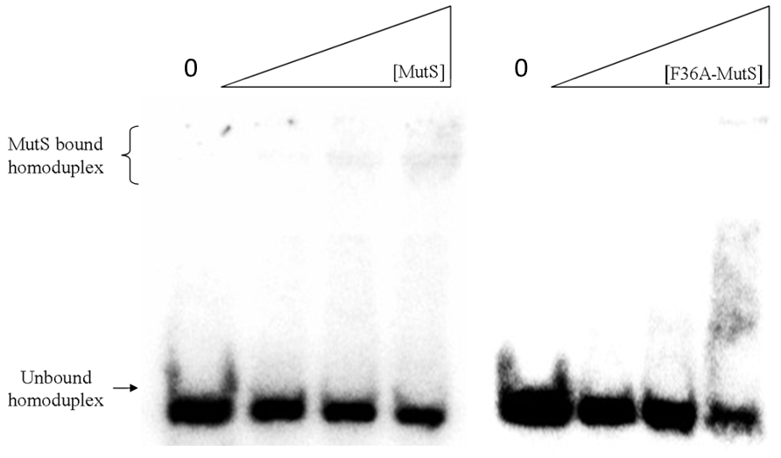

Additional file 6 - Neither MutS nor MutS F36A specifically bind homoduplex DNA.
Mobility shift assay using purified MutS and MutS F36A and labeled homoduplex oligonucleotide. Lane 1, far left, is a negative control with radiolabeled homoduplex DNA but no protein. Lanes 2-4 contain increasing amounts of MutS (38, 75 and 150 nM). Lanes 6-8 contain increasing amounts of MutS F36A (38, 75 and 150 nM).

