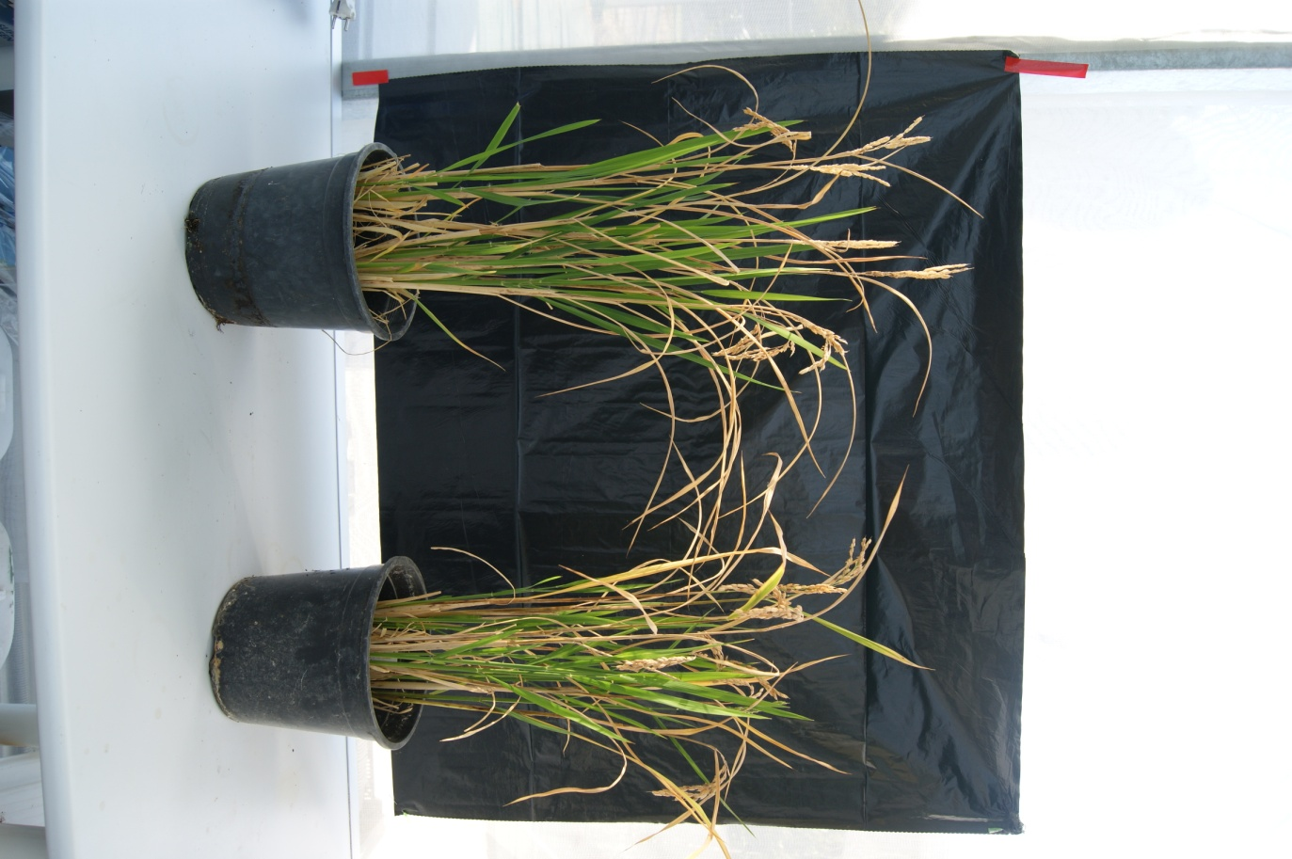
Additional File 4
Senia
S-bp100.2i

