Supplemental Table S1

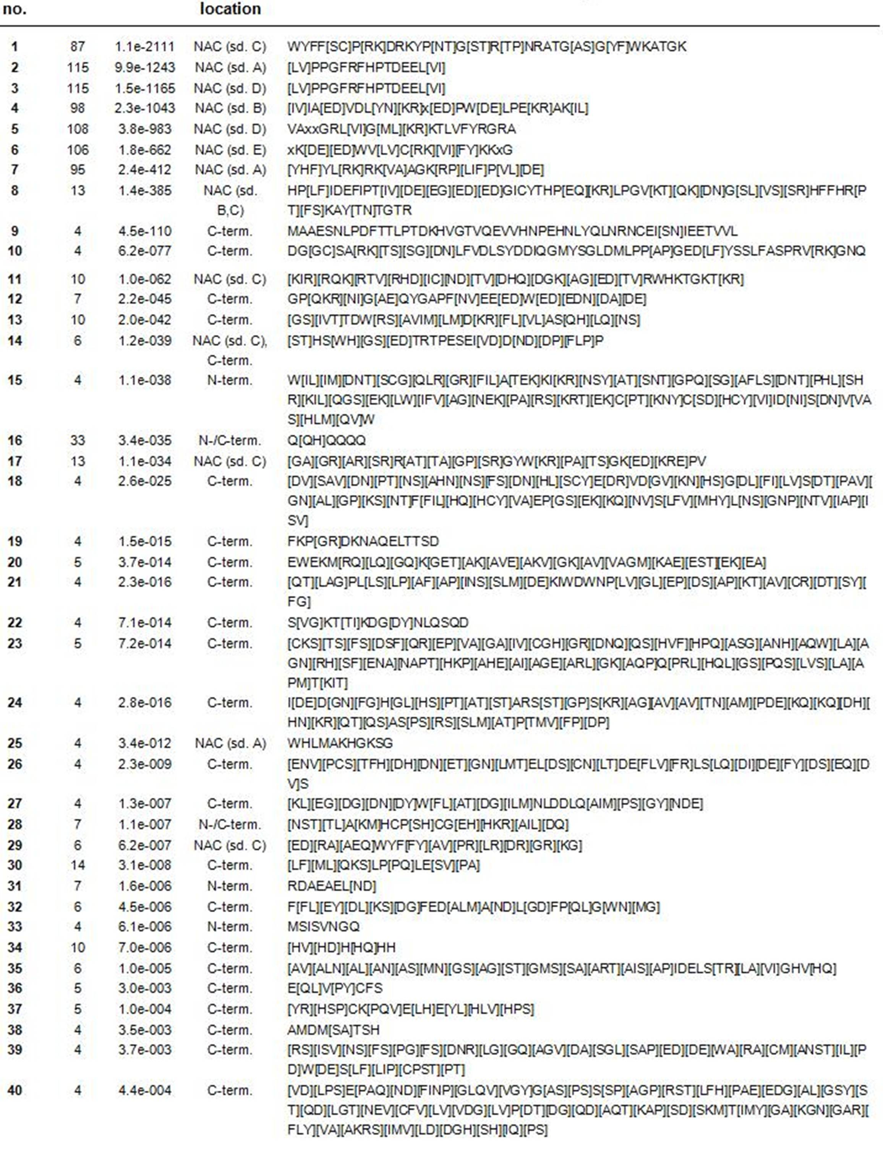

Supplemental Table S1. A list of motifs detected within the 116 NAC proteins.
The protein sequences were screened with MEME (Multiple Em for Motif Elicitation, http://meme.nbcr.net/meme/cgi-bin/meme.cgi ) at a cut off p-value of e⁻¹⁰. The motif location is given as follows: C-/N-term. – C-/N- terminus, NAC – NAC domain, sd. A-E – subdomain A-E.

