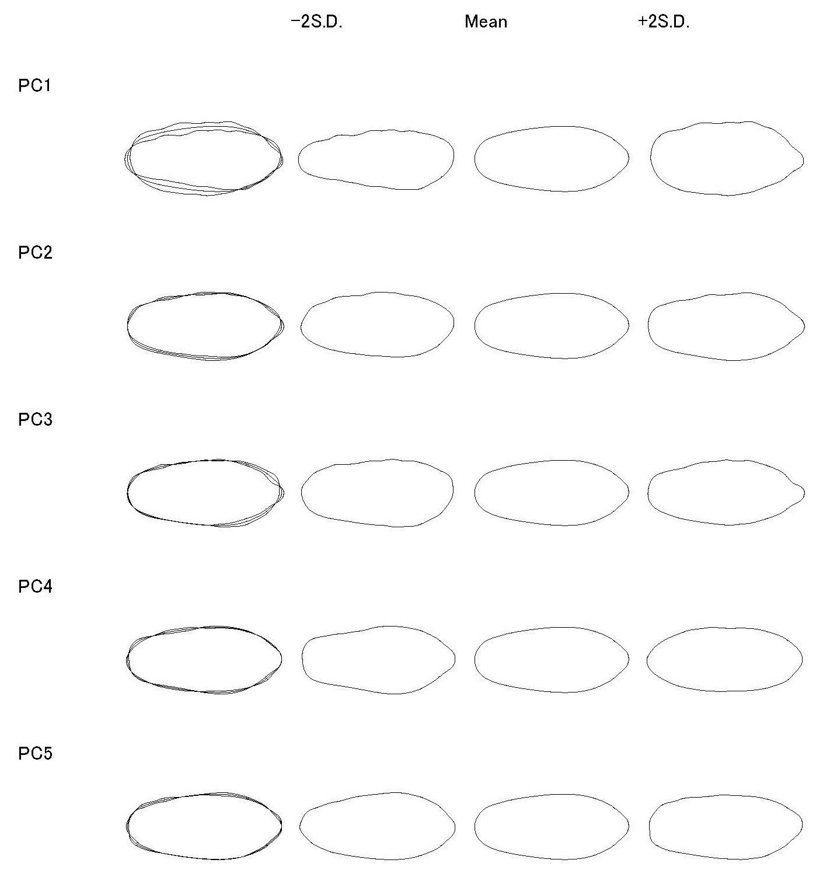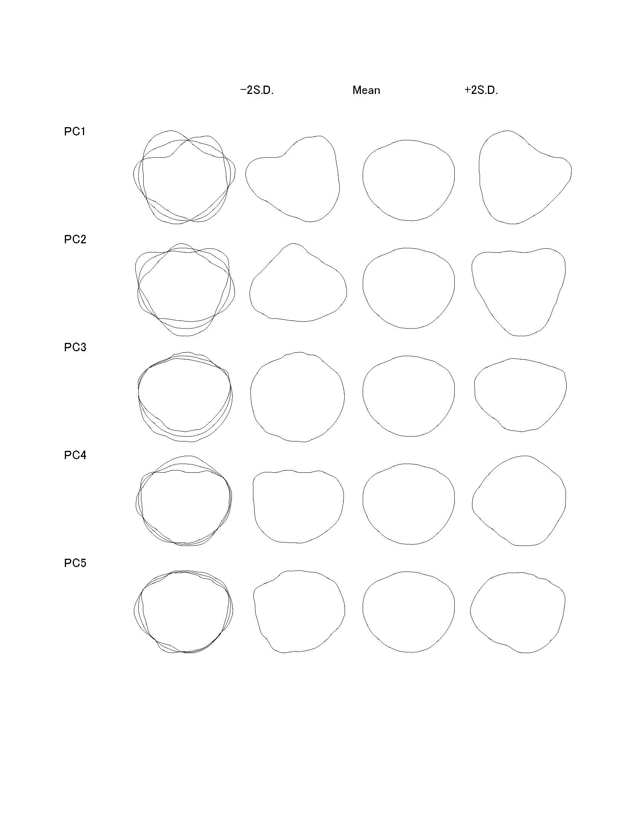
Figure S4. Transformation of grain shape into five principal components to generate high-throughput quantitative data suitable for genetic analysis (Accession: AUS34404)

