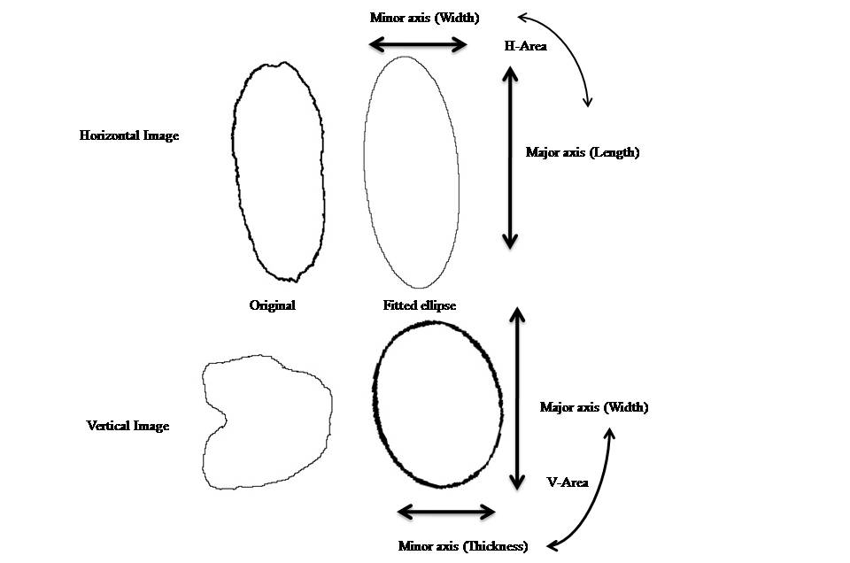
Figure S3. Dimension axis and their measurement demonstrated by ImageJ software for original grain image and its fitted ellipse.

