F_{ST}
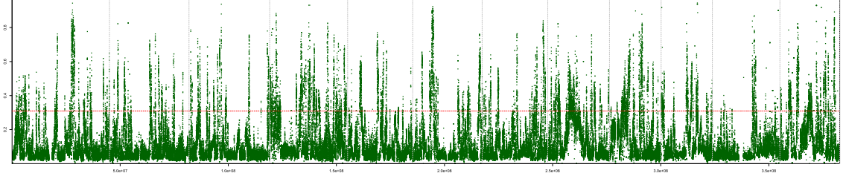
a
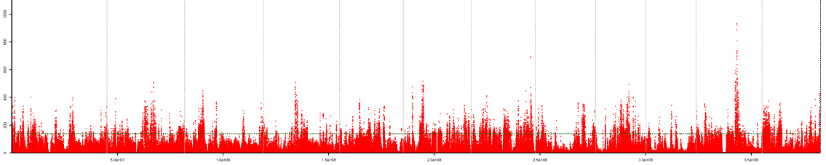
b
XP-CLR

Additional file 21: EDR scanning for Japonica. (a) F_{ST} values between upland japonica and irrigated japonica were plotted against physical coordinates over the genome; the red horizontal dashed line refers to the top 5‰ threshold. (b), XP-CLR scores were plotted against genomic coordinates; the green horizontal dashed line refers to the top 5‰ threshold. EDRs were obtained by taking the intersection of the EDRs given by the two approaches. The vertical dashed lines in (a) and (b) indicate the boundaries between two chromosomes.

