F_{ST}
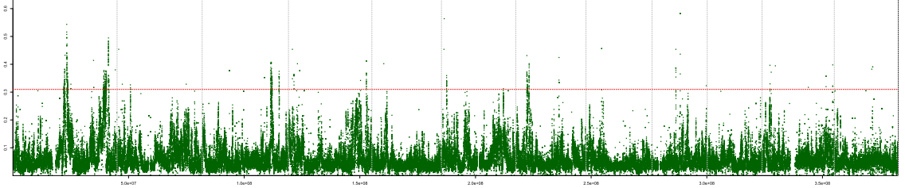
a
XP-CLR
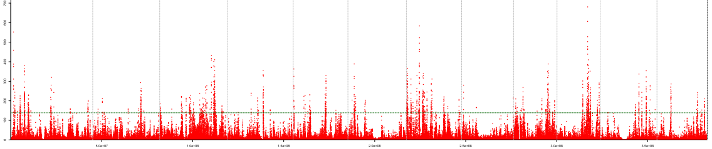
b

Additional file 25: EDR scanning for type Indica. (a) F_{ST} values between upland indica and irrigated indica were plotted against physical coordinates over the genome; the red horizontal dashed line refers to the top 5‰ threshold. (b), XP-CLR scores were plotted against genomic coordinates; the green horizontal dashed line refers to the top 5‰ threshold. EDRs were obtained by taking the intersection of the EDRs given by the two approaches. The vertical dashed lines in (a) and (b) indicate the boundaries between two chromosomes.

