Additional file 5. RNase and DNase activity test using the extract of the bacteria containing the pET28 vector without insert (negative control), avoiding the possible action of some bacterial component on the obtained result. A. DNase activity. B. RNase activity.
A
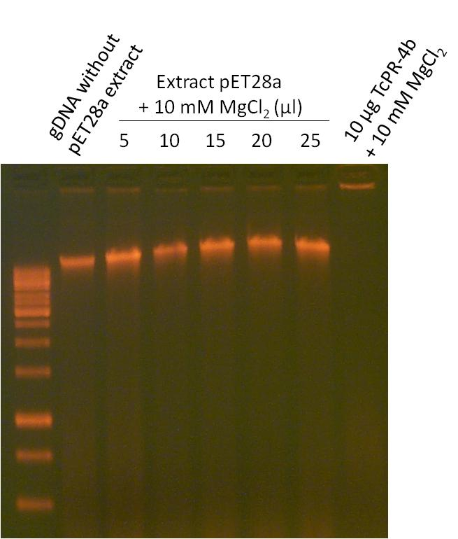

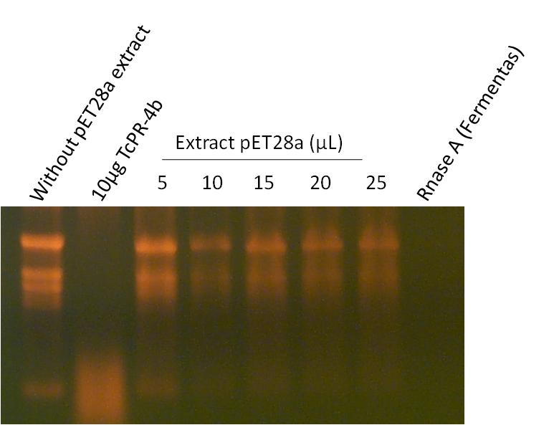
B

