Spatial gradients in cell wall composition and transcriptional profiles along elongating maize internodes

Qisen Zhang¹, Roshan Cheetamun², Kanwarpal S. Dhugga³, J. Antoni Rafalski⁴, Scott V. Tingey⁴, Neil J. Shirley¹, Jillian Taylor¹, Kevin Hayes³, Mary Beatty³, Antony Bacic², Rachel A. Burton¹, Geoffrey B. Fincher¹*

Supplemental Tables and Figures

Supplemental Table S1 Linkage analyses of cell wall preparations along the 10th elongating maize internode. S2: Section 2; S4: Section 4; S6: Section 6; S8: Section 8. The data are averages of three biological replicates.

 |  | S2 |  | S4 |  | S6 |  | S8
 |  | Average | SD | Average | SD | Average | SD | Average | SD
Xyl(p)
 | terminal | 1.9 | 0.2 | 1.4 | 0.3 | 1.4 | 0.3 | 1.4 | 0.1
 | 2- | 1.6 | 0.2 | 3.4 | 0.2 | 3.2 | 0.5 | 3.0 | 0.1
 | 4- | 11.9 | 0.4 | 30.7 | 2.3 | 32.9 | 3.7 | 29.5 | 3.0
 | 2,4- | 1.4 | 0.2 | 1.6 | 0.8 | 2.2 | 0.9 | 1.6 | 0.6
 | 3,4- | 7.5 | 0.2 | 5.4 | 0.4 | 5.0 | 0.8 | 4.8 | 1.1
 | 2,3,4- | 5.6 | 0.3 | 4.1 | 0.0 | 4.9 | 2.6 | 5.6 | 1.5
Ara(f)
 | terminal | 7.9 | 0.8 | 5.1 | 0.4 | 5.2 | 1.1 | 4.0 | 0.1
 | 2- | 0.2 | 0.2 | 0.1 | 0.1 | 0.1 | 0.1 | 0.1 | 0.1
 | 3- | 0.2 | 0.2 | 0.1 | 0.1 | 0.1 | 0.1 | 0.1 | 0.1
 | 5- | 0.8 | 0.1 | 0.5 | 0.0 | 0.4 | 0.0 | 0.4 | 0.1
 | 2,5- | 0.1 | 0.1 | 0.1 | 0.1 | 0.1 | 0.1 | 0.1 | 0.1
 | 3,5- | 0.6 | 0.2 | 0.2 | 0.2 | 0.4 | 0.4 | 0.2 | 0.2
Gal(p)
 | terminal | 0.6 | 0.1 | 0.4 | 0.1 | 0.4 | 0.2 | 0.1 | 0.0
 | 3- | 0.1 | 0.1 | 0.1 | 0.1 | 0.1 | 0.1 | 0.0 | 0.0
 | 6- | 0.1 | 0.1 | 0.1 | 0.1 | 0.1 | 0.1 | 0.1 | 0.1
 | 3,6 | 1.0 | 0.5 | 0.4 | 0.2 | 0.2 | 0.2 | 0.3 | 0.1
Glc(p)
 | terminal | 0.8 | 0.3 | 0.5 | 0.5 | 0.5 | 0.5 | 0.6 | 0.2
 | 3- | 3.7 | 0.9 | 1.3 | 0.3 | 1.0 | 0.4 | 1.1 | 0.0
 | 4- | 49.2 | 2.6 | 42.1 | 1.6 | 39.5 | 5.5 | 45.0 | 1.4
 | 4,6- | 2.9 | 0.1 | 1.9 | 0.1 | 1.7 | 0.1 | 1.3 | 0.5
Man(p)
 | 4- | 1.9 | 0.5 | 0.7 | 0.0 | 0.7 | 0.1 | 0.5 | 0.0

Supplemental Table S2 PCR primers used for quantitative RT-PCR
Gene name | Forward | Reverse
ZmCesA1 | CGAGACAGTGACTCTTATTTGAAG | ACTGCACGCATAACAAAACTTC
ZmCesA2 | ATCTGAACAGGCTCAGCCAAAGATC | CCAGCACTACAAGCAAGGTAGAAAG
ZmCesA3 | CGAACTGGCTGCTGAATAACATTG | GGTATGCACGACAGTCAACATGAAAC
ZmCesA4 | TGGAAGGTTTGTACTTTGTAGAAAC | TGGTAAACAATATCCACTGGTCTGT
ZmCesA5 | GATGAGCTGAAGATAGTTAAAGAGTGG | GACCAGCGGAGGTACATATAGCA
ZmCesA6 | CCGTCAGTGTGTGGTCGAAGAAG | CAATACTGCACTCACGAGGCTG
ZmCesA7 | GCAAGGTCTTTTGATTCTGC | TCCAATGAACAGGCATACAT
ZmCesA8 | CTGTGTCCATTGGAGCAGGAGA | TGTCCTTTGTCGCTAATATACAGACTG
ZmCesA9 | GGAGGTGGAAGGTTTGTAGA | TAAACGGAGTATCCCCTTGT
ZmCesA10 | CTCCATCTTCTCGCTCGTCT | GCCCAAAAGTGCCTGTATGT
ZmCesA11 | GTCTCCTCTGTCTATCTCGCATC | GAGCCGAATTTTAACATTTCAGG
ZmCesA12 | AATTGCTGAGCTGTTTATTAAGGTTC | GCCATTTAACAATCAAACCTTGTCC
ZmCesA13 | GCTGTCTATCACGGTTCAAA | GGGTCCAAGAACATTACACA

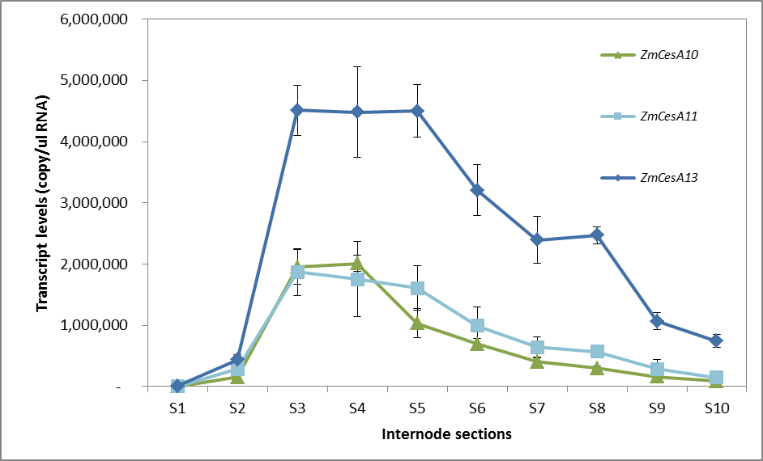

Supplemental Figure S1 QPCR analysis of secondary wall CesA genes
QPCR was conducted with primers list in Table S2 with the same RNA for the microarray experiment. Similar transcript profiles were obtained for the primary wall CesA genes from both QPCR and microarray experiments (Figure 4)

Supplemental Figure S2 The mRNA levels of Csl genes

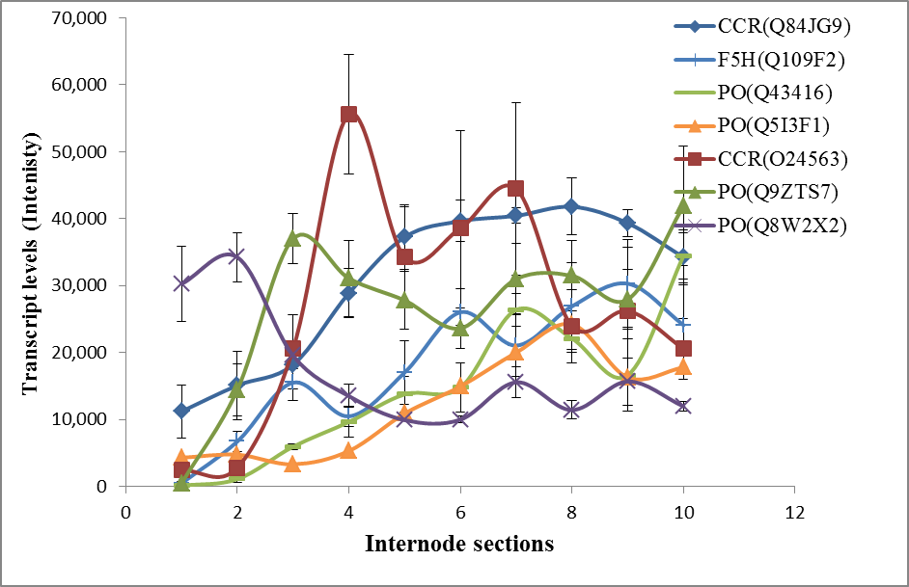

Supplemental Figure S3 Transcript levels of genes involved in lignin synthesis.

