Web-appendix 2: Examples of extrapolated behaviour of relative risk functions after 150 grams per day.

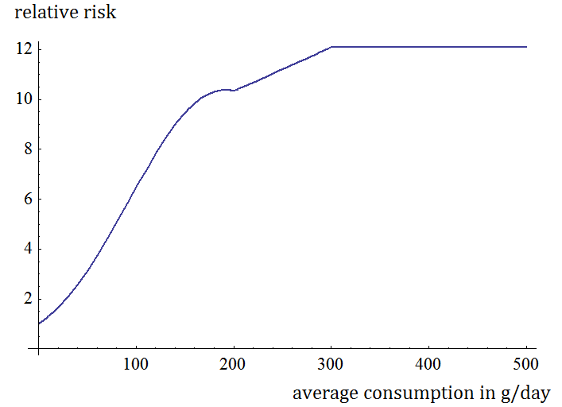
Figure 1: relative risk function for oral cavity and pharynx cancer
In the case of Oral Cavity and Pharynx cancer, the behaviour of the risk function for a daily alcohol intake larger than 200g/day was a piecewise linear function. Between 200g/day and 300g/day, the function is linear with a slope equal to the average slope of the function between 150g/day and 200g/day. After 300g/day, the function is simply kept constant. A similar shape has been adopted for liver cirrhosis.
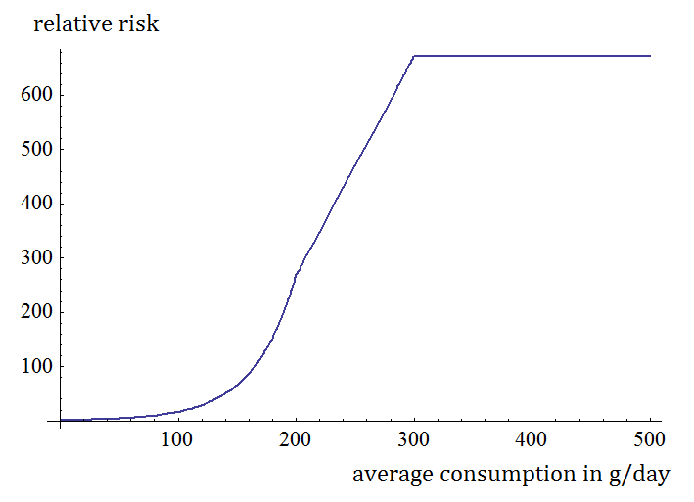
Figure 2: relative risk function of liver cirrhosis
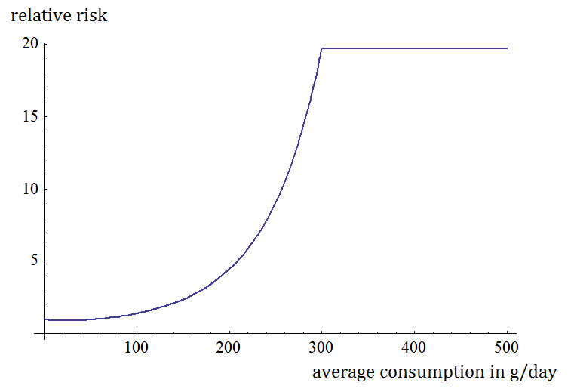
Figure 3: relative risk function of diabetes
In the case of diabetes, the function was simply capped at its value at 300 grams per day.

changes made on relative risk functions after 150g/day
 | men | women
Oral cavity and pharynx cancer | 200-300 g/day : linear with same average slope as between 150 and 200 g/day | 200-300 g/day : linear with same average slope as between 150 and 200 g/day
 | after 300g/day: capped | after 300g/day: capped
oesophagus cancer | cap at 300g/day | cap at 300g/day
colon cancer | no change | no change
rectum cancer | no change | no change
liver cancer | 200-300 g/day : linear with same average slope as between 150 and 200 g/day | 200-300 g/day : linear with same average slope as between 150 and 200 g/day
 | after 300g/day: capped | after 300g/day: capped
larynx cancer | 200-300 g/day : linear with same average slope as between 150 and 200 g/day | 200-300 g/day : linear with same average slope as between 150 and 200 g/day
 | after 300g/day: capped | after 300g/day: capped
breast cancer | no change | no change
epilepsy | no change | no change
pancreatitis | after 150g/day: linear with same average slope as between 100 and 150g/day | after 150g/day: linear with same average slope as between 100 and 150g/day
lower respiratory infections | no change | no change
hemorrhagic stroke | no change | no change
ischemic stroke | no change | cap at 300g/day
hypertension | no change | cap at 300g/day
liver cirrhosis | 200-300 g/day : linear with same average slope as between 150 and 200 g/day | 200-300 g/day : linear with same average slope as between 150 and 200 g/day
 | after 300g/day: capped | after 300g/day: capped
diabetes | cap at 300g/day | no change
tuberculosis | no change | no change
IHD | no change | no change
MVA | no change | no change
suicide | no change | no change
other injuries | no change | no change

