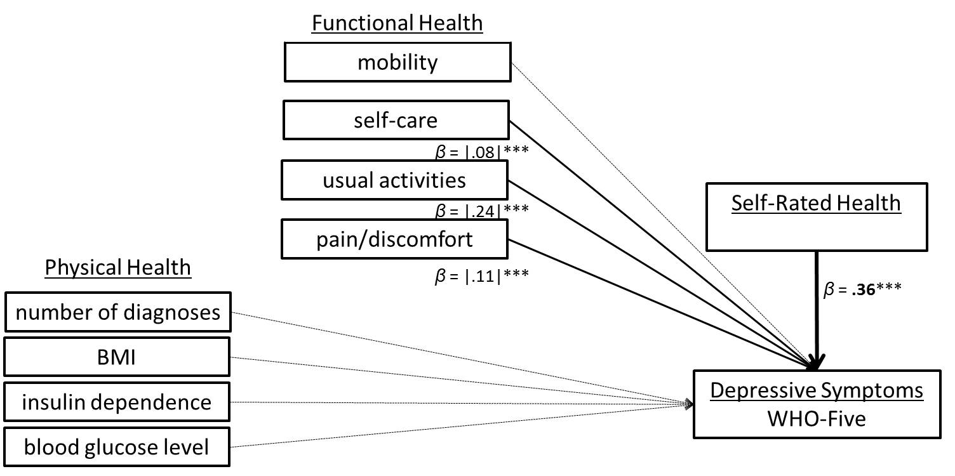Figure 3c. Path model Part III: Depressive Symptoms in terms of WHO-Five
Note: non- significant paths are displayed in a dotted line; *** p < .001

