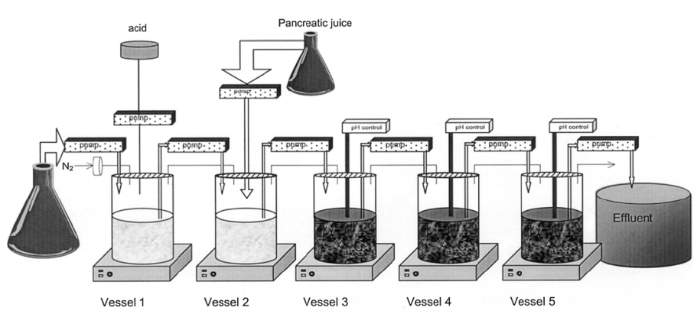

Additional file 1: Figure S1. Schematic representation of the Simulator of the Human Intestinal Microbial Ecosystem (SHIME®). Possemiers et al. [31]. Vessel 1: stomach; vessel 2: small intestine; vessel 3: ascending colon; vessel 4: transverse colon; vessel 5: descending colon.

