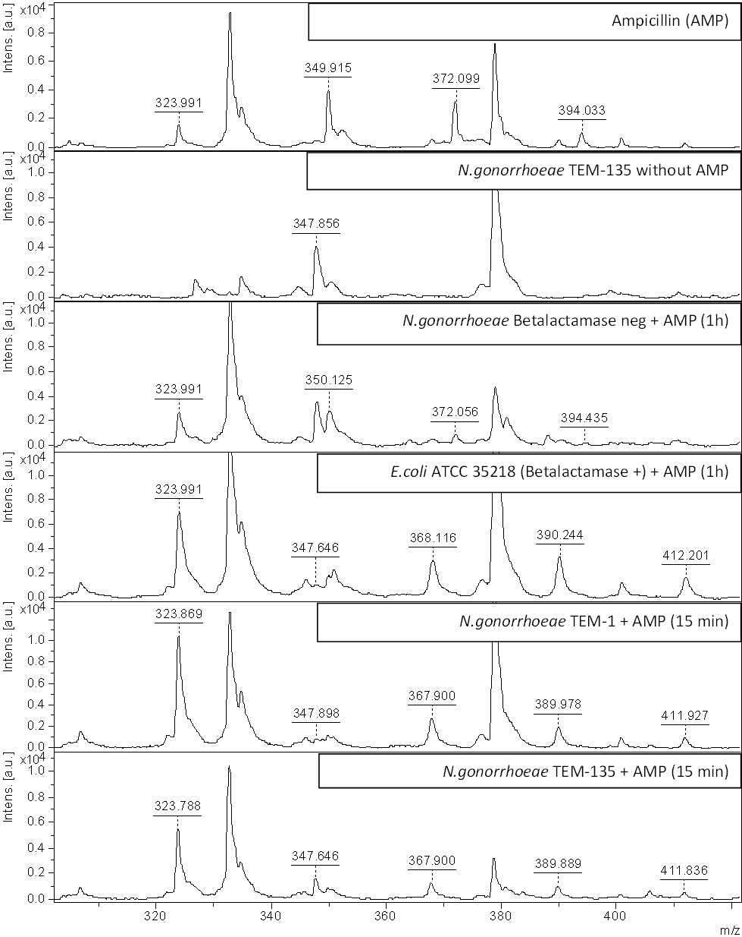
Supplementary Figure 1. β-lactamase hydrolysis assay. MALDI-TOF MS spectra of ampicillin after incubation with Neisseria gonorrhoeae (β-lactamase negative, TEM-1 producing and TEM-135 producing) and Escherichia coli ATCC 35218 (TEM-1 producing). Ampicillin alone (top) and N. gonorrhoeae incubated in water (second from top) are also shown in the figure. Intact ampicillin displayed the peaks of 350.4 Da, 372.4 Da and 394.4 Da while hydrolysed ampicillin displayed the peaks of 324.4 Da, 368.4 Da, 390.4 Da and 412.4 Da. The peak of 324.4 Da was observed with low intensity also in the top-spectrum indicating a slight spontaneous hydrolysis.

