Supplemental Appendix

Detailed Population Assessments
The Philippines
Study site, subject recruitment, and DMFT score collection for the Filipino samples were those used in our prior genome-wide linkage study [17]. The 477 subjects (253 males and 224 females) from 72 pedigrees came mainly from Cebu Island and share a common Malaysian ancestry. This allowed us to reduce the influence of behavioral and environmental factors on caries experience. DNA samples were extracted from peripheral blood according to standard protocols. The age range of the subjects was two to 72 years (mean age 22.6 years). The mean DMFT score was 9.7 with a range of zero to 32. Dental caries experience definitions for fine-mapping and all follow-up studies were made according to our original genome-wide linkage analysis [17]. The University of Pittsburgh and the H.O.P.E Foundation International Institutional Review Boards approved the study protocol. Also, the appropriate informed, written consent was obtained from all participants, and age appropriate assent documents were used for children seven to 14 years of age. This allowed us to obtain informed, written consent from both the child and the parents. DMFT scores were collected by one calibrated examiner (A.R.V.). No intra-examiner data could be generated.

Follow-up Studies
The samples for each replication study are outlined in Table 1. Samples from Istanbul, Turkey included 172 patients (79 males and 93 females), who had a mean age of 5.4 years with a range of three to six years of age. Ninety-two of these patients had high caries experience with a dmft (caries experience in the primary dentition) of four or more, and 80 of the children were caries-free [22]. Istanbul University and the University of Pittsburgh Institutional Review Boards approved the study of these samples, and appropriate written informed consent was obtained from the parents of all participating children.
The samples from Rio de Janeiro, Brazil included 500 patients (264 males and 236 females). These patients had a mean age of nine years with a range of seven to 14 years. Samples were used with the approval of the University of Pittsburgh Institutional Review Board and the Federal University of Rio de Janeiro Institutional Review Board. Age appropriate assent documents were used for children between seven and 14 years, and informed written consent was obtained from both the child and the parents.
A study sample from Nova Friburgo, Brazil was used as well. This included 320 subjects (162 males and 158 females). The children had a mean age of 3.5 with a range of one to six years. The mean dmft score was 1.4 with a range of zero to 16. Samples were used with the approval of the University of Pittsburgh Institutional Review Board and the Fluminense Federal University ethics committee.
Samples from subjects recruited in the Patagonian Argentina were also used. Samples from a subset of these subjects were also used in the real-time PCR experiments. Sixty-six subjects had a mean age of 27.96 years, ranging from two to 72 years old. Seventy-seven had low caries experience as determined by DMFT/dmft scores stratified by age, and 68 had high caries experience. Samples were used with the approval of the University of Pittsburgh Institutional Review Board and the Centro de Educación Médica e Investigaciones Clínicas “Norberto Quirno” (CEMIC).
Dental caries was diagnosed using a modified World Health Organization protocol recommended for oral health surveys [1]. Teeth lost to trauma or primary teeth lost to exfoliation were not included in the final DMFT/dmft scores. When records indicated that teeth were extracted for orthodontic reasons or periodontal disease, or treatments were performed in sound teeth, these situations were not included in the final DMFT/dmft scores. The studies developed in Turkey included white spot lesions as evidence of caries. For all studies, carious lesions were recorded as present when a break in enamel was apparent on visual inspection. All the examiners carried out the clinical examination after being calibrated by an experienced specialist. Details about the determination of caries experience were previously described [22,24].
In this study, the populations were classified as either ‘low caries experience’ or ‘high caries experience,’ based on DMFT/dmft distribution in each cohort (DMFT/dmft mean and standard deviation) and the subject’s age. The criteria used here for classification of caries experience took age into consideration, since it is expected that caries experience will increase in the general population with age [56].

Supplemental Figure 1. Linkage Disequilibrium (D’) of ESRRB SNPs Showing Association with Dental Caries (1=rs2860216, 2=rs4903419, 3=rs745011, 4=rs1077430, 5=rs10132091, 6=rs6574293, and 7=rs4903399).

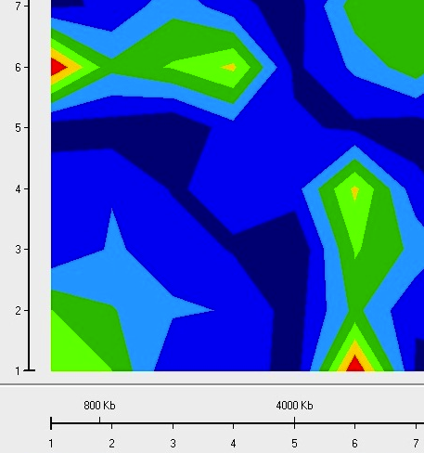

Supplemental Figure 2. Results of Meta-Analyses.
rs745011
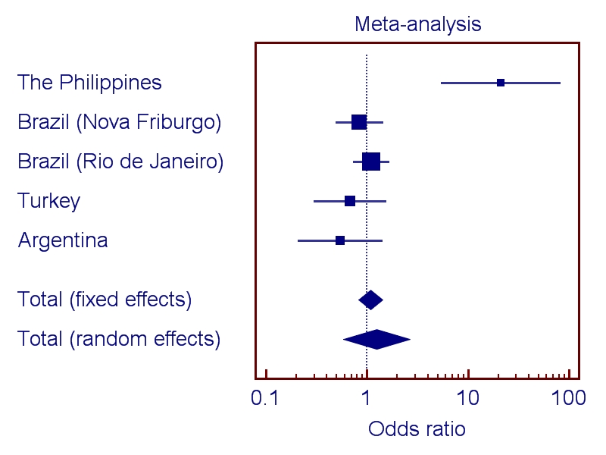

Supplemental Figure 3. Results of Meta-Analyses.
rs1077430
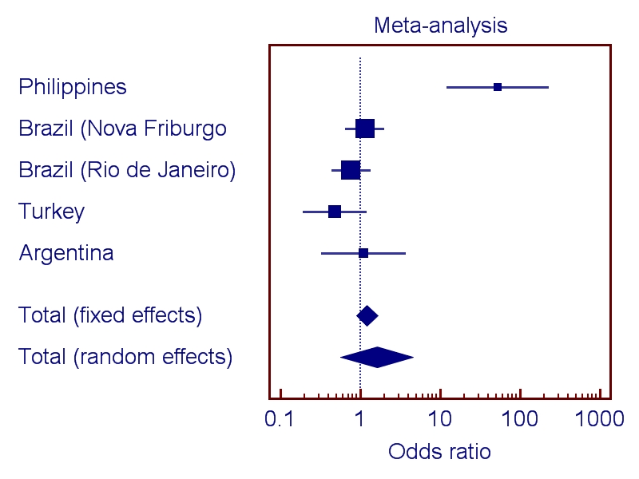

Supplemental Figure 4. Results of Meta-Analyses.
rs2860216
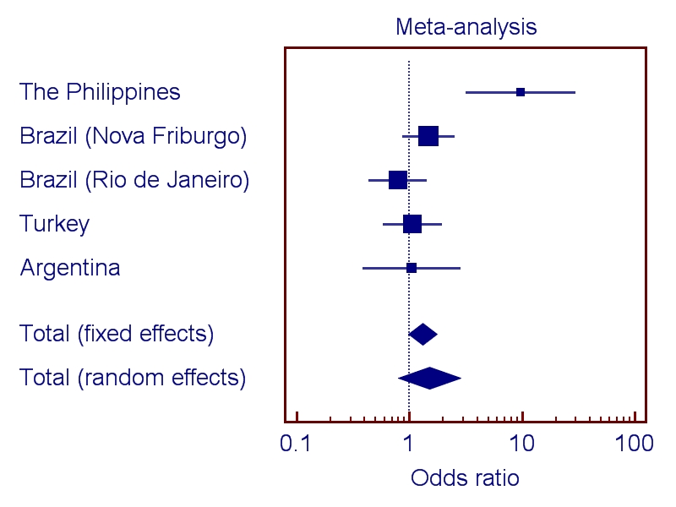

Supplemental Figure 5. Results of Meta-Analyses.
rs4903399
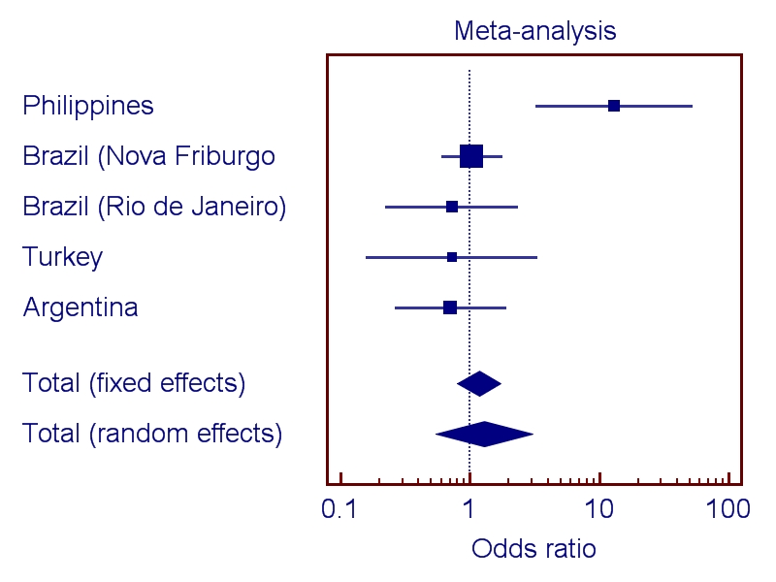

Supplemental Figure 6. Results of Meta-Analyses.
rs4903419
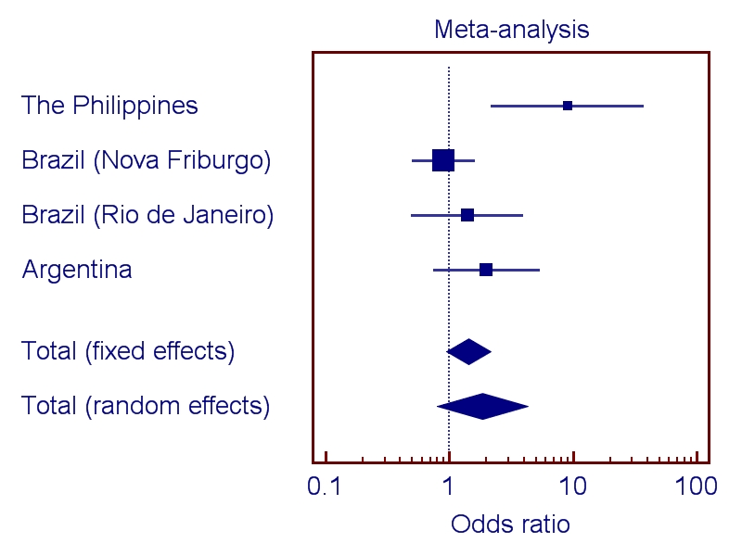

Supplemental Figure 7. Results of Meta-Analyses.
rs6574293
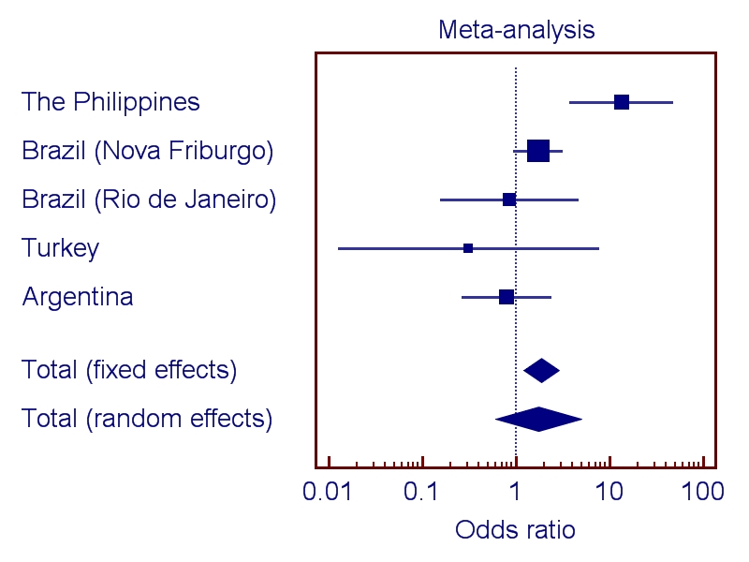

Supplemental Figure 8. Results of Meta-Analyses.
rs10132091
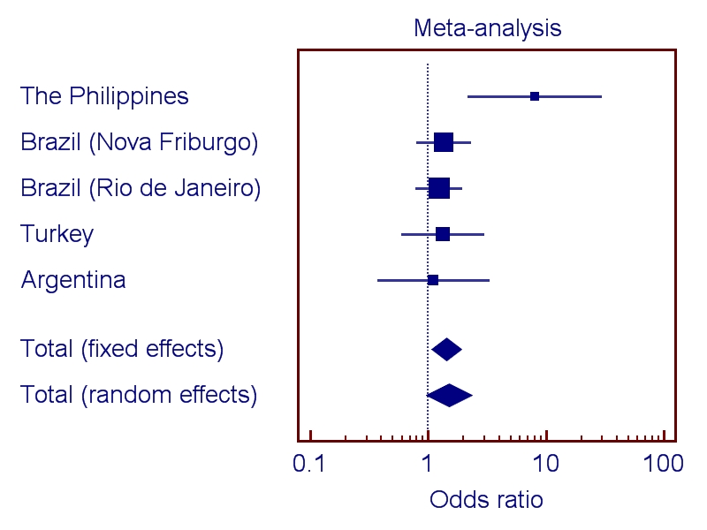

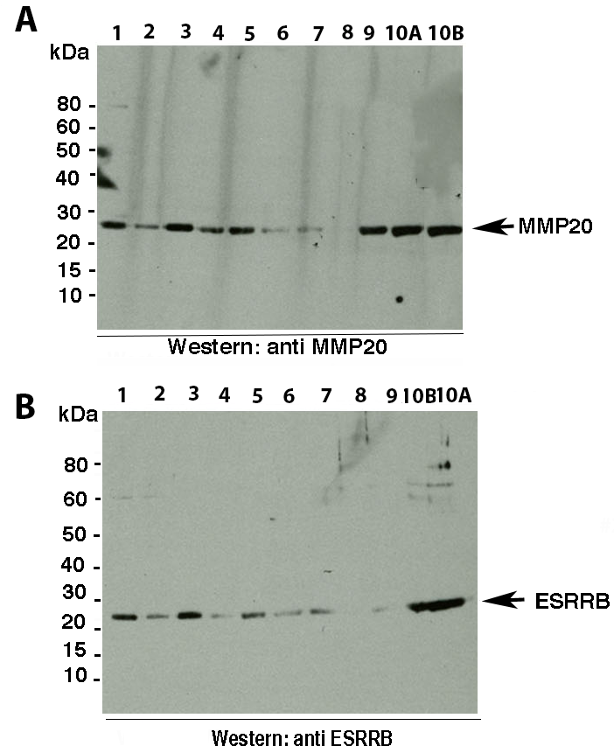
Supplemental Figure 9. Western Blot analysis of ESRRB in Whole Saliva from 10 Healthy Female Subjects. Subject 10 (A and B are two samples from the same individual) had active dental work done which may relate to the higher levels of ESRRB. Quantitative inferences can be made from known equal amounts of protein concentrations loaded into the gel (17.5 μg per lane). Since we were working with saliva samples, we did not use house keeping gene product antibodies as they are not secreted proteins.

Supplemental Figure 10. Immunohistochemical Analysis Showing Esrrb Expression in Secretory Stage Ameloblasts. Immunohistochemistry of demineralized, paraffin sections of mouse mandibular molar at 4 days postnatal (20X).

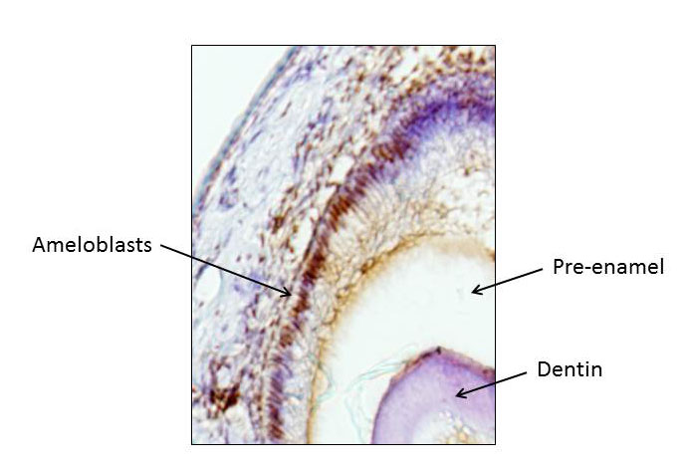

Supplemental Table 1. Dental Caries Status of the Two Families Segregating ESRRB Mutations and DFNB35.

DFNB35 Turkish Family
Individual | Age (Years) | ESRRB Mutation Status | Self-Report | Dental Caries Experience Definition
II:6 | 48 | Heterozygous | Edentulous since 3 years ago due to caries and gum recession | High
II:5 | 52 | Homozygous | Edentulous since 5 years ago due to caries and gum recession | High
II:4 | 54 | Homozygous | Edentulous due to caries and gum recession | High
II:3 | 49 | Not a carrier | No problems reported | Low
II:2 | 56 | Not a carrier | No problems reported | Low
II:1 | 59 | Not a carrier | No problems reported | Low
III:1 | 23 | Homozygous | Edentulous on the maxillary arch and posterior mandibular | High
III:2 | 27 | Homozygous | Molars with decay | High
II:11 | 55 | Heterozygous | All teeth except 10 extracted by the person since they were mobile. Last 10 teeth extracted by a dentist more recently (caries and gum recession) | High
Supplemental Table 1. Dental Caries Status of the Two Families Segregating ESRRB Mutations and DFNB35 continued.
II:12 | 56 | Heterozygous | Edentulous since 5 years ago due to caries and gum recession | High
III:8 | 32 | Homozygous | Two molars extracted due to pain and inflammation | Low
III:9 | 34 | Homozygous | 3 to 5 teeth extracted | Low
III:10 | 26 | Unknown | Unknown
II:9 | 55 | Heterozygous | All maxillary teeth with the exception of the four incisors were extracted, as well as all mandibular teeth (caries and every pregnancy 2 or 3 teeth were extracted due to pain) | High
III:6 | 36 | Unknown | 3 teeth extracted and 2 teeth with fillings (caries) | Low
III:5 | 34 | Unknown | 6 teeth extracted and 2 or 3 teeth with fillings (caries) | Low
III:7 | 38 | Homozygous | Unknown

DFNB35 Czech Family
Individual | Age (Years) | ESRRB Mutation Status | Self-Report | Dental Caries Experience Definition
III:3 | 4 | Homozygous | Caries-free | Low
Supplemental Table 1. Dental Caries Status of the Two Families Segregating ESRRB Mutations and DFNB35 continued.
II:1 | 32 | Heterozygous | Periodontitis, and increased “dental stones” | Unknown
II:2 | 32 | Heterozygous | Increased caries after age of 24 (7 new cavities), which started before pregnancy | High
I:3 | 55 | Heterozygous (DNA testing was not possible, but due to the consanguinity of the pedigree, this person is likely to be a carrier) | Increased caries after age of 25 | High

Supplemental Table 2. SNPs Studied and Summary of Results of Fine-Mapping of the Filipino Population.
Marker | Allele | Minor Allele Frequency | Gene | Location | p-value
rs4903399 | T | 0.28 |  | chr. 14 76775202 | 0.02
rs6574293 | A | 0.07 | ESRRB | chr. 14 76870600 | 0.007
rs7160372 | T | 0.45 |  | chr. 14 76816376 | 0.47
rs1642866 | A | 0.15 |  | chr. 14 77014035 | 0.34
rs7151924 | C | 0.31 |  | chr. 14 76778069 | 0.17
rs4903419 | G | 0.11 |  | chr. 14 76984655 | 0.009
rs2361289 | C | 0.20 | ESRRB | chr. 14 76910170 | 0.17
rs1077430 | C | 0.30 | ESRRB | chr. 14 76897677 | 0.09
rs2860216 | C | 0.29 |  | chr. 14 77006008 | 0.003
rs11159198 | T | 0.45 | ESRRB | chr. 14 76867381 | 0.61
rs1642818 | C | 0.35 |  | chr. 14 77057801 | 0.26
rs7160845 | C | 0.20 |  | chr. 14 77038124 | 0.42
rs10132091 | C | 0.42 | ESRRB | chr. 14 76870818 | 0.007
rs6574292 | A | 0.39 | ESRRB | chr. 14 76866718 | 0.46
rs11623206 | C | 0.28 |  | chr. 14 76750175 | 0.56
rs9944037 | C | 0.41 | ESRRB | chr. 14 76903733 | 0.92
rs12586444 | T | 0.48 | ESRRB | chr. 14 76861565 | 0.91
rs6574310 | A | 0.19 |  | chr. 14 77049704 | 0.69
rs1676303 | C | 0.13 |  | chr. 14 76992164 | 0.06
rs1867654 | A | 0.43 | ESRRB | chr. 14 76937722 | 0.53
rs7152058 | T | 0.20 |  | chr. 14 76806538 | 0.91
rs12437118 | A | 0.37 |  | chr. 14 76983730 | 0.31
rs745011 | C | 0.33 | ESRRB | chr. 14 76917275 | 0.04
rs9323631 | T | 0.35 | ESRRB | chr. 14 76951278 | 0.1
rs2885232 | T | 0.35 | ESRRB | chr. 14 76957391 | 0.52
rs958729 | T | 0.12 |  | chr. 14 76991986 | 0.8

Supplemental Table 3. Primer Sets for Sequencing ESRRB exons and exon-intron boundaries.
Gene Exon | Forward Primer (5’-3’) | Reverse Primer (5’-3’) | Temperature | Product Size (Base Pairs)
1 | ACTTTCCTGCGTCCATCAGT | CAGAGTCTGGGGAGGAGAAA | 56.5 | 378
2 | ATGTTTCCGCAGCATTTATC | GCCACATGCTCTCTAAATCC | 51.3 | 578
3 | CTCCTCCCACTCTGCGTTC | GGACAGACAGACCGAGAAGC | 57.7 | 214
4 | CCACAAACAGTGTGTCTGCAT | GGTCTGGCCATTCATTCATT | 55.9 | 248
5 | ATGCAATGTGACCCTAGAGC | AAGACAGCATGGTCTGCATC | 54.9 | 337
6 | TAATGCCAGAAACTTGCTCC | CACAGAAGTACCGCTCCAAC | 53.0 | 720
7 | TGCTTTGAGAACACTAGGGG | AAGAAATTCCAATTCCCACC | 54.5 | 448
8 | CCCTGCGTCCTCTGTCTCTA | AGAGCAAGACTCCGTCTCCA | 58.0 | 430
9 | GGATGCGCCATTACTGTTAG | CCCAAGATCCACATTGTCTC | 53.6 | 424
10 | GGAGCTCTTAGGAACCCAAC | TCCTCTCCAATGCTACAAGG | 55.1 | 439
11 | TTACGCTACACAGGGAAAGC | CTTAGGAAATGCTCAGCCAG | 54.9 | 640
12 | ACCTCTTGAGAAATGTCCCC | CATGATACAGGGGTTGAAGG | 54.3 | 577
12 | TGCTAATGCTCGTCCTTGTG | GAGCCATGATACAGGGGTTG | 55.2 | 380
13 | TGTGGGGCTCGACTGTAACT | CACTCCTGAAGGGAGTCAGC | 58.3 | 98
14 | TCCCAGGAAACTCCTCTACC | AGCTGCTCTGCAGTTTGTG | 55.6 | 477
14 | CTCACTGTGCTGTGTCCTTG | ATGGACCCCTTCAGTACCAG | 55.9 | 393
14 | CTGGCATCTGCTGTCTGTCT | GGAGAGGGTCCTCATCTGG | 57.1 | 365
14 | AGTTCAGGGGCCAACTTCTT | TGACAAAGCCAGTCTGGAAA | 56.6 | 336
14 | TCCCCTTGTCCTTATACGTTC | CCAGAAAGACAATGTGTGAAGAA | 53.8 | 600
Primers used for polymerase chain reaction (PCR) amplification were designed using Primer3 software [57] and supplied by Integrated DNA Technologies (Integrated DNA Technologies, Inc.). The samples were sent to Functional Biosciences, Inc. for purification and sequencing. The sequences were then verified against the reference sequence transcript and the sequences from two unrelated CEPH (Foundation Jean Dausset-Centre d’Etude du Polymorphisme Humain) DNA samples [58] using Sequencher 5.1 software (Gene Codes Corporation).

Supplemental Table 4. Primer Sets.
Gene | Forward Primer (5’-3’) | Reverse Primer (5’-3’) | Product Size (Base Pairs)
ESRRBlong | ctatagcgtcaaactgcagggcaaagtg | ctgctcttggccaacctgccctct | Less than 100
ESRRBshort | tgacgacaagctggtgtacg | tctgtaggtgggcattggtc | 511
ESRRB- Δ10 | tgacgacaagctggtgtacg | atccctgcttgtgaaggcag | 511
GAPDH | accacagtccatgccatcac | tccaccaccctgttgctgta | 452
ESRRBlong, estrogen-related receptor beta long isoform
ESRRBshort, estrogen-related receptor beta short isoform
ESRRB- Δ10, estrogen-related receptor beta Δ10 isoform
GAPDH, glyceraldehyde-3-phosphate dehydrogenase

Supplemental Table 5. Results of Association Studies in the Turkish Children.

Marker | Cases | Controls
rs4903399
CC | 52 | 47
CT | 31 | 33
TT | 3 | 4
 |  | p= 0.8
C | 135 | 127
T | 37 | 49
 |  | p=0.17
rs6574293
AA | 0 | 1
AG | 4 | 6
GG | 85 | 77
 |  | p=0.44
A | 4 | 8
G | 174 | 160
 |  | p=0.2
rs1077430
CC | 8 | 15
CT | 30 | 33
TT | 49 | 38
 |  | p=0.16
C | 46 | 63
T | 128 | 109
 |  | p=0.04
rs2860216
CC | 7 | 6
CT | 37 | 36
TT | 41 | 42
 |  | p=0.95
C | 51 | 48
T | 119 | 120
 |  | p=0.77

Supplemental Table 5. Results of Association Studies in the Turkish Children Continued.

rs10132091
CC | 16 | 12
CT | 45 | 47
TT | 27 | 25
 |  | p=0.74
C | 77 | 71
T | 99 | 97
 |  | p=0.78
rs1676303
CC | 1 | 14
CT | 21 | 13
TT | 66 | 56
 |  | p=0.001
C | 23 | 41
T | 153 | 125
 |  | p=0.006
rs745011
CC | 12 | 15
CT | 32 | 31
TT | 44 | 34
 |  | p= 0.53
C | 56 | 61
T | 120 | 99
 |  | p=0.22

Supplemental Table 6. Results of Association Studies in the Brazilian (Nova Friburgo) Children.

rs# |  | Genotype frequency (%) |  |  |  |  |  | p-value
rs# | Allele | Affected group |  |  | Unaffected group |  |  | Genotype | Allele | Dominant Model | Recessive Model
rs# |  | dd | dD | DD | dd | dD | DD
rs4903399 | G/A | 3 | 29 | 63 | 9 | 43 | 106 | 0.59 | 0.81 | 0.9 | 0.36
rs6547293 | A/G | 4 | 21 | 71 | 9 | 19 | 137 | 0.08 | 0.2 | 0.08 | 0.64
rs1077430 | A/G | 10 | 39 | 32 | 17 | 57 | 55 | 0.85 | 0.81 | 0.65 | 0.86
rs2860216 | A/G | 17 | 45 | 32 | 30 | 59 | 68 | 0.25 | 0.36 | 0.15 | 0.84
rs10132091 | A/G | 25 | 40 | 31 | 225 | 72 | 63 | 0.12 | 0.05 | 0.25 | 0.04
rs1676303 | A/G | 5 | 30 | 64 | 8 | 51 | 110 | 0.99 | 0.91 | 0.94 | 0.91
rs745011 | A/G | 18 | 38 | 33 | 31 | 74 | 52 | 0.77 | 0.71 | 0.53 | 0.93

Supplemental Table 7. Results of Association Studies in the Brazilian (Rio de Janeiro) Children.
rs# |  | Genotype frequency (%) |  |  |  |  |  | p-value
rs# | Allele | Affected group |  |  | Unaffected group |  |  | Genotype | Allele | Dominant Model | Recessive Model
rs# |  | dd | dD | DD | dd | dD | DD
rs4903399 | T/C | 4 | 52 | 143 | 9 | 88 | 229 | 0.83 | 0.61 | 0.69 | 0.59
rs6547293 | A/G | 2 | 41 | 158 | 4 | 75 | 262 | 0.89 | 0.63 | 0.63 | 0.85
rs1077430 | C/T | 21 | 83 | 94 | 42 | 125 | 146 | 0.63 | 0.54 | 0.85 | 0.35
rs2860216 | C/T | 18 | 87 | 109 | 37 | 14 | 176 | 0.73 | 0.54 | 0.75 | 0.43
rs10132091 | C/T | 37 | 97 | 80 | 51 | 177 | 125 | 0.48 | 0.88 | 0.63 | 0.36
rs1676303 | C/T | 10 | 62 | 142 | 14 | 109 | 231 | 0.85 | 0.94 | 0.79 | 0.68
rs745011 | C/T | 47 | 73 | 78 | 77 | 145 | 126 | 0.54 | 0.8 | 0.46 | 0.66

Supplemental Table 8. Results of Association Studies in the Argentinean Population.
rs# |  | Genotype frequency (%) |  |  |  |  |  | p-value
rs# | Allele | Affected group |  |  | Unaffected group |  |  | Genotype | Allele | Dominant Model | Recessive Model
rs# |  | dd | dD | DD | dd | dD | DD
rs4903399 | T/C | 2 | 20 | 31 | 1 | 10 | 11 | 0.8 | 0.54 | 0.5 | 0.88
rs6547293 | A/G | 1 | 12 | 49 | 0 | 6 | 18 | 0.71 | 0.82 | 0.69 | 0.53
rs1077430 | C/T | 8 | 15 | 14 | 1 | 8 | 6 | 0.41 | 0.42 | 0.88 | 0.2
rs2860216 | C/T | 13 | 27 | 18 | 8 | 9 | 8 | 0.58 | 0.61 | 0.93 | 0.36
rs10132091 | C/T | 3 | 18 | 17 | 1 | 9 | 9 | 0.93 | 0.77 | 0.85 | 0.71
rs1676303 | C/T | 0 | 3 | 33 | 0 | 2 | 11 | NA | 0.48 | 0.47 | NA
rs745011 | C/T | 7 | 18 | 33 | 3 | 11 | 10 | 0.41 | 0.32 | 0.21 | 0.96

Supplemental Table 9. Summary of Sequencing Results and Case-Control Comparisons.
Allele | SNP | Homozygous | Heterozygous | Homozygous
T/C | rs10132091 | TT-22 (27.5%) | CT-44 (55.0%) | CC-14 (17.5%)
C/T | rs61742642 | CC-71 (87.7%) | CT-9 (11.3%) | TT-0 (0.0%)
T/C | rs3813545 | TT-53 (71.6%) | CT-20 (27.0%) | CC-1 (1.4%)
T/C | rs3829784 | TT-10 (14.1%) | CT-43 (60.5%) | CC-18 (25.4%)
G/C | rs45533334 | GG-52 (91.2%) | CG-4 (7.0%) | CC-1 (1.8%)
C/A | rs35544003 | CC-69 (92%) | CA-6 (8.0%) | AA-0 (0.0%)
C/G | rs2361292 | CC-11 (14.1%) | CG-27 (34.6%) | GG-40 (51.3%)
T/C | rs55835922 | TT-40 (54.8%) | CT-18 (24.7%) | CC-15 (20.5%)
 |  | Caries Affected Frequencies
Allele | SNP | Homozygous | Heterozygous | Homozygous
T/C | rs10132091 | TT-16 (30.2%) | CT-27 (50.9%) | CC-10 (18.9%)
C/T | rs61742642 | CC-40 (86.9%) | CT-6 (13.0%) | TT-0 (0.0%)
T/C | rs3813545 | TT-37 (74.0%) | CT-12 (24.0%) | CC-1 (2.0%)
T/C | rs3829784 | TT-7 (15.2%) | CT-27 (58.7%) | CC-12 (24.0%)
G/C | rs45533334 | GG-34 (87.2%) | CG-4 (10.3%) | CC-1 (2.6%)
C/A | rs35544003 | CC-48 (90.6%) | CA-5 (9.4%) | AA-0 (0.0%)
C/G | rs2361292 | CC-9 (16.7%) | CG-16 (29.6%) | GG-29 (53.7%)
T/C | rs55835922 | TT-28 (59.6%) | CT-14 (29.8%) | CC-5 (10.6%)
 |  | Caries-Free Frequencies
Allele | SNP | Homozygous | Heterozygous | Homozygous
T/C | rs10132091 | TT-6 (22.2%) | CT-17 (62.9%) | CC-4 (14.8%)
C/T | rs61742642 | CC-31 (91.2%) | CT-3 (8.8%) | TT-0 (0.0%)
T/C | rs3813545 | TT-16 (66.7%) | CT-8 (33.3%) | CC-0 (0.0%)
T/C | rs3829784 | TT-3 (12.0%) | CT-16 (64.0%) | CC-6 (24.0%)
G/C | rs45533334 | GG-18 (100%) | CG-0 (0.0%) | CC-0 (0.0%)
C/A | rs35544003 | CC-21 (95.5%) | CA-1 (4.5%) | AA-0 (0.0%)
C/G | rs2361292 | CC-2 (8.3%) | CG-11 (45.8%) | GG-11 (45.8%)

Supplemental Table 10. Detailed Methods and Results of Enamel Microhardness Testing.

rs# | Tooth Group |  | Genotype frequency (%) |  |  |  |  |  | p-value
rs# | Tooth Group | Tooth Surface | Above Mean Enamel Microhardness |  |  | Below Mean Enamel Microhardness |  |  | Genotype | Allele | Dominant Model | Recessive Model
rs# | Tooth Group |  | dd | dD | DD | dd | dD | DD
rs4903399 | Baseline Teeth | Mesial | 7 | 22 | 29 | 2 | 11 | 18 | 0.6339 | 0.3362 | 0.4678 | 0.4023
rs6574293 | Baseline Teeth | Mesial | 1 | 3 | 53 | 1 | 2 | 34 | 0.09857 | 0.1023 | 0.844 | 0.7556
rs4903419 | Baseline Teeth | Mesial | 3 | 38 | 20 | 8 | 19 | 11 | 0.04481 | 0.1628 | 0.6687 | 0.01298
rs1077430 | Baseline Teeth | Mesial | 4 | 16 | 20 | 3 | 3 | 14 | 0.1453 | 0.3857 | 0.1405 | 0.5695
rs2860216 | Baseline Teeth | Mesial | 7 | 25 | 30 | 2 | 18 | 18 | 0.5412 | 0.7089 | 0.9212 | 0.3067
rs10132091 | Baseline Teeth | Mesial | 14 | 26 | 22 | 9 | 19 | 10 | 0.6515 | 0.479 | 0.3401 | 0.8987
rs1676303 | Baseline Teeth | Mesial | 1 | 11 | 50 | 2 | 14 | 22 | 0.04555 | 0.01229 | 0.01392 | 0.299
rs745011 | Baseline Teeth | Mesial | 11 | 21 | 26 | 9 | 13 | 12 | 0.5913 | 0.2553 | 0.37 | 0.3996
rs4903399 | Baseline Teeth | Distal | 5 | 19 | 28 | 4 | 14 | 19 | 0.9676 | 0.7884 | 0.8163 | 0.8537
rs6574293 | Baseline Teeth | Distal | 1 | 4 | 50 | 1 | 1 | 37 | 0.5917 | 0.6108 | 0.4709 | 0.805
rs4903419 | Baseline Teeth | Distal | 7 | 35 | 17 | 4 | 22 | 14 | 0.8012 | 0.5703 | 0.5149 | 0.7721
rs1077430 | Baseline Teeth | Distal | 3 | 10 | 20 | 4 | 9 | 14 | 0.7186 | 0.3769 | 0.496 | 0.492
rs2860216 | Baseline Teeth | Distal | 6 | 26 | 27 | 3 | 17 | 21 | 0.8159 | 0.5302 | 0.5911 | 0.624
rs10132091 | Baseline Teeth | Distal | 15 | 27 | 17 | 8 | 18 | 15 | 0.6561 | 0.3393 | 0.4125 | 0.4896
rs1676303 | Baseline Teeth | Distal | 1 | 14 | 44 | 2 | 11 | 28 | 0.5937 | 0.363 | 0.4913 | 0.3587
rs745011 | Baseline Teeth | Distal | 11 | 18 | 26 | 9 | 16 | 12 | 0.3621 | 0.1937 | 0.1563 | 0.622
rs4903399 | Baseline Teeth | Buccal | 6 | 21 | 27 | 3 | 12 | 20 | 0.7938 | 0.4853 | 0.5097 | 0.6979
rs6574293 | Baseline Teeth | Buccal | 2 | 4 | 53 | 0 | 1 | 34 | 0.3774 | 0.09664 | 0.1917 | 0.2709
rs4903419 | Baseline Teeth | Buccal | 4 | 34 | 23 | 7 | 23 | 8 | 0.07682 | 0.04632 | 0.08231 | 0.06775
rs1077430 | Baseline Teeth | Buccal | 4 | 14 | 19 | 3 | 5 | 15 | 0.4269 | 0.4878 | 0.292 | 0.7934
rs2860216 | Baseline Teeth | Buccal | 4 | 27 | 31 | 5 | 16 | 17 | 0.5156 | 0.3722 | 0.6091 | 0.2554
rs10132091 | Baseline Teeth | Buccal | 13 | 31 | 18 | 10 | 14 | 14 | 0.4386 | 0.8653 | 0.4164 | 0.5373
rs1676303 | Baseline Teeth | Buccal | 2 | 17 | 43 | 1 | 8 | 29 | 0.7527 | 0.4737 | 0.4517 | 0.8657
rs745011 | Baseline Teeth | Buccal | 11 | 24 | 24 | 9 | 10 | 14 | 0.5074 | 0.648 | 0.8704 | 0.3359-
rs4903399 | Baseline Teeth | Occlusal | 3 | 20 | 30 | 6 | 13 | 17 | 0.2298 | 0.1399 | 0.3842 | 0.09097
rs6574293 | Baseline Teeth | Occlusal | 2 | 1 | 54 | 0 | 4 | 33 | 0.08926 | 0.7491 | 0.3169 | 0.2494
rs4903419 | Baseline Teeth | Occlusal | 4 | 37 | 20 | 7 | 20 | 11 | 0.1884 | 0.2725 | 0.6887 | 0.06775
Supplemental Table 10. Detailed Methods and Results of Enamel Microhardness Testing continued.
rs1077430 | Baseline Teeth | Occlusal | 5 | 11 | 21 | 2 | 8 | 13 | 0.8201 | 0.7846 | 0.9857 | 0.5719
rs2860216 | Baseline Teeth | Occlusal | 2 | 28 | 31 | 7 | 15 | 17 | 0.04385 | 0.1009 | 0.4803 | 0.01241
rs10132091 | Baseline Teeth | Occlusal | 14 | 30 | 17 | 9 | 15 | 15 | 0.4863 | 0.4685 | 0.268 | 0.9883
rs1676303 | Baseline Teeth | Occlusal | 1 | 15 | 45 | 2 | 10 | 27 | 0.5934 | 0.4442 | 0.6219 | 0.3185
rs745011 | Baseline Teeth | Occlusal | 13 | 21 | 23 | 7 | 13 | 15 | 0.9455 | 0.7212 | 0.8126 | 0.7513
rs4903399 | Baseline Teeth | Lingual | 6 | 20 | 31 | 3 | 13 | 16 | 0.8733 | 0.8189 | 0.6908 | 0.8627
rs6574293 | Baseline Teeth | Lingual | 1 | 3 | 54 | 1 | 2 | 33 | 0.9385 | 0.6975 | 0.7965 | 0.7308
rs4903419 | Baseline Teeth | Lingual | 8 | 34 | 19 | 3 | 23 | 12 | 0.7158 | 0.6929 | 0.9641 | 0.4216
rs1077430 | Baseline Teeth | Lingual | 3 | 10 | 21 | 4 | 9 | 13 | 0.5977 | 0.2653 | 0.3621 | 0.4327
rs2860216 | Baseline Teeth | Lingual | 7 | 27 | 28 | 2 | 16 | 20 | 0.5389 | 0.3143 | 0.468 | 0.3067
rs10132091 | Baseline Teeth | Lingual | 12 | 29 | 21 | 11 | 16 | 11 | 0.5392 | 0.3171 | 0.6084 | 0.2686
rs1676303 | Baseline Teeth | Lingual | 3 | 13 | 46 | 0 | 12 | 26 | 0.221 | 0.9294 | 0.5326 | 0.1686
rs745011 | Baseline Teeth | Lingual | 12 | 20 | 24 | 8 | 14 | 14 | 0.9279 | 0.7479 | 0.706 | 0.9282
rs4903399 | Baseline Teeth | Tooth | 5 | 21 | 26 | 4 | 12 | 21 | 0.746 | 0.6859 | 0.5291 | 0.8537
rs6574293 | Baseline Teeth | Tooth | 1 | 4 | 49 | 1 | 1 | 38 | 0.5681 | 0.5664 | 0.4367 | 0.8295
rs4903419 | Baseline Teeth | Tooth | 1 | 35 | 20 | 10 | 22 | 11 | 0.003294 | 0.02441 | 0.2812 | 0.0007535
rs1077430 | Baseline Teeth | Tooth | 3 | 12 | 16 | 4 | 7 | 18 | 0.4697 | 0.6975 | 0.4141 | 0.6197
rs2860216 | Baseline Teeth | Tooth | 3 | 25 | 29 | 6 | 18 | 19 | 0.3154 | 0.2422 | 0.5073 | 0.1327
rs10132091 | Baseline Teeth | Tooth | 11 | 29 | 17 | 12 | 16 | 15 | 0.3673 | 0.8029 | 0.5913 | 0.3112
rs1676303 | Baseline Teeth | Tooth | 0 | 12 | 45 | 3 | 13 | 27 | 0.05809 | 0.02524 | 0.07484 | 0.04289
rs745011 | Baseline Teeth | Tooth | 12 | 21 | 20 | 8 | 13 | 18 | 0.7144 | 0.471 | 0.4177 | 0.8067
rs4903399 | Artificial Caries | Mesial | 7 | 16 | 25 | 2 | 17 | 22 | 0.2917 | 0.4068 | 0.882 | 0.1301
rs6574293 | Artificial Caries | Mesial | 0 | 3 | 45 | 2 | 2 | 42 | 0.3227 | 0.2755 | 0.6516 | 0.1442
rs4903419 | Artificial Caries | Mesial | 3 | 29 | 18 | 8 | 28 | 13 | 0.2136 | 0.155 | 0.3097 | 0.1021
rs1077430 | Artificial Caries | Mesial | 3 | 11 | 15 | 4 | 8 | 19 | 0.6 | 0.6675 | 0.4549 | 0.7577
rs2860216 | Artificial Caries | Mesial | 6 | 24 | 21 | 3 | 19 | 27 | 0.3179 | 0.133 | 0.1635 | 0.3243
rs10132091 | Artificial Caries | Mesial | 10 | 21 | 20 | 13 | 24 | 12 | 0.2791 | 0.1244 | 0.1145 | 0.4109
rs1676303 | Artificial Caries | Mesial | 1 | 10 | 40 | 2 | 15 | 32 | 0.3357 | 0.1365 | 0.1439 | 0.5343
rs745011 | Artificial Caries | Mesial | 10 | 19 | 18 | 10 | 15 | 20 | 0.7662 | 0.7191 | 0.5495 | 0.9125
rs4903399 | Artificial Caries | Distal | 3 | 15 | 22 | 6 | 18 | 25 | 0.7558 | 0.522 | 0.7083 | 0.4602
rs6574293 | Artificial Caries | Distal | 1 | 4 | 40 | 1 | 1 | 47 | 0.3334 | 0.2474 | 0.1947 | 0.9515
Supplemental Table 10. Detailed Methods and Results of Enamel Microhardness Testing continued.
rs4903419 | Artificial Caries | Distal | 5 | 26 | 15 | 6 | 31 | 16 | 0.967 | 0.837 | 0.7957 | 0.9432
rs1077430 | Artificial Caries | Distal | 2 | 11 | 21 | 5 | 8 | 13 | 0.2696 | 0.1269 | 0.3621 | 0.1105
rs2860216 | Artificial Caries | Distal | 7 | 17 | 23 | 2 | 26 | 25 | 0.1108 | 0.4734 | 0.8599 | 0.05246
rs10132091 | Artificial Caries | Distal | 11 | 20 | 16 | 12 | 25 | 16 | 0.887 | 0.8266 | 0.6801 | 0.9279
rs1676303 | Artificial Caries | Distal | 1 | 9 | 37 | 2 | 16 | 35 | 0.3686 | 0.1622 | 0.1585 | 0.6301
rs745011 | Artificial Caries | Distal | 8 | 15 | 20 | 12 | 19 | 18 | 0.61 | 0.2797 | 0.342 | 0.4947
rs4903399 | Artificial Caries | Buccal | 6 | 21 | 23 | 3 | 12 | 24 | 0.3415 | 0.1463 | 0.1451 | 0.5036
rs6574293 | Artificial Caries | Buccal | 2 | 2 | 46 | 0 | 3 | 41 | 0.3477 | 0.4064 | 0.8276 | 0.1799
rs4903419 | Artificial Caries | Buccal | 4 | 31 | 19 | 7 | 26 | 12 | 0.3613 | 0.2331 | 0.3628 | 0.199
rs1077430 | Artificial Caries | Buccal | 6 | 13 | 17 | 1 | 6 | 17 | 0.1418 | 0.03 | 0.07059 | 0.1395
rs2860216 | Artificial Caries | Buccal | 4 | 25 | 26 | 5 | 18 | 22 | 0.7446 | 0.8652 | 0.8721 | 0.5046
rs10132091 | Artificial Caries | Buccal | 9 | 25 | 21 | 14 | 20 | 11 | 0.1492 | 0.04419 | 0.1429 | 0.08126
rs1676303 | Artificial Caries | Buccal | 0 | 17 | 38 | 3 | 8 | 34 | 0.06337 | 0.9843 | 0.4738 | 0.05187
rs745011 | Artificial Caries | Buccal | 12 | 18 | 22 | 8 | 16 | 16 | 0.8586 | 0.9579 | 0.8237 | 0.7228
rs4903399 | Artificial Caries | Occlusal | 4 | 19 | 19 | 5 | 14 | 28 | 0.3137 | 0.3301 | 0.1762 | 0.8618
rs6574293 | Artificial Caries | Occlusal | 1 | 3 | 37 | 1 | 2 | 50 | 0.7332 | 0.4592 | 0.4532 | 0.854
rs4903419 | Artificial Caries | Occlusal | 0 | 28 | 16 | 11 | 29 | 15 | 0.006097 | 0.03781 | 0.3325 | 0.001653
rs1077430 | Artificial Caries | Occlusal | 3 | 6 | 17 | 4 | 13 | 17 | 0.4306 | 0.3427 | 0.2334 | 0.9784
rs2860216 | Artificial Caries | Occlusal | 3 | 17 | 25 | 6 | 26 | 23 | 0.3703 | 0.1695 | 0.1713 | 0.4608
rs10132091 | Artificial Caries | Occlusal | 8 | 21 | 16 | 15 | 24 | 16 | 0.5107 | 0.2596 | 0.4905 | 0.2617
rs1676303 | Artificial Caries | Occlusal | 0 | 12 | 33 | 3 | 13 | 39 | 0.2773 | 0.4438 | 0.7882 | 0.1117
rs745011 | Artificial Caries | Occlusal | 9 | 16 | 17 | 11 | 18 | 21 | 0.9785 | 0.9477 | 0.8825 | 0.9472
rs4903399 | Artificial Caries | Lingual | 4 | 17 | 22 | 5 | 16 | 25 | 0.8905 | 0.9051 | 0.7636 | 0.8064
rs6574293 | Artificial Caries | Lingual | 0 | 4 | 39 | 2 | 1 | 48 | 0.13 | 0.936 | 0.5292 | 0.1893
rs4903419 | Artificial Caries | Lingual | 4 | 32 | 12 | 7 | 25 | 19 | 0.2049 | 0.6222 | 0.1888 | 0.3936
rs1077430 | Artificial Caries | Lingual | 3 | 10 | 14 | 4 | 9 | 20 | 0.7186 | 0.6365 | 0.496 | 0.9035
rs2860216 | Artificial Caries | Lingual | 7 | 20 | 21 | 2 | 23 | 27 | 0.1667 | 0.1468 | 0.4138 | 0.06087
rs10132091 | Artificial Caries | Lingual | 6 | 25 | 17 | 17 | 20 | 15 | 0.05528 | 0.05762 | 0.4816 | 0.01652
rs1676303 | Artificial Caries | Lingual | 1 | 14 | 33 | 2 | 11 | 39 | 0.596 | 0.6614 | 0.4868 | 0.6057
rs745011 | Artificial Caries | Lingual | 8 | 19 | 18 | 12 | 15 | 20 | 0.5135 | 0.7191 | 0.8037 | 0.3674
rs4903399 | Artificial Caries | Tooth | 4 | 20 | 22 | 5 | 13 | 25 | 0.4299 | 0.5863 | 0.3301 | 0.6466
Supplemental Table 10. Detailed Methods and Results of Enamel Microhardness Testing continued.
rs6574293 | Artificial Caries | Tooth | 1 | 3 | 42 | 1 | 2 | 45 | 0.8777 | 0.6839 | 0.6516 | 0.9757
rs4903419 | Artificial Caries | Tooth | 2 | 32 | 15 | 9 | 25 | 16 | 0.06936 | 0.3681 | 0.8817 | 0.02758
rs1077430 | Artificial Caries | Tooth | 4 | 10 | 15 | 3 | 9 | 19 | 0.7408 | 0.4016 | 0.4549 | 0.6197
rs2860216 | Artificial Caries | Tooth | 6 | 22 | 22 | 3 | 21 | 26 | 0.5075 | 0.2823 | 0.4233 | 0.2945
rs10132091 | Artificial Caries | Tooth | 9 | 23 | 18 | 14 | 22 | 14 | 0.4473 | 0.2013 | 0.3912 | 0.2348
rs1676303 | Artificial Caries | Tooth | 0 | 13 | 37 | 3 | 12 | 35 | 0.2127 | 0.3286 | 0.656 | 0.07864
rs745011 | Artificial Caries | Tooth | 11 | 17 | 19 | 9 | 17 | 19 | 0.9247 | 0.7191 | 0.8611 | 0.6923
rs4903399 | Fluoride Teeth | Mesial | 6 | 15 | 24 | 3 | 18 | 23 | 0.5265 | 0.6874 | 0.9202 | 0.3081
rs6574293 | Fluoride Teeth | Mesial | 0 | 3 | 43 | 2 | 2 | 44 | 0.3379 | 0.3372 | 0.738 | 0.1617
rs4903419 | Fluoride Teeth | Mesial | 3 | 28 | 17 | 8 | 29 | 14 | 0.2877 | 0.2115 | 0.393 | 0.1354
rs1077430 | Fluoride Teeth | Mesial | 3 | 10 | 12 | 4 | 9 | 20 | 0.7186 | 0.6365 | 0.496 | 0.9035
rs2860216 | Fluoride Teeth | Mesial | 6 | 25 | 18 | 3 | 18 | 30 | 0.07802 | 0.02893 | 0.02709 | 0.2664
rs10132091 | Fluoride Teeth | Mesial | 9 | 21 | 19 | 14 | 24 | 13 | 0.3053 | 0.1123 | 0.1545 | 0.2806
rs1676303 | Fluoride Teeth | Mesial | 1 | 9 | 39 | 2 | 16 | 33 | 0.2523 | 0.1015 | 0.09745 | 0.5815
rs745011 | Fluoride Teeth | Mesial | 10 | 19 | 16 | 10 | 15 | 22 | 0.5028 | 0.399 | 0.2732 | 0.9125
rs4903399 | Fluoride Teeth | Distal | 3 | 16 | 24 | 6 | 17 | 23 | 0.6214 | 0.3811 | 0.583 | 0.3428
rs6574293 | Fluoride Teeth | Distal | 2 | 5 | 41 | 0 | 0 | 46 | 0.02667 | 0.002615 | 0.007098 | 0.1617
rs4903419 | Fluoride Teeth | Distal | 5 | 29 | 15 | 6 | 28 | 16 | 0.9368 | 0.9766 | 0.8817 | 0.7762
rs1077430 | Fluoride Teeth | Distal | 3 | 10 | 21 | 4 | 9 | 13 | 0.5977 | 0.2653 | 0.3621 | 0.4327
rs2860216 | Fluoride Teeth | Distal | 7 | 18 | 25 | 2 | 25 | 23 | 0.1353 | 0.645 | 0.6889 | 0.08061
rs10132091 | Fluoride Teeth | Distal | 11 | 21 | 18 | 12 | 24 | 14 | 0.6895 | 0.4777 | 0.3912 | 0.8122
rs1676303 | Fluoride Teeth | Distal | 2 | 9 | 39 | 1 | 16 | 33 | 0.2474 | 0.3286 | 0.1814 | 0.5577
rs745011 | Fluoride Teeth | Distal | 7 | 18 | 21 | 13 | 16 | 17 | 0.3106 | 0.1327 | 0.397 | 0.1294
rs4903399 | Fluoride Teeth | Buccal | 6 | 23 | 23 | 3 | 10 | 24 | 0.1557 | 0.08014 | 0.05463 | 0.5968
rs6574293 | Fluoride Teeth | Buccal | 2 | 1 | 48 | 0 | 4 | 39 | 0.13 | 0.936 | 0.5292 | 0.1893
rs4903419 | Fluoride Teeth | Buccal | 5 | 34 | 16 | 6 | 23 | 15 | 0.5955 | 0.9741 | 0.594 | 0.4745
rs1077430 | Fluoride Teeth | Buccal | 6 | 14 | 17 | 1 | 5 | 17 | 0.08933 | 0.01751 | 0.03354 | 0.1638
rs2860216 | Fluoride Teeth | Buccal | 5 | 24 | 27 | 4 | 19 | 21 | 0.9987 | 0.9605 | 0.9614 | 0.9775
rs10132091 | Fluoride Teeth | Buccal | 9 | 25 | 22 | 14 | 20 | 10 | 0.09203 | 0.02278 | 0.07807 | 0.06326
rs1676303 | Fluoride Teeth | Buccal | 0 | 14 | 42 | 3 | 11 | 30 | 0.1369 | 0.186 | 0.451 | 0.04726
rs745011 | Fluoride Teeth | Buccal | 12 | 19 | 22 | 8 | 15 | 16 | 0.9562 | 0.9105 | 0.9629 | 0.8067
Supplemental Table 10. Detailed Methods and Results of Enamel Microhardness Testing continued.
rs4903399 | Fluoride Teeth | Occlusal | 3 | 18 | 23 | 6 | 15 | 24 | 0.5265 | 0.6874 | 0.9202 | 0.3081
rs6574293 | Fluoride Teeth | Occlusal | 2 | 3 | 39 | 0 | 2 | 48 | 0.2517 | 0.05637 | 0.1748 | 0.1275
rs4903419 | Fluoride Teeth | Occlusal | 1 | 30 | 17 | 10 | 27 | 14 | 0.02098 | 0.0672 | 0.393 | 0.005556
rs1077430 | Fluoride Teeth | Occlusal | 4 | 9 | 16 | 3 | 10 | 18 | 0.8839 | 0.6675 | 0.8213 | 0.6197
rs2860216 | Fluoride Teeth | Occlusal | 3 | 17 | 28 | 6 | 26 | 20 | 0.1311 | 0.05354 | 0.0469 | 0.3559
rs10132091 | Fluoride Teeth | Occlusal | 11 | 21 | 16 | 12 | 24 | 16 | 0.9591 | 0.8467 | 0.7836 | 0.9848
rs1676303 | Fluoride Teeth | Occlusal | 0 | 13 | 35 | 3 | 12 | 37 | 0.2299 | 0.4622 | 0.8445 | 0.0911
rs745011 | Fluoride Teeth | Occlusal | 8 | 18 | 19 | 12 | 16 | 19 | 0.6458 | 0.509 | 0.8611 | 0.3674
rs4903399 | Fluoride Teeth | Lingual | 5 | 17 | 23 | 4 | 16 | 24 | 0.9271 | 0.6874 | 0.7456 | 0.752
rs6574293 | Fluoride Teeth | Lingual | 0 | 4 | 41 | 2 | 1 | 46 | 0.1406 | 0.8329 | 0.6098 | 0.1707
rs4903419 | Fluoride Teeth | Lingual | 5 | 32 | 13 | 6 | 25 | 18 | 0.4175 | 0.542 | 0.2495 | 0.7223
rs1077430 | Fluoride Teeth | Lingual | 3 | 11 | 14 | 4 | 8 | 20 | 0.4929 | 0.512 | 0.3297 | 0.8298
rs2860216 | Fluoride Teeth | Lingual | 7 | 21 | 22 | 2 | 22 | 26 | 0.2086 | 0.1669 | 0.4233 | 0.08061
rs10132091 | Fluoride Teeth | Lingual | 8 | 25 | 17 | 15 | 20 | 15 | 0.2452 | 0.2013 | 0.6681 | 0.09624
rs1676303 | Fluoride Teeth | Lingual | 1 | 14 | 35 | 2 | 11 | 37 | 0.6877 | 0.8451 | 0.656 | 0.5577
rs745011 | Fluoride Teeth | Lingual | 8 | 19 | 20 | 12 | 15 | 18 | 0.5135 | 0.399 | 0.8037 | 0.2622
rs4903399 | Fluoride Teeth | Tooth | 4 | 20 | 20 | 5 | 13 | 27 | 0.2688 | 0.3555 | 0.1693 | 0.752
rs6574293 | Fluoride Teeth | Tooth | 2 | 4 | 39 | 0 | 1 | 48 | 0.1018 | 0.01159 | 0.03722 | 0.1358
rs4903419 | Fluoride Teeth | Tooth | 3 | 32 | 13 | 8 | 25 | 18 | 0.1458 | 0.9299 | 0.3787 | 0.1354
rs1077430 | Fluoride Teeth | Tooth | 5 | 8 | 16 | 2 | 11 | 18 | 0.4041 | 0.4016 | 0.8213 | 0.1933
rs2860216 | Fluoride Teeth | Tooth | 7 | 21 | 21 | 2 | 22 | 27 | 0.1727 | 0.1164 | 0.313 | 0.07023
rs10132091 | Fluoride Teeth | Tooth | 8 | 22 | 19 | 15 | 23 | 13 | 0.198 | 0.06122 | 0.1545 | 0.1201
rs1676303 | Fluoride Teeth | Tooth | 0 | 11 | 38 | 3 | 14 | 34 | 0.17 | 0.1015 | 0.2256 | 0.08474
rs745011 | Fluoride Teeth | Tooth | 8 | 17 | 21 | 12 | 17 | 17 | 0.5431 | 0.2291 | 0.397 | 0.312
rs4903399 | Baseline-Artificial Caries | Mesial | 1 | 19 | 21 | 8 | 14 | 26 | 0.04456 | 0.4068 | 0.7813 | 0.02648
rs6574293 | Baseline-Artificial Caries | Mesial | 1 | 2 | 40 | 1 | 3 | 47 | 0.9594 | 0.936 | 0.8734 | 0.9028
rs4903419 | Baseline-Artificial Caries | Mesial | 4 | 28 | 14 | 7 | 29 | 17 | 0.7282 | 0.837 | 0.8606 | 0.4762
rs1077430 | Baseline-Artificial Caries | Mesial | 3 | 8 | 18 | 4 | 11 | 16 | 0.716 | 0.425 | 0.4141 | 0.7577
rs2860216 | Baseline-Artificial Caries | Mesial | 3 | 17 | 26 | 6 | 26 | 22 | 0.2734 | 0.1189 | 0.1154 | 0.4241
Supplemental Table 10. Detailed Methods and Results of Enamel Microhardness Testing continued.
rs10132091 | Baseline-Artificial Caries | Mesial | 10 | 23 | 13 | 13 | 22 | 19 | 0.6363 | 0.7453 | 0.4594 | 0.7821
rs1676303 | Baseline-Artificial Caries | Mesial | 1 | 13 | 32 | 2 | 12 | 40 | 0.7312 | 0.7717 | 0.6167 | 0.6549
rs745011 | Baseline-Artificial Caries | Mesial | 10 | 14 | 19 | 10 | 20 | 19 | 0.7152 | 0.8596 | 0.599 | 0.7411
rs4903399 | Baseline-Artificial Caries | Distal | 6 | 18 | 22 | 3 | 15 | 25 | 0.5054 | 0.2272 | 0.3301 | 0.3428
rs6574293 | Baseline-Artificial Caries | Distal | 0 | 3 | 43 | 2 | 2 | 44 | 0.3379 | 0.3372 | 0.738 | 0.1617
rs4903419 | Baseline-Artificial Caries | Distal | 5 | 29 | 15 | 6 | 28 | 16 | 0.9368 | 0.9766 | 0.8817 | 0.7762
rs1077430 | Baseline-Artificial Caries | Distal | 4 | 8 | 12 | 3 | 11 | 22 | 0.5472 | 0.2426 | 0.3948 | 0.3246
rs2860216 | Baseline-Artificial Caries | Distal | 2 | 25 | 22 | 7 | 18 | 26 | 0.1217 | 0.7845 | 0.5428 | 0.09207
rs10132091 | Baseline-Artificial Caries | Distal | 13 | 24 | 12 | 10 | 21 | 20 | 0.2791 | 0.1244 | 0.1145 | 0.4109
rs1676303 | Baseline-Artificial Caries | Distal | 1 | 12 | 36 | 2 | 13 | 36 | 0.8464 | 0.6419 | 0.7484 | 0.5815
rs745011 | Baseline-Artificial Caries | Distal | 3 | 14 | 18 | 7 | 20 | 20 | 0.232 | 0.2525 | 0.8037 | 0.1038
rs4903399 | Baseline-Artificial Caries | Buccal | 2 | 11 | 22 | 7 | 22 | 25 | 0.2589 | 0.08617 | 0.1263 | 0.2679
rs6574293 | Baseline-Artificial Caries | Buccal | 0 | 4 | 36 | 2 | 1 | 51 | 0.1109 | 0.9064 | 0.4171 | 0.2186
rs4903419 | Baseline-Artificial Caries | Buccal | 5 | 23 | 13 | 6 | 34 | 18 | 0.9493 | 0.9336 | 0.9433 | 0.7729
rs1077430 | Baseline-Artificial Caries | Buccal | 1 | 5 | 15 | 6 | 14 | 19 | 0.2027 | 0.05114 | 0.09041 | 0.2215
rs2860216 | Baseline-Artificial Caries | Buccal | 3 | 18 | 20 | 6 | 25 | 28 | 0.8866 | 0.7525 | 0.8964 | 0.624
rs10132091 | Baseline-Artificial Caries | Buccal | 9 | 24 | 8 | 14 | 21 | 24 | 0.04395 | 0.1757 | 0.02564 | 0.8354
rs1676303 | Baseline-Artificial Caries | Buccal | 3 | 9 | 29 | 0 | 16 | 43 | 0.1007 | 0.363 | 0.8138 | 0.03489
rs745011 | Baseline-Artificial Caries | Buccal | 8 | 15 | 13 | 12 | 19 | 25 | 0.6881 | 0.529 | 0.4173 | 0.9282
rs4903399 | Baseline-Artificial Caries | Occlusal | 3 | 15 | 20 | 6 | 18 | 27 | 0.8084 | 0.795 | 0.9769 | 0.5492
rs6574293 | Baseline-Artificial Caries | Occlusal | 1 | 2 | 41 | 1 | 3 | 46 | 0.9489 | 0.8842 | 0.8276 | 0.9271
Supplemental Table 10. Detailed Methods and Results of Enamel Microhardness Testing continued.
rs4903419 | Baseline-Artificial Caries | Occlusal | 6 | 25 | 14 | 5 | 32 | 17 | 0.8081 | 0.7505 | 0.9684 | 0.5207
rs1077430 | Baseline-Artificial Caries | Occlusal | 2 | 11 | 15 | 5 | 8 | 19 | 0.3731 | 0.8698 | 0.6508 | 0.3072
rs2860216 | Baseline-Artificial Caries | Occlusal | 3 | 22 | 20 | 6 | 21 | 28 | 0.504 | 0.8652 | 0.5197 | 0.4608
rs10132091 | Baseline-Artificial Caries | Occlusal | 11 | 22 | 12 | 12 | 23 | 20 | 0.5838 | 0.384 | 0.3011 | 0.7562
rs1676303 | Baseline-Artificial Caries | Occlusal | 2 | 11 | 32 | 1 | 14 | 40 | 0.7452 | 0.6801 | 0.8579 | 0.4437
rs745011 | Baseline-Artificial Caries | Occlusal | 10 | 15 | 17 | 10 | 19 | 21 | 0.906 | 0.7133 | 0.8825 | 0.659
rs4903399 | Baseline-Artificial Caries | Lingual | 5 | 15 | 26 | 4 | 18 | 21 | 0.6651 | 0.652 | 0.468 | 0.8064
rs6574293 | Baseline-Artificial Caries | Lingual | 2 | 1 | 46 | 0 | 4 | 41 | 0.1406 | 0.8329 | 0.6098 | 0.1707
rs4903419 | Baseline-Artificial Caries | Lingual | 6 | 25 | 17 | 5 | 32 | 14 | 0.5624 | 0.7051 | 0.393 | 0.6697
rs1077430 | Baseline-Artificial Caries | Lingual | 3 | 10 | 18 | 4 | 9 | 16 | 0.8839 | 0.6675 | 0.8213 | 0.6197
rs2860216 | Baseline-Artificial Caries | Lingual | 2 | 24 | 23 | 7 | 19 | 25 | 0.1823 | 0.5615 | 0.8351 | 0.09207
rs10132091 | Baseline-Artificial Caries | Lingual | 15 | 19 | 15 | 8 | 26 | 17 | 0.1915 | 0.2103 | 0.7706 | 0.07622
rs1676303 | Baseline-Artificial Caries | Lingual | 2 | 8 | 39 | 1 | 17 | 33 | 0.133 | 0.2125 | 0.09745 | 0.5343
rs745011 | Baseline-Artificial Caries | Lingual | 10 | 17 | 18 | 10 | 17 | 20 | 0.9696 | 0.8088 | 0.8037 | 0.9125
rs4903399 | Baseline-Artificial Caries | Tooth | 4 | 16 | 23 | 5 | 17 | 24 | 0.9697 | 0.8317 | 0.9012 | 0.8064
rs6574293 | Baseline-Artificial Caries | Tooth | 0 | 2 | 45 | 2 | 3 | 42 | 0.3161 | 0.08763 | 0.2385 | 0.1529
rs4903419 | Baseline-Artificial Caries | Tooth | 5 | 27 | 17 | 6 | 30 | 14 | 0.7676 | 0.542 | 0.4727 | 0.7762
rs1077430 | Baseline-Artificial Caries | Tooth | 1 | 10 | 16 | 6 | 9 | 18 | 0.2046 | 0.2415 | 0.7139 | 0.08222
rs2860216 | Baseline-Artificial Caries | Tooth | 1 | 23 | 25 | 8 | 20 | 23 | 0.05786 | 0.133 | 0.5535 | 0.01715
rs10132091 | Baseline-Artificial Caries | Tooth | 11 | 27 | 11 | 12 | 18 | 21 | 0.08499 | 0.2103 | 0.04476 | 0.8979
rs1676303 | Baseline-Artificial Caries | Tooth | 2 | 12 | 35 | 1 | 13 | 37 | 0.8232 | 0.7516 | 0.9007 | 0.5343
Supplemental Table 10. Detailed Methods and Results of Enamel Microhardness Testing continued.
rs745011 | Baseline-Artificial Caries | Tooth | 9 | 18 | 17 | 11 | 16 | 21 | 0.7536 | 0.8546 | 0.6188 | 0.7749
rs4903399 | Fluoride-Artificial Caries | Mesial | 4 | 18 | 21 | 5 | 15 | 26 | 0.6651 | 0.652 | 0.468 | 0.8064
rs6574293 | Fluoride-Artificial Caries | Mesial | 0 | 1 | 42 | 2 | 4 | 45 | 0.1973 | 0.03257 | 0.08245 | 0.1893
rs4903419 | Fluoride-Artificial Caries | Mesial | 8 | 25 | 13 | 3 | 32 | 18 | 0.1772 | 0.2116 | 0.5418 | 0.06397
rs1077430 | Fluoride-Artificial Caries | Mesial | 4 | 10 | 14 | 3 | 9 | 20 | 0.6089 | 0.2867 | 0.3297 | 0.5544
rs2860216 | Fluoride-Artificial Caries | Mesial | 4 | 26 | 16 | 5 | 17 | 32 | 0.03454 | 0.06719 | 0.01462 | 0.9218
rs10132091 | Fluoride-Artificial Caries | Mesail | 8 | 24 | 14 | 15 | 21 | 18 | 0.3321 | 0.5962 | 0.7568 | 0.2187
rs1676303 | Fluoride-Artificial Caries | Mesial | 0 | 11 | 35 | 3 | 14 | 37 | 0.2474 | 0.2012 | 0.4008 | 0.1046
rs745011 | Fluoride-Artificial Caries | Mesial | 9 | 17 | 14 | 11 | 17 | 24 | 0.5251 | 0.3914 | 0.2814 | 0.8767
rs4903399 | Fluoride-Artificial Caries | Distal | 3 | 13 | 21 | 6 | 20 | 26 | 0.7776 | 0.4588 | 0.5291 | 0.5968
rs6574293 | Fluoride-Artificial Caries | Distal | 2 | 5 | 35 | 0 | 0 | 52 | 0.009261 | 0.000624 | 0.002213 | 0.1117
rs4903419 | Fluoride-Artificial Caries | Distal | 3 | 26 | 12 | 8 | 31 | 19 | 0.493 | 0.8327 | 0.7122 | 0.3125
rs1077430 | Fluoride-Artificial Caries | Distal | 5 | 6 | 16 | 2 | 13 | 18 | 0.1812 | 0.6365 | 0.7139 | 0.1348
rs2860216 | Fluoride-Artificial Caries | Distal | 3 | 17 | 22 | 6 | 26 | 26 | 0.7138 | 0.4149 | 0.4555 | 0.5808
rs10132091 | Fluoride-Artificial Caries | Distal | 11 | 18 | 13 | 12 | 27 | 19 | 0.8109 | 0.6086 | 0.8484 | 0.5188
rs1676303 | Fluoride-Artificial Caries | Distal | 1 | 11 | 30 | 2 | 14 | 42 | 0.9339 | 0.9937 | 0.9138 | 0.7575
rs745011 | Fluoride-Artificial Caries | Distal | 8 | 15 | 14 | 12 | 19 | 24 | 0.8205 | 0.704 | 0.5797 | 0.9821
rs4903399 | Fluoride-Artificial Caries | Buccal | 2 | 20 | 14 | 7 | 13 | 33 | 0.01097 | 0.2549 | 0.03016 | 0.2399
rs6574293 | Fluoride-Artificial Caries | Buccal | 2 | 1 | 36 | 0 | 4 | 51 | 0.1517 | 0.3801 | 0.9391 | 0.08958
rs4903419 | Fluoride-Artificial Caries | Buccal | 5 | 26 | 10 | 6 | 31 | 21 | 0.4585 | 0.334 | 0.2117 | 0.7729
rs1077430 | Fluoride-Artificial Caries | Buccal | 3 | 5 | 13 | 4 | 14 | 21 | 0.6138 | 0.8136 | 0.548 | 0.6428
Supplemental Table 10. Detailed Methods and Results of Enamel Microhardness Testing continued.
rs2860216 | Fluoride-Artificial Caries | Buccal | 4 | 17 | 20 | 5 | 26 | 28 | 0.955 | 0.9975 | 0.8964 | 0.8257
rs10132091 | Fluoride-Artificial Caries | Buccal | 9 | 18 | 14 | 14 | 27 | 18 | 0.9269 | 0.7053 | 0.7013 | 0.8354
rs1676303 | Fluoride-Artificial Caries | Buccal | 2 | 9 | 30 | 1 | 16 | 42 | 0.5802 | 0.9083 | 0.8279 | 0.3587
rs745011 | Fluoride-Artificial Caries | Buccal | 8 | 11 | 16 | 12 | 23 | 22 | 0.682 | 0.7212 | 0.5008 | 0.8386
rs4903399 | Fluoride-Artificial Caries | Occlusal | 3 | 17 | 23 | 6 | 16 | 24 | 0.6214 | 0.5863 | 0.9012 | 0.3428
rs6574293 | Fluoride-Artificial Caries | Occlusal | 1 | 2 | 41 | 1 | 3 | 46 | 0.9489 | 0.8842 | 0.8276 | 0.9271
rs4903419 | Fluoride-Artificial Caries | Occlusal | 6 | 21 | 20 | 5 | 36 | 11 | 0.04046 | 0.1904 | 0.02187 | 0.6184
rs1077430 | Fluoride-Artificial Caries | Occlusal | 4 | 9 | 15 | 3 | 10 | 19 | 0.8182 | 0.512 | 0.6508 | 0.5544
rs2860216 | Fluoride-Artificial Caries | Occlusal | 3 | 20 | 24 | 6 | 23 | 24 | 0.653 | 0.4113 | 0.5636 | 0.3892
rs10132091 | Fluoride-Artificial Caries | Occlusal | 13 | 17 | 17 | 10 | 28 | 15 | 0.2399 | 0.9478 | 0.3999 | 0.2971
rs1676303 | Fluoride-Artificial Caries | Occlusal | 1 | 14 | 32 | 2 | 11 | 40 | 0.5416 | 0.5756 | 0.4116 | 0.6301
rs745011 | Fluoride-Artificial Caries | Occlusal | 9 | 18 | 15 | 11 | 16 | 23 | 0.5178 | 0.5033 | 0.3183 | 0.9472
rs4903399 | Fluoride-Artificial Caries | Lingual | 2 | 14 | 26 | 7 | 19 | 21 | 0.1497 | 0.04392 | 0.1042 | 0.1135
rs6574293 | Fluoride-Artificial Caries | Lingual | 1 | 2 | 41 | 1 | 3 | 46 | 0.9489 | 0.8842 | 0.8276 | 0.9271
rs4903419 | Fluoride-Artificial Caries | Lingual | 9 | 24 | 15 | 2 | 33 | 16 | 0.05441 | 0.283 | 0.9895 | 0.01896
rs1077430 | Fluoride-Artificial Caries | Lingual | 4 | 7 | 18 | 3 | 12 | 16 | 0.4697 | 0.6975 | 0.4141 | 0.6197
rs2860216 | Fluoride-Artificial Caries | Lingual | 7 | 18 | 23 | 2 | 25 | 25 | 0.1461 | 0.4031 | 0.9872 | 0.06087
rs10132091 | Fluoride-Artificial Caries | Lingual | 13 | 22 | 13 | 10 | 23 | 19 | 0.5014 | 0.2195 | 0.3112 | 0.3512
rs1676303 | Fluoride-Artificial Caries | Lingual | 1 | 11 | 36 | 2 | 14 | 36 | 0.7656 | 0.4622 | 0.5209 | 0.6057
rs745011 | Fluoride-Artificial Caries | Lingual | 10 | 13 | 21 | 10 | 21 | 17 | 0.3441 | 0.4717 | 0.2309 | 0.8259
rs4903399 | Fluoride-Artificial Caries | Tooth | 2 | 18 | 24 | 7 | 15 | 23 | 0.2164 | 0.2866 | 0.7456 | 0.08498
Supplemental Table 10. Detailed Methods and Results of Enamel Microhardness Testing continued.
rs6574293 | Fluoride-Artificial Caries | Tooth | 1 | 4 | 42 | 1 | 1 | 45 | 0.3861 | 0.3054 | 0.2385 | 1
rs4903419 | Fluoride-Artificial Caries | Tooth | 10 | 27 | 13 | 1 | 30 | 18 | 0.01562 | 0.03928 | 0.2495 | 0.004472
rs1077430 | Fluoride-Artificial Caries | Tooth | 1 | 8 | 19 | 6 | 11 | 15 | 0.1184 | 0.0269 | 0.1018 | 0.06768
rs2860216 | Fluoride-Artificial Caries | Tooth | 6 | 21 | 23 | 3 | 22 | 25 | 0.5751 | 0.4425 | 0.6889 | 0.2945
rs10132091 | Fluoride-Artificial Caries | Tooth | 13 | 22 | 15 | 10 | 23 | 17 | 0.7639 | 0.4777 | 0.6681 | 0.4759
rs1676303 | Fluoride-Artificial Caries | Tooth | 3 | 8 | 39 | 0 | 17 | 33 | 0.03439 | 0.5578 | 0.1814 | 0.07864
rs745011 | Fluoride-Artificial Caries | Tooth | 7 | 17 | 19 | 13 | 17 | 19 | 0.4929 | 0.2797 | 0.599 | 0.2343

