Figure 1. Distribution of wake bouts in PD+RBD and PD-RBD

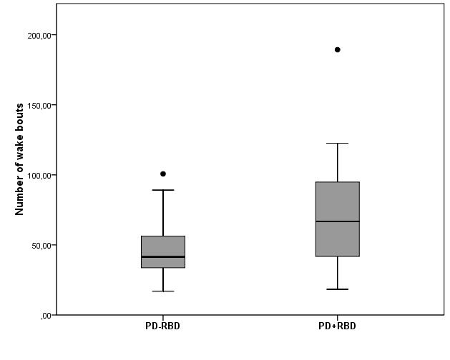
Boxplot of number of wake bouts per night measured over 8 nights in PD+RBD and PD-RBD

