Figure 2. ROC curve number of wake bouts
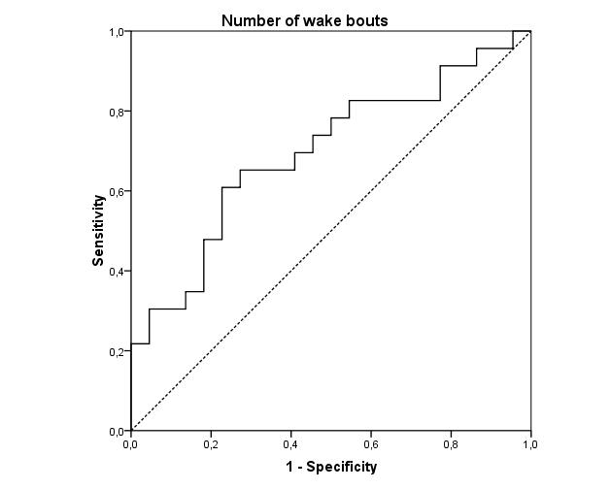
Number of wake bouts measured over 8 nights
Area under the curve (AUC) = 0.696

