Supplementary Figure 1
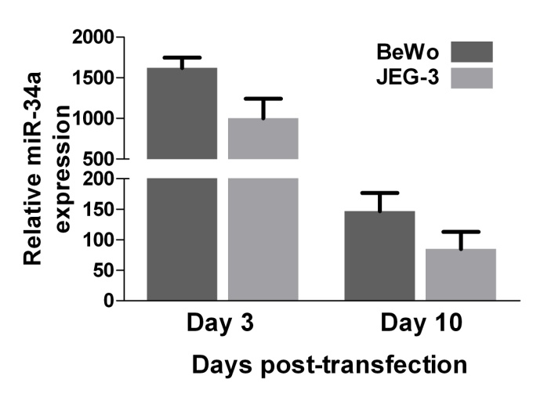

Expression level of miR-34a at different time points post-transfection. Levels of miR-34a were determined by TaqMan miRNA assays and normalized by RNU6B as described in the Materials and Methods. Relative expression level was expressed as fold over control.

