Supplementary Material: The cost of lost productivity due to premature cancer-related mortality: an economic measure of the cancer burden

Figure 1A: Male wage rate transition between ages 15-64 for 2009
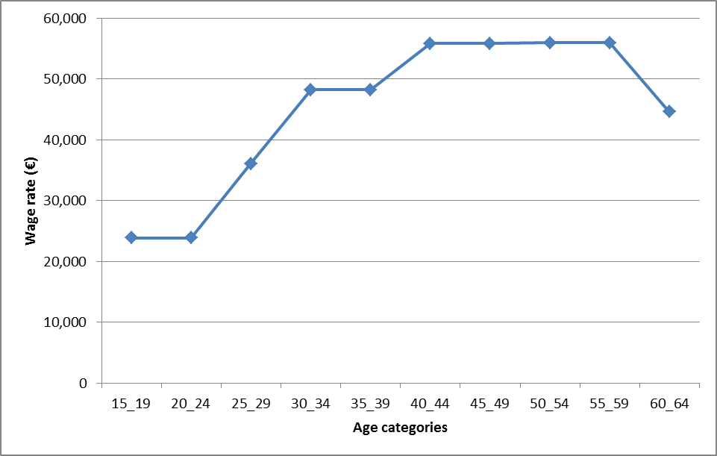

Figure 2A: Female wage rate transition between ages 15-64 for 2009
