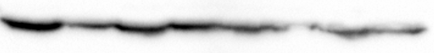
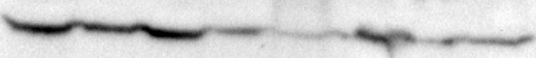
231 Native
231 25 PACR
231 50 PACR
ZR75 Native
ZR75 25DOCR
ZR75 50DOCR
ZR75 25PACR
ZR75 50PACR
α/β Tubulin
GAPDH

