 | loxP | eCD73^{-/-}
CD73 / α-SMA / DAPI | 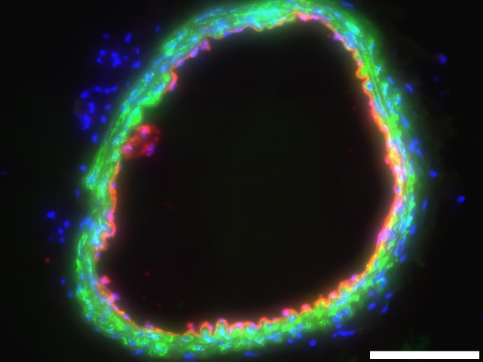  A | 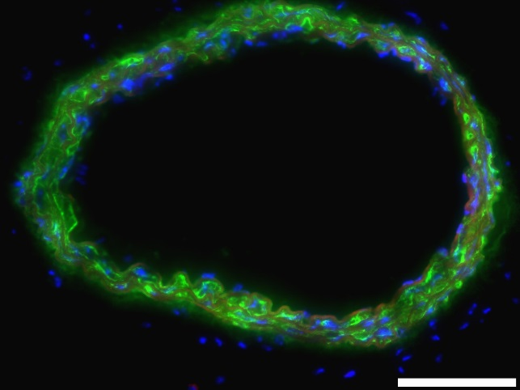  B

Additional file 1 Figure S1. Immunohistochemistry of carotid artery in Tie2-Cre⁺ CD73 ^{flox/flox} (eCD73^{-/-}) mice. Immunohistochemical analysis of carotid artery showed strong CD73 expression (red) on endothelial cells of CD73^{flox/flox} (loxP) mice (A) und lack of CD73 activity on endothelium in eCD73^{-/-} mice (B). Smooth muscle cells were identified by staining with α-SMA (green) and nucleus with DAPI staining (blue). Bars: 200 µm.

