Supplementary table 1: Comparison of IC50 values after treatment with GEM or ET-743 on BTC cells
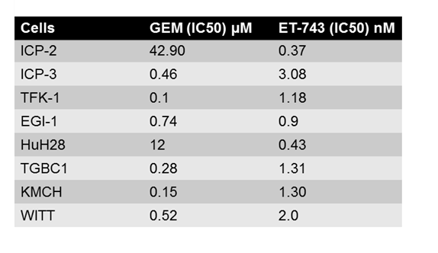
ICP-2/3 primary cells derived from 3 intrahepatic cholangiocarcinoma patients. TFK-1, WITT and EGI-1: extrahepatic cholangiocarcinoma cell lines; HUH28 intrahepatic cholangiocarcinoma cell line; TGBC1: gallbladder carcinoma cell line; KMCH intrahepatic mixed with hepatocarcinoma cell line.

