Supplemental Materials

for the paper titled A Spatial Model to Predict the Incidence of Neural Tube Defects

Table S1. Optimal fitted variogram models of local and regional residuals by cross validation
Model | L_R | R_R | C_V
Model type | Spherical | Stable | Spherical
Parameter | - | 0.697 | -
Major range | 2425.41 | 13836 | 2543.79
Nugget | 0.606 | 1.167 | 0
Partial sill | 0.043 | 0.303 | 1.261
Note: L_R—local residual; R_R—regional residual;
C_V-- cross variogram between local and global residuals

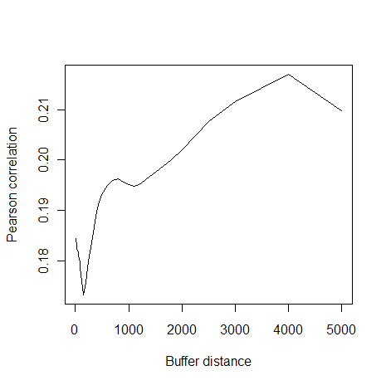
a). Calcareous lithosol
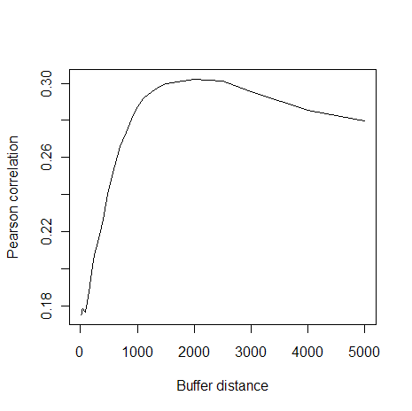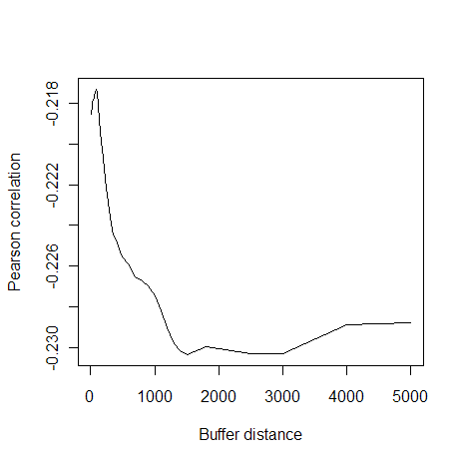
b). Brick clay lithodological type(Q*) c). Trias Liujiagou Group lithodological type (T*)

Figure S1. Correlation of the soil (a) and lithodological types (b, c) along the decaying buffer distances

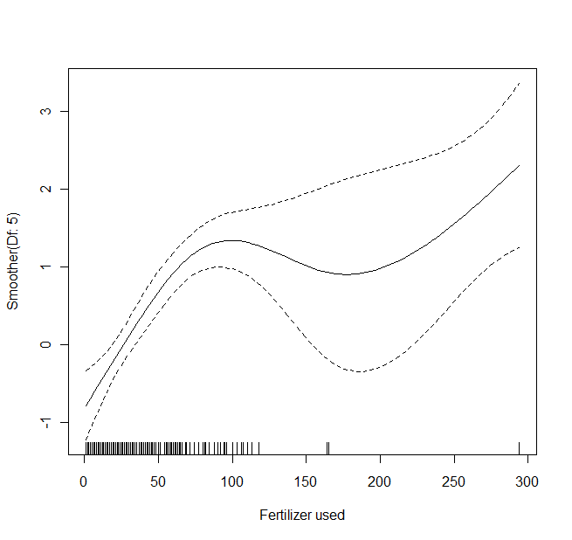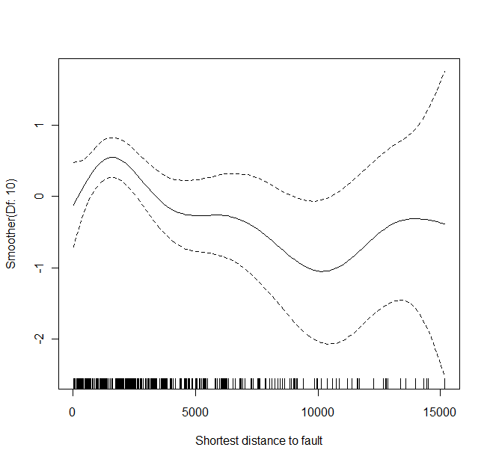
a b
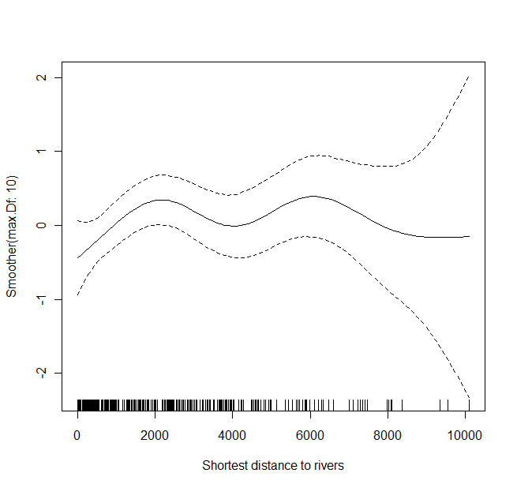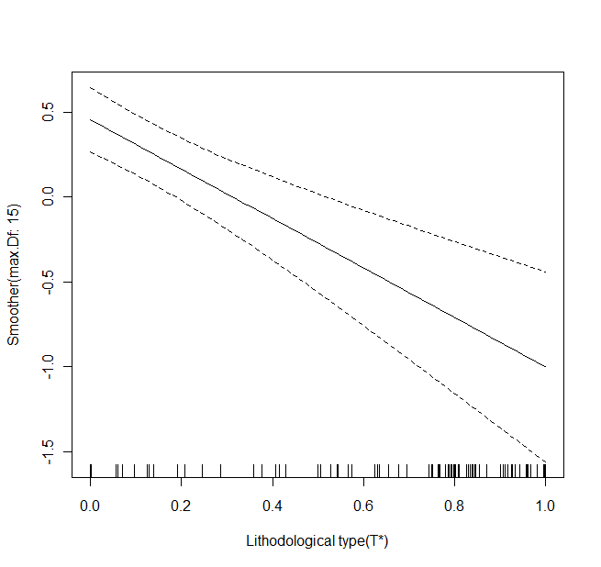
c d
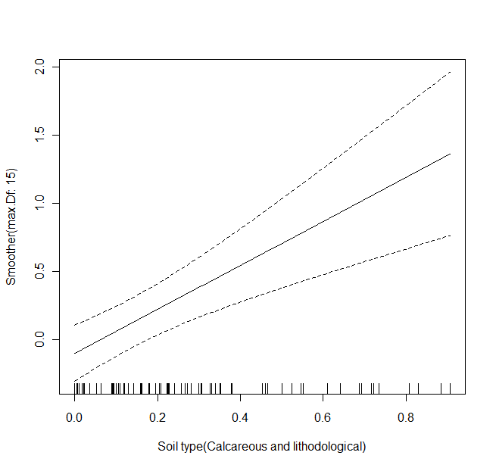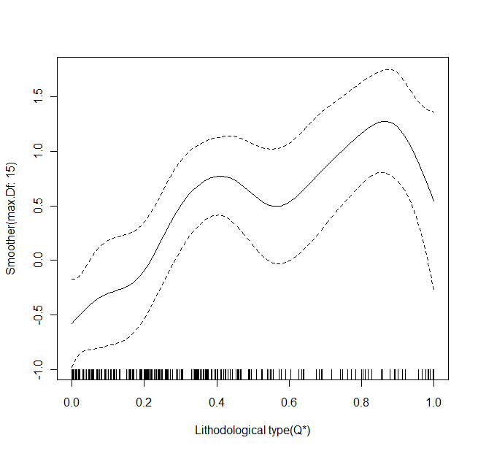
e f
Figure S2. Non-linear/linear relationship between local covariates and the expected NTD incidences modeled by GAM

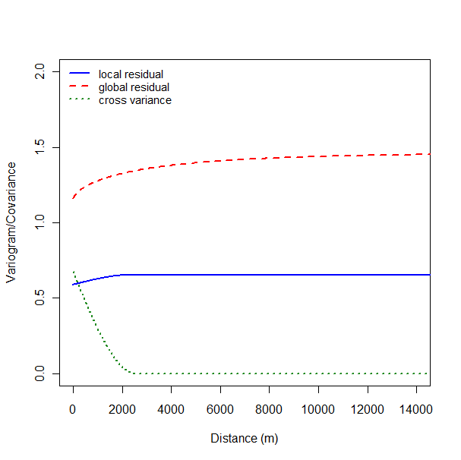

Figure S3 Variograms of local and regional residuals and cross covariance

